Brandon Just
Fall SC3353
Section #1
Performing Arts Center

From: Brandon Just
To: Nathan.Gunter@TravelOK.com
All-American Rejects to open OSU performing arts center
Mr. Gunter,
Putting on performances that go beyond Oklahoma State University onto a national spotlight is something we are trying to achieve. Our new performing arts center will allow our students to show their true potential. To inspire our students on our opening night, hometown heroes The All-American Rejects will put on a performance you won’t want to miss.
I think this story would be great for Oklahoma Today. I know you are a fan of rock music and the concert won’t be until April 15, 2013 so this will give you time to prepare the story. The All-American Rejects are from Stillwater and will appeal to people from the state and Oklahoma State graduates. The new performing arts center will be feature the newest sound equipment and beautiful architecture. People from all over the state will be willing to come see a show after seeing this performance.
We are offering exclusive interviews with the band and backstage passes to the show. You will be the only reporter who has these privileges of interviewing the band before and after the concert. You will also have front-row seating to the concert and stage rights for the photographer. Please let me know any other way I can help. My direct phone line is 405 – 623 – 2021.
I will call you Oct. 10, to check on any additional details you will need for the story and if there is any other information I can help with. Thank you for your time and I look forward to hearing from you again.
###
Brandon Just
Sports Media Major
405 – 623 – 2021
bljust@okstate.edu

Oklahoma State University
Stillwater, Okla.
405 – 744 – 5000
News Release
For Immediate Release FOR MORE INFORMATION
Oct. 5, 2012 Brandon Just
Sports Media Major
bljust@okstate.edu
OSU to build new performing arts center
STILLWATER, Okla. – Oklahoma State University is seeking donors to help build the new performing arts center. The committee just began their fundraising process on Oct. 1, and need $40- $60 million dollars to complete the project. They will need 50 to 80 percent of the money before they will be able to break ground. Based on their feedback on the donations that have already come in they are hoping construction will begin in the next two years.
“We obviously have the talent here,” Jason Caniglia associate vice president of development said. Caniglia said the new performing arts center will allow Oklahoma State to compare to other top music schools and also be used as a recruiting tool.
The new arts center will take the lead role in place of the Seretean Center and include state of the art technology and architecture. When completed it will include 1,250 seats and be approximately 140,000 square feet. On opening night the All-American Rejects will be performing to provide inspiration current and future students.
This project is supported by the Oklahoma State Branding Success campaign and all donors whose names will remain private at this time.
###
For information, visit http://bit.ly/NjHwUa

OKLAHOMA STATE UNIVERSITY
119 Student Union
Stillwater, Okla. 74075
405 – 744 – 5000
FACT SHEET
FOR IMMEDIATE RELEASE FOR MORE INFORMATION CONTACT
Oct. 3, 2012 Brandon Just
Sports Media Major
405 – 623 – 2021
bljust@okstate.edu
OSU performing arts center opening night
What: The All-American Rejects will have a concert for the opening night for the new performing arts center.
Who: The All-American Rejects are from Stillwater, Okla. and have had their albums certified platinum six times. They were ranked No. 73 on the Hot 100 Artist of the 2000s.
Where: Stillwater, Okla.
When: April 15, 2013 at 8 p.m.
Why: “We love playing in front of our home town and hope to inspire more people to follow their dreams,” Tyson Ritter lead vocalist said.
###
-Brandon Just, Sports Media Major

Performing Arts Photo Gallery

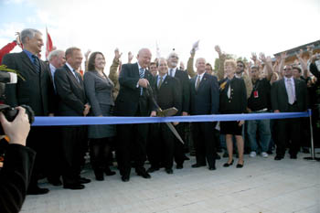
Donors celebrate breaking ground on Oct. 1, 2012, for the performing arts center south of
campus on Walnut Street.
Smith Construction’s crew working on the roof of the performing arts
center Wednesday afternoon.
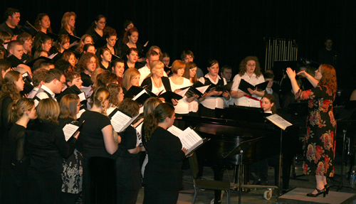
OSU choir practicing for opening night with The All-American Rejects at the
Seretean Center Oct. 8, 2012.

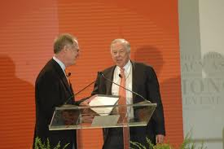
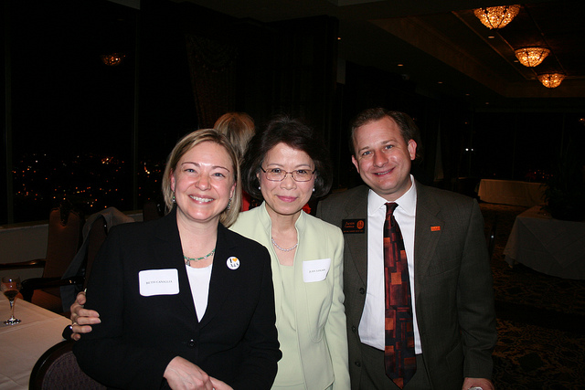
OSU President Burns Hargis (left) introducing lead donor Walter Jones
(right) at the ground breaking ceremony for the performing arts center
Oct. 2, 2012.

Associate VP for development Jason Caniglia (left) celebrating with major donors
Sue Kwon (center) and Pam Giles (right) after an alumni fundraising party on
Aug. 10.

Reference Page
Performing Arts Center Opening Night
The All-American Rejects
April 15, 2013
For ticket information email bljust@okstate.edu

- OSU/A&M Regents select architects for future performing arts center and business building, In News and Communication. July 23, 2012, Retrieved on Sep. 30, 2012, from https://news.okstate.edu/index.php/press-releases/381-osuaam-regents-select-architects-for-future-performing-arts-center-and-business-building.
- Caniglia, J. (personal communication, Oct. 1, 2012).
- The All-American Rejects, Wikipedia, Retrieved on Oct. 4, 2012, from http://en.wikipedia.org/wiki/The_All-American_Rejects.
- Ritter, T. (personal communication, Oct. 1, 2012)*.
- Images, Google Images, Retrieved on Oct. 3, 2012, from https://www.google.com/imghp?hl=en&tab=wi.
* “as per assignment instructions, source was fabricated.”

