

**Strategic Message Planner: Wonder Water**

1. **Advertising Goal:**

* In 2013 the goal is to capture 10 percent of the sports drink market in the United States.

1. **Client Key Facts:**

* The client is 23 years old.
* Wonder Water was founded in 2012 and is located in Stillwater, Okla.
* Wonder Water has lower sodium content then both Gatorade and PowerAde.
* It also has the daily value in both vitamin B6 and B12.
* Current revenues are $100,000 and are using this for advertising.
* Wonder Water is the only current product of theirs.

1. **Product Key Features:**

* What is the product?
  + Category- Sports Drinks
  + Features- Contains vitamin B6, B12, and also replenishes electrolytes during exercise.
  + Attributes- 20 and 32 ounce bottles. Flavors include Fruit Punch, Wonder Blue, Yella Lemonade and Purple Drank.
* Product Purpose?
  + Why Created? - Wonder Water was created to give athletes longer lasting, more energized time frames of energy exertion.
  + Other uses?- Can use before workouts for energy boost.
* What is the product made out of?
  + Materials- Plastic for the bottle and the label. Ink for printing on the label.
  + Ingredients- Sodium, potassium, carbohydrates, sugars, protein, vitamin B6 and vitamin B12.
  + Intangible Ingredients - Wonder Water increases virility in men.
* Who and what made the product?
  + Who created the project? – Brandon Just from Wonder Water.
  + What vendors supplied materials? – Wonder Labs.
  + What are the vendor’s features? - Wonder Labs has an FDA approved facility in Oklahoma City, Okla., and has been making quality ingredients since 1965.
  + What equipment is used to make the product? – There are two separate machine operated assembly lines. The first machine makes the bottles and places the labels on them. The second machine mixes the ingredients and places the liquid inside of the bottles.
  + Where is the product sold? – Wonder Water is currently sold in Oklahoma and is developing this strategic message planner to expand to the entire United States market.

1. **Target Audience:**

* Demographics
  + Ages- 8 years old to anyone still active.
  + Sex- Male and females.
  + Ethnicity- Americans.
* Psychographics
  + Lifestyle- Anyone who is still active in sports or exercising.
  + General Attitude- People who strive to get better every day.
  + Values- People who expect to meet goals they have set and are looking for a healthy boost.

1. **Product Benefits:**

* Wonder Water gives you an extra boost of energy which allows you to have longer and higher intensity workouts.
* Wonder Water has your daily value in vitamin B6 and B12. This increases energy levels and the metabolism in your cells to help you burn fat.
* Wonder Water contains electrolytes to help prevent dehydration, in return allow you to have extended periods of exercise.
* The potassium in Wonder Water will prevent cramping during long periods of activity in extreme temperatures.
* The protein contained in Wonder Water will help with muscle recovery after intensive workouts.

1. **Direct Competitors: Sports drinks**

* Gatorade
  + Description- Gatorade is a sports drink developed at the University of Florida in 1965. Gatorade is owned by PepsiCo and is distributed in 80 different countries. In the United States, Gatorade has captured approximately 75 percent of the sports drink market.
  + Brand Image- Gatorades brand image is extremely strong and positive. They have some of the most popular athletes in the United States endorsing their products. In football it has become widely popular to give the winning coach a “Gatorade shower.”
* PowerAde
  + Description- PowerAde was created in 1988 and is owned by Coca-Cola. In 1988, they were the official sports drink of the Olympics. They are the rival brand of Gatorade but only capture approximately 22 percent of the United States market for sports drinks.
  + Brand Image- PowerAde has a positive image especially during Olympic time periods because they sponsor the majority of sports. They are also popular overseas where they sponsor many professional sports teams.

1. **Indirect Competitors: Energy Drinks**

* Red Bull
  + Description- Red Bull is an energy drink company that was created in 1987 and sold more than 4.6 billion cans worldwide in 2011. Red Bull provides energy but is not considered a healthy beverage.
  + Brand Image- Red Bull is associated with extreme sports and is looked as fun and exciting by its consumers.
* Monster Energy
  + Description- Monster Energy was introduced in 2002 and currently distributed by Coca Cola. They rely on sponsoring sporting events for their advertisements instead of the traditional media approach. Monster Energy is geared toward extreme sports like Red Bull.
  + Brand Image- Monster Energy has a strong brand image specifically using their logo as their main selling point. Consumers of Monster Energy show support by wearing T-shirts or putting stickers on their vehicles with the logo.
* NOS Energy Drink
  + Description- NOS was introduced in 2004 and is produced by Coca Cola Company. NOS is designed to look like a nitrous oxide canister that is use to enhance performance in vehicles.
  + Brand Image- NOS is popular among NASCAR and video game fans because they sponsor racing events and professional video game players.

1. **Product Brand Image:**

* Current Brand Image- An exciting change of pace from Gatorade and PowerAde, focusing more on working out and preparation than the sporting event itself. Only currently known about in Oklahoma.
* Desired Brand Image- Client wants to be known nationwide as the sports drink for hard working athletes that put the time in off of the playing field.
* Brand Image Challenge- PowerAde and especially Gatorade have such a tight grip on the sports drink market getting shelf space and distribution will be a big challenge.

1. **Strategic Message:**

* Wonder Water is a healthy, effective energy boost for athletes who strive to become better on and off the field.

1. **Support:**

* Wonder Water has your daily value in vitamin B6 and B12 making it a healthy option.
* B6 and B12 are also an energy boost that does not have any negative side effects.
* The electrolytes will keep the body replenished during a game or a long workout.

**Print Ad**

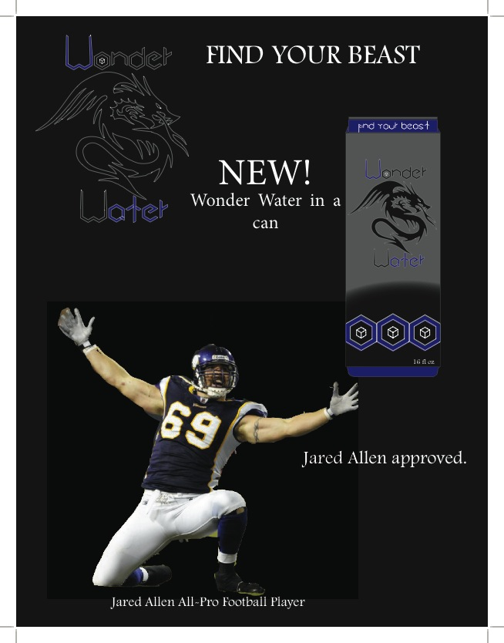

Visit www.wonderwater.com

**Radio Spot**

Title: Find Your Beast  
Client: Wonder Water  
Length: 30 seconds  
Air Dates: Nov. 8, 2012 – April 8, 2013

|  |  |
| --- | --- |
| MUSIC: (War Drums play throughout)  ANNOUNCER:  JARED ALLEN:  SFX: Football tackle sound.  JARED ALLEN:  SFX: Weights clanking with man breathing.  JARED ALLEN:  SFX: Man takes two deep breaths. | Jared Allen. All-Pro football player.  They call me a beast on the field.  My work off the field is where my true beast shows.  To fuel me during an intense workout, my drink of choice is Wonder Water. |

|  |  |
| --- | --- |
| JARED ALLEN:  ANNOUNCER:  MUSIC: (fade out at 29 seconds) | It contains vitamins B6 and B12 to give you a healthy energy along with electrolytes to keep going when you want to quit. Wonder Water allowed me to find my beast. Where’s yours?  Wonder Water. Find your beast.  Visit WWW – DOT – Wonder Water – DOT - COM  ### |

**TV Spot**

Title: Find Your Beast  
Client: Wonder Water  
Length: 60 seconds  
Air Dates: Nov. 8, 2012 – April 8, 2013

|  |  |
| --- | --- |
| Wide Shot – Man looking over large crowd during medieval times. (:05)  Close Up – Scrawny kid looking up in amazement. (:04)  Close Up – Same kid drinking bottle of Wonder Water. (:03)  Medium Shot – Same kid doing pushups. (:02)  Medium Shot – Same kid chopping wood. (:03)  Close Up – Same kid running. (:02)  Medium Shot – Crowd of men standing around a stone with a sword in it. Men fail to pull out sword. (:10)  Close Up – Kid is now a young man, muscular and with a beard walks out of the crowd. (:03)  Medium Shot – Young man pulls the sword out of the stone with ease and lifts it over his head with one hand. (:04)  Close Up – Crown placed on young man’s head while he is drinking a Wonder Water. (:03)  Wide Shot – Young man riding away from kingdom on a horse. (:05)  Medium Shot – Young man walking into large cave. (:04)  Close Up – Young man face to face with a dragon. (:04)  Medium Shot – Young man flying through the air on the dragon while holding Wonder Water. (:05)  Picture – Wonder Water logowith text saying visit [www.wonder](http://www.wonder)water.com . (:03) | KING:  I present you Wonder Water!  MUSIC:  (Eye of the Tiger by Survivor)  MUSIC:  (Pause)  MAN IN CROWD:  Whoever is man enough to pull out the sword shall be king!  MUSIC:  (Eye of the Tiger queues again.)  YOUNG MAN:  AHHHHHHHHHH!  BEAUTIFUL YOUNG WOMAN:  (Worried Voice.) Where are going?  YOUNG MAN:  (Deep manly voice.) To find my beast.  YOUNG MAN:  HAHAHAHAHAHAHA!  MUSIC:  (Fades out at (:57)  ANNOUNCER:  Wonder Water. Find your beast.  ### |

**Story Board**







**Reference Page**

1. Gatorade, Wikipedia, Retrieved Oct. 31, 2012, from <http://en.wikipedia.org/wiki/Gatorade>.
2. PowerAde, Wikipedia, Retrieved Nov. 1, 2012, from <http://en.wikipedia.org/wiki/Powerade>.
3. Monster Energy, Wikipedia, Retrieved Nov. 1, 2012, from <http://en.wikipedia.org/wiki/Monster_Energy>.
4. Red Bull, Wikipedia, Retrieved Nov. 2, 2012, from <http://en.wikipedia.org/wiki/Red_Bull>.
5. NOS Energy, Wikipedia, Retrieved Nov. 2, 2012, from <http://en.wikipedia.org/wiki/NOS_(drink)>.
6. MLK Image, Google Images, Retrieved Nov. 3, 2012, from <http://www.easternct.edu/cgi-bin/mt/mt-search.cgi?IncludeBlogs=13&search=MLK%20Awards>.
7. Skinny Kid Image, Google Images, Retrieved Nov. 3, 2012, from <http://www.dreamstime.com/stock-photography-skinny-kid-image9018392>.
8. Kid Drinking Image, Google Images, Retrieved Nov. 3, 2012, from <http://freshhealthyvending.com/healthy-vending/vending-machines-seen-as-a-major-cause-of-childhood-obesity/>.
9. Pushups Image, Google Images, Retrieved Nov. 3, 2012, from <http://www.sheknows.com/health-and-wellness/articles/844477/wallie-exercises-a-fun-kid-friendly-workout>.
10. Chopping Wood Image, Google Images, Retrieved Nov. 3, 2012, from <http://crossingtheprairie.blogspot.com/2011/05/chopping-wood.html>.
11. Kid Running Image, Google Images, Retrieved Nov. 3, 2012, from <http://www.jedword.com/2011/01/08/lickety-split-to-run-at-a-great-speed/>.
12. Sword in Stone Image, Google Images, Retrieved Nov. 3, 2012, from <http://iteachlit.edu.glogster.com/arthurian-allusion-reference-/>.
13. Bearded Man Image, Google Images, Retrieved Nov. 3, 2012, from <http://www.paymanproduction.com/?p=2270>.
14. Lifting Sword Image, Google Images, Retrieved Nov. 3, 2012, from <http://cs.wellesley.edu/~rds/rds05/projects/camelot/processframe1.html>.
15. Crowning King Image, Google Images, Retrieved Nov. 3, 2012, from <http://reptilecynrik.deviantart.com/art/Crowning-of-the-King-119901031>.
16. King on Horse Image, Google Images, Retrieved Nov. 3, 2012, from <http://ealsmiddleages.wikispaces.com/King+Arthur>.
17. Cave Image, Google Images, Retrieved Nov. 3, 2012, from <http://www.picture-newsletter.com/cave/index.htm>.
18. Man vs. Dragon Image, Google Images, Retrieved Nov. 3, 2012, from <http://jimflora.blogspot.com/2008/10/man-vs-dragon.html>.
19. Man Riding Dragon Image, Google Images, Retrieved Nov. 3, 2012, from <http://www.mononarag.com/>.