Ocelots
Habitat and Appearance
The ocelot, Leopardus pardalis, is a small mammalian cat of the order Carnivora and the family Felidae that lives in rainforests and dry scrublands throughout Central and South America. They live from southern Texas all the way into northern Argentina. Ocelots have a golden brown pelt with a white underbelly and brown/black spots that look kind of like doughnuts with dark tan inside and black stripes on their face as figure 1 shows (San Diego Zoo). Ocelots usually grow to 26-39 inches in length and can weigh between 24-35 pounds; they also have keen sight and hearing which allows them to easily move around at night when they prefer to hunt (San Diego Zoo).
Diet and Early Life
Ocelots are nocturnal and are primarily ambush predators meaning they prefer to wait in thick brush and pounce on their prey which ranges from birds and rodents to lizards and even fish. Ocelots spend most of their time on the ground, but they are good climbers and swimmers.
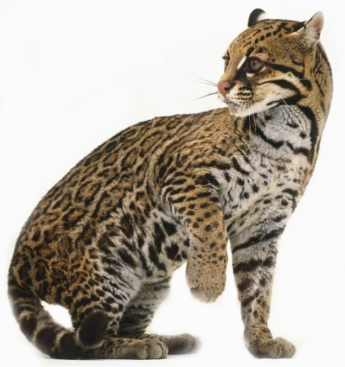
Ocelots are usually born in litters of one to four kittens, and mothers are usually only pregnant for two months before giving birth. Ocelots weigh less than a pound at birth and are cared for completely by their mother and they are taught how to hunt. By the time they are eight months old, the ocelots are old enough to fend for themselves, but they may stay within their mother’s range for up to two years before moving to other areas (San Diego Zoo).
Threats to the Ocelot
Figure 1- physical appearance of and ocelot
The biggest threats to ocelots are hunting and habitat loss; the San Diego Zoo explains that ocelots used to live in Arkansas and Louisiana and Texas, but because of hunting and habitat loss, there are an estimated 100 ocelots living in the US. As mentioned before, ocelots prefer to utilize thick vegetation in order to wait and ambush their prey, but as more and more people begin to cut down heavy vegetation in the rainforests and areas where ocelots live, the ocelots are forced to move where there is ample vegetation for them to live and thrive (San Diego Zoo). Ocelots were also once highly regarded for their beautiful coats. They would be hunted and their skins were used to make fur coats and people would pay huge bucks for an ocelot coat. Bringing ocelots or their coats into the US has been illegal for thirty years, so hunting has decreased as a large-scale threat to their well-being (San Diego Zoo).
References
Mammals: Ocelot. The San Diego Zoo

