HOME SWEET HOME

If your house needs a good, detailed cleaning this summer, call ME!!!
Tina Detwiler
660-341-7887
tina_detwiler@hotmail.com
I can offer you excellent cleaning services to prepare your house for the students’ return. Allow me to give the house a personal and professional cleaning. I have great references, a strong work ethic, and pay attention to detail.
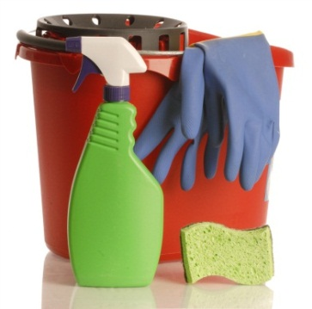
Your home will not only look and smell clean, but it will BE clean.
- Move furniture to clean floors
- Clean under mattresses
- Wipe down walls & doors
- Clean and polish furniture (desks, coffee tables, etc)
- Clean light fixtures & air vent covers
- Change light bulbs (you supply the bulbs)
- Vacuum or mop depending on the floor surface
- Wash baseboards
- Clean bathroom fixtures, floors, mirrors, & showers
- Scrub & polish dining room chairs & table legs
- Clean all common living areas, stairs, elevator, bedrooms, dining room, kitchenette area, bathrooms & foyer.
Your home will be shiny & clean and smell fresh. This is a top to bottom clean that will leave your home ready for fall tenants. Let me tackle the grime and take away the worry of cleaning the house.
Satisfaction guaranteed at a price to make you smile.
Please call for an appointment at your convenience
The job can include carpet shampoo, stripping & waxing floors, and private kitchen cleaning.

