A Renewable Energy Website for Young Adults
Introduction
In a society that is heavily reliant on non-renewable resources such as coal and natural gas for our energy needs, many people do not ever consider that these resources will run out without proper attention and conservation. Whether we think about it or not, everyone relies on energy; it powers our homes, businesses, and schools and it powers everything we use in our daily lives. With our heavy energy reliance it is to our benefit to consider possible alternative forms of energy that are renewable and can actual save us money in the long-run. Renewable energy sources such as wind, solar, and geothermal energy are all currently used in the United States but each are grossly overshadowed by the use of coal power. The final aim of this project is to construct a website that will serve to educate middle - to high-school age students about these alternative forms of energy and encourage them to consider moving their communities away from coal power.
Project Description
As mentioned above, the aim of the project is to create an easy-to-navigate website that will provide information about wind, solar, and geothermal energy to middle school and high school age members of the public in order to educate them on the benefits of these alternate forms of energy in order to influence a transition away from our heavy reliance on coal and natural gas. The information for the website will come from the Environmental Protection Agency (EPA), renewable energy support groups, and specific case studies of each energy source; the website itself will be created using the Wix Free Website Builder. There will be a couple pages devoted to each form of energy to allow readers to more easily find the information that they want without having to search far and wide in the website. For example, if a reader wants to know how much power a single windmill can produce, he will be able to navigate to the wind power section and easily find the sub-page explaining the power of each windmill. The home page will offer an introduction to what information the website presents; pages two, three, and four will provide information about the alternative energy sources such as history and development, economics, uses of the produced energy, and current projects involving the energy sources. The final page will provide readers with contact information to learn more about alternative energy sources. Here is what the front page of my potential website looks like so far.
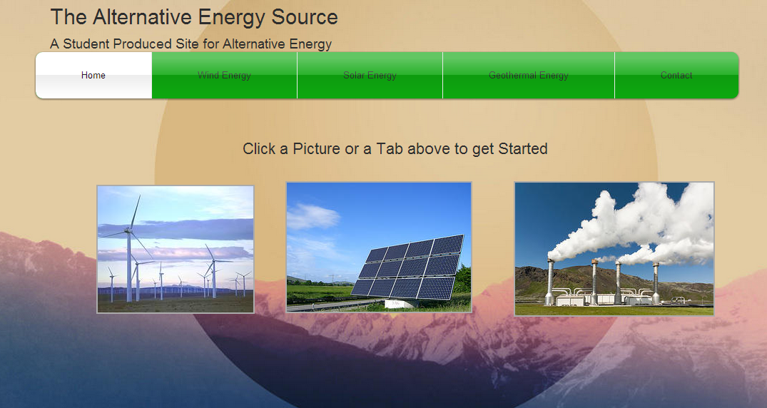
The pictures and the tabs will lead to the different pages of the website, where readers will be able to learn more about each type of renewable energy. As more research is conducted, the pages will be filled out and more editing will be done to make sure the pages look professional.
Justification and Statement of Worth
Currently, there is a plethora of information about renewable resources that is easily available online and can easily overwhelm a person looking for a few simple answers or wanting some general information about alternative energy options. The creation of a website that focuses on presenting the most important information on alternative energy in laymen’s terms will have the largest benefit to the greatest number of people. Anyone from middle-school to middle-age will be able to gain a broad understanding about the energy options available outside of coal and natural gas and the information that will be available on the website will hopefully serve to educate the interested public as well as quell some common misconceptions about these energy sources.
This project will also benefit me as a writer; I am used to writing research papers that are not usually meant to be read by persons with a layman’s knowledge of a particular subject. This project will allow me to venture into an unfamiliar information medium to express my interest in alternative energy. I have had no previous experience in web design and utilizing a simple website generator like Wix will allow me to easily devise straightforward website that I can use to present the information I want people to see without having to worry about the subtle and not-so-subtle nuances of designing a website. I will be able to design my website using either HTML5 or Flash without having any knowledge to write or edit either code and through my research, I hope to learn some new information about these forms of renewable energy.
To be able to complete my project in the given amount of time, I will need to do an extensive amount of research for both the information on renewable energy and on how to use and edit web pages on Wix. While I have some collected information about wind and solar power, I will need to research more to have a larger amount of information to draw from; in the same token, I do not know much about geothermal energy so I will have to extensively research that topic alongside the others. The time spent doing research will be thorough and combined with the work I will have to do to put together the information and format the web page itself will take up an amount of time equivalent to writing a ten page paper.
Methodology
In order to complete the project, there will be two major steps that I will work on and complete concurrently. The first step will be to research and find information about wind, solar, and geothermal energy from both government sources (EPA, Dept. of Energy, and the National Renewable Energy Laboratory) and from non-government groups devoted to using renewable energy (American Council on Renewable Energy, American Wind Energy Association, etc). I will keep my research limited to the points mentioned previously. While conducting research, I will also be working with Wix in order to become more familiar with the coding and design within the program so I can figure out what exactly what can be with the created website to make sure that I can present the information in a easily accessible and aesthetically pleasing fashion.
The second step in the project will be started after I begin researching information and have become more familiar with designing websites using Wix. While I research and explore the possibilities of Wix, I will begin adding the information to the different pages of the website; also working on the design of the web pages by adding images, setting up the pages so the information can be accessed in the same way on each page, and making sure all the text is both legible and consistently designed. I hope to begin designing the website before adding the information as well, some design changes can be made without having the information; the page tabs, my personal contact information, and some images can be added and adjusted before the information so I will work on the design while I search for information.
Timeline
- October 24- Submit proposal at the beginning of class
- Oct 25-Nov 6- Research wind, solar, and geothermal energy (economic, development, energy usage, and current projects) Also, begin adding information to the wind energy page
- Nov 7- Submit a progress report of the research and website (show all the work done on the website to this point)
- Nov 8-21- Finish editing and adding information to wind energy and solar energy pages
- Nov 22-Dec 4- Complete the geothermal energy page, and make any final editing changes, make sure that everything is coherent and consistent.
- December 5- Submit the final project
Risks and Constraints
For this project, there are not really any risks or constraints to its completion. The only constraints would be my abilities to learn how to work with Wix, two weeks is more than enough time to conduct the research and find the information that I need and it should be plenty of time for me to familiarize myself with Wix. Any problems with designing the website can easily be solved with online tutorials and assistance from Wix itself; in the preliminary research that I have done with Wix up to this point all questions have been answered by the Wix Support Center, and I am sure any questions that may arise will be answered as well. Using both my resources and time wisely will help to reduce any constraints that may arise while working through the project.
Conclusions
With our heavy reliance on non-renewable energy sources, it is in our best interests as a nation to consider possible energy alternatives. The created website will offer readers with information from credible sources on some of these alternative energy sources, and will hopefully encourage them to spread the word about these cleaner and renewable sources. The project will also give me a chance as a writer and an environmental enthusiast to tell others about my environmental interests while becoming more familiar with a current and highly useful medium that is outside of my usual area of expertise. I hope that this project will encourage readers and other students to take a larger interest in renewable resources and will allow them to teach others about these resources.

