Formal Report

Daniel White

Abstract
This report serves the purpose of discussing my overall experience in a professional writing class. The idea is to describe and discuss both my professional and personal writing experiences while analyzing some of my specific accomplishments within the class. By discussing these experiences, I can give readers insight to the professional writing process, to some of my personal struggles and difficulties in completing the assigned projects, and to the pertinence of professional writing as an environmental science major. The specific projects I chose to analyze were the projects that I felt best pertained to my hopeful career path and best allowed me to show my versatility in medium choice and writing style. The analysis of the chosen projects is given in consideration of the pertinence of the skills I learned to my career focus. For each project, I discuss the most difficult part in completing it and my process of working through it and then use the analysis to explain how each project is important to my overall writing skills and my ability to tailor to specific audiences.
Introduction
As a future professional environmental scientist, the importance of professional writing cannot be stressed enough. This report illustrates some of the specific skills and ideas that I gained from taking a course on professional writing and the analysis within explains how those skills have affected me personally and professionally. The report will analyze the accomplishments and struggles I faced in working through each project and the analysis will show how my work in the class greatly improved my professional writing skills.

Overview
When I signed up to take this professional writing class, I was largely uncertain of what the class would entail and what I was going to be expected to do. Once I got into the class, I saw that most of the project required a large amount of time and effort to complete and at first glance, they were overwhelming to me. As an Environmental Science major, most of my writing experience has been in the form of essay writing and reports summarizing a performed experiment which required research skills, computer skills, and meeting deadlines more than most other skills. Each of the projects required me to utilize these skills, but it was also necessary for me to be a more critical thinker, be more creative, and be able to write for different audiences which were a little more difficult for me. The software demonstration and the critical autobiography projects were both well outside of my usual writing style whereas the technical definition and my career-related projects were both more familiar and comfortable for me to complete but encouraged me to explore new mediums for my writing.
Every project completed in the class has not only helped broaden my experiences in professional writing, they also helped me become more proficient in my writing skills as a whole. The skills gained from the projects and my work in the class will greatly help me in the professional field.
Software Demonstration
The software demonstration that I conducted in class was one of the few projects that really required me to step out of my comfort zone in a number of ways. For my demonstration, I put together a simple flyer about a cookout at Capital using Adobe InDesign which I had never used before. Before I actually began working on the demonstration, I watched a few YouTube videos and found that the program was much like Microsoft Publisher which made learning the program easier because I have a little experience in Publisher. Between my previous knowledge and the YouTube videos, I was quickly able to pick up on a few of the finer points of working with InDesign which made it easier for me put together an informative and concise set of directions. I used my directions and presentation to demonstrate how to add text and images to a flyer and then do some simple work with the image and text (moving, cropping, italicizing, etc). Using InDesign for a demonstration not only gave me practice using a program unfamiliar to me, I also improved my skills in public speaking.
Critical Autobiography
The critical autobiography was a project that I became progressively excited about as I worked through it. The autobiography gave me a chance tell readers about who I am personally and professionally while learning to write critically to connect my personal experiences to my professional work. We completed the project early on in the semester, so not much in the way of using color or extensive creativity had been discussed in class; I was not comfortable enough with taking large creative liberties, so I focused on filling out the content of the autobiography. Letting my words speak for themselves allowed me to detail both my personal life (my Scouting and family experiences) and professional life (the Capital Chemistry Department and Trinity Summer Camp experiences) while critically analyzing those important experiences using a medium that I’m comfortable with. No matter what career I go into in relation to environmental science, critical thinking and analysis will be important skills to have and the critical autobiography helped me develop those skills.
The hardest aspect of writing my critical autobiography was finding a good balance of narrative and analysis. It would’ve been easy to pick a few points of my life that I felt had the most influence on the person I am today and just write about them; the point of the project was to take those experiences and critically analyze them to explain their pertinence to my hopeful career path which proved to be the challenge of the assignment.
Like most people, I have plenty of stories about my life and how those experiences have influenced me as a person, but I sat down and chose the four words that I thought best described me as a person and I wrote my autobiography around those words. From the words and my memories, I picked a few experiences from my life and wrote how they shaped my interests and my career choices. While writing the autobiography, I managed to find a good balance between my narrative and my analysis of the important experiences and the paper itself became much easier to write.
Proposal/Career-Related Project
Of the professional writing projects that were completed, the career-related project definitely benefited me the most. For most professions, especially research in the scientific fields, writing a solid and concise grant proposal to an organization, university, or the government is an extremely important skill to have and utilize. I came up with a few possible topics and I eventually chose to use my project to discuss forms of alternative energy, a topic that has been of great interest to me. I have seen many alternative energy sources in action near my hometown and Capital. With the nation’s heavy reliance on coal and natural gas, not many people know about the cleaner alternatives that are available and they have a right to know that there are more options. For my project, I decided to build a website in order to educate the general public about some alternative energy sources that exist and are more widely used. The hardest parts of writing the proposal was (1) narrowing down the focus of my project to focus on a few energy sources rather than a majority of them, (2) doing some preliminary research on each energy source to determine the most important aspects to discuss, and (3) familiarizing myself on building a website, which is a new medium for me, in order to construct and complete my project. Narrowing down the topics for discussion proved to be easier than I would have originally thought; wind, solar, and geothermal energy are three of the most prevalent sources of natural energy so it will be easier for readers to relate and realize that these energy sources can be utilized in their own hometowns and homes. Between researching each resource and learning how to build a website using Wix Free Website Builder, I put a great deal of time into getting everything set up for my project and finding all the information that would actually go into the website. After I completed those steps, the proposal itself was quite easy to write because I have a large interest in the topic and I knew exactly what I wanted to do with the project itself.
The actual project was much more complex than writing the proposal. While the research I did in order to write my proposal was useful, I found myself having to do more research to find more specific information in some areas. It was easy to summarize my project in order to write my proposal, but when I had to elaborate in order to fill the pages of the website, more work and knowledge was necessary. This obstacle has been large and difficult to overcome, but it hasn’t been impossible; my interest in alternative energy sources really helped me the most in elaborating and my research helped elaborate on the parts that I don’t have as much knowledge about. Being able to choose my overall project idea and being able to expand my knowledge while educating other as I have really makes me excited about my potential career paths in Environmental Science.
The project itself has also given me a large amount of practice in document design. Filling the pages of my website with information has been an arduous task, but the work has been largely familiar to me; the aspect of document design in my website is the new challenge for me. I have had to work to find a design for the content that is easy for a potential reader to skim through and not feel overwhelmed; this work has included finding a font color that contrasts with the website background (I chose a brighter green to contrast the black), splitting up the text on each page to make it easier to read, and ensuring that the designs are consistent on each page (same font, same font size, and same color where necessary). I split up the text on each of the pages by including different forms of media to educate visitors through something other than reading text. The Proposal and Career-Related Project both continued to enhance my professional writing skills by giving me practice in writing proposals and for a specific audience, both of which will be helpful in my professional career choices. At the same time, my work with Wix has given me a little more experience in creating and editing websites which may be a useful skill to have.
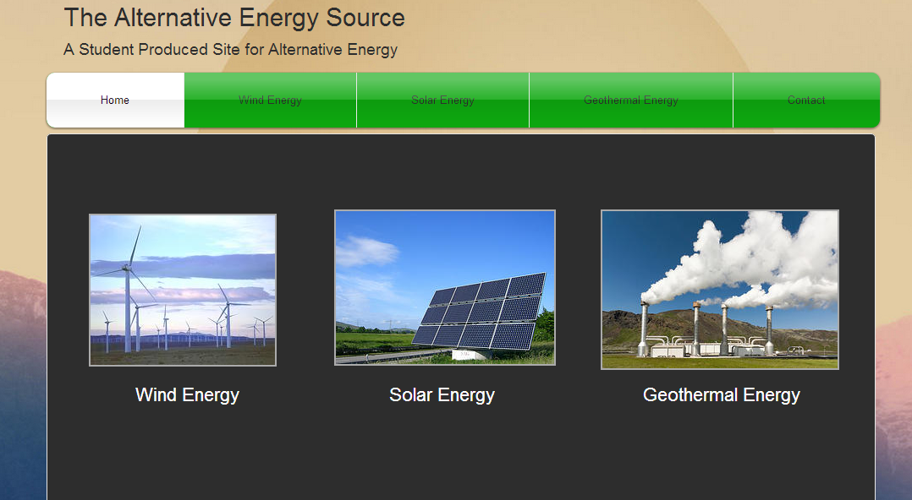
Here is the front page of my website, it shows the major pages of the site and indicates a little bit of what I did using Wix.
Conclusion
All in all, my work in this class have made me a well-rounded and better writer overall. While it’s hard to estimate the full benefit of my experiences in the class it is easy to tell that no matter what career path I take, having professional writing skills and knowledge will be extremely beneficial. Through each and every project, we learned some of the many ways that professional writing can give us an advantage in the professional job market and I feel that my work has well prepared me for professional writing in many jobs. One of the most important skills I will take from my work is writing for a specific audience; every project required that we consider who our audience was and successfully completing the project required that our target audience would be able to utilize and benefit from our work. I know that no matter who my audience is, I will be able to tailor my writing styles and abilities to most benefit the target of my writing. Through the entire class, I have gained experience in professional writing, expanded both my knowledge of professional writing and my love for the environment and environmental science, and I have improved my skills as a writer.

