Navigation Design
Information Architecture
Elizabeth Ahlman

Summary and Explanation

I based the designs for the home page and subsequent pages on YouTube’s design. Their layout has worked well for them, so I thought it would be a good idea to emulate some of their ideas. On that site, the search bar takes precedence on every page and there are featured videos on the home page. There are related videos on each individual video’s page that are selected based on user input.
For the process flow, I decided to have people be registered users of the site (which is free) before they can suggest that a podcast be added to the site. This is in order to trace the origin of every podcast that is played through the site. It is important to know where each podcast came from and why it is there so that security issues can be addressed and user behavior can be tracked. The darker blue arrows represent the most used path through the podcast suggestion flow.

Wireframes: Home Page to Individual Podcast Page
Home Page:
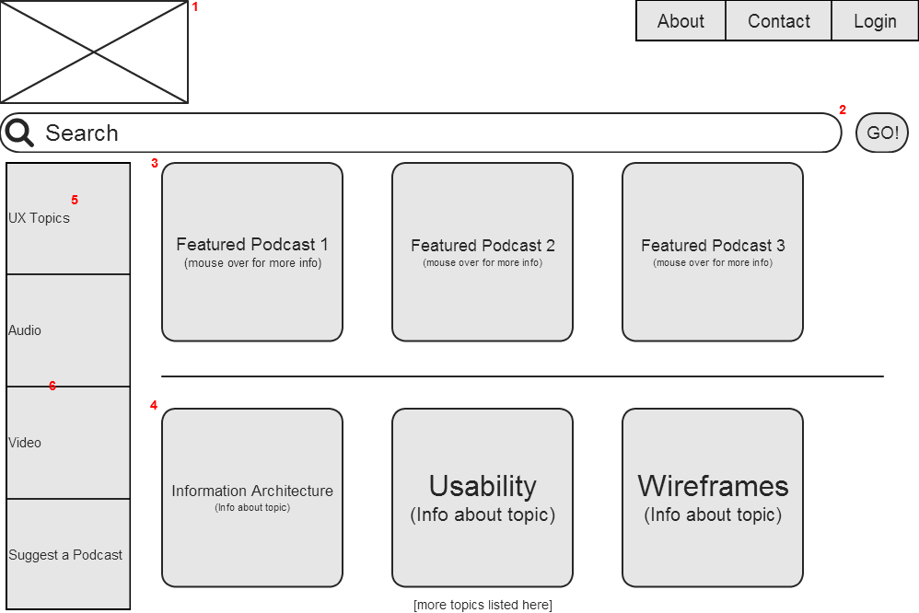

1) This will be the company’s logo.
2) There will be a predictive search feature such as Google employs.
3) The featured podcasts will be the most viewed and/or highest rated podcasts of the week.
4) The topics under User Experience will be displayed here as clickable links, but will also be accessible under “UX Topics” in the left navbar.
5) This will be a pop-out menu that users can scroll down to find their topic of choice.
6) Most users will wants to find a podcast by topic, but some might want to narrow by audio or video first.

After clicking on Information Architecture:
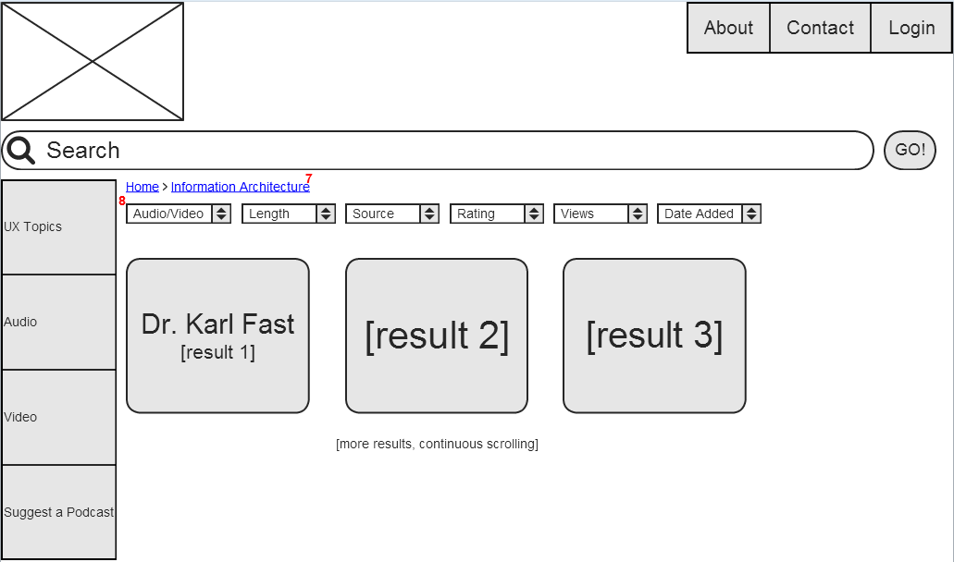

7) Breadcrumbs will be provided on every page after the home page so users always know where they are in the site’s architecture.
8) These sorting options will be available on every page after the first initial narrowing of the user’s search.

After clicking on Dr. Karl Fast:
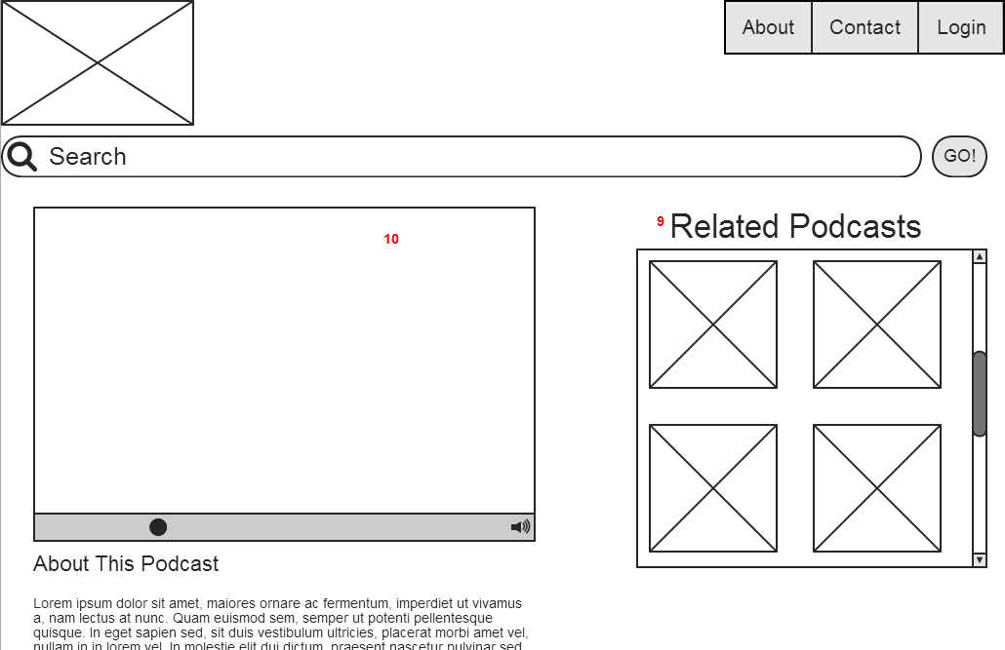

9) The related podcasts will be chosen based on the user’s search history, recently viewed podcasts, suggested podcasts, and favorite podcasts.
10) This box will either be a video player or just show a picture of the speaker if the format is audio only.

