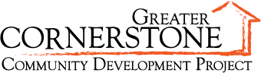

Media Contact:
Kari Culp, Schnake Turnbo Frank | PR
(918) 269-9505, kculp@stfpr.com

MEDIA ADVISORY: Greater Cornerstone Community Development Center Holds Grand Opening
WHAT: The Greater Cornerstone Community Center will host the grand opening of its 20,698 square foot building that will house a range of health, educational, community enrichment and basic social services agencies. This project is led by a small group of dedicated community leaders committed to breaking the cycle of poverty in west Tulsa.

WHO: Willard Jones, executive director
Donald E. Pray, campaign advisor and trustee with the Bernsen Foundation
Mary Ann Hille, campaign advisor and trustee with the Hille Foundation

WHEN: 4 p.m. to 6 p.m. Thursday, September 13, 2012

WHERE: 4122 W. 55th Pl (South Haven)

For more information visit www.gccdp.com

###

