Inappropriate Language in Children’s Shows
Amanda Herrin
Final Paper
Communication Research Methods
Rogers State University

Abstract

There are many educational channels safe for children to view. However, the concern is what children are really listening to when watching television even when parents are around. Many programs use explicit language that our children do not need to hear and be exposed too. But what happens when inappropriate or foul language is found in television targeting children. As children grow up, they tend to repeat what they hear. Television shows deem inappropriate language or euphemisms for those words as being acceptable by society. When kids hear inappropriate words, they are more likely to use them if it is accepted and deemed appropriate by the television shows. But what do the parents/adults think about the words and euphemisms and how they are used? However, my hypothesis is that adults would categorize certain words or euphemisms used on these shows as inappropriate. That is what this paper intends to reveal.

Inappropriate Language in Children’s Shows
A Review of the Literature

In the study, “Excessive media consumption and behavioral problems--a cross-sectional study on pre-school children” looks at the relationship between excessive media consumption (TV, video games use) of more than three hours per day and the behavioral problems in 5- 6-year-old kids. Boys were more often “excessive” media consumers than girls and showed more abnormal values on the total difficulties score of the “Strengths and Difficulties Questionnaire” (SDQ) than girls. In this study it was shown that there was a evidential association between excessive media consumption and abnormal SDQ values, especially among 5- to 6-year-old girls, but which is less noticeable in boys. Also it was suggested that parents of preschool kids with excessive media consumption should be informed and the children should go through a screening for behavioral problems as well.
In “How educators perceive the impact of media on preschool children” Sindik talks about several theories about the impact of media on people, mainly children. Also an important part in interceding these effects lies with the educators of preschool children in and kindergarten. The research that was conducted was taken from four kindergartens in Zagreb and Zagreb County, and the data related to research problems was gathered from 86 kindergarten teachers, using the questionnaire titled “Preschool Children and the Media – Teachers”. The results showed that there were significant differences in perceptions about the desirability of using certain types of media, and the concept of the real media exposure of children, in relation to the different age groups of children that kindergarten teachers work with.
In the study “Screen media in the kindergartener: To the connection of medium use, behavior up maturities and ADHS." Manfred took relevant variables such as, parenting style or socioeconomic variables into consideration to find associations between screen media use, behavior problems, and ADHD. The results were that “daily television use was associated significantly with increased sleep problems, aggressive behavior, and attention problems”. But daily computer use showed fewer attention problems.
In the study "Preschool Children and the Media" Thorn talks about the use of electronics by preschool children and their exposure to the mass media. In the study it was shown that about half of the kids in the U.S. under the age of 6 have used a computer while 99% of them live in a home with at least 1 television. Also, looked at was the internet use among children, their time spent watching television and videos, and the way they actually view media. Interestingly this article also takes a look at how media affects children in utero and the effect that it has on their development and psychology.
In "Television viewing, computer use, obesity, and adiposity in USpreschool children" there were 3 hypotheses in preschool children: 1) that watching more than 2 hours of TV/videos daily is associated with obesity, 2) that computer use is associated with obesity, and 3) that more than 2 hours of media use daily is associated with obesity. Media use had borderline significance with higher skinfold thicknesses. The conclusion was that “watching more than 2 hours/day of TV/videos in US preschool-age children was related with a higher risk of being overweight or at risk for overweight and higher adiposity-findings in support of national guidelines to limit preschool children's media use. Computer use was also related to higher adiposity in preschool children, but not weight status.” The research conducted a cross-sectional study using nationally representative data on children, aged 2-5 years from the National Health and Nutrition Examination Survey, 1999-2002.
In the study "To watch or not to watch: Infants and toddlers in a brave new electronic world", the questions have been asked about the impact of television and video materials on the cognitive and social development of preschoolers and older children. The study showed that broad exposure to these media that infants and toddlers plays a role in early development.
This study, "Parents of preschoolers: expert media recommendations and ratings knowledge, media-effects beliefs, and monitoring practices" examined preschooler parents' knowledge about expert recommendations for children's screen media experience. Also their knowledge of specific screen media ratings, their beliefs about the effects, and the actual monitoring practices. Preschoolers were exposed to an average of 12 hours of screen media over a week. Parents believed that media do have either short or long-term effects on preschoolers. The results of how the preschoolers did on factual questions was poor (mean score: 2.83 of 11). Only 34% of the parents correctly identified the expert recommendation for children older than 2 years old. Conclusions drawn were that parents should continue to be educated about the need for preschoolers to take part in activities that encourage language development, socialization, imagination, and physical activity. Also it was suggested that professionals should work to improve the ratings, and eventually to implement a universal ratings system for all screen media, parents need to be encouraged to improve their understanding of current recommendations for screen media exposure and television and video game ratings.
In the study, “Cartoons Are No Laughing Matter: Sex, Drugs and Profanity on Primetime Animated Programs”, The Parents Television Council and Nielsen Media Research study identified 565 incidents of explicit language in TV-PG (n=211) and TV-14 (n=354) shows. Thirty-seven of those incidents were bleeped “f**k” or “sh*t” or euphemisms for those words. A disturbing 27% of the incidents for “f**k” and “sh*t” occurred in TV-PG programs.

Content Analysis of Inappropriate Words used in Children’s television
My objective in this content analysis is to see what is considered “bad language” in shows targeted towards children. The purpose is to evaluate what is gate-words that lead to and are inappropriate words for children to hear/ use on shows targeting them. Objective was fulfilled by questioning adults after watching several afternoon/prime time children’s shows.
The terms the watershed or safe harbor are used for the time period (or the times delimiting this) in television schedules during which 'adult content' can be shown, starting at10 pm, and ending at 6am. Adult content is usually defined as images or language depicting or referring to explicit sexual intercourse, graphic violence, or drug use and the use of strong language.
Information asked of each program was; the type of show (comedy, drama, mixed etc.) the time it came on, the television rating and what could be potentially be considered foul/ inappropriate language and its target audience. The 12 adults in my focus group (10 with children, 2 without) were asked the spot the inappropriate/gate-word, to count how many times it was used and then encouraged to comment on the severity of the word. (Refer to table p. 9)
In a study released March 2, 2006 from the Parents Television Council “They analyzed 443.5 hours of Saturday-morning and after-school shows for children ages 5 to 10. The results "showed 'staggering' amounts of violence, as well as verbal abuse, offensive language, antisocial attitudes and behaviors, excretory content, disrespect for adults and sexual content."(The Washington Times, March 3, 2006 by Cheryl Wetzstein)
In 1987 the FCC wanted to narrow the "safe harbor" during which indecent programming could be broadcast. Since 1978 the FCC considered 10 p.m. to 6 a.m. a "safe harbor" during which indecent programming could broadcast. Court of Appeals decision in 1988 reversed the FCC's safe harbor policy, ruling that the commission could not enforce a ban against indecent evening broadcasts until it further investigated children's viewing behavior (Action for Children's Television v. FCC, 1988). Shortly thereafter, Congress attempted to enact a 24-hour ban against indecent speech. In 1991 the 24-hour ban was ruled unconstitutional (Action for Children's Television v. FCC, 1991). (Kaye, Sapolsky p.6)
The Parents Television Council and Nielsen Media Research study identified 565 incidents of explicit language in TV-PG (n=211) and TV-14 (n=354) shows. Thirty-seven of those incidents were bleeped “f**k” or “sh*t” or euphemisms for those words. A disturbing 27% of the incidents for “f**k” and “sh*t” occurred in TV-PG programs. Two hundred and twenty- four incidents of explicit language in TV-PG and TV-14 programming consisted of sexual slang or misogynistic language including: bit*h, pus*y, coc*, di*k, suck, screw, douche, as*, balls, slut, whore, ho, and skank. Other language children and teens were exposed to during viewing included damn, crap, hell, piss and bastard. (parentstv.org) In a study released March 2, 2006 from the Parents Television Council “They analyzed 443.5 hours of Saturday-morning and after-school shows for children ages 5 to 10. The results "showed 'staggering' amounts of violence, as well as verbal abuse, offensive language, antisocial attitudes and behaviors, excretory content, disrespect for adults and sexual content."(The Washington Times, March 3, 2006 By Cheryl Wetzstein)
The entertainment industry claims that if it rates a product as inappropriate for children, parent raters agree that it is inappropriate for children. Yet “Parents cannot assume the content of commercials will be consistent with the program rating or label”. (Carrington p.86)
Age and content-based television ratings system in 1997 alerted viewers programs that contain violent, sexual, or profane images and words but did not end the controversy surrounding offensive content. (Kaye, Sapolsky p. 430)
Data collection consisted of analysts viewing animated programs that aired during the study period and conducting a content analysis to address the following variable categories: content ratings (TV-G, Y7, TV-PG, TV-14, TV-MA), types of sexual behaviors and references (i.e. nudity, sexual gestures, sexual clothing, etc.), type of animated violence (fantasy violence, cartoon violence, and/or physical violence), type of violent content shown (shooting, stabbing, dismemberment, torture, etc.), drugs, foul language, and number of times these acts were displayed visually or referenced. (Kaye, Sapolsky p. 430)
According to Merriam Webster online dictionary a euphemism is “the substitution of an agreeable or inoffensive expression for one that may offend or suggest something unpleasant; also : the expression so substituted.” Euphemisms are formed in a number of ways. Indirectness or roundaboutness is one of the most common. To "speak around" a given word, is basically implying it without saying it. Periphrases have become known as established euphemisms for particular words or ideas. Altering the pronunciation or spelling of a taboo word (such as a swear word) to form a euphemism is known as taboo deformation. (http://www.merriam-webster.com/dictionary/euphemism)
Some children’s programs that are included in this analysis that use these euphemisms are, Adventure Time with using the word, “friggin” inplace of of fuc*, Victorious and iCarly using the words “wazz” and “shizz” in place of “piss” and “sh*t”, and in Regular Show, used the euphemism “screwed” in place of “fuc*ed”.
The procedures for this research were appropriate in the sense that in order to find out what apparent or adult considers as being bad or foul and inappropriate language in a children’s television show, the research needed to be viewed from the perspective of the adult and not the child. If the child were asked to point out the bad words in a children’s program, they would become confused and part of that confusion can attribute to the fact that they would not understand the euphemisms. By using an adult, they are already familiar with what is considered inappropriate language in society and amongst their peers -persons their age and people who are parents also if they themselves are parents. Also adults have a better grasp on what euphemisms are and can decipher which words would be used in place of the inappropriate word.
In conclusion, the theoretical and practical significance of this research is that children’s television shows are slipping under the radar when it comes to disguising inappropriate words as everyday innocent utterances and euphemisms. Whether the adults in this research had children or not, they still found certain words in the randomly selected children targeted programs, inappropriate or unsuitable for the age group it targeted in relation to the program rating.

Table of Focus group results:

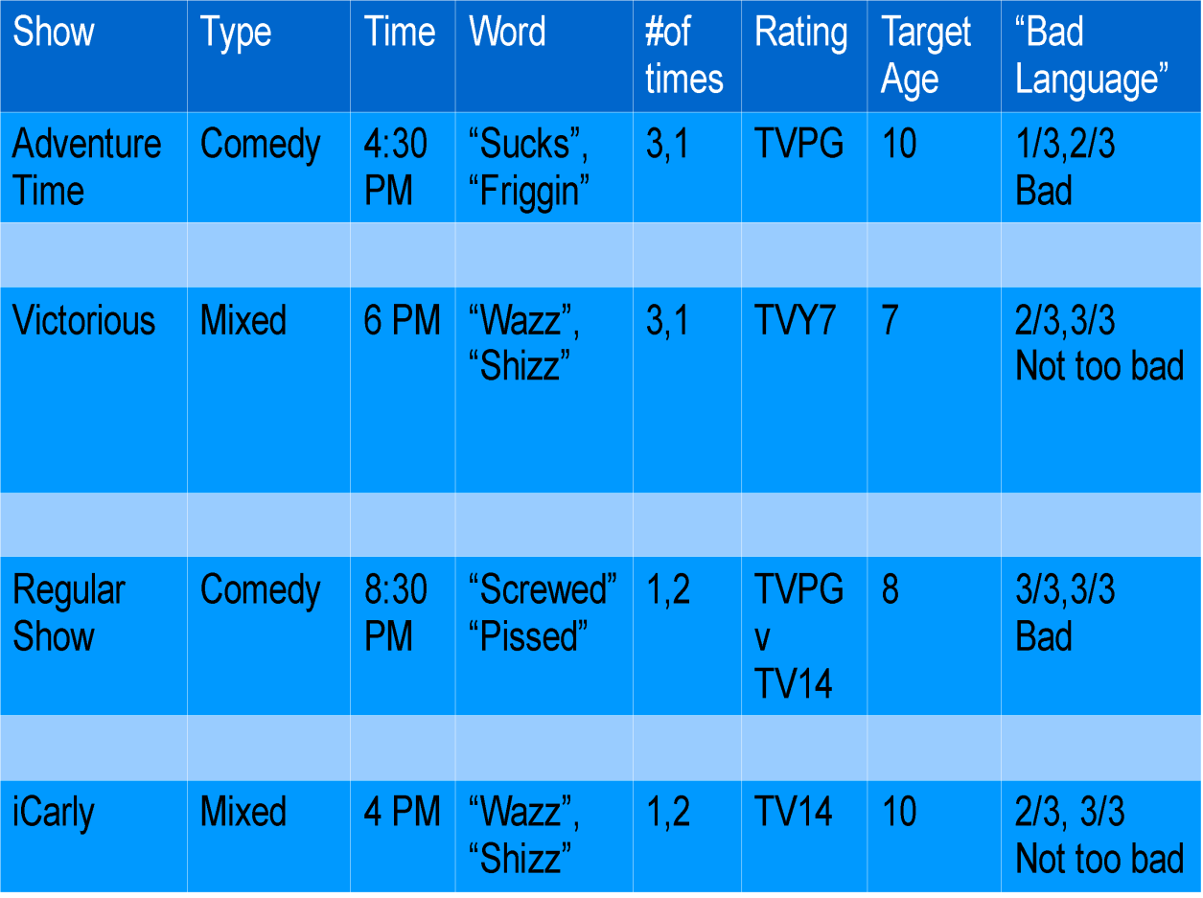

Questionnaire
- What words did you find inappropriate for children to use?
- What words did you find inappropriate for children to hear
- How offensive did you find the word/words?
- How many times did you spot the inappropriate language?

Bibliography
Boneberger A; Bolte G; von Kries R Excessive media comsumption and behavioural problems--a cross- sectional study on pre-school children Country of Publication: Germany NLM ID: 9204210 Publication Model: Print-Electronic Cited Medium: Internet ISSN: 1439-4421 (Electronic) Linking
Sindik, Joško, and Zvjezdana Veselinović. "Kako odgojiteljice percipiraju utjecaj medija na predškolsku djecu? (Croatian)." Medijska Istrazivanja/Media Research 16.2 (2010): 107-131. Library, Information Science & Technology Abstracts with Full Text. EBSCO. Web. 3 Oct. 2011.
Manfred Döpfner, et al. "Bildschirmmedien im kindergartenalter: Zum zusammenhang von mediennutzung, verhaltensauffälligkeiten und ADHS." Zeitschrift für Gesundheitspsychologie 18.2 (2010): 55-68. PsycINFO. EBSCO. Web. 3 Oct. 2011
Thorn, William J. "Preschool Children and the Media." Communication Research Trends 27.2 (2008): 3-27. Communication & Mass Media Complete. EBSCO. Web. 4 Oct. 2011.
Mendoza, Jason A., Fred J. Zimmerman, and Dimitri A. Christakis. "Television viewing, computer use, obesity, and adiposity in USpreschool children." International Journal of Behavioral Nutrition & Physical Activity 4.(2007): 44-53. Academic Search Complete. EBSCO. Web. 4 Oct. 2011.
Courage, Mary L., and Mark L. Howe. "To watch or not to watch: Infants and toddlers in a brave new electronic world." Developmental Review 30.2 (2010): 101-115. Academic Search Complete. EBSCO. Web. 4 Oct. 2011.
E. McBroom, et al. "Parents of preschoolers: expert media recommendations and ratings knowledge, media-effects beliefs, and monitoring practices." Pediatrics 123.3 (2009): 981-988. CINAHL with Full Text. EBSCO. Web. 5 Oct. 2011.
Cartoons Are No Laughing Matter: Sex, Drugs and Profanity on Primetime Animated Programs 2011. Parents Television Council, parentstv.org
Barbara K. Kaye, Ph.D., Barry S. Sapolsky, Ph.D. (2001). “Offensive Language in Prime Time Television: Before and After Content Ratings”
Wetzstein, Cheryl. Washington Times - Politics, Breaking News, US and World News. 03 Mar. 2006. Web. 19 Nov. 2011. <http://www.washingtontimes.com/>.
Carrington, A. V. (2002). Children at risk, a bibliography.
(p. 86). Nova Publishers.
Kaye, B.K., & Sapolsky, B.S. (2004b). Watch you mouth! An analysis of profanity
uttered by children on prime time television. Mass Communication and Society,
430.
Merriam-Webster, I. (n.d.). Merriam-webster. Retrieved from
http://www.merriam-webster.com/dictionary/euphemism

