Do relationship with mother and feelings of independence affect knowledge of birth control?
In 2011, a total of 329,797 babies were born to women aged 15–19 years of age in the United States (Center for Disease Control and Prevention, 2012). With this astonishing number of adolescent women giving birth researchers are finding it interesting to examine adolescent’s knowledge of birth control and what factors contribute to this knowledge.
Ryan, Franzetta, and Manlove (2007) found that knowledge, perceptions and motivations surrounding sexual activity and contraception are important predictors of contraception outcomes although there are differences between genders. More specifically, for males greater perceived condom knowledge is associated with increased probability of ever using contraception and for females, higher levels of actual reproductive health knowledge is associated with increased probability of ever using contraception.
Another current study found that greater relationship satisfaction between adolescents and their mothers was associated with a higher probability of birth control use and a lower probability of both sexual intercourse and pregnancy (Jaccard & Dittus, 2000).
Dilorio, Kelley and Hokenberry (1999) found similar results when examining communication on sex-based topics between adolescents and their parents. They found that both male and female adolescents are more likely to discuss sex-based topics with their mother; they also found that condom use is frequently included in those sex-based topics.
Contrary to the above literature, a study conducted by Commendor (2011) associated with maternal relationship and contraceptive use found that maternal parenting style did not correlate with age, decision self- esteem, or contraceptive use.
There is conflict in the literature about maternal relationship, knowledge of birth control and birth control use. Given these finding and the literature I have found I have decided to focus my research questions and hypothesis on the following topics. First, I wanted to examine the relationship between mother and adolescents and how this relates to knowledge of birth control.
Although there was not a lot of research on feelings of independence I am also looking to examine feelings of independence in relation to knowledge of birth control and adolescent’s relationship with mother.

Hypotheses
In this paper I test the following hypotheses:
- Females will report more knowledge of birth control than males
- Age (13-16) and feelings of independence will interact with knowledge of birth
- Students with better relationship with mother will have more feelings of independence
- Students with better relationship with mother will have more knowledge of birth control
Method
4,834 adolescents and young adults participated in the study. For the present paper I analyzed data from a subset of 2891 of adolescents age 13 through 16. I created this group based on age combining age thirteen, fourteen, fifteen, and sixteen. There are 1,288 of males and 1,508 of females in this sample.
Materials
Independence. In the interview participants were asked to rate their feelings of independence on a scale from 1 (strongly agree) to 5 (strongly disagree) on an item which specifically said “You are independent”. To test hypothesis two, I recoded this independence variable into two groups those who said they felt independent and those who did not report feeling independent. The feelings of independence group included students who answered 1(strongly agree) and 2 (agree) to the independence question. The no feelings of independence group included students who answered 4 (disagree) and 5 (strongly disagree) to the independence question.
Knowledge of Birth Control. Participants were asked to rate on a scale of 1 (strongly agree) to 5 (strongly disagree) how much they agreed or disagreed with three statements regarding knowledge of birth control methods. Specifically, the three items were “You are quite knowledgeable about how to use a condom correctly”, “You are quite knowledgeable about the rhythm method of birth control and when it is ‘safe’ time of the month for a women to have sex and not get pregnant”, and “You are quite knowledgeable about the withdrawal method of birth control ”. A composite variable of Knowledge of Birth Control was created by averaging the scores on these three items. The composite had a good reliability α = .78.
Good relationship with mother. In the interview there was an item that asked participants to rate on a scale from 1 (strongly agree) to 5 (strongly disagree) if they had a good relationship with their mother. Specifically the item said “Overall, you are satisfied with your relationship with (Mom’s Name)”.
Procedure
This data came from the Add Health Study Wave II which took place from April to August of 1996. This study was conducted by the Carolina Population Canter of University of North Carolina at Chapel Hill. Wave II data collection includes follow-up in-home interviews with adolescents. An in-home sample of 27,000 adolescents was drawn consisting of a core sample from each community, which came from a bigger stratified random sample of all eligible high schools in the United States, plus selected special oversamples.
Results
Descriptive Statistics
Independence. Students reported a mean feeling of independence score of 1.85 (SD = .80) on a 1 (strongly agree) to 5 (strongly disagree) scale which is very close to a two (agree) on the scale, suggesting that students agree that they feel independent, on average. The distribution of scores appears to be positively skewed, with a median of two and a mode of two. A histogram of the distribution is shown below.
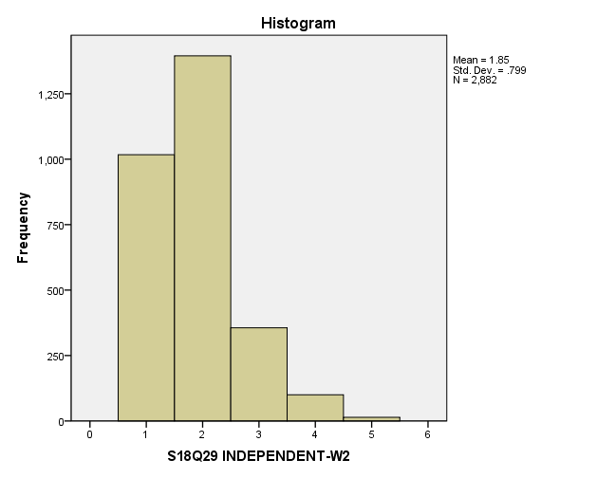
Knowledge of Birth Control. Students reported a mean knowledge of birth control of 2.26 (SD = .92), on a 1 (strongly agree) to 5 (strongly disagree) scale. This mean is very close to the median and mode which are both 2. This suggests that students that students, on average, report being knowledgeable about birth control. A histogram of the distribution is shown below.
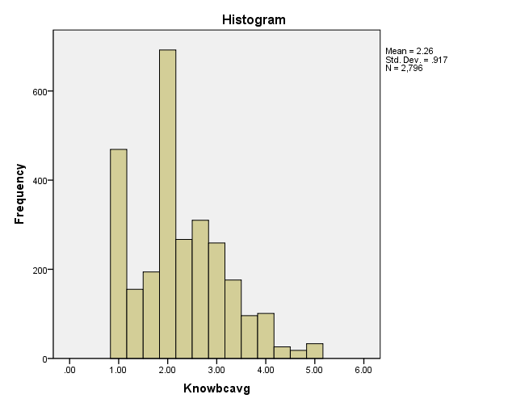

Good relationship with mother. Students reported a mean relationship with mother of 1.69 (SD =.85). This mean score is very close to the median score of two and the mode score of one. This means that, on average, students reported an overall good relationship with mother from the scale 1 (strongly agree) to 5 (strongly disagree). A histogram of the distribution is shown below.
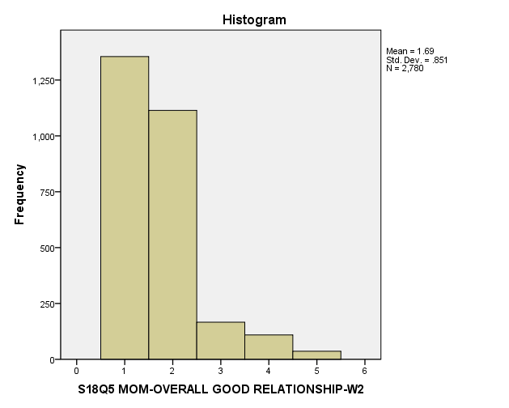
Hypothesis Tests
To test hypothesis one, females will report more knowledge of birth control than males; I conducted an independent sample t-test to test the knowledge of birth control of males and females. This test was significant t(2794) = -4.26, p <.001 suggesting that females (M=2.33) have more knowledge of birth control than males(M=2. 11). Hypothesis one was supported.
A 4 (age: 13, 14, 15,16) x 2 (feeling of independence: yes, no) Factorial ANOVA was calculated to test hypothesis two, age and feelings of independence will interact with knowledge of birth control, with knowledge of birth control as the dependent variable. Age and feelings of independence were between-subjects variables. There was not a significant main effect of age on knowledge of birth control, F(3,2437) =2.05, p =.11. There was a significant main effect of feeling of independence on knowledge of birth control, F(1, 2437) =5.29, p = .02. The students who reported feelings of independence (M=2.27) reported more knowledge of birth control than those who did not repot feelings of independence (M=2.52). There was not a significant interaction between the two variables, F(3,2437) =1.25, p=.29. Hypothesis two was not supported because there was not a significant interaction between age and feelings of independence.
To test hypothesis three, students with better relationship with mother will have more feelings of independence, I conducted a correlational analysis. The two variables of relationship with mother and feelings of independence are correlated, r(2780) =.14, p < .001. Therefore hypothesis three was supported meaning that as relationship with mother is better, feelings of independence are greater.
I conducted a correlational analysis to test hypothesis four, students with better relationship with mother will have more knowledge of birth control. The analysis showed that there was a significant correlation between relationship with mother and knowledge of birth control, r(2780) =.07, p < .001 . This means that as relationship with mother is better, knowledge of birth control is greater, thus hypothesis four was supported.
Discussion
Maternal relationship and feelings of independence are important factors to examine in relation to knowledge of birth control. The present study tested four hypotheses and found varied results. Hypothesis one, females will have more knowledge of birth control than males, was supported. This finding is similar to a study conducted by St. Lawerence (1993) which found that female adolescents are more knowledgeable than males about HIV/AIDs as well as condom use. This may be because females are the ones who are at risk of pregnancy and are more knowledgeable to prevent pregnancy from occurring.
In hypothesis two, age and feelings of independence may interact with knowledge of birth control; there was significant main effect between age and knowledge of birth control. This could be contributed to the fact that younger adolescents have not yet had sexual education in schools whereas older children have. There was not a significant main effect of feelings of independence on knowledge of birth control, nor was there a significant interaction between the variables. This could be attributed to the difference in size between the groups who reported feelings of independence and those who did not.
Hypothesis three, students with better relationship with mother will have more feelings of independence, was supported. Although these variables are weekly correlated suggesting that there is little influence of relationship with mother and feelings of independence, this would be a good topic for research in the future. More research could be beneficial in finding what factors in a good relationship with mother contribute to feelings of independence. Factors including good communication or encouragement could influence students to feel more independent.
In testing hypothesis four, as relationship with mother is better, knowledge of birth control is greater, there was a significant correlation. This could be explained by the fact that adolescents with a better relationship with their mother feel more comfortable talking to them openly about birth control and therefore have gained more knowledge from her. In the future it would be interesting to ask participants where they received their knowledge of birth control, school, family, friends, and analyze where the knowledge came from with relationship with mother.
The findings in which this study presents are important to examine given the current birth rates of adolescents. One overall limitation to the study is that the adolescents all attend different schools with different programs for sex education so there is not a standardized way that students are being taught their knowledge of birth control in schools as well as there are many outside influences that also serve as sources of knowledge for adolescents. The present study found links between feelings of independence, age, gender and good relationship with mother on knowledge of birth control suggesting that knowledge of birth control can be influenced by many variables.

References
(2012). Retrieved from Centers for Disease Control and Prevention website: http://www.cdc.gov/TeenPregnancy/index.htm

Ryan , S. Franzetta , K. Manlove , J. (2007). Knowledge, perceptions, and motivations for contraception: Influences on teens' contraceptive consistency. Youth and Society, 39, 182-208. doi: 10.1177/0044118X06296907

Jaccard , J. Dittus , P. J. (2000). Adolescent perceptions of maternal approval of birth control and sexual risk behavior. American Journal of Public Health, 90(9), 1426-1430. doi: 10.2105/AJPH.90.9.1426
Commendador, K. (2011), The relationship between maternal parenting style, female adolescent decision making, and contraceptive use. Journal of the American Academy of Nurse Practitioners, 23: 561–572. doi: 10.1111/j.1745-7599.2011.00635.x

DiIorio , C. Kelley , M. Hockenberry-Eaton , M. (1999). Communication about sexual issues: Mothers, fathers, and friends. Journal of Adolescent Health, 24, 181-189. doi: 10.1016/S1054-139X(98)00115-3

St. Lawrence , J. S. (1993). African American adolescents' knowledge, health-related attitudes, sexual behavior, and contraceptive decisions: Implications for the prevention of adolescent HIV infection. Journal of Consulting and Clinical Psychology, 61, 104-112. doi: 10.1037/0022-006X.61.1.104

Output
Hypothesis One
Group Statistics
 | BIOLOGICAL SEX-W2 | N | Mean | Std. Deviation | Std. Error Mean
Knowbcavg | Male | 1288 | 2.1786 | .85262 | .02376
 | Female | 1508 | 2.3263 | .96344 | .02481

Independent Samples Test
 |  | Levene's Test for Equality of Variances |  | t-test for Equality of Means
 |  | F | Sig. | t | df | Sig. (2-tailed) | Mean Difference | Std. Error Difference | 95% Confidence Interval of the Difference
 |  |  |  |  |  |  |  |  | Lower | Upper
Knowbcavg | Equal variances assumed | 22.974 | .000 | -4.259 | 2794 | .000 | -.14769 | .03468 | -.21569 | -.07969
 | Equal variances not assumed |  |  | -4.300 | 2790.477 | .000 | -.14769 | .03435 | -.21504 | -.08033

Hypothesis Two
Between-Subjects Factors
 |  | N
age13_16 | 13.00 | 192
 | 14.00 | 631
 | 15.00 | 769
 | 16.00 | 853
ind_yes_no | 1.00 | 2337
 | 2.00 | 108

Tests of Between-Subjects Effects
Dependent Variable:Knowbcavg
Source |  |  | Type III Sum of Squares |  | df |  | Mean Square |  | F | Sig.
Corrected Model |  |  | 34.724ª |  | 7 |  | 4.961 |  | 5.969 | .000
Intercept |  |  | 1590.286 |  | 1 |  | 1590.286 |  | 1913.621 | .000
age13_16 |  |  | 5.113 |  | 3 |  | 1.704 |  | 2.051 | .105
ind_yes_no |  |  | 4.397 |  | 1 |  | 4.397 |  | 5.291 | .022
age13_16 * ind_yes_no |  |  | 3.113 |  | 3 |  | 1.038 |  | 1.249 | .290
Error |  |  | 2025.233 |  | 2437 |  | .831
Total |  |  | 14269.222 |  | 2445
Corrected Total |  |  | 2059.957 |  | 2444
a. R Squared = .017 (Adjusted R Squared = .014)

Estimates
Dependent Variable:Knowbcavg
age13_16 | Mean | Std. Error |  | 95% Confidence Interval
 |  |  |  | Lower Bound |  | Upper Bound
13.00 | 2.595 | .165 |  | 2.272 |  | 2.918
14.00 | 2.406 | .097 |  | 2.217 |  | 2.596
15.00 | 2.204 | .076 |  | 2.055 |  | 2.352
16.00 | 2.360 | .075 |  | 2.213 |  | 2.506

Univariate Tests
Dependent Variable:Knowbcavg
 | Sum of Squares |  |  | df |  | Mean Square |  | F | Sig.
Contrast | 5.113 |  |  | 3 |  | 1.704 |  | 2.051 | .105
Error | 2025.233 |  |  | 2437 |  | .831
The F tests the effect of age13_16. This test is based on the linearly independent pairwise comparisons among the estimated marginal means.
Estimates
Dependent Variable:Knowbcavg
ind_yes_no |  | Mean | Std. Error |  | 95% Confidence Interval
 |  |  |  |  | Lower Bound |  | Upper Bound
1.00 |  | 2.265 | .022 |  | 2.222 |  | 2.309
2.00 |  | 2.517 | .107 |  | 2.307 |  | 2.727

Pairwise Comparisons
Dependent Variable:Knowbcavg
(I) ind_yes_no |  | (J) ind_yes_no |  | Mean Difference (I-J) |  | Std. Error |  | Sig.ª |  | 95% Confidence Interval for Differenceª
 |  |  |  |  |  |  |  |  |  | Lower Bound |  | Upper Bound
1.00 |  | 2.00 |  | -.251* |  | .109 |  | .022 |  | -.466 |  | -.037
2.00 |  | 1.00 |  | .251* |  | .109 |  | .022 |  | .037 |  | .466
Based on estimated marginal means
*. The mean difference is significant at the .05 level.
a. Adjustment for multiple comparisons: Least Significant Difference (equivalent to no adjustments).

Univariate Tests
Dependent Variable:Knowbcavg
 | Sum of Squares |  | df |  | Mean Square |  | F |  | Sig.
Contrast | 4.397 |  | 1 |  | 4.397 |  | 5.291 |  | .022
Error | 2025.233 |  | 2437 |  | .831
The F tests the effect of ind_yes_no. This test is based on the linearly independent pairwise comparisons among the estimated marginal means.

3. age13_16 * ind_yes_no
Dependent Variable:Knowbcavg
age13_16 | ind_yes_no | Mean | Std. Error | 95% Confidence Interval
 |  |  |  | Lower Bound | Upper Bound
13.00 | 1.00 | 2.399 | .067 | 2.267 | 2.530
 | 2.00 | 2.792 | .322 | 2.160 | 3.424
14.00 | 1.00 | 2.363 | .037 | 2.291 | 2.436
 | 2.00 | 2.449 | .190 | 2.077 | 2.822
15.00 | 1.00 | 2.161 | .034 | 2.095 | 2.228
 | 2.00 | 2.246 | .148 | 1.956 | 2.536
16.00 | 1.00 | 2.138 | .032 | 2.076 | 2.201
 | 2.00 | 2.581 | .146 | 2.295 | 2.867

Hypothesis Three
Descriptive Statistics
 | Mean | Std. Deviation | N
S18Q5 MOM-OVERALL GOOD RELATIONSHIP-W2 | 1.69 | .851 | 2780
S18Q29 INDEPENDENT-W2 | 1.85 | .799 | 2882

Correlations
 |  | S18Q5 MOM-OVERALL GOOD RELATIONSHIP-W2 | S18Q29 INDEPENDENT-W2
S18Q5 MOM-OVERALL GOOD RELATIONSHIP-W2 | Pearson Correlation | 1 | .135**
 | Sig. (2-tailed) |  | .000
 | N | 2780 | 2776
S18Q29 INDEPENDENT-W2 | Pearson Correlation | .135** | 1
 | Sig. (2-tailed) | .000
 | N | 2776 | 2882
**. Correlation is significant at the 0.01 level (2-tailed).

Hypothesis Four
Descriptive Statistics
 | Mean | Std. Deviation | N
S18Q5 MOM-OVERALL GOOD RELATIONSHIP-W2 | 1.69 | .851 | 2780
Knowbcavg | 2.2582 | .91686 | 2796

Correlations
 |  | S18Q5 MOM-OVERALL GOOD RELATIONSHIP-W2 | Knowbcavg
S18Q5 MOM-OVERALL GOOD RELATIONSHIP-W2 | Pearson Correlation | 1 | .065**
 | Sig. (2-tailed) |  | .001
 | N | 2780 | 2691
Knowbcavg | Pearson Correlation | .065** | 1
 | Sig. (2-tailed) | .001
 | N | 2691 | 2796
**. Correlation is significant at the 0.01 level (2-tailed).

