June 2010
Marketing Plan
Country: Germany
Prepared for: Optibike, LLC

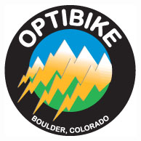
Optibike LLC
6859 North Foothills Highway
Boulder, CO 80302
Phone: 303.443.0932
Attn: Jim Turner

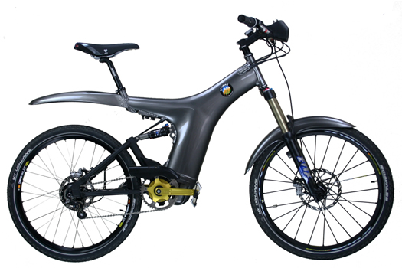

Country Notebook
Market Audit and Competitive Market Analysis – Germany

- Introduction

Vision, in today’s economic environment, entails more than just knowing where one wants to go. The impetus must be on the strength of a strategic marketing and financial plan which defines how to get there for Optibike. Vision demands the integrated mix of making tough decisions on complex business models, the right managerial staff and a streamlined focus on financial costs and long-term competitiveness in the e-bicycle business.
The quest of vision now relies on how Optibike can effectively capitalize on industry trends and global environment concerns, yet leveraging broader product capabilities. The time is now to enter the global market for electronic bicycles. The graph below depicts electric bike world market sales projected through 2016.
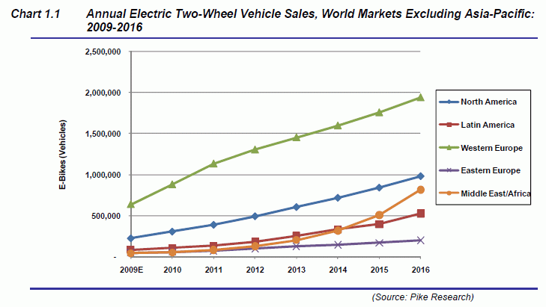
Source: (Grist, 2010)
The challenge is how to increase market share while continuing to invest in innovations that drives future opportunities amidst government intervention and regulation. Our team’s goal is to provide superior added value to our business partners by systemically addressing every aspect of Optibike’s individual business model and plans.
Optibike is a private manufacturer of electric bikes in the United States. The founder and principle designer of Optibike is Jim Turner. Optibike, based in Boulder, Colorado, has been producing and selling e-bicycles or e-bikes since 2005 to primarily an American market. Optibike’s 2009 revenues were approximately $1.3 million dollars and employed only 6 workers.
The entry level price for Optibike’s best selling model, the Optibike 850R is $11,995.00. (Optibike, 2010) Optibike’s target market consists of affluent clientele who are conscientious regarding environmental and safety concerns. It is also noted that customers within this realm are equally committed to a “lifestyle leadership” in style and quality. Optibike’s have been sold to customers ranging from 22 to 80 years old. (Greenpages, 2010) Optibike has been successful in carving out a well defined market niche in the United States.
From a worldwide standpoint, e-bicycle production has surpassed bicycle production since 2000 largely due to their popularity in the Asian markets. Sales outside of America have been by either word of mouth or via internet. Until now, Optibike has not made any strategic effort to enter into international markets.
Given Optibike’s proven success, their main mission remains the same: Make the World’s best electric bicycle, with no compromises in quality, performance or style. Therefore, based on our business analysis and marketing acumen, we recommend that Optibike position itself to expand into the Germany marketplace.

- The Product
  - Evaluate the product as an innovation as it is perceived by the intended market
    - Relative advantage
      - The largest advantage the OptiBike would have would be its durability and level of endurance. It can be used both in the city as well as on cross-country rides.
    - Compatibility
      - With OptiBike holding the patent for their model/make of electronic bicycle, there is not a lot of compatibility in regards to other competition. There is however compatibility with the needs of their target market and what they are offering.
    - Complexity
      - Some persons in the intended market may believe that the bike is too complex and require more effort than they are willing to put in for a weekend ride. However, that is the nature of the bike regardless of the market. The general target audience is limited to the professional rider and not the casual weekend rider.
    - Trialability
      - Setting up shop where customers can request a trial run may be tricky as each bike is really built for the owner. They are customized on many different levels increasing the value for the owner, not a renter. That being said, test drives around the block are fine, but longer cross-country trials may not work out well without the customized options. To get around this, OptiBike could set up a “trial program” which would put the cost of customizing a bike back on the renter. There would need to be limitations as to what they could and could not customize and there would also need to be various price ranges, just like when you rent a car. If you go more than x miles, the price changes to $___. Or if you are going to go through y terrain, there will be an additional $___ fee for specialized maintence.
    - Observability
      - Anybody could observe OptiBike at the local facility. By producing the bike in Germany, there will be many models on hand, ready to be inspected. They could also observe the bike using hands on commercials with 3D, rotating controls. This will help give the customer a better feel for what the bike is, how it moves, how it handles various terrains etc. Setting something up like a motorcycle racing game would be ideal. This could give the customer a full circle feel without having to pursue a trial run or rental agreement.
  - Major problems and resistances to product acceptance based on the preceding evaluation
    - The biggest problem to overcome is finding the specific target audience. The second problem is going to be the cost of the bike. Due to the technology and the customization, again the customer needs to be more of a professional bike rider than a casual weekend rider.
    - The general acceptance of the bike in Germany should be limited. They are very pro-bicycles and physical activity.

- The Market
  - Describe the market(s) in which the product is to be sold
    - Geographical location
Located in the center of Europe, Germany borders the Netherlands, Belgium, Luxembourg, and France on the west; Switzerland and Austria on the south; the Czech Republic and Poland on the east; Denmark on the north; and the Baltic Sea on the northeast. Due to the central location of Germany in Europe, it makes it a logical destination for vacationing and bicycling. Many of its bordering countries are also very popular. Technically, one could visit the Netherlands, France, and Switzerland all from Germany on a bicycle. However, purchasing a visa for each country would be a necessity.
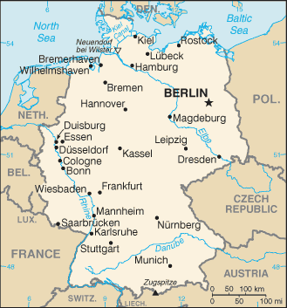
Whether you enjoy flat surfaces or mountain biking, Germany has it all. Germany is located in Central Europe, covering an area of 356,959 square kilometers. It is bordered by the North Sea, Denmark and the Baltic Sea in the north, by the Netherlands, Belgium, Luxembourg and France in the west, Poland and the Czech Republic in the east, and Austria and Switzerland in the south. It extends approx. 850 kilometers from its northern border to the Alps in the south and approx. 650 kilometers from the western to the eastern border. About one third of the land is covered by forests and woodlands and about 50% of the land is used for agricultural production. Basically, Germany is flat in the north and elevated in the south. It can be divided into several topographic regions:
- The flat North German Lowlands including the North Sea coast, the Wadden Sea, the Frisian Islands and the Baltic Sea coast;
- The mountainous Central German Uplands with their extensive forests, rifts and valleys;
- The Rhine River Valley area with its mild climate in the west;
- The beautiful Alpine Foreland in southern Germany with its rolling green hills and stunning glacial lakes;
- The German Alps in Bavaria with their peaks well above 2000 meters. (Germany.co.za, 2010)
Germany’s climate also makes it conducive to bicycling year-round. Most of Germany has a temperate seasonal climate in which humid westerly winds predominate. The climate is moderated by the North Atlantic Drift, which is the northern extension of the Gulf Stream. This warmer water affects the areas bordering the North Sea including the area along the Rhine, which flows into the North Sea. Consequently in the north-west and the north, the climate is oceanic; rainfall occurs year round with a maximum during summer.
Winters are mild and summers tend to be cool, though temperatures can exceed 30°C (86°F) for prolonged periods. In the east, the climate is more continental; winters can be very cold, summers can be very warm, and long dry periods are often recorded. Central and southern Germany are transition regions which vary from moderately oceanic to continental. (Wikipedia, 2010)

    - Forms of transportation and communication available in that (those) region(s)
As a densely populated country in a central location in Europe and with a developed economy, Germany has a dense and modern transportation infrastructure.
The first highway system to have been built, the extensive German Autobahn network famously features sections where no speed limit is in force. The country's most important waterway is the river Rhine. The largest port is that of Hamburg. Frankfurt Airport is a major international airport and European transportation hub. Air travel is used for greater distances within Germany but faces competition from the state-owned Deutsche Bahn's rail network. High-speed trains, called ICE connect cities for passenger travel. Many German cities have rapid transit systems and Public transport is available in most areas.
Since German Reunification substantial efforts have been necessary to improve and expand the transportation infrastructure in what had previously been East Germany. (Transport in Germany, 2010)
The German Tourism industry and the federal train system have cooperated in making the entire country “bicycle friendly.” In Germany, individuals, groups, and entire families take bicycling vacations for a week or more. Some bicyclist’s camp out in camp areas called Campingplatz, while others use the local hotels, guesthouses (Gasthaus and Gästehaus), bed and breakfast establishments.
The country is well suited for bicycle recreation due to much of the country being flat. River valleys and canals are plentiful, signed bike routes are well documented, and marked hiking trails are everywhere. It is easy to find your way around in Germany. Every community has established their own signed bike routes. You can frequently obtain free maps from these communities or at many of the hotels. In addition to the plethora of community bike routes, there are the mapped and signed long distance routes. (Bicycling in Germany, 2010)
While worldwide production continues to rise at an impressive rate, the U.S. remains one of the lowest developed countries where people travel by bicycle including e-bicycles as indicated by the following graph:

Percent of Trips by Travel Mode (all trip purposes)
Country | Bicycle | Walking | Public Transit | Car | Other
Netherlands | 30 | 18 | 5 | 45 | 2
Denmark | 20 | 21 | 14 | 42 | 3
Germany | 12 | 22 | 16 | 49 | 1
Switzerland | 10 | 29 | 20 | 38 | 1
Sweden | 10 | 39 | 11 | 36 | 4
Austria | 9 | 31 | 13 | 39 | 8
England/Wales | 8 | 12 | 14 | 62 | 4
France | 5 | 30 | 12 | 47 | 6
Italy | 5 | 28 | 16 | 42 | 9
Canada | 1 | 10 | 14 | 74 | 1
United States | 1 | 9 | 3 | 84 | 3
Source: (International Bicycle Fund, 2010)

Germany represents growth opportunities for e-bike sales, has a fair population of people that rely on bicycles as a mode of transportation, has bike friendly infrastructure and governments that legislate bike friendly regulations. Such is this traffic-calmed street in Freiburg, Germany, restricts car speeds to 30km/hr and gives cyclists and pedestrian’s priority over motorists. Most residential streets in German cities are traffic calmed, thus making them ideal for cycling, even without any special facilities such as lanes or paths. (Informaworld, 2010)

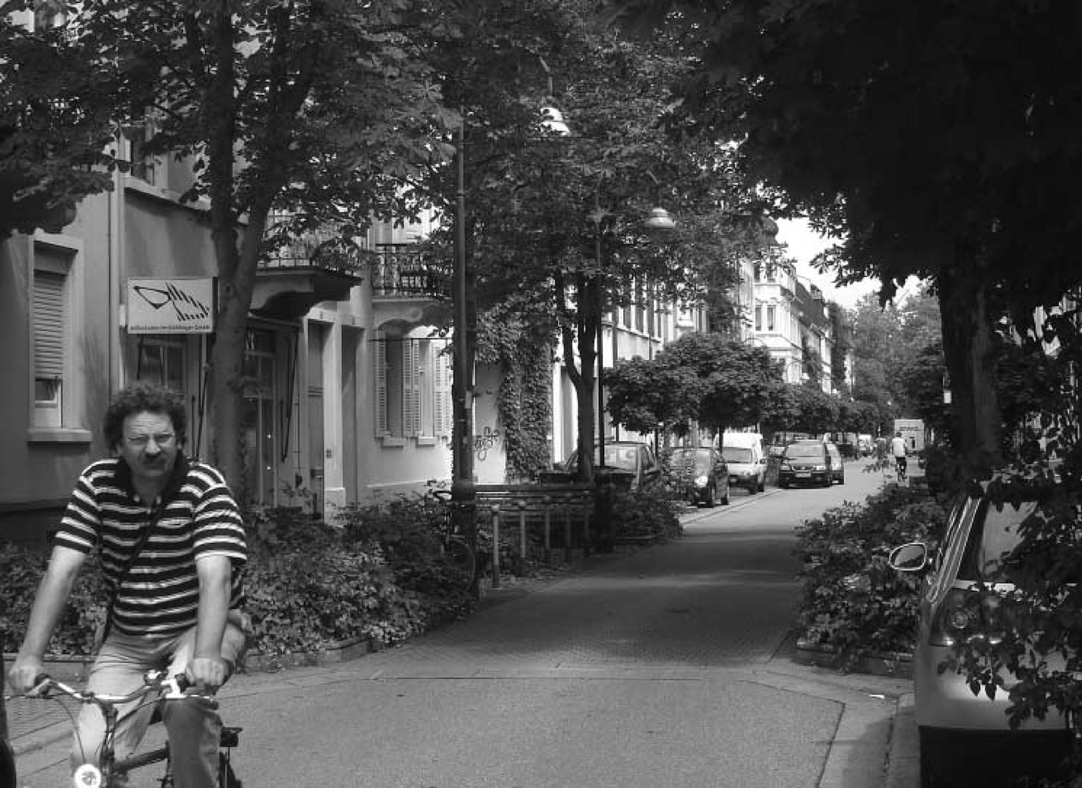

    - Consumer buying habits
      - Product-use patterns
The total annual turnover generated by bicycles in Germany amounted to 13.36 billion Euros, the Federal Ministry of Economic Affairs and Technology said in September 2009. This figure included the turnover of bicycle related tourism, if the bicycle ride itself was the main reason for the touristic activities. The amount of 13.36 billion is even more than the overall budget of the Federal State of Hamburg, which amounts to 10.9 billion Euros.
The good news is that the relationship between regular bicycles and electric bicycles looks much better, when we compare the average price of electric bikes of around 1,700 Euros to that of regular bikes (about 500+ Euros). This means the potential turnover growth of e-bikes is much higher.
Although the car remains an important status symbol to Germans and still is their preferred means of transport (with 3.1 million units sold in 2008), the circulation of bicycles is much higher. According to government estimates, the inventory of bicycles reached 73 million in Germany (compared to 41.32 million cars in early 2009). (ExtraEnergy.org, 2008)

      - Product feature preferences
E-bike customers have some similar and some unique preferences. According to an on-line bike and conversion kit seller, Eco Wheelz (How to Choose and Electric Bike, 2010), there are several primary features that are the primary preferences for consumers.

- Budget: Obviously, a smaller budget creates limitations. A bigger budget equates to more range, longer life and lighter weight. (Optibike is on the high end of budgets)
- Type of terrain: Flat terrain will require less power, torque and cost. Hilly terrain may require rider assistance or more power. (Optibike is all terrain)
- Amount of pedaling required: If the plan is to pedal a lot, a higher power system may not be necessary and pedal-assist is a good option. Otherwise, a throttle and increased power may be needed. (Optibike has pedal-assist, throttle and on and off modes)
- Type of range required: If you're within 10-20 miles, most e-bikes will do. But more range will require more assistance or larger batteries. (Optibike has a 45 to 57 mile range with an optional 100+ mile range touring battery)
- Weight: Most e-bikes can handle up to 250lbs, but expect reduced range with more weight. Consider a kit for more carrying capability. (Optibike’s heavy duty package has handled riders up to 310 lbs)
- Speed: 15-20 mph feels fast on a bicycle! In the U.S., the law says anything over 20 mph isn't a bike. In Germany, speed is not an issue. Kits can offer more speed on certain e-bikes. (With electric assist on, Optibike can go anywhere between 20 and 34+ mph)

      - Shopping habits
Germans are turning to cycling (to get from A to B and as leisure and fitness activities) in ever bigger numbers. Indicators for this are the continuously rising quality and average prices of bicycles sold. In 2008 the average price of a regular bicycle was 386 Euros (ZIV), with all sales channels included. In specialized retail shops, however, the average price was 500 Euros and it is expected that 2009 saw a strong upward jump from that level. A survey conducted by Sinus Sociovision in Heidelberg, and published in August 2009, suggested consumers would spend 570 Euro on average for a new bicycle.
Compared to the overall retail sector, which lost 0.5 percent turnover in 2009 due to the financial and economic crisis, the bicycle and bicycle-related branches are doing quite well. According to the Federal Statistical Office, bicycle retailers in Germany grew their combined turnover by 5.2 percent in 2008. The total value of bicycles sold by German retailers amounted to about 5 billion Euros per year, the Federal Ministry of Economic Affairs and Technology stated in a Research Report in September 2009. (ExtraEnergy.org, 2008)
    - Distribution of the product
      - Typical retail outlets
A typical retail outlet in Germany has a wide variety of components from many manufacturers. Of course, German brands have a special place in the store. The traditional German tire manufacturer has personalized displays for its line of products. Tires and tubes in a variety of models for a wide range of uses give any cyclist a great deal to think about before hitting a trail or road. Depending on where the store is located in Germany, it may cater to Mountain bikes (Central to Southern Germany) or city bikes (Northern Germany). For instance, Düsseldorf has no hills, and the urban infrastructure includes bike paths and a good many privileges for the cyclists. This makes the city a great market for such bicycles. Rider comfort is the number-one goal in the models sold there. A good bike store will have an adequate maintenance and service area. (Netto, 2010) The pictures below illustrate a “medium” sized store by German standards:

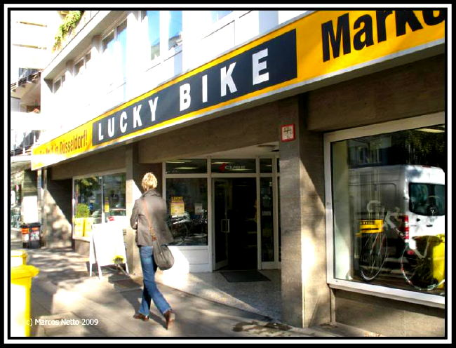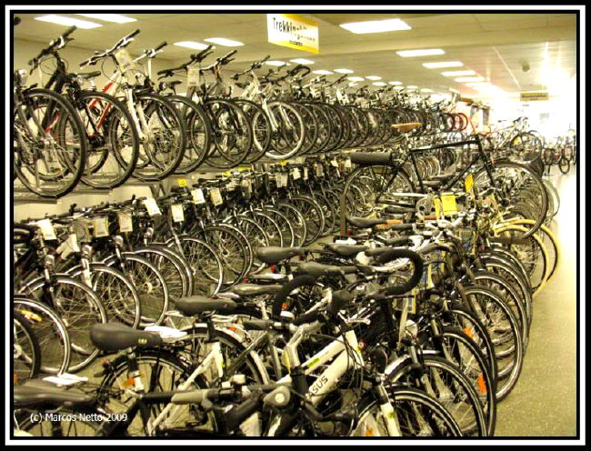
(Netto, 2010)

      - Product sales by other middlemen
Interestingly, most bicycles are sold through specialized retailers - 63 percent of all units sold, representing 75 percent of total turnover. Quality-focused, specialized bicycle retailers increased their combined turnover by 10.2 percent in 2009 (after 9 percent in 2008). This result proves that a lot of personal attention to individual customers is a prerequisite for selling bicycles. Today, specialized bicycle retailers sell more bikes compared to other sales channels than they did back in the 90’s when the mountain bike had its big boom. According to the Federal Statistical Office, there were 5,600 bicycle selling points in Germany in 2007, 4,110 of which were regarded as qualified bicycle retail shops. (ExtraEnergy.org, 2008)

    - Advertising and promotion
      - Advertising media usually used to reach your target market(s)
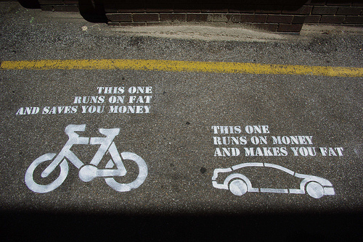
(Quickrelease.tv, 2010)
Advertising in Germany uses essentially the same types of media used in the U.S.:
- Retail Outlets – Direct advertising in the form of flyers and banners at outlets which will sell or take orders for e-bikes.
- Print Media – Adds are placed in various bicycle and health focused magazines. Newspaper advertising is also run, usually for sales.
- Internet Advertising – Usually less expensive than print media, however, Germany is a destination for bicycle vacations for travelers and locals. There are internet sites specifically for bicycle vacation planning. Advertising on these sites is common. Also, since blogs have become more frequent and credible, we will tap into and begin an e-bike blog with a specific blog dedicated to Optibike owners.
- Sales Promotions – Directed to the retail outlets, print media and internet.
- Trade Shows – While mostly wholesalers are the main customer at trade shows, customers also attend. It is a venue to educate both level of customer on the quality and features of e-bikes.

      - Sales promotions customarily used (sampling, coupons, etc)
Sales and promotions for bicycles are similar to American promotions. A German magazine featuring a competitor’s (Riese und Müller) electronic bicycles is shown below:
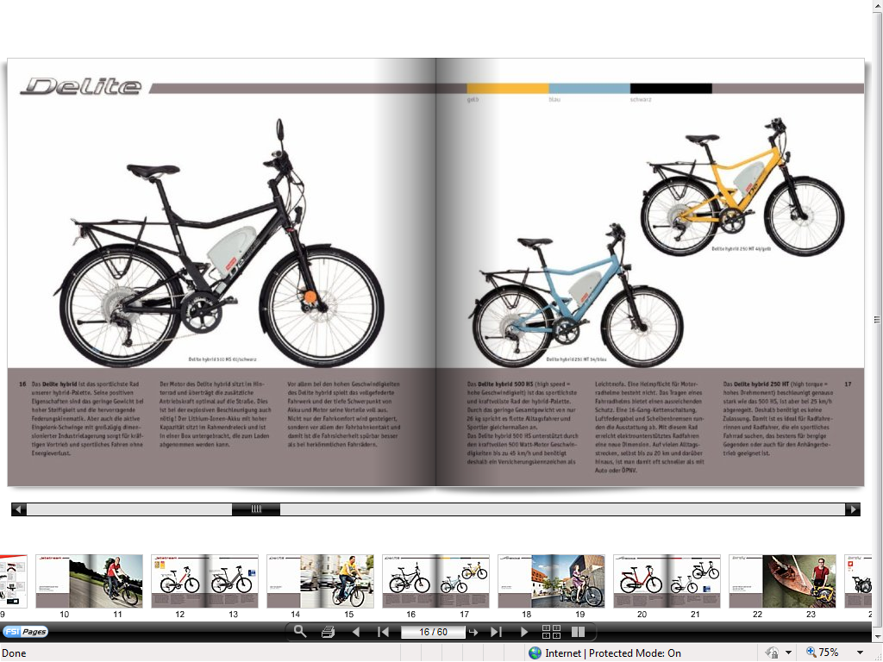
    - Pricing strategy
      - Customary markups
Markup on bikes is not huge. This is especially true for the upper end. You're looking at 32-35%. Now that's providing that you get list price for the bike. And we all know that these days everything is negotiated.
Now the markup on accessories is where shops make up for it. You're looking at 100% on many items that you add to these bikes. (Yahoo Answers, 2008)

      - Types of discounts available
Obviously negotiation is one way to get a discount. Sales discounts are the only other type of discount to a retail consumer.

  - Compare and contrast your product and the competition’s product(s)
    - Competitor’s product(s)
      - Brand Names, Features and Packages
Considering many of Optibike’s competitors have already begun marketing and selling in Germany, a comparison of U.S. e-bike manufacturers as well as German e-bike manufacturers must be completed to thoroughly understand the full scope of the competition. Due to its affluent demographic, Optibike’s competition in the U.S. is limited to several e-bike manufactures. Pedego (Balloon Series), Currie Technologies (Izip Express), Giant (Twist Freedom Express DX), PiMobility (PiCycle), and Electric Motion Systems (E+ Ellsworth Ride 3.0)

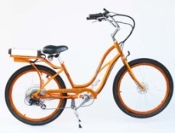 Pedego, based in California markets their product as an eco-friendly alternative to other modes of transportation. Additionally, the company markets to consumers who find it hard to ride a normal bicycle through hilly areas or for health reasons. Pedego offers the only electric tandem available.

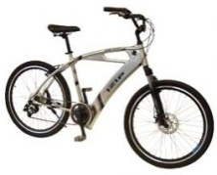 Currie Technologies, is the leading U.S. manufacturer of electric bikes and scooters, Currie Technologies also offers electric bikes through independent dealers, on-line sellers, and big-box retailers. Over the past few years, the company has revamped their product offerings, changed designs and introduced Lithium batteries.

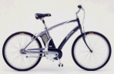 Giant Bicycle Company is one of the world's leading bicycle manufacturers. Giant is consistently rated very high by U.S. bicycle dealers, and the only bicycle industry company on the Forbes 200 List of Outstanding Companies Worldwide.

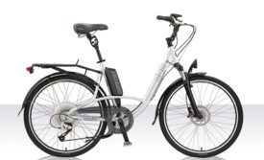 OHM has worked together with BionX (hub motor kit) and Moli Energy (Lithium batteries) to create a power assist drive system with exceptional range and features. The system also includes a "smart" charger that will charge the battery in approximately 4 hours. When completed, charging stops, an indicator light illuminates and the battery automatically returns to power-save mode.

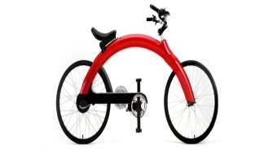 The Pi has a striking arch design hinting at the innovation underneath. The bicycle is light weight, with a high power Li-Ion battery located within the aluminum arch, to a suspension seat system that can easily fit people ranging in heights between 5’2” to 6’8”. Pi’s patent-pending air lift seating system offers nearly infinite adjustment.

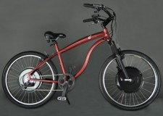 The Electric Motion E+ line is designed to the highest standards of quality, performance, reliability, and safety. Each frame is custom-made, and all components are of the highest quality in bicycle standards.

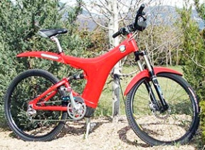 Optibike is arguably the leader in high performance electric bikes. Having had bikes on the market for a few years, Jim rolled out the flagship of the Optibike line, the Limited Edition Optibike OB1. The first OB1 was quickly inducted into the California Academy of Sciences Museum calling it, “The Future of Transportation.” Optibike combines speed, long run times and exceptional hill climbing ability in an integrated package with style.
Optibike’s promotional and product mix combined with its ongoing research to develop the next generation of electric bicycles will allow it to retain a competitive edge, retaining and expanding the company’s current market niche in the U.S. Optibike anticipates that the price will decline as economies of scale increase, thus decreasing the cost of production.
Within Germany, there are many more manufacturers that have entered the e-bike market. However, considering the long list of e-bike brands in Germany, there are only two that are true competitors, Riese und Müller ($3,999) and ErockIT ($20,000).

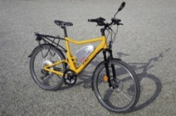 Riese und Müller is Germany’s highest priced and best quality e-bikes. Riese und Müller bike styles are based on a more traditional bicycle style, adding modern queues to the design. Riese und Müller is located in Darmstadt, Germany founded by Markus Riese und Heiko Müller in 1993. They are famous for designing and assembling fully suspended bicycles only. That being, the system or systems used to suspend the rider and all or part of the bicycle in order to protect them from the roughness of the terrain over which they travel. Bicycle suspensions are used primarily on mountain bikes, but are also common on hybrid bicycles, and can even be found on some road bicycles. Bicycle suspension can be implemented in a variety of ways:
- Suspension front fork
- Suspension stem (although these have fallen out of favor)
- Suspension seat post
- Rear suspension
        - Suspension hub …or any combination of the above.
Bicycles with suspension front forks and rear suspensions are referred to as full suspension bikes. Frames are produced by other companies such as Pacific Cycles, Taiwan. Bikes sold in Australia, Japan and the USA are directly built in, and shipped from, Taiwan. (Wikipedia, 2010)

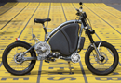 The ErockIT is a relatively new entry, first introduced in 2008. However it is considered more of a hybrid between a motorcycle and a bicycle than any other e-bike model. With a top speed of 50mph, the ErockIT places itself in a different class than most bicycles. The ErockIT design combines common bicycle handling (pedalling for acceleration, brake levers to the left and right of the handlebars) with the power of a motorcycle which allows cyclists to cover longer distances at much faster speeds.
Designed as an emissions-free alternative to motorcycles, the electric motor, coupled with the simplicity of the bicycle, means the ErockIT is more accessible to a wider range of people and doesn’t require any special training or licenses to operate. (GreenMuse, 2009) The ErockIT is only offered in one model and the price was recently cut in half from $40,000 to $20,000. The ErockIT is also manufactured in Germany.

According to ExtraEnergy estimates, 250,000 electric bikes were sold in Europe in 2007. In 2008, this number will be higher. All the positive media reports have created a new perception of electric bikes among people of any age. They are not the strange granny's bikes anymore but a serious alternative to cars and other polluting vehicles. This change of trend was obvious at the bicycle shows Euro bike and IFMA this year. Visitors were very open towards pedelecs and e-bikes and showed positive interest and curiosity towards new forms of mobility and vehicle concepts. Pedelecs (also) sell for highest average price. On September 4, 2008, the German bicycle dealer magazine SAZ published a research, which showed people in Germany spend more money on pedelecs than on any other bicycle category. This statement means that the customer is really paying more money for the added value he gets from an electric bike compared to a regular bike (faster and more comfortable, riding uphill or against head wind with ease, carrying loads more easily).

    - Competitor’s Prices
Prices for the U.S. competitors are listed below:

U.S. Competitors Brand Name | power (watts) | btry. type | gearing | motor cntrl. | retail price
Pedego | 500 | LFP | none | throttle | $1700-$1900
Currie Technologies | 400-750 | LFP | fixed | both | $1500-$3500
Giant Twist | 600 | SLA | fixed | pedal assist | $2000
OHM Cycles | 250-350 | Li-Ion | fixed | both | $2400-$3500
Pi Mobility | 400-750 | Li-Ion | varies | throttle | $3000-$5000
Electric Motion | 1000 | NiMH | none | both | $4000
Optibike | 400-850 | NiMH, Li-Ion | varies | both | $6000-$14000
Watts: average Joe or Jane = 100-150W, Lance Armstrong = 300W, pushing air out of the way on an upright bike at 25 mph = 700W.
Battery Chemistry: SLA = Sealed Lead-Acid, NiMH = Nickel-Metal Hydride, Li-Ion = Lithium Ion, LFP = Lithium Iron Phosphate.
Gearing: none (many hub motors, one motor revolution = one wheel revolution), fixed gear reduction for more torque, varies when geared motor drives the chain through the bicycle gears which increases torque about 50% (in low gear) for better hill-climbing and offers better top-end speed (in high gear) than direct drive systems using motors of similar wattage.
Motor Control: pedal-assist (assists when you pedal), throttle (thumb or twist throttle on handlebar), or both.
Source: (Electric-Bikes.com, 2010)

German bicycles are referred to as pedelecs. The graph and information below displays the average price for a pedelec and German consumer rationale for paying more for an e-bike or pedelec.
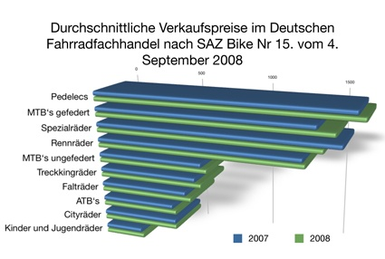
Source: (ExtraEnergy.org, 2008)

Key for graph above:
1,685 EUR – Pedelecs: e-bike sales
1,523 EUR – MTB’s gefedert: full suspension mountain bikes
1,456 EUR – Speziairader: special bikes
1,353 EUR – Rennrader: racing bikes
743 EUR – MTB’s ungerfedert: hard tail mountain bikes
702 EUR – Treckkingrader: trekking bikes
680 EUR – Faltrader: standard or miscellaneous bikes
520 EUR – ATB’s: all-terrain bikes
517 EUR – Cityrader: city bike
273 EUR – Kinder und Jugendrader: kids' bikes
The average sales price for a pedelec in Germany is 1,685 Euros (last year it was 1,639 Euros). According to the SAZ survey, the average retail price of other bicycle types in Germany is lower compared to pedelecs. On the basis of the SAZ analysis Mr. Neupert concludes that bicycle dealers, who let the pedelec pass by their business, will have to cope with a significant decrease in turnover. Dealers who become experts in electric bikes, however, have the unique chance to increase their turnover and make more profit. It should be worth the effort, if sales numbers really rise as ExtraEnergy predicts. For the year 2018 Mr. Neupert’s organization expects sales between 1.5 and 3.25 million pedelecs per year––in Germany.” ^{(ExtraEnergy.org, 2008)}

    - Competitors promotion and advertising methods
Promotion and advertising methods are similar in Germany and on the internet; magazine articles display the product or people riding the product or the product in scenic areas. The two screenshots are from Optibike’s and Riese und Muller’s on-line web sites. The types of information, options to customize the bicycle, and specifications are available which affects the price. The German version of the screen for Riese und Muller was captured. Many German internet sites provide the option to display in English or German languages.
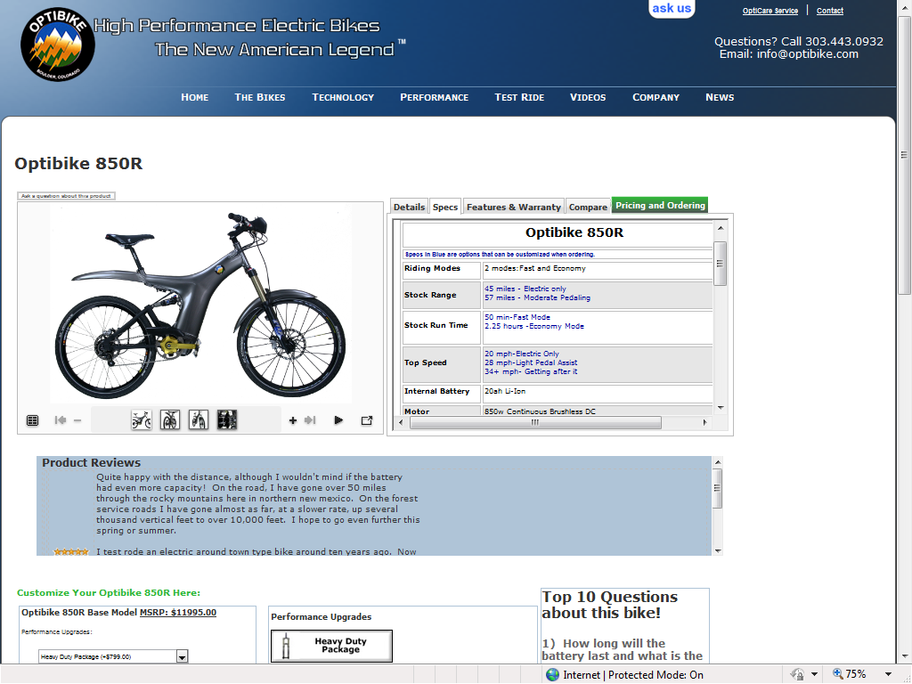

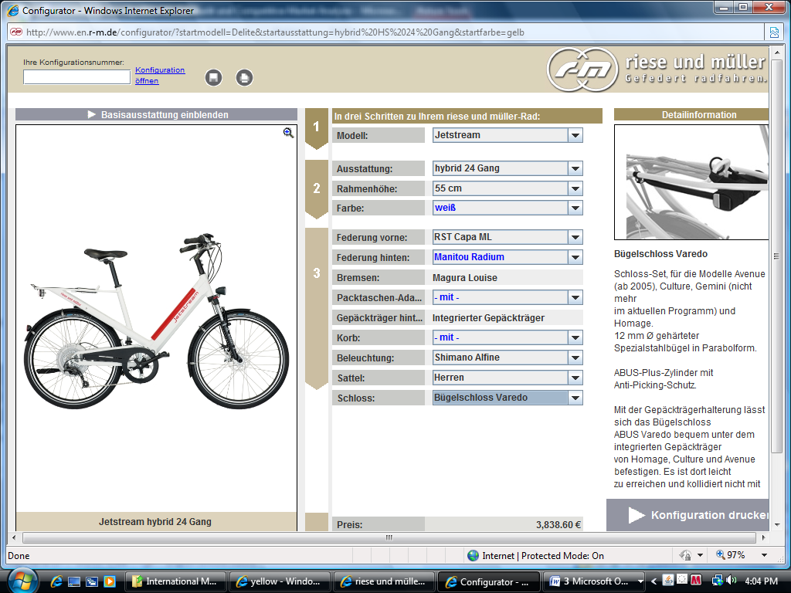
    - Competitors distribution channels
Similar to American distribution channels, German bicycle manufactures use retail outlets, independent bicycle dealers and trade fairs to market and sell bicycles. Obviously the internet has become a growing segment for sales as well in Germany.
In Germany, Zweirad Experten Gruppe better known as ZEG is the largest coalition of bicycle dealers. ZEG, saw its overall turnover increase by 10.8% tot € 393 million in 2009. CEO Georg Honkomp comments: “In particular the growing demand for e-Bikes is a great success and is thanked to growing environmentally conscious thinking,” Overall, the ZEG unifies up to 900 independent bicycle dealers. (Bike Europe, 2010) As many of our competitors are members of the bicycle cooperative, Optibike will join the cooperative
Additionally, independent bicycle dealers also represent a large market share in Germany. In 2008, the independent bicycle dealer’s market share was approximately 70%. (Bike Biz, 2009)

  - Market Size
    - Estimated industry sales for the planning year
Currently, electric bikes are the fastest growing bicycle segment. According to independent industry association VSF, the market volume doubled in two years to 140,000 units in 2009. This was 20,000 units more than the number ZIV originally predicted for 2009. When we compare 140,000 electric bikes to the 4 million regular bicycles sold in Germany every year, this new two-wheel segment is still an infant. Obviously, the media reports on pedelecs and e-bikes are much more attention-catching than the actual sales numbers. (ExtraEnergy.org, 2008)
According to ETRA, the duo forecasts global e-bike sales to grow by “only” 7% to 24.3 million this year in the 2010 edition of their publication Electric Bikes Worldwide Reports.
In comparison to the sluggish growth forecast for the worldwide market, the duo forecasts EU sales to jump by 33% in 2010 from 750,000 units to 1 million units, thereby growing its share in global sales from 3.3% to 4%.
Inside the EU the market is also “lobsided”. According to Jamerson/Benjamin the Netherlands accounted for 28% of all EU sales in 2009 (about 210,000 units). When the 140,000 units sold in Germany in 2009 (a statistic of the independent industry association VSF) are added, it is clear that almost one of every two bikes sold in the EU in 2009, was sold in the Netherlands and Germany. (ExtraEnergy.org, 2010)

    - Estimated sales for your company for the planning year
- Optibike ended 2009 with U.S. revenues of $1.3 million and a net income of $335,000. There was no income in Germany for 2009.
- We will allocate $120,000 investment for license and costs associated with partnership/alliance startup, including training and promotion.
- Anticipation of 30 Optibike units sold in initial year equating to 1/4 of U.S. sales per year at an average cost of $8,300 per bike.
- 5% Increase in sales per year thereafter.
- Cost of goods sold will be 60% of net sales.
- Selling, general & admin will be calculated at the industry standard of .117% of net sales (Conservative estimate. Expenses should be less as shared by licensing partner)
- Depreciation will be 10% of equipment, property & plant worth. Industry standard of .35 and .295 of net sales (Conservative estimate, should also be less due to manufacturing performed by licensing partner)
  - Government participation in the marketplace
    - Agencies that can help you
The new Electrically Power Assisted Cycles (EPAC) standard for safe e-Bikes will change the market for e-Bikes drastically as it will no longer be possible to enter the e-Bike market in Europe by simply importing e-Bikes and selling them. All modern electrical equipment, including the e-Bike, has its own product directives. “These directives cover product aspects such as the environmental impact of the materials used, product safety, Electro Magnetic Compatibility (EMC) and low voltage characteristics. The new European standard EN 15194, aimed at safety and reliability, will classify all directives and become the new standard for all e-Bikes. To qualify an e-Bike as ‘perfectly safe’ for the user as well as his surroundings, it has to comply with this new standard. Putting all the components together does not guarantee high quality and maximum safety of the final product. An e-Bike can lay a claim to a CE-mark only if the final product, including all the individual electronic components has been produced according to the EN standard.
The EPAC standard is far more complicated than the CEN standard we know for bicycles. Manufacturers can do the CEN testing for standard bikes themselves. That is not possible for EPAC. It is too complicated as it is not about testing separate components. To meet the EPAC/EMC standard you have to test the whole system or sub-assemblies and you have to do that again and again after each minor adjustment. Electro Magnetic Compatibility (EMC) is a good example of the importance of the new EN standard. Electro Magnetic Compatibility requirements are designed, for instance, to ensure the safety of people who use a pacemaker or hearing-aid when driving cars or e-Bikes. In our world full of electronic equipment it is of utmost importance that any interference between electric equipment is limited. Everybody knows that you have to switch off your mobile phone in an airplane during take-off and landing. Can you imagine what will happen if a non-certified e-Bike interferes with a passer-by's pacemaker? A non-certified e-Bike is not only dangerous for the driver, but also for his environment.” (Bike Europe, 2009)

    - Regulations you must follow

Generally, the laws of Germany are quite similar to those you are used to in the US. E.g., don't kill anyone, ride or drive on the right side of the road, and obey traffic laws as if you were driving a car. In Europe, everybody rides or has ridden bikes and drivers are tolerant of the challenges all bike riders have. Here are a few guidelines.
- You must have a bell of some type. The idea is to warn pedestrians and other riders when you approach from behind or if they are not paying attention and you approach from the front. I have never heard of someone being arrested or fined for not having a bell however.
- If you ride after dark, you must have a light fore and aft.
- Stay off the sidewalks except for heavy traffic streets. The exception is when a bicycle lane is built into the sidewalk. (Bike lanes may be painted red or green to differentiate them from the pedestrian portion of the sidewalk or pathway.) When there is a bicycle lane on the sidewalk, pedestrians are not suppose to walk in that lane and impede bicycle traffic. You may ring your bell to have them move but a friendly "Hallo" is more polite. If, due to heavy traffic, you opt to ride on the sidewalk out of fear for your life, remember that pedestrians belong there and you should not ring bell for them to get out of your way.
- Ride single file; don’t cross against the light, even if the kids do it. And stop at the stop signs. You are in a foreign country and you may not know the customs of the local drivers.
- Don’t turn right on red at streetlights. This is more important for cars than bikes but it is the law.
- The round blue signs indicate what the path or sidewalk is for. For example, if it has a woman with a child, it is for pedestrians only. If it has a bike, it is for bicycle only. If it has both, both may use the path. Frequently, there is an additional sign with “something” Frei under the round sign that means these types of traffic may also use the path.
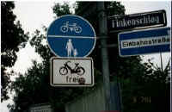
- Many European streets are too narrow for cars to meet side by side and have a car parked in the street. What happens is that cars swerve out over the centerline to drive around parked cars. However, if a car is coming from the other direction and the parked car is in your lane, you must yield to the oncoming car. In other words, you must wait behind the parked car until the oncoming car (or cars) has passed before passing swerving out across the centerline to pass the parked car. This can get interesting when cars are parked on both sides of the road and cars must alternatively swerve in and out and wait and hurry. The locals have it down but it seems like pandemonium to me.
- When you are about to turn a blind corner, ring your bell to warn other possible riders or pedestrians coming toward you around the corner that you are there.
- This next item comes as a surprise to one of our readers. Do not ride your bicycle if you are drunk. That unfortunate reader faced revocation of his driver’s license after being stopped while riding after having three glasses of whiskey. Well, I said above that all laws that apply to car drivers apply to bicycle riders. (Bicycle Germany, 2010)

- Executive Summary
In conclusion, it would be a wise decision for OptiBike to merge into the international market via Germany. There are many similarities between the US (home country) and Germany, like advertising strategies, various terrains and weather patterns as well as a general acceptance of emerging technology. These similarities would help make for a smoother transition and a more successful outcome in a shorter duration. The largest obstacle may be increasing buy-in by the Germans as they currently have 2 other e-bikes on the market that would provide some competition. Fortunately the current economy in Germany is very favorable to the bicycle industry allowing for future growth of more than one e-bike Company.
Growth of an organization really depends on the public’s view and if they deem a new organization worthy or not. The most optimal way for OptiBike to gain buy-in is by moving part of the manufacturing unit over to Germany. This allows them the opportunity to influence a growing economy and give them additional jobs, while the target population gives OptiBike additional sales/business. It would also help OptiBike get the local inside scoop as to what the culture wants and needs. They would be able to make local customizations based on local needs and desires, as well as adapt more rapidly to changes.
Other ways to build value would be to offer specials and to partner up with a local vendor while they build their brand and find their target clientele. The trick would be to be careful as you do not want to decrease value by offering to many specials but you do want to build interest. Proper marketing could definitely increase sales and help OptiBike forge ahead and take advantage of a growing industry in a foreign country. It could also help out the local vendor by increasing their sales and their visibility as an innovative leader in bicycle options for the serious bike rider, or the casual rider looking for an exceptional bicycle.
OptiBike would ensure its customers that it passes, if not exceeds, the EPAC regulations and confirm that safety is at the top of their priority list. They would prove that their concern is not with the bottom dollar/euro, but instead with the satisfaction of the customer. They could market to the whole family and eventually end up thriving on family sales for the longer bicycle vacations. The OptiBike is not just for an individual, but it can be enjoyed by all ages giving everyone the same experience.
Overall OptiBike and Germany seem to be a good fit. There is a passion to be, and have the best on both ends. There is a common concern for the safety of the rider as well as general comfort. Both sides believe in value, not only in money spent, but also in the value of the time spent doing an activity. They gain satisfaction from physical activities, especially when they know that they are damaging the environment less with an e-bike than they would when compared to other methods of transportation.

IV. Preliminary Marketing Plan
Guideline
I. The marketing plan (Synopsis)
Optibike is a private manufacturer of electric bikes in the United States. The founder and principle designer of Optibike is Jim Turner. Optibike, based in Boulder, Colorado, has been producing and selling e-bicycles or e-bikes since 2005 to primarily an American market. Optibike’s 2009 revenues were approximately $1.3 million dollars and employed only 6 workers.
The entry level price for Optibike’s best selling model, the Optibike 850R is $11,995 (which equates to €8,900). (Optibike, 2010) Optibike’s target market consists of affluent clientele who are conscientious regarding environmental and safety concerns. It is also noted that customers within this realm are equally committed to a “lifestyle leadership” in style and quality. Optibike’s have been sold to customers ranging from 22 to 80 years old. (Greenpages, 2010) Optibike has been successful in carving out a well defined market niche in the United States.
From a worldwide standpoint, e-bicycle production has surpassed bicycle production since 2000 largely due to their popularity in the Asian markets. Sales outside of America have been by either word of mouth or via internet. Until now, Optibike has not made any strategic effort to enter into international markets.
Given Optibike’s proven success, their main mission remains the same: Make the World’s best electric bicycle, with no compromises in quality, performance or style. Therefore, based on a business analysis and marketing acumen, it is recommended that Optibike position itself to expand into the Germany marketplace.
After careful review of the barriers of entry and the best countries to facilitate Optibike’s marketing goals, it is suggested that the client enter into a licensing agreement the manufacturing portion to the Schauff Bicycle Company of Germany.
Schauff is also a family owned company and a well respected name in Germany. Under this proposal, Schauff would produce and assemble the Optibike in Germany. These actions would circumvent unnecessary tariffs and shipping costs. Moreover, Schauff’s expertise in German customs and laws would afford Optibike additional advantages with licensing fees, foreign exchange gains and losses as well as in court negotiations. Finally, Optibike will retain all legal rights with respect to its patents on its motor assembly. Thus, in order to maintain its proprietary rights, the motor assembly would be manufactured in the United States and shipped to Germany.

A. Marketing objectives
The objective is to fill the current void of a truly high end e-bike market niche in Germany. Optibike will simultaneously capitalize on the current trend of e-bike growth in Germany. These efforts will ultimately result in capturing this untapped market segment and taking our place as its leader.

1. Target market(s) (specific description of the market)
In Germany, public transportation is extremely popular and driving a car is more of a luxury rather than a common means of transportation. Therefore, instead of people having to walk or drive to bus, train or tube stations, they can utilize the electric bicycle as a convenient and efficient way of getting to their destination.
a. Size and characteristics of target market
The Optibike’s target market is affluent clientele who are conscientious regarding environmental and safety concerns. It is also noted that customers within this realm are equally committed to a “lifestyle leadership” in style and quality. As of July 2010, the total population of Germany was estimated at 82,283,000 (CIA - TheWorldFactbook.com/germany, 2010). The median age for males is 44 and for females is 44, equating to the median age for the entire population of 44.
Criteria | Number | Rank | Memo: US
GNP per capita | 23534.8 | 14 | 33070.3
Population | 82,369,552 | 16 | 303,824,640
GDP PPP per capita | 34065.12 | 21 | 45759.46
Freedom in decision making | 6.9 | 9 | 7.6
Roadways paved | 644480 | 9 | 4209835
PC's per capita / 10K people | 4.9 | 19 | ?
(NationMaster.com, 2010)

From a pure numerical ranking standpoint, the freedom in decision making category represents the mean of self-ratings on a ten point scale. The ratings indicate that Germans feel about 69% confident that they are free to make their own decisions. This is important considering the history of Germany and the Federal Republic currently in control. Germany has a large amount of paved roads. This means the ability to have an enjoyable bicycle ride or a meaningful one. That directly translates into rational for purchasing a bike or an electric bike. GNP per capita or the countries relative overall economic output has been historically associated with a country’s standard of living. The GDP Purchasing Power Parity (PPP) per capita is relative to the U.S. dollar. This figure is important, not due to the trade from U.S. to Germany, but that the average German consumer will have the means to purchase a $5000 to $15,000 bicycle if he or she chooses to do so. Current conversion rate of $1.00: €1.21 equates to €4,100 to €12,400. Additionally, PC’s per capita was reviewed to determine the amount of individual research a consumer could complete when looking for an e-bike. Web research has been a growing factor in the purchase of an expensive item.
b. Target market Segmentation:
i. Age group:
Optibike’s have been sold to customers ranging from 22 to 80 years old. (Greenpages, 2010) Optibike has been successful in carving out a well defined market niche in the United States.

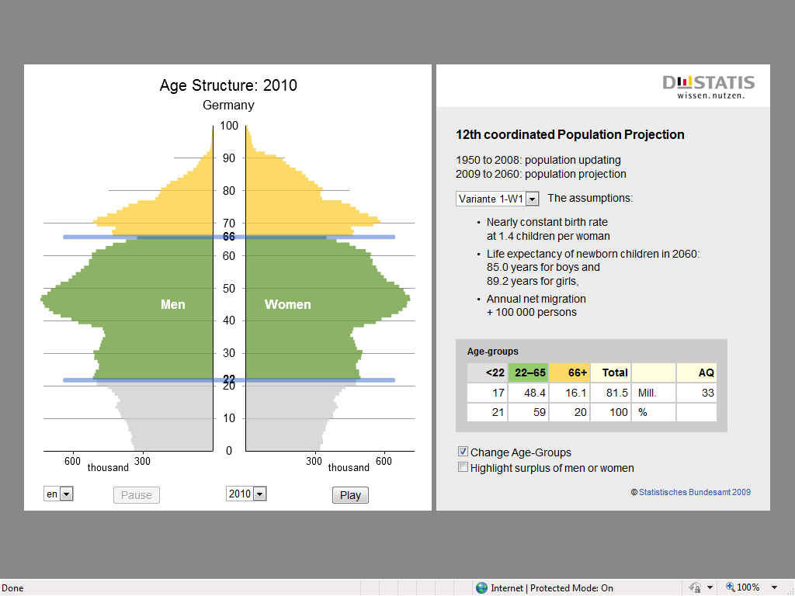
(DeStatis, 2010)

Taking cues from the clearly defined age group in the U.S, the German target age groups for the electric bicycle are young professionals aged between 22 and 65 years old. According to the graph above from the 12th Coordinated Population Projection, the age group representing ages 22 to 65 years amount to approximately 48,400,000, which is 59% of the total population, also given that many Germans choose bicycling as an alternate form of transportation, and many German youths pursue a college education; marketing the e-bicycle to this working class age group, is perceived as an advantage and will result in a greater likely hood of the product being accepted.
ii. Gender:
Those aged between 22 – 64 years amount to 59% of the total population, the number of males in this age group amount to approximately a 1.5 males to every female in this market segment.
“In Germany, as in other modern societies, there has been tremendous progress with regard to the equal rights for women stipulated in the Basic Law. As such, with regard to education girls have not only drawn level with, but have indeed now overtaken boys. At grammar schools they account for 56 percent of graduates; the share of young women embarking on degree courses at university totals almost 54 percent. Of the apprentices who passed their final examination in 2006, 43 percent were young women. And more and more women are embarking on careers. And the alimony laws in the case of divorce in force from 2008 make it all the more important for women to be employed. Nowadays 67 percent of women in Western Germany and 73 percent in Eastern Germany work. Whereas as a rule men are in full-time employment women, especially those with small children, work part time.
With regard to wages and salaries there continue to be differences between the sexes: Female workers, for example, earn just 74 percent of their male counterparts’ pay, and salaried staff a mere 71 percent. For the most part this is due to the fact that women frequently work in lower positions. Even though nowadays they are frequently getting to occupy top jobs on the career ladder, in doing so they still encounter considerable hurdles.” (Facts About Germany, 2010)
Due to the current and ongoing progress of women’s equal rights and growing similarities in education and pay, there will be no differentiation between the genders from a marketing standpoint.
iii. Geographical location:
According to the CIA World Factbook, over 75% of the population is urban. Since most businesses and universities are located in major cities; the target location for introducing the product will be major cities such as Berlin, Germany’s capital, with a population of 3.4 million. Other large urban areas include: Essen, 6.6 million; Frankfurt, 3.7 million; Düsseldorf, 3.2 million; Cologne , 3.1 million and Hamburg, 2.7 million. It is also interesting to note that according to the Organization for Economic Co-operation and Development (OECD), Germany’s household disposal income was approximately 0.06 in 2008 compared to 0.08 in the U.S. for the same time period. Statistically, very close (OECD, 2010).
iv. Rationale for target market choices:
Targeting the major cities, with larger populations allow greater initial exposure for Optibike and accelerate market penetration. Further rationale behind the target market for the geographical area targeted market is because most universities and businesses are located in major cities. The 22-65 professional age groups are represented in these areas given their urban lifestyles and opportunities for traveling to work and school. Both women and men are included in this target market as the e-bicycle is an appropriate mode of transportation for both genders.
2. Expected sales 2010 - 2011
Zero sales for 2010 are anticipated as the remainder of 2010 will be required for obtaining the license and working with our German partner training and preparing for the initial launch. Any incremental sales will be used to offset 2010 costs. Anticipation of 30 Optibike units sold in 2011, launch year equating to 1/4 of U.S. sales per year at an average cost of $10,833 or €8,900 per bike.
- Optibike ended 2009 with U.S. revenues of $1.3 million and a net income of $335,000. There was no income in Germany for 2009.
- 5% Increase in sales per year thereafter (Conservative estimate as growth is expected to be approximately 7%).
- Cost of goods sold will be 60% of net sales.
- Selling, general & admin will be calculated at the industry standard of .117% of net sales (Conservative estimate. Expenses should be less as shared by licensing partner)
- Depreciation will be 10% of equipment, property & plant worth. Industry standard of .35 and .295 of net sales (Conservative estimate, should also be less due to manufacturing performed by licensing partner)

3. Profit expectations 2010 - 2011
Optibike recognizes the recent financial downturn and its effects on global expansion; however, we foresee an economic assessment of low double digit growth within the next 5 to 7 years. Given that forecast, we propose an initial investment of $120,000. The $120,000 investment will be allocated for start-up costs and capital for parts, royalty payments and general costs associated with the partnership/alliance startup, including training and promotion. Schauff would be expected to match that amount once approval was met from its Board of Directors.
Therefore, for 2010, Optibike’s German operations will expect a loss of $120,000, or €99,000. This amount will be offset by the U.S. operations forecasted annualized Gross profit of $541,000 for a combined gross profit of $421,000. For 2011, Optibike anticipates 30 Optibike’s sold in the initial year (1/4) of U.S. sales and well under 1% of the total population at an average cost of €8,900 per bike.

4. Market penetration and coverage
In Europe, the Electric bicycle industry is booming. It is estimated 250,000 e-bikes were sold in 2008 and this number is set to rise dramatically. Trade magazine ‘SAZ’ reported that Germans spend more money on e-bikes than any other bike category. Industry experts predict between 1.5 and 3.3 million electric bicycle sales per year by 2018 in Germany alone. (Nope, 2009). In 2008, e-bikes reached a market share of around 2 percent of the European bicycle market. It is anticipated that the e-bike market will mirror that of the introduction of the mountain bike market. (Eurobike The Global Show, 2010)
Currently, electric bikes are the fastest growing bicycle segment. According to independent industry association VSF, the market volume doubled in two years to 140,000 units in 2009. This was 20,000 units more than the number ZIV originally predicted for 2009. When we compare 140,000 electric bikes to the 4 million regular bicycles sold in Germany every year, this new two-wheel segment is still an infant. Obviously, the media reports on pedelecs and e-bikes are much more attention-catching than the actual sales numbers. (ExtraEnergy.org, 2008)
The above data from ExtraEnergy.com equates to a 3.5% market share in 2009. An increase of approximately 1.5% year-over-year. The table below displays Optibike’s projected market share over 11 years based on the above data.
Year | Optibike Sales: 5% Growth | Market Share | Industry Sales: 2% Growth | Anticipated Revenue (Euro) | Conversion to U.S.
2011 | 30 | 0.021% | 140,000 | € 267,000 | $ 323,479
2012 | 32 | 0.022% | 142,800 | € 280,350 | $ 339,652
2013 | 33 | 0.023% | 145,656 | € 294,368 | $ 356,635
2014 | 35 | 0.023% | 148,569 | € 309,086 | $ 374,467
2015 | 36 | 0.024% | 151,541 | € 324,540 | $ 393,190
2016 | 38 | 0.025% | 154,571 | € 340,767 | $ 412,850
2017 | 40 | 0.025% | 157,663 | € 357,806 | $ 433,492
2018 | 42 | 0.026% | 160,816 | € 375,696 | $ 455,167
2019 | 44 | 0.027% | 164,032 | € 394,481 | $ 477,925
2020 | 47 | 0.028% | 167,313 | € 414,205 | $ 501,821
2021 | 49 | 0.029% | 170,659 | € 434,915 | $ 526,912
As Optibike is a new entrant to the German market, a conservative market share is anticipated. Due to its high end market niche, it is prudent to take a conservative approach at this time. In 2010, global e-bike sales have been projected to increase as much as 7%. The 2% growth projection is over a 11 year period and growth numbers above 4% - 5% we do not believe are sustainable. Estimates will be adjusted as the 2011 calendar year sales figures become available.

B. Promotion mix

Promoting the Optibike in Germany will be a challenge considering the projected number of units to be sold (30) for 2011, when this plan is to be launched. Consideration will be given to the target audience, potential return on investment, and the most effective means of reaching the target audience.

1. Advertising

Advertising through the traditional media is not feasible considering the relatively low number of target sales units for 2011. Optibike should rely on personal promotions and public appearances to generate buzz about the units and direct interested parties to the licensing partner’s website.

a. Objectives

The objective here will be to promote the name and performance of the units through personal interaction, thereby prompting consumers to go online to order their customizable units.

b. Media mix

Television advertising simply is not feasible considering the projected number of units to be sold for 2011. The same goes for radio advertising in the short-term. Germans are big on coupons and samples. As a way to cater to these desires, Optibike can make units available for test rides at the numerous Bike Expos held yearly. Another option would be to sponsor outdoor events such as the Forest Folk Festival, the Museum Quay Festival and the Autumn Dippe Fair. These events promote outdoor life and activities and are very popular in Germany.
The Optibike website is currently the organizations main sales generator. It features information on the technology behind the bikes, performance information, and most importantly video testimonials. A licensing agreement with the Schauff Bicycle Company provides the opportunity to appear on their website bringing some of the same successful sales tools. Testimonials with German citizens should be employed on the Schauff website in the same manner as they are featured on the American Optibike website.

c. Message

Messaging for Optbikes will emphasize the idea of these units being more of an item within the genre, occupying the upper tier of the available market. Messaging will emphasize high function, exceptional safety, and environmental consciousness. Images will incorporate practical and recreational riding, featuring both male and female riders between the ages of 22-65.

d. Costs

Costs associated with the Media Mix will include any expenses encountered to participate in the various Expos, Fairs and Festivals including travel, lodging, entrance fees, and the shipping and upkeep of sample units.

2. Personal selling

Along with participating in public fairs, expos, etc., Optibike can also employ viral marketing techniques by putting a number of the units on the streets allowing the public to interact with the host rider. This host rider will be well-versed on the operation and technical assets of the units, as well as providing website and contact information for those interested in either making a purchase, or, learning more about the Optibike.

V. Sources of information

CIA - TheWorldFactbook.com/germany. (2010, 05 04). Retrieved 05 24, 2010, from CIA The World Factbook: https://www.cia.gov/library/publications/the-world-factbook/geos/gm.html
DeStatis. (2010). Retrieved June 2010, from 12th Coordinated Population Projection: http://www.destatis.de/bevoelkerungspyramide/
Eurobike The Global Show. (2010). Retrieved June 2010, from E-bikes have gained velocity on the bicycle market: http://www.eurobike-show.de/eb-en/visitors/news/Die_E-Bikes_sind_ein_grosser_Renner_auf_dem_Fahrradmarkt.php?lg=de
ExtraEnergy.org. (2008, December). Retrieved June 2010, from Pedelecs Make Most Money: http://extraenergy.org/main.php?language=en&category=information&subcateg=99&id=2174
Facts About Germany. (2010, June). Retrieved June 2010, from http://www.tatsachen-ueber-deutschland.de/en/society/main-content-08/women-and-men.html
Greenpages. (2010, April). Retrieved April 2010, from Greenpages: http://www.thegreenpages.com.au/index.asp?page_id=1258
NationMaster.com. (2010). Retrieved June 2010, from http://www.nationmaster.com/red/country/gm-germany/ind-industry&all=1
Nope. (2009). Retrieved June 2010, from http://www.nope.com.au/about-nope/emerging-ev-market/
OECD. (2010). Retrieved June 2010, from http://stats.oecd.org/Index.aspx?DatasetCode=CSP2010
Optibike. (2010, April). Retrieved April 2010, from Optibike.com: http://www.optibike.com/
Seah, S. (n.d.). How to Learn German Fast. Retrieved May 2010, from A brief History of Germany: http://howtolearngermanfast.blogspot.com/2008/05/brief-history-of-germany.html
Wikipedia. (2010, May). Retrieved May 2010, from Germany: http://en.wikipedia.org/wiki/Germany
Appendixes
Porters Five Forces
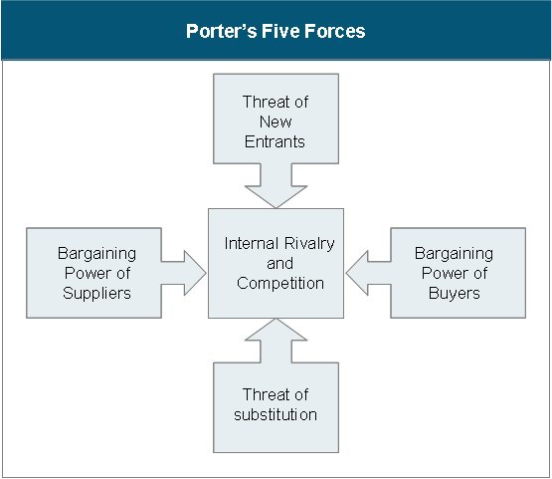

Threat of New Entrants
- Challenging because it is in a new country.
- Experience needed as it requires a lot of knowledge of the product.
- Great economies of scale.
- More cost benefits because of the experience available.
- Technology protected, however very high competition.
- Low barriers to entry.
- Protected intellectual property.
- Important resources available for the expansion.

Bargaining Power of Suppliers
- Optibike maintains tight control over what it feels is the heart of its products, the power source. This fact may limit it sources of components when assembling the units. There will therefore be a certain amount of risk associated with maintaining their established standards. Suppliers can opt to raise prices as the popularity of Optibike increases. In addition, the size and/or amount of products purchased from its suppliers will play a role in the bargaining strength of Optibike. At this moment their products are not mass produced at significant levels which may interfere with their ability to volume-price components
- While Optibike delivers products worldwide, it continues to maintain control over the manufacturing process. This prevents further exposure by eliminating the need for suppliers to deliver components to new locations. Conversely, this tight control may limit availability and expedience of delivery to perspective customers who may opt for more readily available competitor options.
- Product-level quality will likely continue to be maintained as Optibike continues to control the manufacturing process, and has the option of where to purchase initial components. Even if the quality level of components from current suppliers begins to suffer, Optibike can explore other options. The risk then becomes their ability to find competitive pricing. Service-level quality can be an issue as the need for localized parts and service increases. Germany has a large population of consumers who enjoy and even rely upon these types of products, and they may not always be willing to wait extended periods of time for repairs and service. Optibike will need to establish and monitor quality control guidelines with service providers worldwide to ensure their expected level of quality is preserved.
- Optibike suppliers are not competitors and hold no sway or influence over Optibike customers

Threat of Substitution
- Low possibility of a substitute because of the cost and expense involved in making this product.
- Developing brand loyalty to customers.
- Because of the competition, there is a wide variety of costs of which Optibike is in the higher range, creating their own niche; lessening the threat of a substitution for customers.

Bargaining Power of Buyers
- Numerous options, some which compete directly, others that offer a variation on the theme. Several similar categories including scooters, cruisers and conversion kits for non-powered bicycles.
- Very large current market with great potential for expansion. Market growth has been substantial and projections suggest continued increases. Certainly other manufactures will make their products more competitive in price, performance, etc., providing more evenly-matched options for consumers.
- Products in this market are relatively expensive. Service life can be numerous years making frequent replacements unfeasible. Most likely, dissatisfaction with a product will result in negative pr and lack of product referrals by current customers
- While the electric-powered bike is not a mandatory product, its popularity continues to grow in response to both the global economic crisis and pressures to find replacements for fossil fuels. In addition, overcrowding in major cities will likely make smaller, more economical travel much more desirable.
- Consumers are purchasing alternative transportation in ever-increasing numbers, so as demand rises prices can either remain stable or rise accordingly. One complication is the availability of other options. Right now each Optibike is made to order. The ability and willingness to mass produce the bikes would serve to further increase market share.

Internal Rivalry and Competition
- Due to the growing popularity of the e-bike, internal competition amongst e-bike manufacturers keeps the prices from skyrocketing and fuels the growth of technology.
- Because of the demand and the competition, possibility of price war.
- Barriers for exit are fairly high because of the expense required.
- Possibility of future growth because of the growing demand.
- Low switching costs for customers because of the choices.
- Intensity in competition to try to gain the market share.
- Diversity in the competition because it is in a new country and new culture

