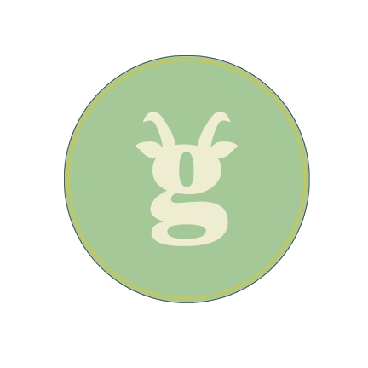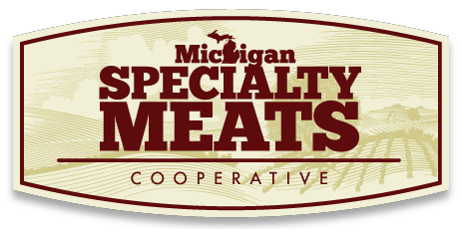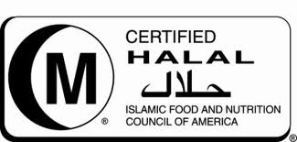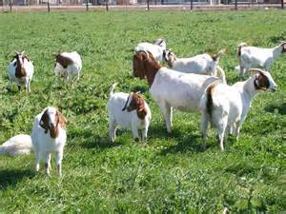

Windsong Ridge Meat Goat Farm

Petoskey, MI

213-439-0133

269-967-6289

Hunt’s Boer Goats

East Leroy, MI

Breezy Boer Acres

Dowagiac, MI

269-782-0661

**Feature Producers**

**December 5**

American-Arab

Anti-Discrimination

Benefit Gala

**June 21**

Farm Tour

Like us!

Follow us!

Check out our website at

www.grazedrightfarms.com

Grazed Right FarmsTM

is a brand of

Michigan Specialty

Meat Cooperative that markets and sells   
goat meat.

**Who We Are**

Elk

Deer

Goat

Pheasants

**Upcoming Events**

**Our Products**

*Grazed Right…Raised Right*