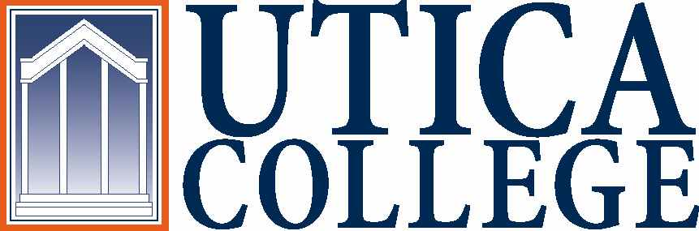

Contact Information:
Vasiliki K. Feggulis
Utica College
vkfeggul@utica.edu
cell: (732) 484-1121
work: (315) 792-3062

March 23, 2012

Therapeutic Recreation: Where Inspiration Comes Standard
Therapeutic Recreation (TR) is much more than fun and games. While often misinterpreted, TR stands alone as a major that not only prepares students to care for the body, but to inspire others and make life worth living.

UTICA, NY – Imagine: one day you get cut off while driving. Your car flips over multiple times, landing on its roof. You are pulled out, clinging to life. After being taken to a hospital, doctors report that you’re paralyzed and have severe brain damage. You can no longer walk or perform many basic functions. There is even a possibility you may never lift your head again.
These are the scenarios that Certified Therapeutic Recreation Specialists (CTRS) are faced with daily. Utica College’s Therapeutic Recreation Chair, Kirsten Impicciatore, has dealt with this very situation herself.
“I took a patient who had a traumatic brain injury to the Pepsi Arena out in Albany to see U2,” Impicciatore said. “Because of his brain injury, his neck was very flaccid, but he kept his head up in the van and through the show and the whole way home.”
This patient had been a musician before his car accident. During the show, Bono reached out to touch Impicciatore, and she in turn touched her patient, a gesture that made him absolutely radiate with happiness.
TR is much more than attending concerts, playing bingo and knowing the rules of Yahtzee, however – it’s a relatively new field, established at Utica College in 1981, focused around not only rehabilitating an individual’s muscles and physical functions, but also nourishing their mind and spirit even in the aftermath of a traumatic event.
“With all other therapies, everything’s really obvious,” Jocelyn Oakley, a sophomore TR major, said. “You get medicine and you’re fixed…But with TR it’s internal.”
This ability to spark a change in someone’s demeanor is what fuels many TR students and professors.
“When you see that you made a change to someone’s spirit…it’s crazy,” Oakley continued. “It’s crazy what it does to you.”
Sarah Burnett-Wolle, assistant professor of TR, has been fortunate enough to experience this change in spirit on many occasions while working in the field. During her tenure at a nursing home, she witnessed a patient with an increased level of dementia, who hadn’t said an intelligible word in almost a full year, sing along with some visiting ragtime musicians. It was the last time she ever spoke.
“If I had to boil [TR] down to four words, I’d say ‘fun with a purpose,’” Burnett-Wolle said. “What requires students to be here for four years is the purpose. Without the growth, it’s just fun and games.”
Early on, TR majors at Utica College get to work closely with actual patients, facilitating a true hands-on experience. This early exposure allows students to become comfortable working with a wide variety of people with an even wider variety of mental, physical and emotional ailments. Across the board, professors and students alike emphasize the need for stimulation, regardless of the state of the individual.
“They’re still humans,” Impicciatore said, leaning forward slightly, her tone unmistakably serious. “If their eyes are open…you don’t know if they can hear the music, or taste the food. But what if they can?”
The nontraditional approach that TR takes to medicine makes it a field that is expected to be in high demand soon. With the growing number of people retiring and entering nursing homes, the demand for TR is expected to skyrocket within the next 20 years, giving the recreation-therapists-in-training a renewed promise of job security. Burnett-Wolle, also a large contributor to the gerontology department (the study of aging), is a big promoter for this need that is arising in the industry. By 2030, over one fifth of the U.S. population will be over the age of 65, and stimulation during this transitional period is crucial.
“Some people, like in nursing homes, they get everything they love taken away from them,” Oakley said. “You feel like you have nothing to look forward to.”
The program, because the concentration requires minimal classes outside of the 13 major-specific courses, comes with a great deal of room for electives. This allows students to pursue various other interests in addition to TR and find creative ways to incorporate their passions into the therapeutic process. Oakley, for example, enjoys theatre and has been able to take classes in and incorporate the discipline into her work.
“I had a student who was really into martial arts and while he was working at the House of Good Sheppard, he got permission to put a punching bag in [for the residents],” Impicciatore said.
There is also a sense of trust and community that flows through the department; many students even call Impicciatore “mom.” This is exponentially more important in TR than in many other majors because of the nature of the work. During the “Outdoor Recreation” course, students take a trip to the Adirondack Mountains and partake in a ropes course, their classmates in total control of the rope attached to their harness.
“If I had to take ‘Outdoor Recreation’ with the 40 kids in my bio class and one of them was holding my rope, I’d be like, ‘no,’” Oakley said, laughing. “[But] you really do trust [the other TR majors].”
However, like many scenarios in the medical field, the endings aren’t always traditionally happy, as is the case with Impicciatore’s patient who attended the U2 concert.
“[By] the next day, he had forgotten the whole experience,” she said. “But for that moment, he was having a fantastic time.”
This is what individuals in the TR field strive for every day: a spike in morale, no matter how fleeting.
“The major is so much more rewarding than I thought,” Oakley said. “You immediately see how you can impact people’s lives. It’s something that’ll stick with you forever.”
For more information on the therapeutic recreation department at Utica College, please contact Burnett-Wolle at saburnettwolle@utica.edu.

