Lesson Plan Template
ETAP 524
Spring 2013
Name: Lauren Beaulieu | Module: 6
Lesson Plan Title
Volume of Cylinders
Discipline and Topic
This lesson is designed for regular 7th grade mathematics and will fill a regular 43 minute period. Students will learn how to calculate the volume of triangular and rectangular figures. We will build upon this topic in future lessons.
Target Population
This lesson will be presented to students in regular seventh grade math. Each class is inclusive.
- General Characteristics: The students are in seventh grade and range in age from 12-13. Each class has about 20 students.
- Entry Competencies: Students have previously covered calculating the area of polygons, identifying solids, and calculating the volume of prisms.
- The students in this class learn best by doing hands-on activities where they are able to discover and construct their own learning. They learn best when given several different modes of learning and have literacy of a wide variety of medias.
Curriculum Alignment and Standards
This lesson satisfies the NYS standard 7.G.6. for seventh grade geometry. Students will solve real-world and mathematical problems involving area, volume and surface area of two- and three-dimensional objects composed of triangles, quadrilaterals, polygons, cubes, and right prisms. The students learn to calculate the volume of cylinders. This lesson builds upon their knowledge of solid figures, calculating the area of regular polygons, and calculating the volume of prisms. We will continue to build on this topic and this will appear on their Regents exam.

7.G.6. Solve real-world and mathematical problems involving area, volume and surface area of two- and three-dimensional objects composed of triangles, quadrilaterals, polygons, cubes, and right prisms.

ISTE NETS Standards
Students
1. Students use digital media and environments to communicate and work collaboratively, including at a distance, to support individual learning and contribute to the learning of others.
a. Contribute to project teams to produce original works or solve problems
2. Students use critical thinking skills to plan and conduct research, manage projects, solve problems, and make informed decisions using appropriate digital tools and resources.
  - Collect and analyze data to identify solutions and/or make informed decisions
Teacher

- Teachers use their knowledge of subject matter, teaching and learning, and technology to facilitate experiences that advance student learning, creativity, and innovation in both face-to-face and virtual environments.
- Promote, support, and model creative and innovative thinking and inventiveness
- Engage students in exploring real-world issues and solving authentic problems using digital tools and resources
- Teachers design, develop, and evaluate authentic learning experiences and assessment incorporating contemporary tools and resources to maximize content learning in context and to develop the knowledge, skills, and attitudes identified in the NETS·S.
- Design or adapt relevant learning experiences that incorporate digital tools and resources to promote student learning and creativity
- Customize and personalize learning activities to address students’ diverse learning styles, working strategies, and abilities using digital tools and resources
- Provide students with multiple and varied formative and summative assessments aligned with content and technology standards and use resulting data to inform learning and teaching.

Goals
Using real world and mathematical examples, students will be able to compute the volume of cylinders.

Objectives
- Students will be able to use the correct formula to calculate the volume of a cylinder given the dimensions with 80% accuracy.
- Students will be able to solve real world examples involving the volume of cylinders, rectangular prisms, and triangular prisms with 80% accuracy.
Underlying Educational Theory
This lesson draws upon constructivist theory of learning in that it asks students to build upon their prior knowledge to learn a new topic. Students have prior knowledge of solid figures and calculating the area of regular polygons and calculating the volume of prisms. Students use this knowledge in order to calculate the volume of cylinders. Students will be able to connect this new topic to their own experiences in the real-world

Materials Description and Timing
- Computer-. This lesson can be done in a one computer classroom.
- SMARTboard- this lesson is designed using an interactive whiteboard, specifically a SMARTboard. The SMARTboard is used so that the teacher and the students can write directly onto and interact with the PowerPoint presentation.
- BrainPop- A brainpop video on the volume of prisms will be shown to review the material from last class. At the end of the lesson, the students will view another brainpop video on the volume of cylinders and will be asked to answer the questions that follow the video and hand in their responses as their exit slip (selection rubric included for these videos).
- PowerPoint- the lesson will be presented using PowerPoint (selection rubric included for this software).
- Note packets- will be given to students so that they can follow along with the PowerPoint and fill in appropriate information. The discovery activity and each slide from the PowerPoint will be part of the note packet.
Supplemental Materials/Links
- Discovery activity: http://illuminations.nctm.org/Lessons/Popcorn/Popcorn-AS-Cylinders.pdf (will need paper, rulers, popcorn)
- Volume of Prisms BrainPop video: http://www.brainpop.com/math/geometryandmeasurement/volumeofprisms/
- Volume of Cylinders BrainPop video and quiz: http://www.brainpop.com/math/geometryandmeasurement/volumeofcylinders/

Lesson
Introductory Activity- Students will view the brainpop video to review finding the volume of prisms (3 minutes).
Developmental Activity- The students will view the PowerPoint and fill in their note packets on the new concept which is finding the volume of cylinders. The students and I will complete two examples together as a class (6 minutes).
Discovery Activity- Students will work with a partner to complete the activity from illuminations.nctm.org. I will provide them with the popcorn to do the activity. I will then demonstrate for the students how to fold the paper, and they will answer the questions that follow. I will walk around and assist the students as needed. We will discuss the results of the activity (20 minutes).
Concluding Activity- The students and I will then view another brainpop video on volume of cylinders. This time, the questions that follow the video will be given to the students as a handout and they will be asked to answer the questions on their own and hand it in as their exit slip (15 minutes).
Homework- Students will complete a take home quiz on solids, volume of prisms, and cylinders for homework.
Assessment of Students
Informal Assessment: Students will be assessed informally based on the discovery activity, participation, and the completion of examples during the developmental activity.
Formal Assessment: Students will be assessed formally based on their exit slip responses which are based on the brainpop video. Out of the 10 questions, students are expected to answer 8 of them correctly. They will also be assessed formally based on their take home quizzes which cover topics from the last 3 lessons. They are expected to score an 80% on the take home quiz. If a student receives lower than a 65% they will be required to make quiz corrections. The corrections will be optional for all other students.
Evaluation of Students and Lesson
This lesson will be successful if 75% of the students achieved the objectives with 80% accuracy. This will be determined based on their participation and responses during class and more specifically, by using the exit slips responses and the take home quiz. The evaluation of the students will let me know which students are struggling, what students are struggling with, and what modifications I need to make for the future. Students who receive lower than a 65% on he take home quiz will be required to make quiz corrections.
Low Tech Modification
If the lesson is stripped of technology then the students will still be given a note packet, but the notes and examples will be presented on the black or white board. The students will be able to complete the discovery activity. The students will not be able to view the videos. Instead, they will complete examples that will be found in their note packets in order to review before the lesson, and also complete an example in their note packets as an exit slip.

Appendix

- Take-home quiz with student sample
- BrainPop video assessment student sample
- Illuminations activity student sample
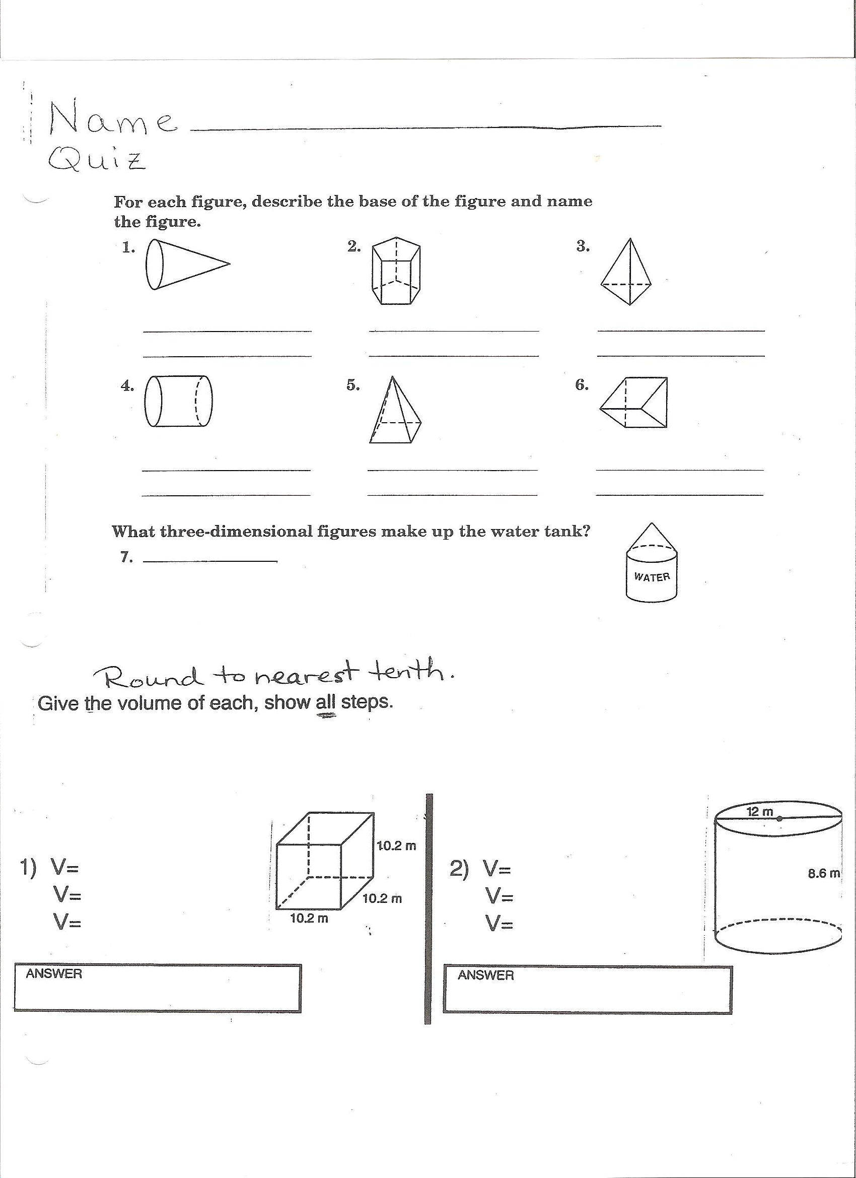
1.

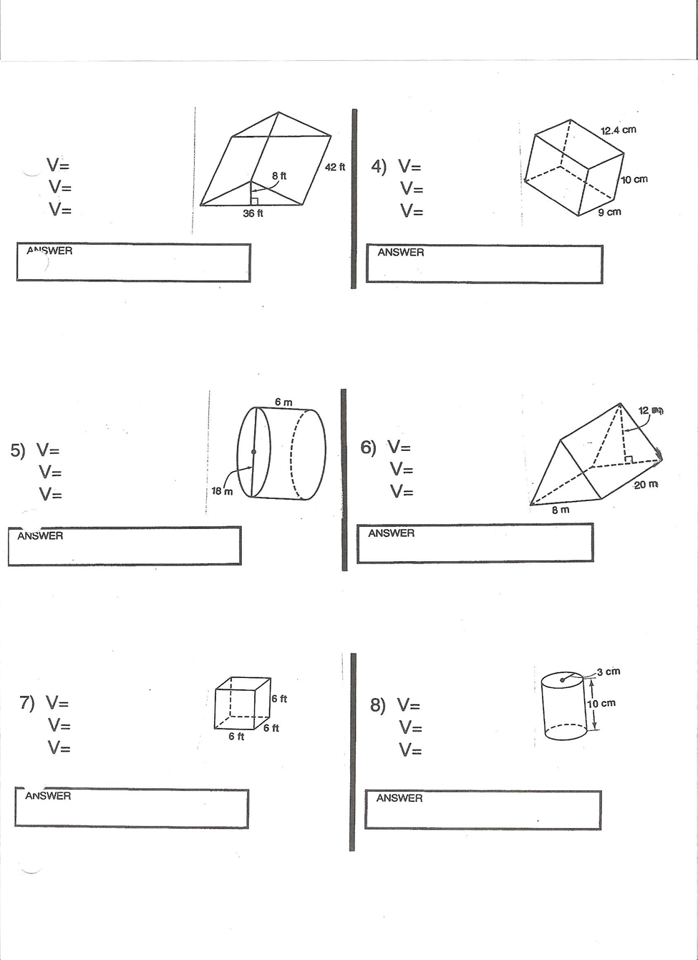
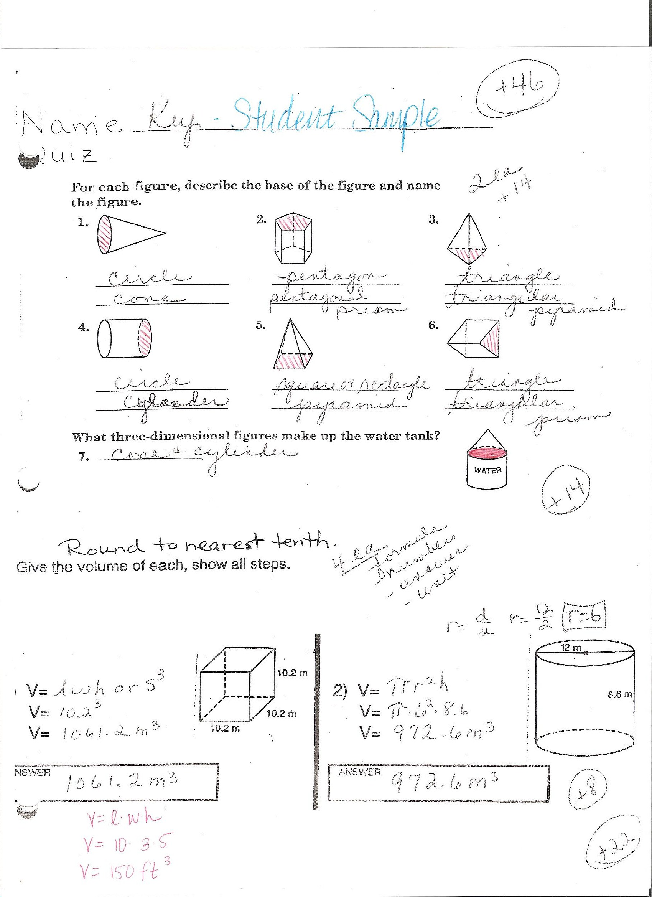
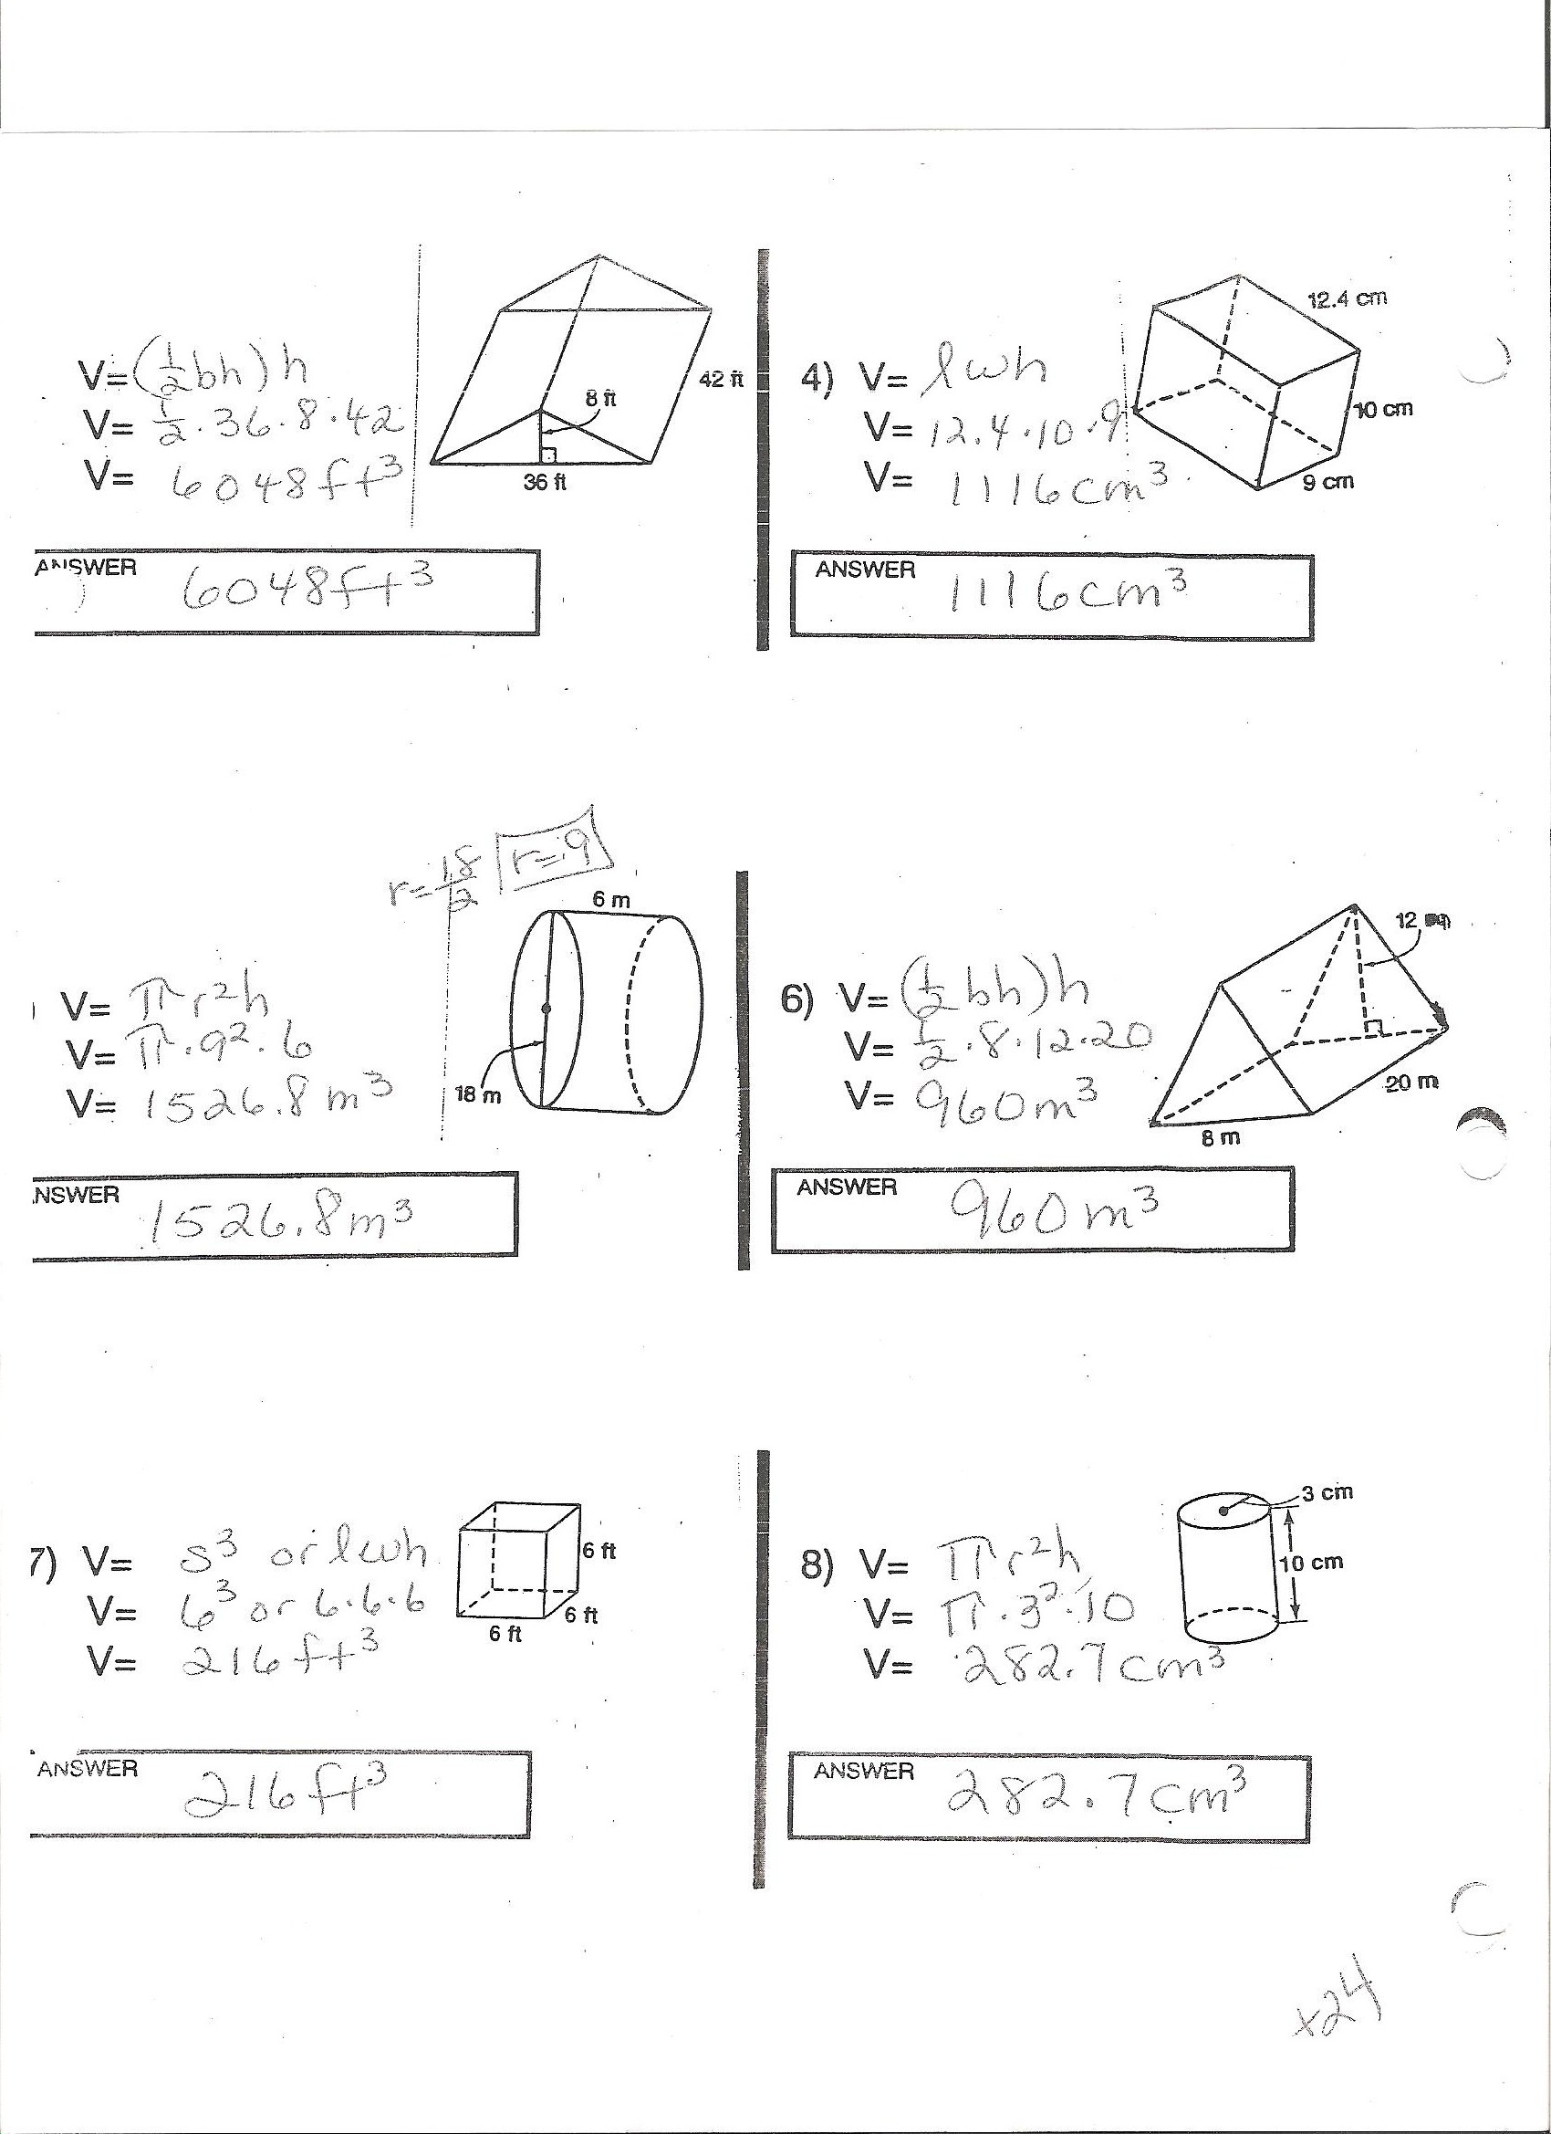
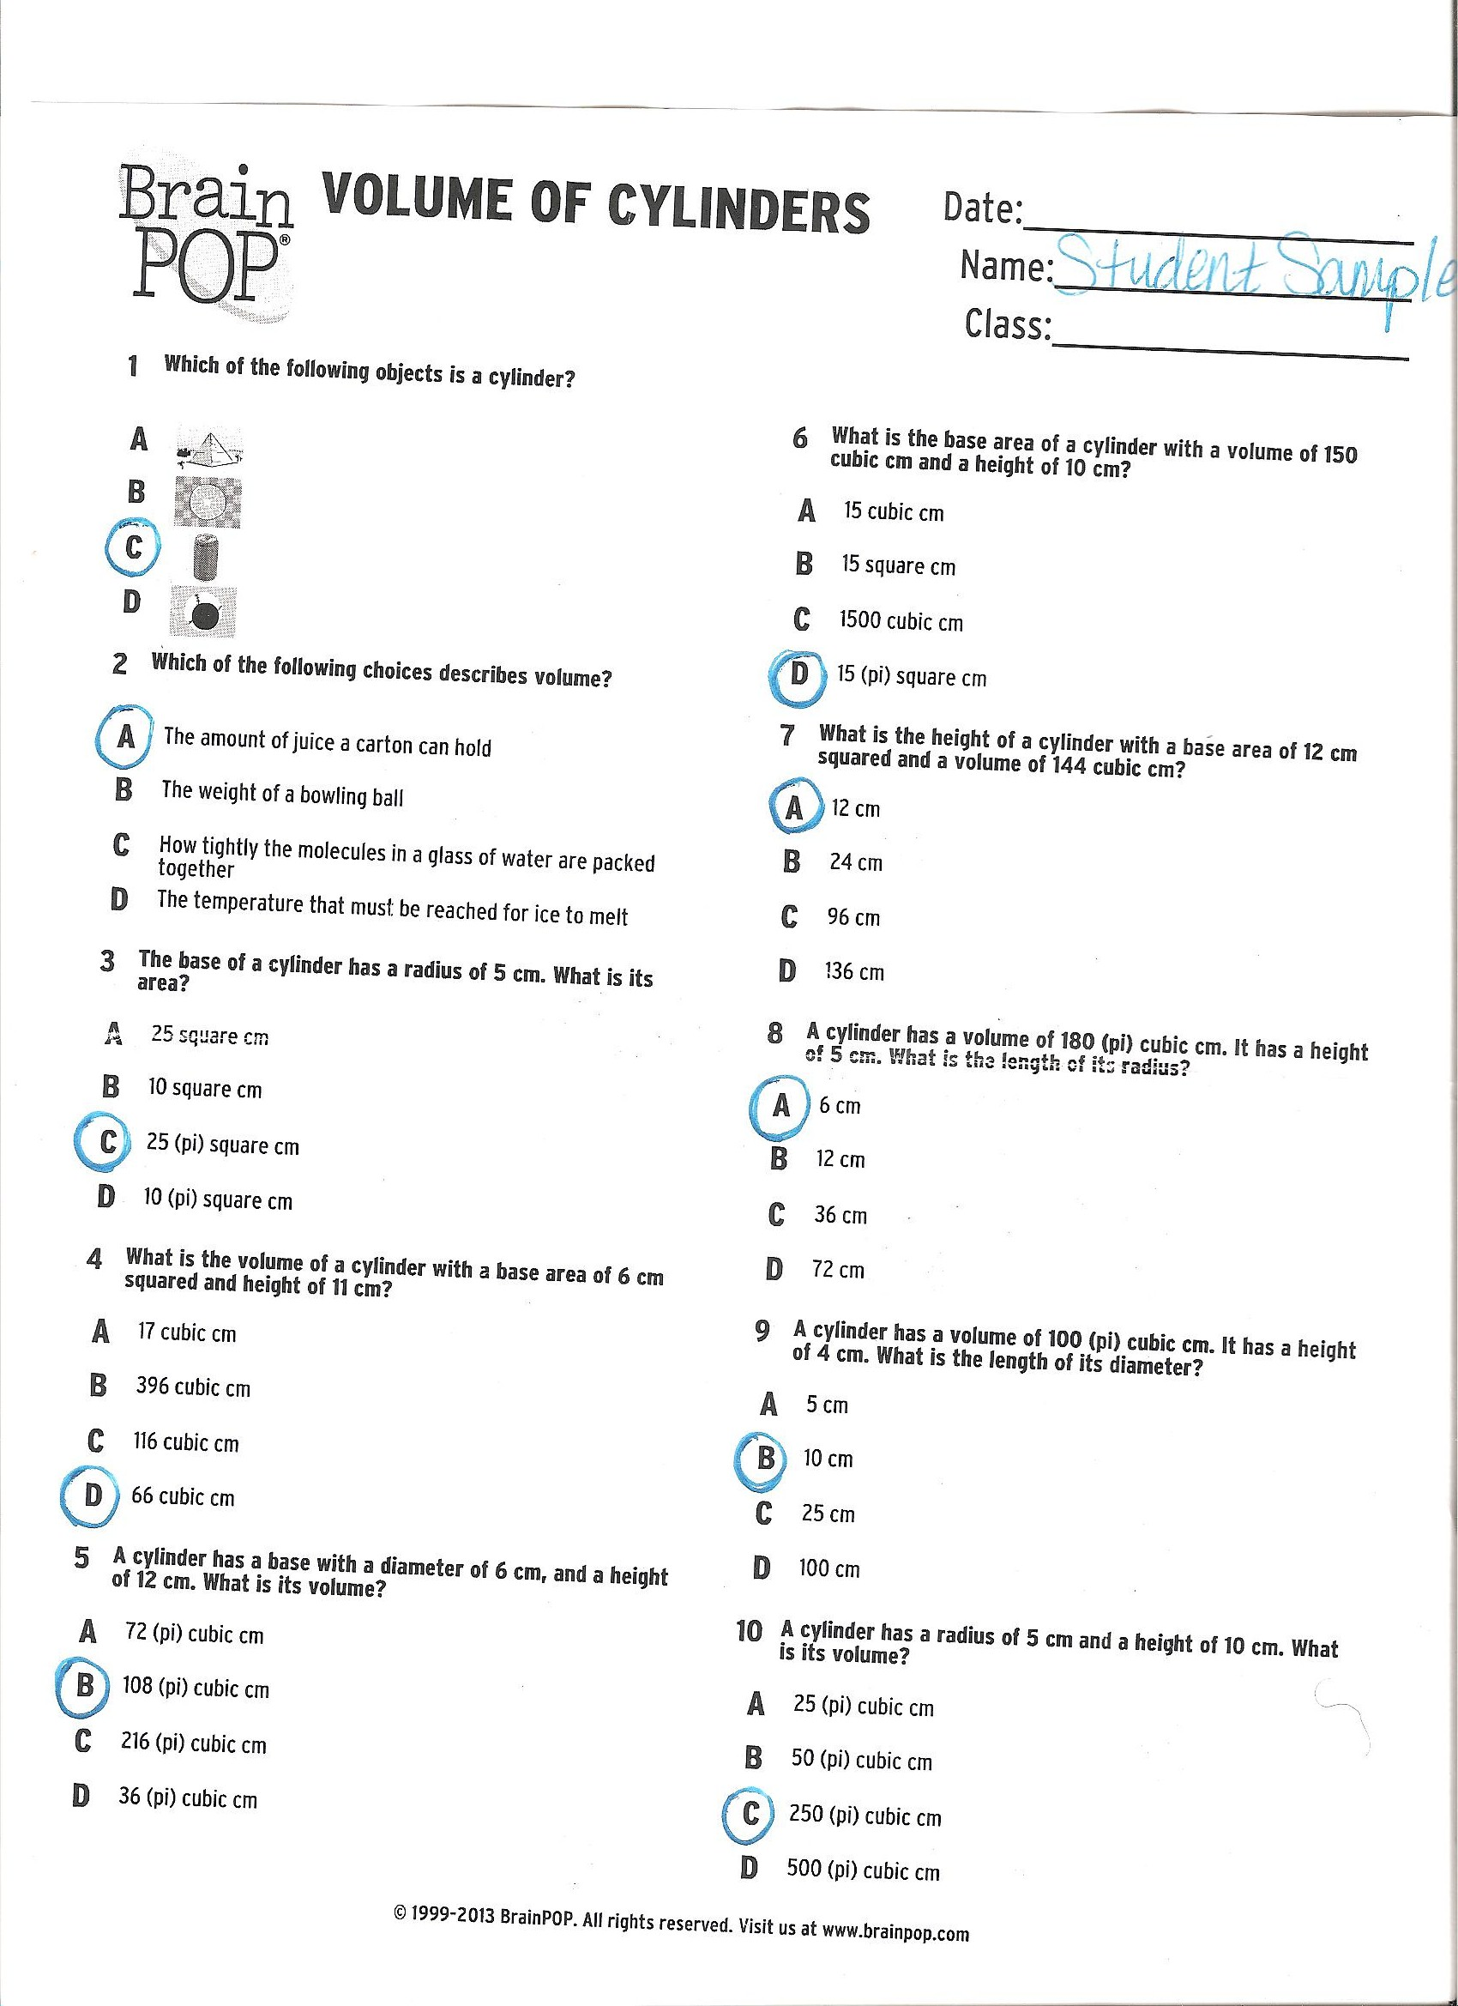
2.
3. http://illuminations.nctm.org/Lessons/Popcorn/Popcorn-AK-Cylinders.pdf

