Who’s Who

@



Discovering the Resources Inside Cadbury Adams

Cadbury Adams’ internal colleagues are specially trained to meet the needs of you, the Field Sales Colleagues. Teams of subject matter experts with highly specialized skills work together each day to ensure that your needs are being met at all times. Every team member is dedicated to the Cadbury Adams goals of 30% Gum Share, Double Digit Sales Growth, and Double Digit Profit Growth. We have developed the following “Who's Who” guide to help you understand the role that each internal colleague plays in your headquarters.

This guide is a tool that helps link Field Sales Colleagues to their internal partners. This quick reference guide provides information about colleagues closely related to the services you need everyday to do your job.

Four groups directly interface with Field Sales Colleagues to support their needs: Customer Business Development, Category Development & Planning, Demand & Inventory Control, and SBS Customer Services. Within each of these groups are sub-elements geared to specific needs.

Customer Business Development
Customer Business Development is an organizational structure that embodies four value-added components that leverage our ability to meet the company growth agenda. These key areas are In-Store Merchandising, Sales Services & Support (formerly known as Sales Ops), Sales Training, and growthMAX. The overall mission of Customer Business Development is to provide Field Sales Colleagues with the support required to make an impact in the marketplace. This means building credibility by contributing leadership and platforms for success in the areas of yearly planning, new item launches, and growing our base business. It also means delivering exceptional customer service through open stock and special pack management.

Our commitment is to boost your productivity by streamlining information—like the recent reduction in Sales Bulletins and notifications—and minimizing administration, as you experienced in TRACC Lite, so you can spend more time with our customers.

Category Development & Planning
Category Development & Planning is an exciting area that used to be known as “Customer Marketing.” The mission of this team is to develop strategic category plans in concert with marketing to include:
- development of category insights and selling platforms for new item launches and existing business,
- work closely with channel directors and channel customer marketing managers to make volume calls, and
- determination of key matrix such as ACV Distribution and forecasting demand.

It also completes the development and execution of our annual planning process with several national account managers and team leaders of regional business. This process helps us identify category-specific opportunities resulting in programs and merchandising that meet customer expectations. The agenda of deliverables also includes a shared responsibility in the delivery of our annual plan and Key Performance Indicators (KPI). We are fortunate to have a partner like Interscope to assist us in our category-development agenda for the organization.

Demand and Inventory Control
Demand & Inventory Control optimizes the fulfillment of demand in the time period when supply is effectively fixed. Members of this team monitor actual performance to plan and communicate or intervene when necessary. They manage abnormal demands and act as daily liaisons with the Sales force and Master Scheduler to maintain the plans as “current.” Demand control works in the near term time frame to eliminate noise, provide stability, and enable conformance to demand and supply plans.

SBS Customer Services
SBS Customer Services is located in Plano, Texas; it serves as the point of contact for order process, validation of correct pricing and terms, track and trace of shipments, collections of Accounts Receivable, and resolution of returns. While it is located in a different state, state-of-the-art technology and systems allow for instant resolution on problems that Field Sales Colleagues may face by working together with Sales Services & Support and Demand and Inventory Control.

The following guide is organized by group, name, title, description, question that may be posed to this colleague, and telephone extension.

Customer Business Development

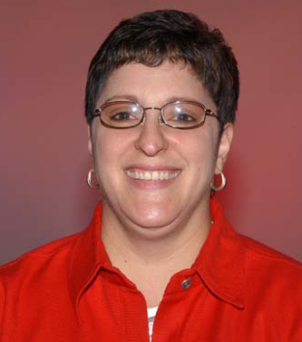

Dena Clem

VP, Customer Business Development
Responsible for the leadership and management of the Headquarter-based office Sales support functions for the US including In-Store Solutions, Sales Services & Support, Sales Training, and Trade Strategy (i.e. growthMAX).
Q: How can I get my team to implement new growthMAX strategies effectively at their customers?
Ext: 2922

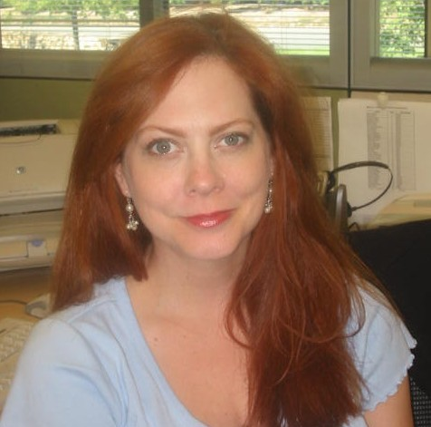
L’Aura Goldner

Administrative Assistant
Provides direct administrative support to VP, Customer Business Development and the Customer Business Development team. This includes scheduling and technical support
Q: Where do I get a template for a vacation planner?
Ext: 2287

In-Store Solutions

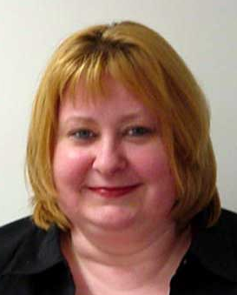

Mary Westerhaus

Team Leader, In-Store Solutions (merchandising & marketing)
Leads the vision and the team that creates and executes all in-store merchandising, including pre-packs, semi-permanent racks, permanent racks, POP across all categories
Q: How do we create more flexible merchandising for our customers?
Ext. 2341



Greg Cooper

Merchandising Manager Permanent

Leads the development and execution of high-impact cost-effective national permanent merchandising focused on delivering Cadbury-Adams business strategies. Greg is responsible for designing, budgeting and inventory control related to all aspects of permanent merchandising encompassing all categories, Gum, Mints, Candy & HALLS.

Q: How do I best leverage permanent displays at my customer?
Ext. 2863



Alice Moore

Merchandising Project Manager – Specialist
Overseas all merchandising transactions with the Resolve fulfillment center. Alice provides all details associated with permanent displays available in Resolve. She is responsible for the development of custom racks.
Q: How do I order a Z5068 permanent rack?
Ext. 2138

Christine Squillante

Merchandising Manager Temporary
Develops and execute high-impact cost-effective pre-packs merchandising focused on delivering Cadbury-Adams business strategies. Christine is responsible for initiating, managing and executing the design of all national pre-pack displays encompassing all categories, Gum, Mints, Candy & HALLS.

Q: What are the national counter unit offerings?
Ext. 2615



Angelica Fillion

Merchandising Analyst
Collaborates with brand, finance, operations and vendors in the pre-pack process, from design to analysis (formerly special packs). Angelica overseas all the pre-pack details including tech specs and jpeg images. She is responsible for the development of custom pre-pack displays.
Q: What are the parameters to create a custom pre-pack ?
Ext. 2912


Bruce Pye
Graphics Manager, In-Store Solutions
Responsible for managing art work from design to production for temporary displays, permanent racks, POP, event signage, brochures, in-ad coupons, premiums, trade shows and sales meetings. Send sales graphic request directly to Bruce. Reporting directly to Bruce is Peter Folz.
Q: How do I submit an account specific graphics request?
Ext. 2012

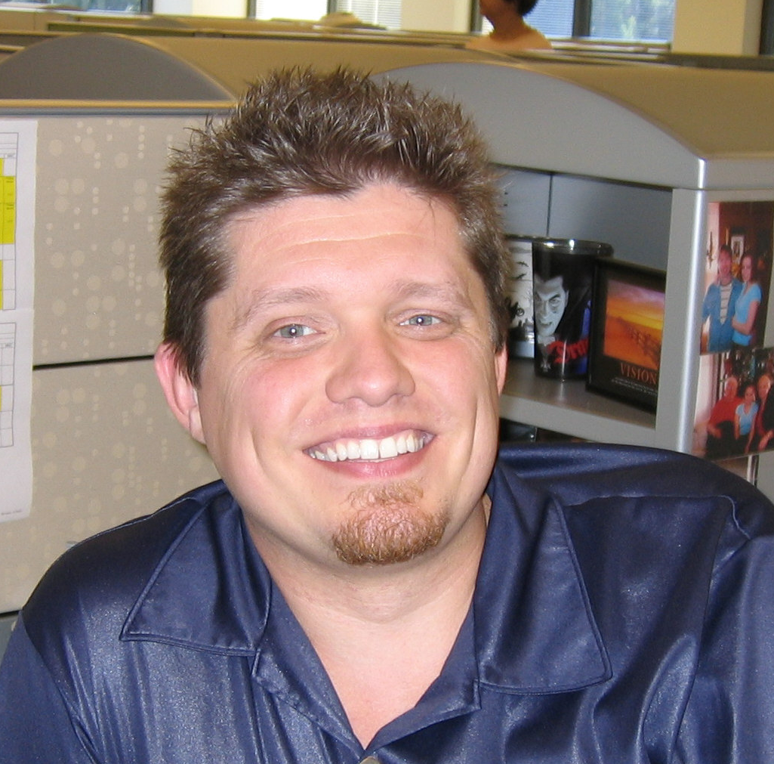Peter Folz

Graphic Specialist, In-Store Solutions
Responsible for graphic design for temporary displays, permanent racks, POP, event signage, brochures, in-ad coupons, premiums, trade shows and sales meetings.
Q: When can I expect that my graphic request will be completed?
Ext. 2557

Sales Service and Support

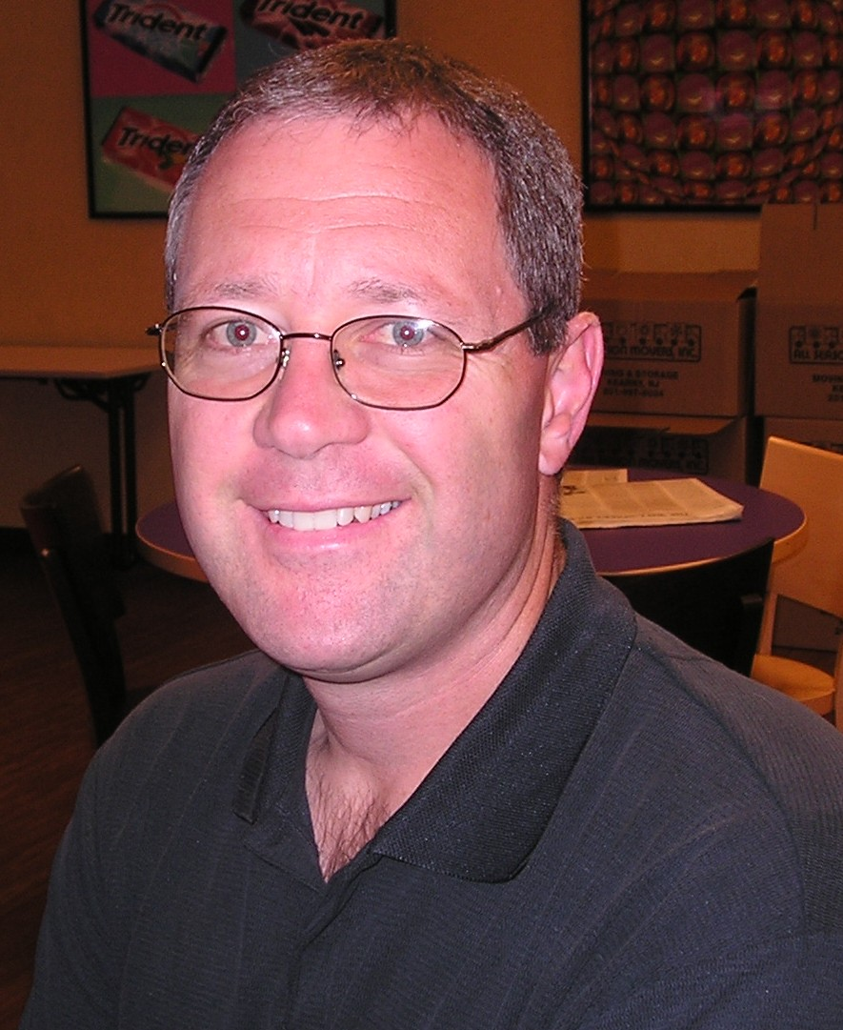
Bill Sofio

Director, Sales Services and Support

Liaison between cross-functional areas of Sales, SBS Customer Services, and Customer Logistics. Responsible for defining business requirements including platform management of TRACC, KnowledgShare, SAP, etc., the management and development of sales policies, procedures, and processes and the effective communication of sales materials.

Q: How does growthMAX impact TRACC?
Ext. 2738

(Sales Communications)

VACANT

Manager, Sales Communications

Oversees all aspects of Sales Communications group. Investigates and proposes key changes to communication platforms (e.g. KnowledgeShare, TRACC). Plans and organizes all aspects of National Sales Meetings/Regional Road Shows/Overachievers Meetings.
Q: How do I get a message out to the entire sales force?
Ext.

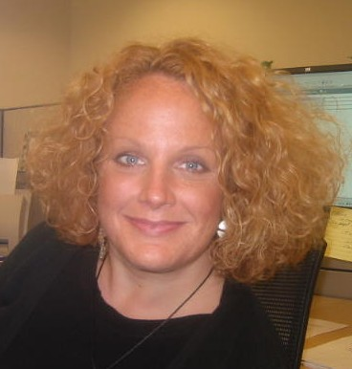Melissa Batchilder

Editor/Communications Specialist
Responsible for end goal of communication development, editing, and publication across all categories (e.g. Gum, Mints, Candy, Halls.) Assists in all written communication projects including bulletins, presentations, and customer letters. Manages all material in KnowledgeShare under the Reports tab.
Q: Can someone review/edit a letter I'm writing to a customer? Where are the latest selling materials located?
Ext. 2030



Nichole Davidson

Promotional Specialist
Manages national and custom Special Pack programs throughout the promotional process. Creates all national program deal sheets, trade grids, and survey sheets. Manages all material in KnowledgeShare under the Showcases tab.
Q: How can I get a Deal Sheet or Survey Sheet created for a National Program?
Ext. 2836

(Business Solutions)

Alero Ogedegbe

Team Leader, Business Solutions
Manages the process of development and maintenance of the Siebel TRACC system. Oversees the maintenance of Account Master Data in all systems. Manages the rollout of TRACC enhancements to the organization. Oversees all TRACC training for the organization.
Q: I have a new idea for an improvement to TRACC, who can I discuss this with?
Ext. 2556

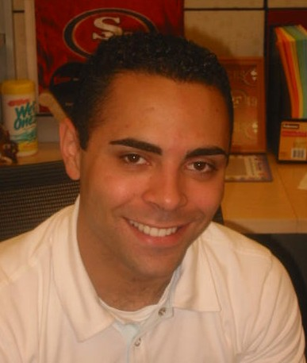Frank Derbin

Associate Manager
Facilitates business solutions—process improvements, systems development, or the definition of new policy/procedure—in conjunction with business and information technology experts.
Q: Is there any type of technology or system to solve ______ ?
Ext. 2151



Karen Marr

Analyst
Develops and facilitates TRACC Training. Researches TRACC projects and supports field sales and internal customers by researching and answering TRACC help desk questions.
Q: Where can I get additional TRACC training on how to create payments?
Ext. 2277


Rajeev Kumar

System Analyst/Data Tester
Validates the TRACC system. Performs trouble shooting for TRACC. Works with IT Team to deal with technical issues. Writes and executes Regression scripts. Consolidates accounts for Baseline and Non Baseline accounts. Validates the shipments in TRACC from Cognos. Validates the Crystal Reports for Account Planning and Forecasting.
Q: How does data move in TRACC?
Ext. 2797

(Sales Administration)



Barb Kinnecom

Manager, Sales Administration
Responsible for all aspects of Policies/Procedures impacting the Sales Force, Reclamation Centers, Universal Solutions, Pricing, EDI/EFT, Management of all aspects of new/core items, gratis goods, 1/2/3 piece, Resolve, Fulfillment
Q: How do I order gratis orders? What is the policy on new warehouses?
Ext. 2834

Mary Blackwell

Administrator, Sales Policies/Procedures
Responsible for administrative responsibilities associated with Sales Policies, Procedures, Samples and Fulfillment.
Q: What premiums are available? Can you add me to the Distribution List to receive Bulletins/mailings?
Why am I not receiving voice mail broadcasts?
Ext. 2271



Karla Martinez

Pricing Specialist
Responsible for the data entry of all pricing/price changes into the system. Validates pricing with SBS on key promotions/customer orders and special packs. Works closely with Sales Administration Manager to ensure that all pricing strategies and tactics are analyzed before inputs are made into the system.
Q: Is this the latest price list?
Ext. 2918


Patti Florio
Sales Specialist
Responsible for assisting with the distribution of sales samples. Coordinates Category Development in the maintenance of inventory at Resolve Corp. Updates and maintains colleague information in TRACC on a daily basis as changes arise. Initiate requests for Sales District / Territory Description Changes to the help desk for update in SAP.
Q: How do I get sales samples?
Ext. 2735

Sales Training



Dave Morell

Director, Sales Training
Responsible for driving long-term skill development within the company. Designs skill development strategy for the sales organization across both HQ selling colleagues and Retail services (including broker colleagues). Defines long-term skill development curriculum to drive ongoing colleague training. Leads development of ongoing sales training programs to address organizational skill gaps. Executes specific sales training programs in line with long-term curriculums.
Q: How can I help my team strengthen its skill sets? How can our team work better together to deliver on our contract?
Ext. 2247



Abby Katoni

Sales Training Manager
Co-development of training curriculum, course development and instruction, results measurement, training liaison to the following teams: customer business development, trade development, Wal*Mart.
Q: What is a good way to educate colleagues about changes in our system?
Ext. 2538

Sales Training Manager
Co-development of training curriculum, course development and instruction, results measurement, training liaison to the following teams: customer business development, trade development, Wal*Mart.
Q: Can someone help me with instructional design?
Ext. 2046

Category Development and Planning

Steve McGowan

Director, Category Development and Planning
Responsible for the leadership and development of the Category Development organization. Drives the development of category trade strategic plans in concert with Brand Directors including new item launches, selling stories, merchandising strategies and research initiatives. Develops annual planning process and the annual category/segment trade plans including merchandising, co-marketing and FSI strategies.
Q: Where can I locate the 2006 selling tools and who can review these with me?

Ext. 2430

Steve Zoellner

Team Lead, Gum & Mint
Provides strategic direction on trade programming, delivers category and consumer insight, provides sales planning direction and represents Sales in the development of Marketing strategies and implementation tactics for gum/mint business.
Q: What new gum & mint item information do we have to share with our customers?
Ext. 2860

VACANT
Brandon Kahler
Associate Category Development Manager, Dentyne
Assists the team leader in providing strategic direction on trade programming, delivers category and consumer insight, provides sales planning direction and represents Sales in the development of Marketing strategies and implementation tactics for the Trident business.
Q: What are the new Dentyne Items in 2006? How can the programs and products for these brands impact my category?
Ext. 2205

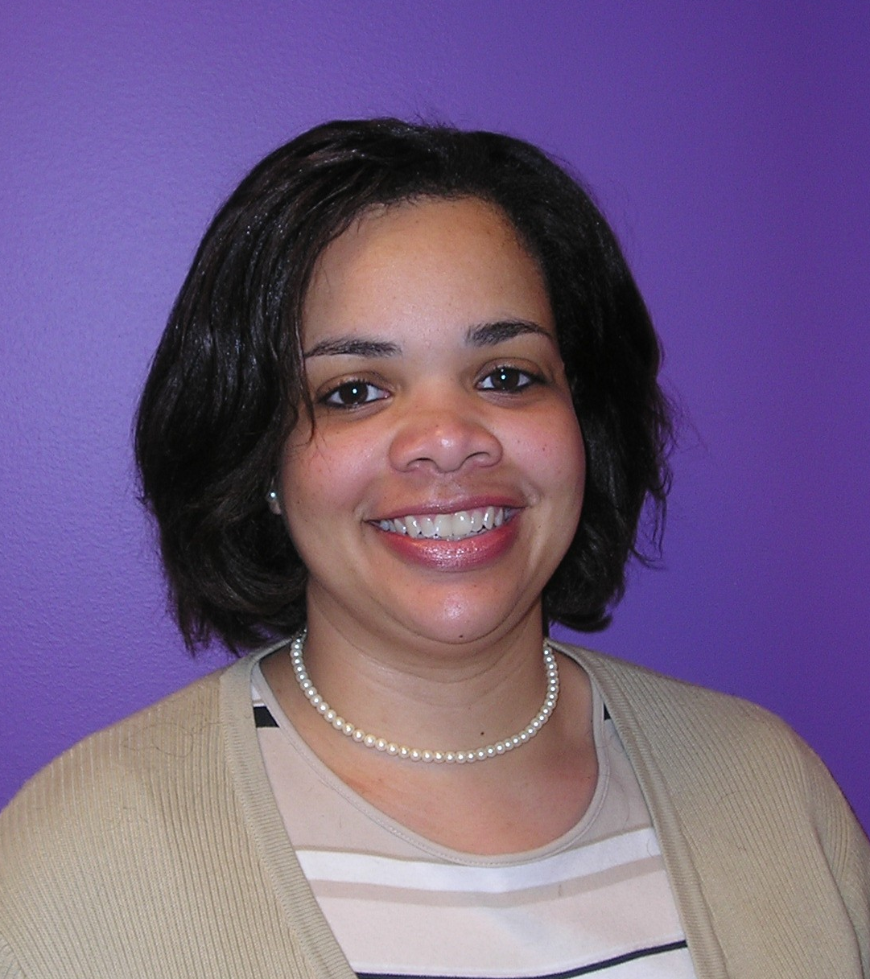
Jeanine Ware

Associate Category Development Manager, Trident/Certs/Heritage
Assists the team leader in providing strategic direction on trade programming, delivers category and consumer insight, provides sales planning direction and represents Sales in the development of Marketing strategies and implementation tactics for the Dentyne and Heritage brands business.
Q: What are the 2006 Trident, Certs, and Heritage Brands programs and new products? How can the programs and products for these brands impact my category?
Ext. 2154



Ken Duer

Team Leader, Futures
Provides strategic direction on trade programming, delivers category and consumer insights, provides sales planning direction and represents Sales in the development of Marketing strategies and implementation tactics for future business enterprises.
Q: What is our activation plan to support future launches?
Ext. 2718



Christine Briganti
Associate Manager, Category Marketing
Assists the team leader in providing strategic direction on trade programming, delivers category and consumer insight, provides sales planning direction and represents Sales in the development of Marketing strategies and implementation tactics for futures business.
Q: Who do I call to explore a sales or marketing opportunity for our Futures business?
Ext. 2718



Craig Olkiewicz

Team Leader, Halls
Provides strategic direction on trade programming, deliver category and consumer insight, provides sales planning direction and represents Sales in the development of Marketing strategies and implementation tactics for the Youth & Fun business.
Q: How can I get the new Halls samples?

Ext. 2156



Brian Cipoletti

Associate Manager, Youth & Fun
Assists the team leader in providing strategic direction on trade programming, delivers category and consumer insight, provides sales planning direction and represents Sales in the development of Marketing strategies and implementation tactics for the Youth & Fun business.
Q: What new merchandising events are we planning for Youth & Fun in 2006?
Ext. 2076


Marty Okner

Team Leader, Halls
Provides strategic direction on trade programming, deliver category and consumer insight, provides sales planning direction and represents Sales in the development of Marketing strategies and implementation tactics for the Halls business.
Q: What is the selling story behind this new item?
Ext. 2181


Mike Lucey

Associate Manager, Halls
Assists the team leader in providing strategic direction on trade programming, deliver category and consumer insight, provides sales planning direction and represents Sales in the development of Marketing strategies and implementation tactics for Halls business.
Q: What are the trade plans for 2006?
Ext. 2195



Mark Rubenstein

Manager, Data Solutions
Provides Category Development and Customer Marketing teams with key fact-based data requirements and analytical support. Responsible for DataAlchemy-based KPI.
Q: How do I use existing DataAlchemy reports and presentations?
Ext. 2674

growthMAX

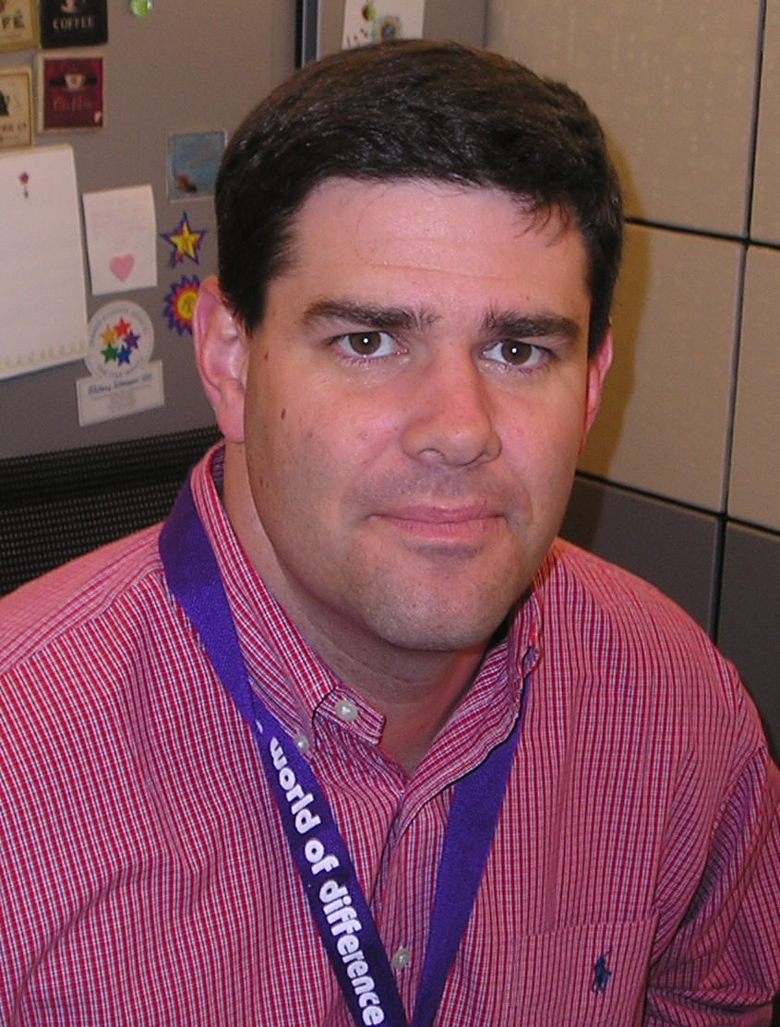

Andrew Capron

Team Lead, growthMAX
Responsibilities include the overall leadership of growthMAX, which has defined a new go-to-market strategy with our trade funds. Works with technical support to ensure IT systems are in place to enable an accrual-based trade funding approach and supporting the continuous development of our colleagues via skill building initiatives.
Q: How was my trade rate established and what will I need to use my trade funds to cover?
Ext. 2755



Chris Fesen

Project Manager, growthMAX
Responsible for managing the overall planning, coordination, delivery and execution of the growthMAX project.
Q: How will growthMAX fuel Cadbury Adams’ growth next year and beyond? How will growthMAX impact my customer?
Ext. 2891

Customer Marketing Managers

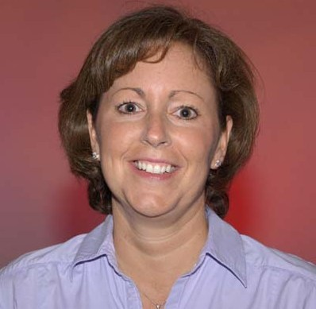
Lori Havilland

Customer Marketing Manager – Convenience
Executes business initiatives that are aligned to Brand Strategy. Recommends investment required at the channel level to achieve annual sales objectives Coordinates the strategic planning process (trade plans) between Customer Marketing and field. Drives account planning process. Understands channel needs and respond with strategic channel specific solutions. Supports account teams to penetrate accounts past the buyer: promotions and operations departments. Manage account specific special pack requests through the approval process.
Q:
Ext: 2218

Nancy Zeidenberg

Customer Marketing Manager – Food
Executes business initiatives that are aligned to Brand Strategy. Recommends investment required at the channel level to achieve annual sales objectives. Coordinates the strategic planning process (trade plans) between Customer Marketing and field. Drives account planning process. Understands channel needs and respond with strategic channel specific solutions. Supports account teams to penetrate accounts past the buyer: promotions and operations departments. Manage account specific special pack requests through the approval process.
Q:
Ext:2690

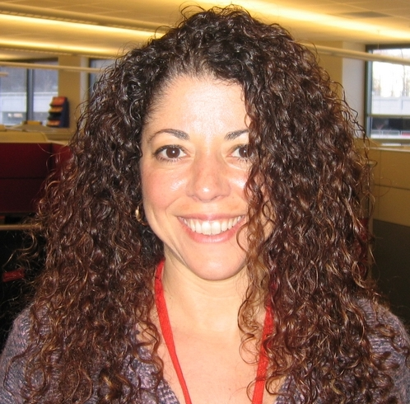
Christine Velez

Customer Marketing Manager – Drug/Mass
Executes business initiatives that are aligned to Brand Strategy. Recommends investment required at the channel level to achieve annual sales objectives. Coordinates the strategic planning process (trade plans) between Customer Marketing and field. Drives account planning process. Understands channel needs and respond with strategic channel specific solutions. Supports account teams to penetrate accounts past the buyer: promotions and operations departments. Manage account specific special pack requests through the approval process.
Q:
Ext: 2069

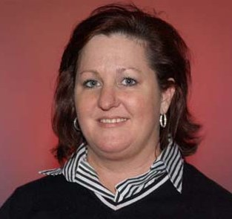
Karen Mitchell

Customer Marketing Manager – Special Markets
Executes business initiatives that are aligned to Brand Strategy. Recommends investment required at the channel level to achieve annual sales objectives. Coordinates the strategic planning process (trade plans) between Customer Marketing and field. Drives account planning process. Understands channel needs and respond with strategic channel specific solutions. Supports account teams to penetrate accounts past the buyer: promotions and operations departments. Manage account specific special pack requests through the approval process.
Q:
Ext: 2605

Demand and Inventory Control



Nick Fiore

Manager
Oversees the team that determines fulfillment of product demand in the time period when supply is effectively fixed along with any abnormal demands. Liaises with the Sales force and Master Scheduler to maintain the plans as “current.” Leads the team in the near term time frame to eliminate noise, provide stability, and enable conformance to demand and supply plans.
Q: Is there enough product available to meet my order?
Ext. 2345

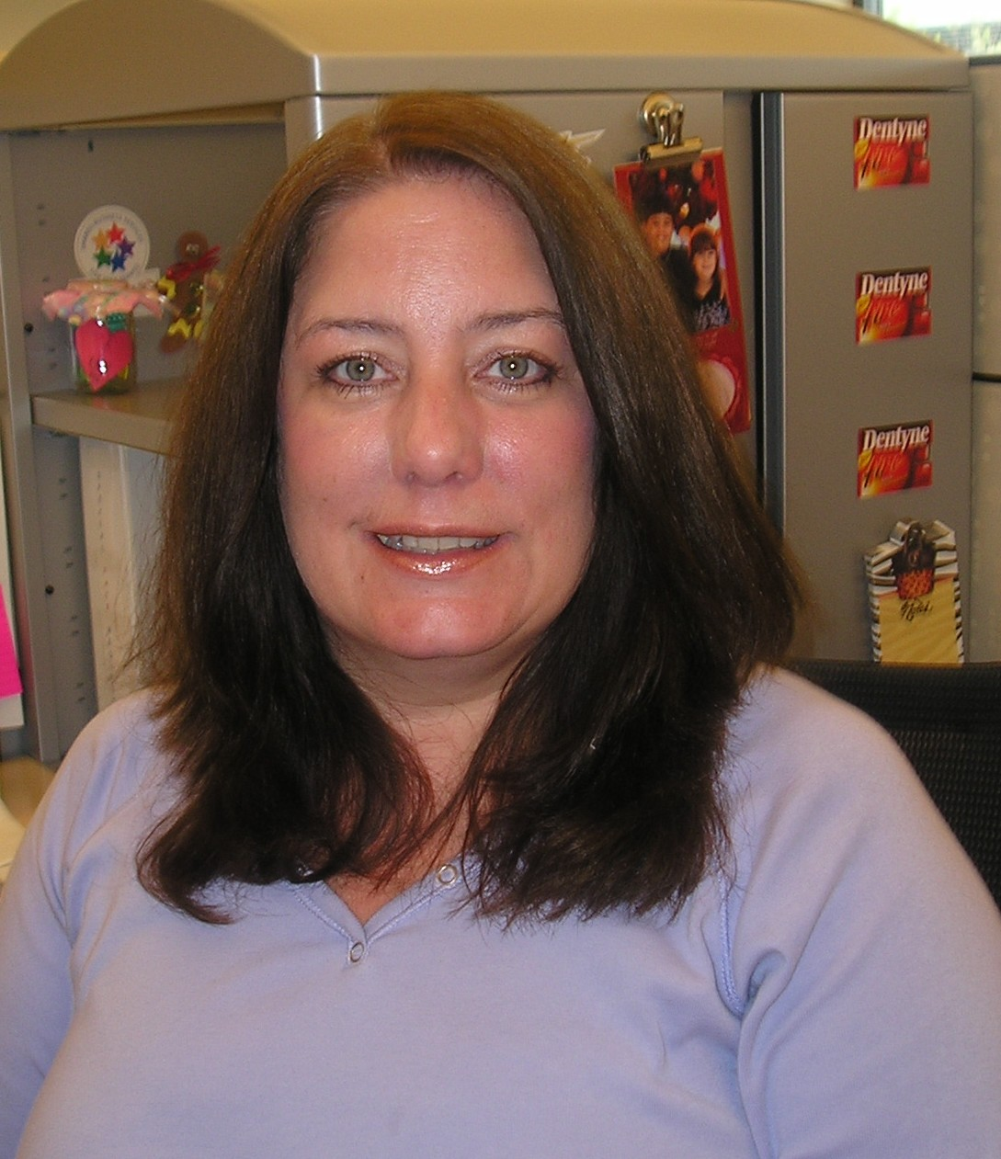

Jannie Hartmann

Analyst, Gum/Mint
Determines fulfillment of Gum/Mint demand in the time period when supply is effectively fixed along with any abnormal demands. Liaises with the Sales force and Master Scheduler to maintain the plans as “current.” Works in the near term time frame to eliminate noise, provide stability, and enable conformance to demand and supply plans.
Q: Is there enough Trident available to meet my order?
Ext. 2544



Sharon Rosado

Anaylst, Youth & Fun
Determines fulfillment of Candy demand in the time period when supply is effectively fixed along with any abnormal demands. Liaises with the Sales force and Master Scheduler to maintain the plans as “current.” Works in the near term time frame to eliminate noise, provide stability, and enable conformance to demand and supply plans.
Q: Is there enough Swedish Fish available to meet my order?

Ext. 2382



Scott Struble

Analyst, Halls
Determines fulfillment of Halls demand in the time period when supply is effectively fixed along with any abnormal demands. Liaises with the Sales force and Master Scheduler to maintain the plans as “current.” Works in the near term time frame to eliminate noise, provide stability, and enable conformance to demand and supply plans.
Q: Is there enough Halls available to meet my order?
Ext. 2936

SBS Customer Services

Judy Laughlin
Team Lead
Develops and directs long-range plans of the Shared Business Services Customer Services function. Oversees the transactional aspect of Order Management, Proof of Delivery (POD), Billing, and Collections and Deduction Management and Customer Master Data accuracy.
Q: What are the lon- range plans for ensuring our credibility in this area?
Ext. 972-673-6607

Kate Haulton
Customer Services Manager
Accountable for the overall management of a customer service team. This includes selection, training & development, performance management, salary recommendations, employee relations, etc.
This position is to implement the strategy as developed by the C2C process owner (Supply Chain) to meet the needs of the commercial agenda.
Q:I’m having difficulty with a particular CSR–can you help?
Ext: 972-673-4686

Jennifer Jones

Director, Customers Services, Finished Goods & Confectionery
Manages the activities of the Customer Service management staff and CSRs in regards to processing sales orders, managing logistics, and collections.
Q: I’m having some difficulty locating an order, can you direct me?
Ext.: 972-673-7421

