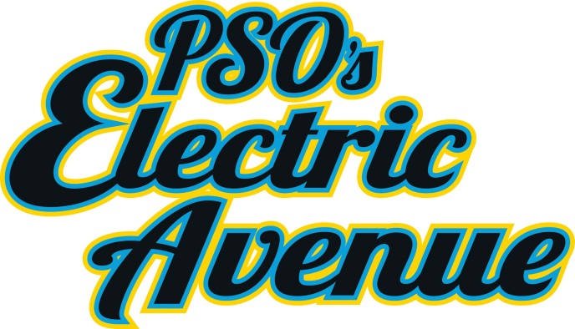
Matt DeRycke
(918)605-3179
mderycke31@yahoo.com

PSOklahoma.com/save
September 26, 2012

Tulsa State Fair holds PSO’s Electric Avenue
People can learn about energy, saving the environment and using energy more wisely

WHAT: PSO’s Electric Avenue at the Tulsa State Fair
WHEN: Tues. Oct. 2- Sun. Oct. 7.
WHERE: QT Center, Lower Level
WHO: PSO Oklahoma
TULSA, Okla.- The Tulsa State Fair will be hosting PSO’s Electric Avenue this year.
Fair goers will be able to come and walk around and enjoy interactive displays like the wind turbine, working solar panels, a sun-light powered car, a battery-powered motorcycle and a geothermal home.
You may even get a chance to meet PSO’s spokesbug, Louie the Lightning Bug!
There will be opportunities to make your Energy Star Effinciency Pledge and get cool stuff, and PSO customers will have a chance to win free HD TV.
PSO’s Electric Avenue makes learning about saving energy, money, and our environment fun.

-30-

