From December 5th to the 10th, 250 packages (Cookie Bombs), each containing two cookies were delivered to 250 students. Each package or Cookie Bomb contained a paper label directing the students to Nex-Tech’s Twitter page through scanning a QR code or manually visiting the page. If a student tweeted about the event, he/she was put in a drawing to win one of five free FHSU hoodie sweatshirts. In order to be considered for the contest prize, each tweet must’ve contained “@Nex-Tech” and “#cookiebomb.” Out of the 250 students that received a Cookie Bomb, 10% responded by tweeting, being considered for the contest prize, and 11% of those that tweeted, tweeted more than one time on the issue.
In this chart, a “response” is defined as a tweet that is originally written and posted by the individual user. This does not take Retweets into account, but does count pictures being posted and simple tweets containing the only two necessary requirements of the tweets, “@Nex-Tech” and “#cookiebomb.”
Date | # Responses | # New People that Responded | # New Follows to Nex-Tech's Twitter page | Activity/Location of Cookie Bombing:
12/5/2012 | 9 | 9 | 4 | 2 consecutive mornings of delivering to 2 separate classes, Wednesday and Thursday
12/7/2012 | 14 | 11 | 5 | Delivered to random students walking to classes on Friday morning (8 am), the last day of real classes before finals
12/10/2012 | 8 | 7 | 3 | Delivered to all students within Forsyth Library

# People that Responded More than Once | 3
# Retweets | 1
# Pictures shared | 1
Total # of Responses | 31
Total # of People that Responded | 27
Total # of Cookie Bombs | 250

Date | # Responses | # People that Responded | Activity/Location of #cookiebombing:
12/5/2012 | 9 | 9 | 2 consecutive mornings of delivering to 2 separate classes, Wednesday and Thursday
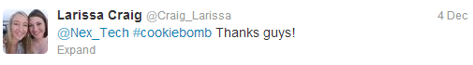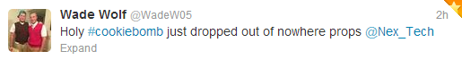
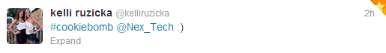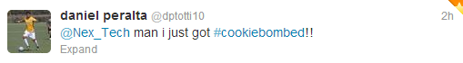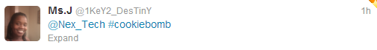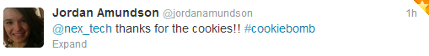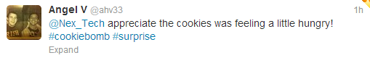

Date | # Responses | # People that Responded | Activity/Location of #cookiebombing:
12/7/2012 | 14 | 11 | Delivered to random students walking to classes on Friday morning (8 am), the last day of real classes before finals

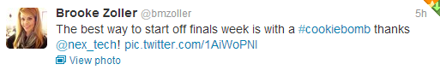
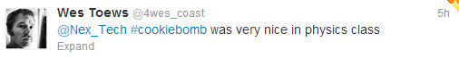
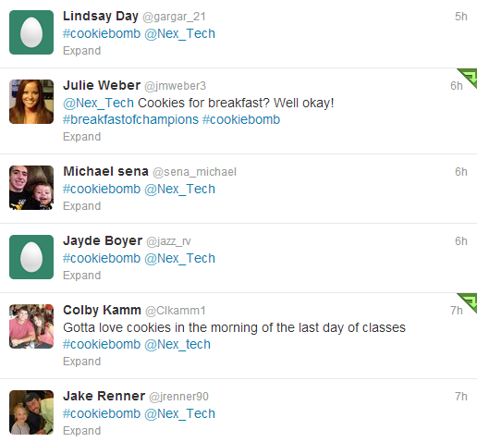
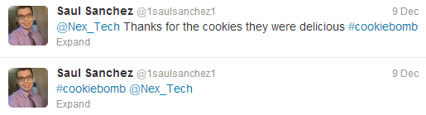
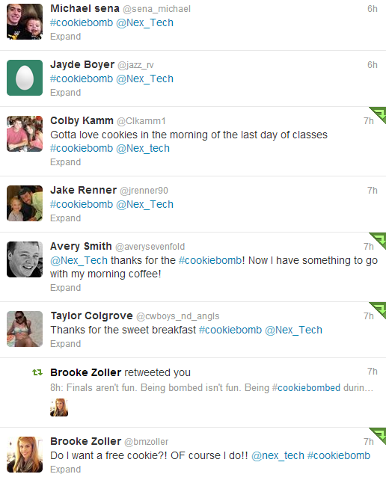

Date | # Responses | # People that Responded | Activity/Location of #cookiebombing:
12/10/2012 | 8 | 7 | Delivered to all students within Forsyth Library

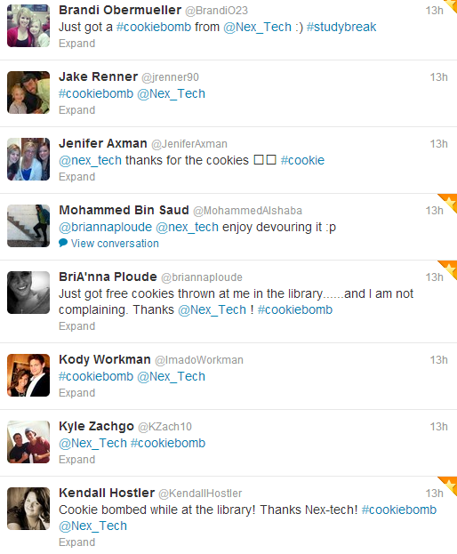

Tweets on winning the FHSU hoodie: (Not accounted for in results above)
