Handouts/Assessments/Evaluations/

Hamburger Template: http://www.writingfix.com/PDFs/Writing_Tools/Hamburger_Paragraph_Template.pdf

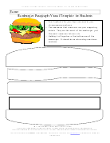

Student Evaluation: Panda Paragraphs

Name____________________________

What was your favorite part of the lesson?

What was your least favorite part?

Did the Hamburger Template help you write paragraphs? Explain.

Did the topic interest you?

What is one thing that you would change or do differently?

Was any part of the lesson or essay confusing to you? If so, explain.

Circle the best answer:

Did I pay attention and listen to all directions? Always Sometimes Never

Did I use my time wisely when researching? Always Sometimes Never

Did I use appropriate websites and suggested links? Always Sometimes Never

Did I ask questions if I was confused? Always Sometimes Never

Did I do my best in all parts of this lesson? Always Sometimes Never

Comments:________________________________________________________________________________________________________________________________________________________________________________________________________________________________
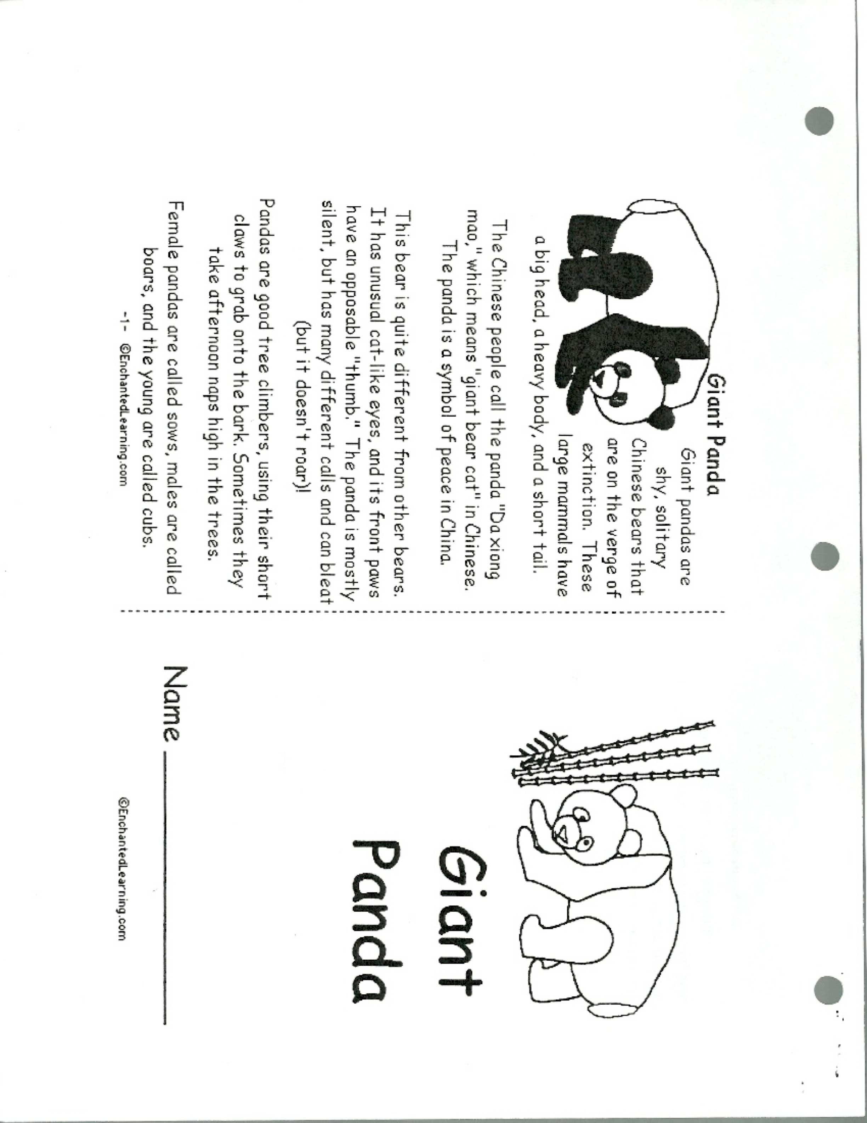
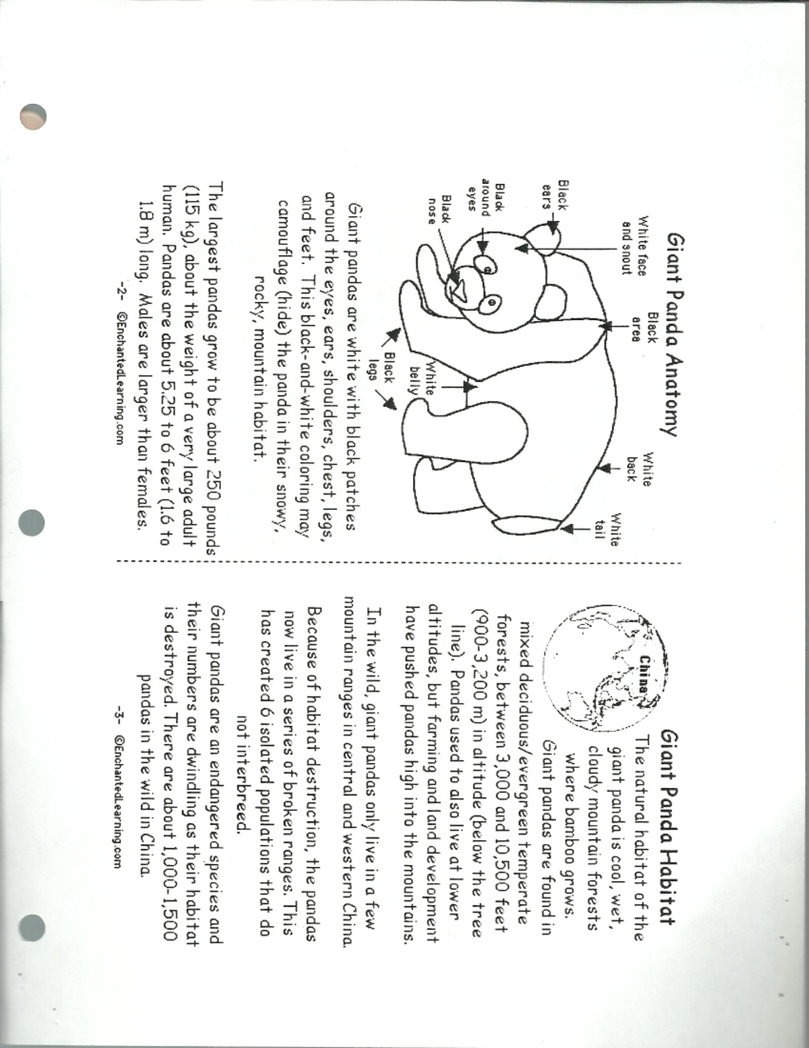
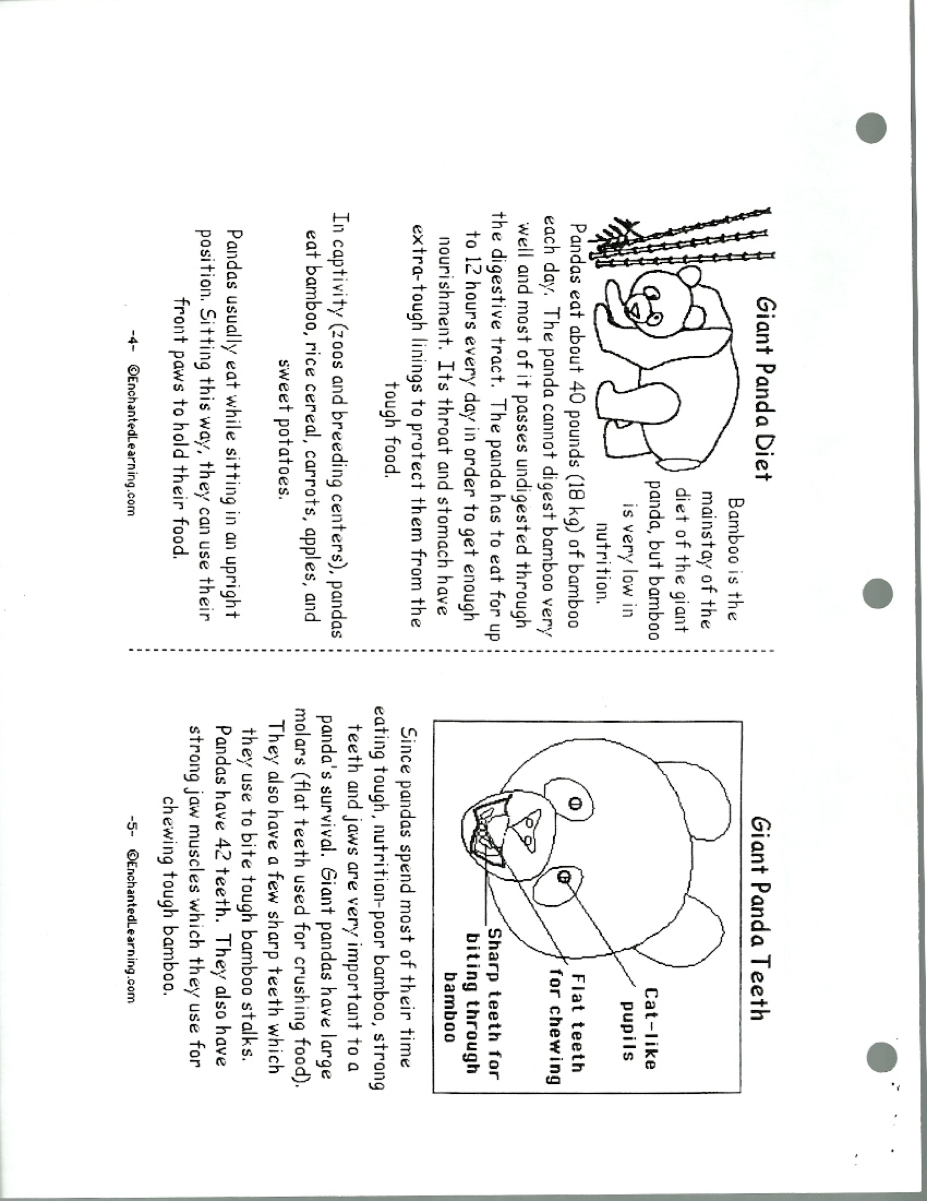
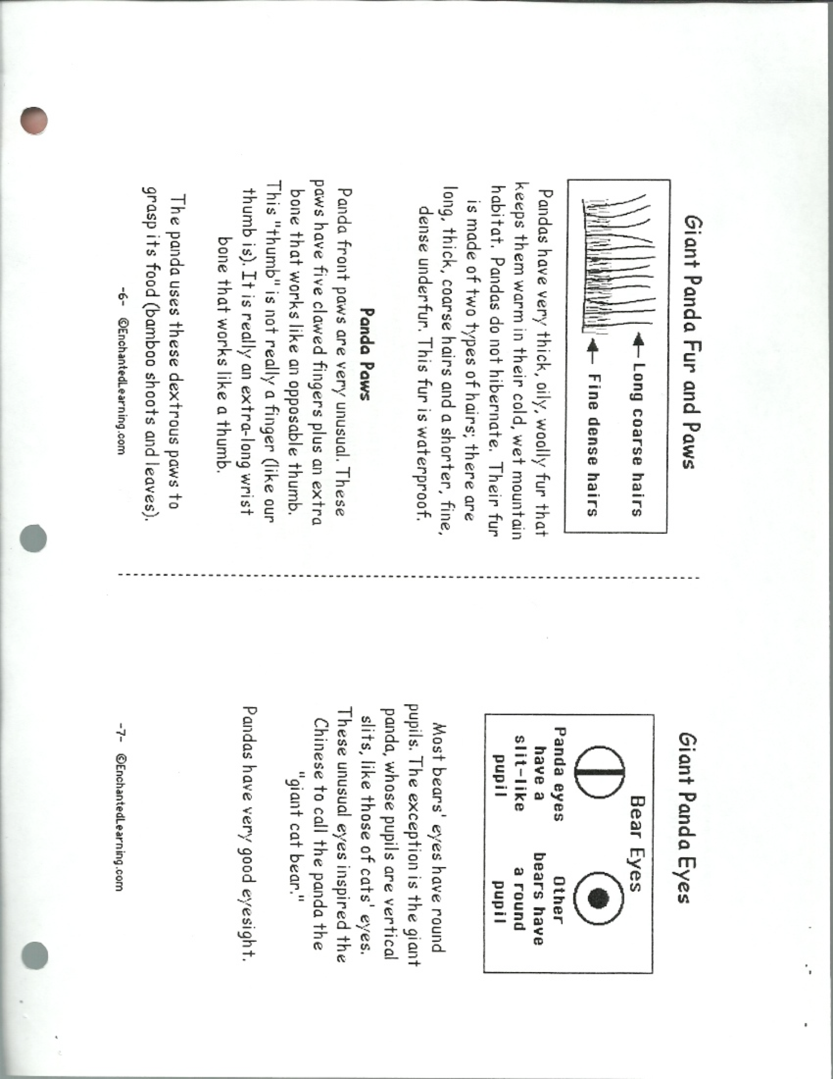
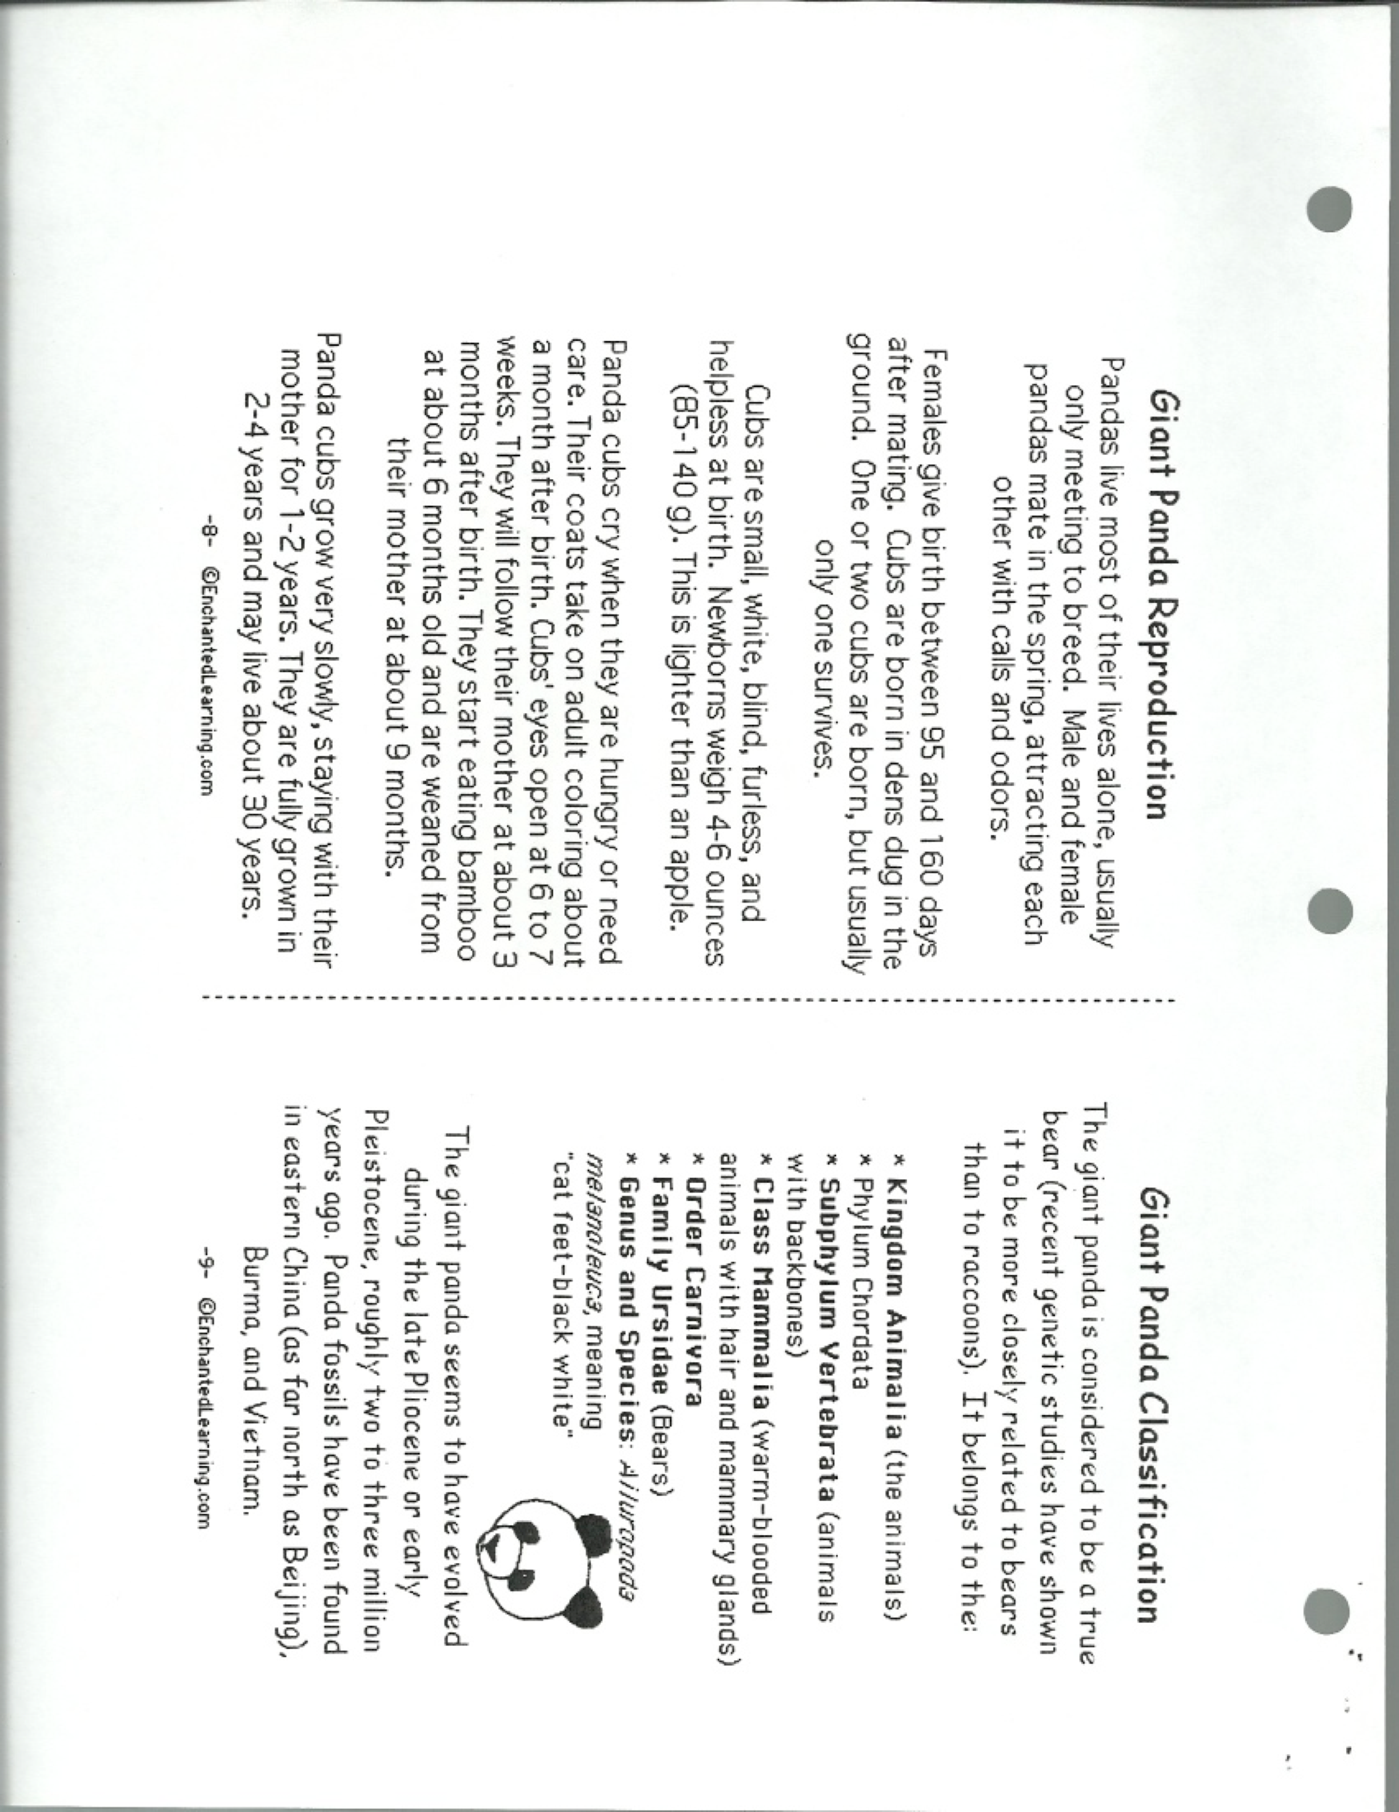

Brick for Assessment

CATEGORY | 4-Excellent | 3-Good/Satisfactory | 2-Needs Improvement | 1-Unsatisfactory
Organization | Information is very organized with well-constructed paragraphs and subheadings. (5 paragraphs-Introduction, 3 body paragraphs, & conclusion) | Information is organized with well-constructed paragraphs. (4 paragraphs) | Information is organized, but paragraphs are not well-constructed. (3 paragraphs) | The information appears to be disorganized. (2 or less paragraphs)
Paragraph Construction | All paragraphs include introductory sentence, explanations or details, and concluding sentence (5 or more sentences). | Most paragraphs include introductory sentence, explanations or details, and concluding sentence. (4 sentences) | Paragraphs included related information but were typically not constructed well. (3 sentences) | Paragraphing structure was not clear. (2 or less sentences)
Mechanics | No grammatical, spelling or punctuation errors. | Almost no grammatical, spelling or punctuation errors | A few grammatical spelling, or punctuation errors. | Many grammatical, spelling, or punctuation errors.
Packet and Internet Sources | Successfully uses suggested packet and internet links to find information and navigates within these sources easily without assistance. (90-100%) | Usually able to use suggested packet and internet links to find information and navigates within these sources easily without assistance. (80-90%) | Occasionally able to use suggested packet and internet links to find information and navigates within these sources easily without assistance. (60-80%) | Needs assistance or supervision to use suggested packet and internet links and/or to navigate within these sources.(Below 60%)

