The New York Downtown Hospital’s Wellness and Prevention Center
Dr. Warren Licht
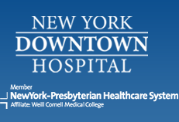

Dr. Warren Licht was instrumental in the creation of New York Downtown Hospital’s Wellness and Prevention Center, which opened its doors in January 2011. Now serving as clinical director, Dr. Licht supports the health of the lower Manhattan community through the center’s innovations in technology, record keeping, and preventive care.
The Wellness and Prevention Center strives to maintain optimum community health by employing disease prevention measures. Physicians use advanced screening and diagnostic tools to detect diseases early and prevent their development.
The center is augmented by three specific facilities: the Adult Wellness Center, the Women’s Health Center, the Breast Center, and the Cardiovascular Health Center. These facilities are integrated within New York Downtown Hospital. The women’s health center provides treatment and management of all aspects of women’s health. The breast center focuses exclusively on breast care services, while the cardiovascular center uses the latest clinical equipment to detect and identify heart and vascular disease.
Upon visiting the Wellness and Prevention Center, each patient is offered health screening that includes a comprehensive physical, medical history, and evidence-based testing. Results of the initial screening are used to develop individualized risk assessments and treatment plans.

