Hi, my name is Marina Cecere, I was born in Guadalajara, Mexico. I come to this country 22 years ago after marrying my husband Anthony. I earned my BSN and MPH at the Autonomous University of Guadalajara; I also earned my degree as an Acupuncturist at the New York College and posteriorly my NPP at Stony Brook University 2 years ago. I have worked as a School Nurse with special education children for the past 12 years. I think as nurses we can create strategies to change policies, laws and regulations. This course will provide me with a better understanding of economics, politics, and policy in relation to healthcare professionals and how these affect the practice of medicine and patient management. Good luck to everybody!!

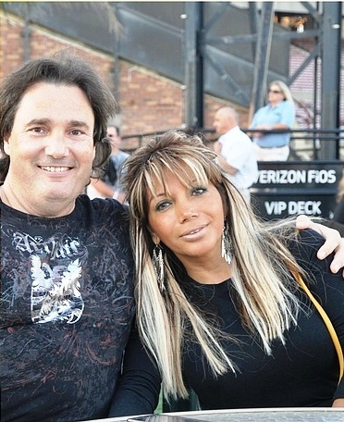
This is a picture of my husband and I at a Jones beach concert last year.

