The National Basketball Association D-League
Thomas Guerriero
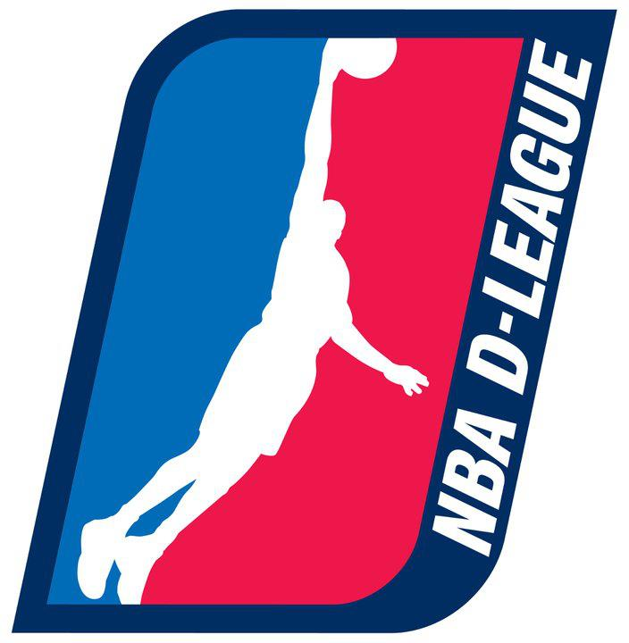
Financial professional Thomas Guerriero has served as chief executive officer of WMX Group Holdings, Inc., and of Global Wealth. Additionally, Guerriero earned recognition as one of the youngest owners of a professional sports team when he became owner of the Springfield Armor, a National Basketball Association (NBA) D-League franchise.
The NBA D (or Development) League consists of 16 teams across the country and produces talent in all areas of the game. Considered the NBA's minor league, this organization provides training to future major league players, coaches, referees, and executives. By the end of the 2011-2012 NBA season, more than a quarter of all players had played for the NBA D-League, and all 30 teams included a representative from the organization. On the court, all referees hired by the NBA over the past decade obtained their start there. Nearly 40 coaches have entered the NBA through this entity, and over 100 front office persons have experience with the D-League. Moreover, this group possesses a dedication to the community, and its members regularly perform outreach by enlightening youths about health, wellness, and education.

