Pavani Rao’s Dietary Analysis project
Part-A

Pavani Rao’s food activity for 3/16/2013
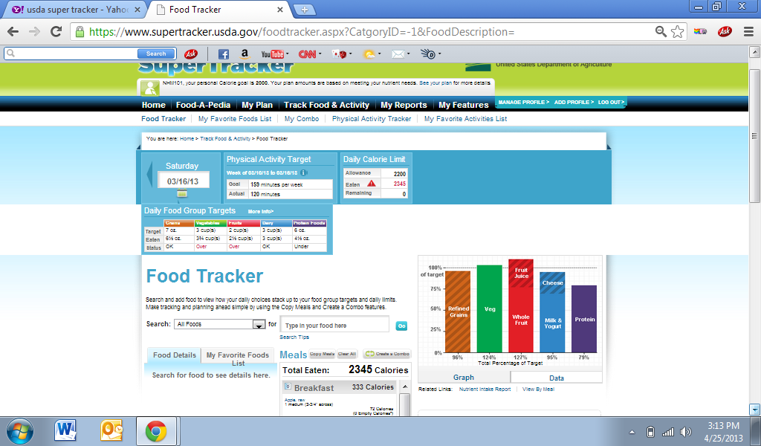
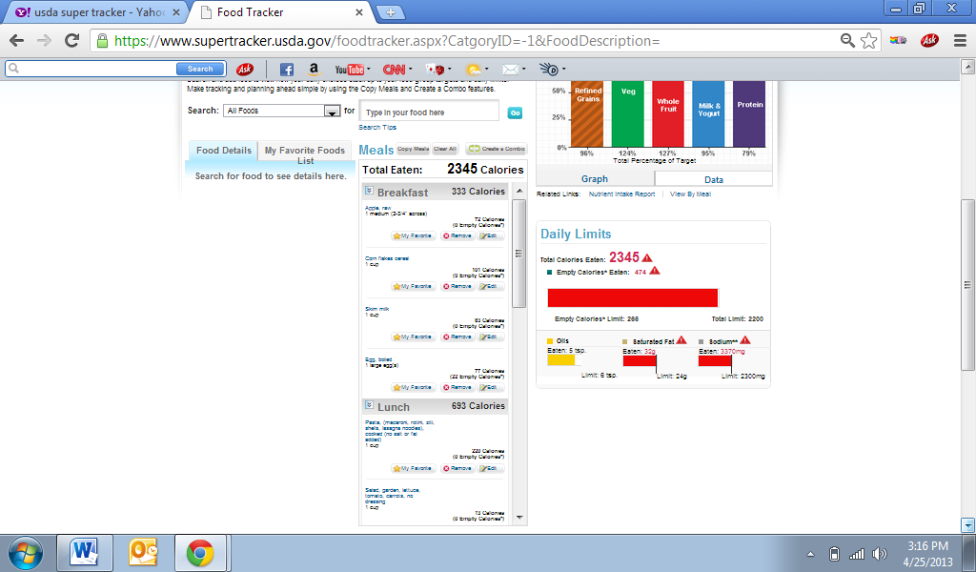

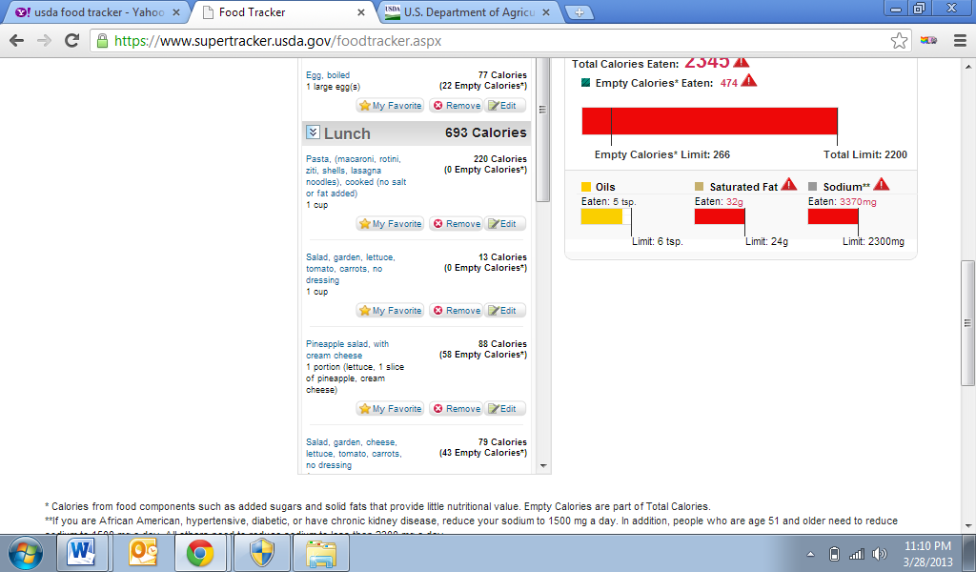
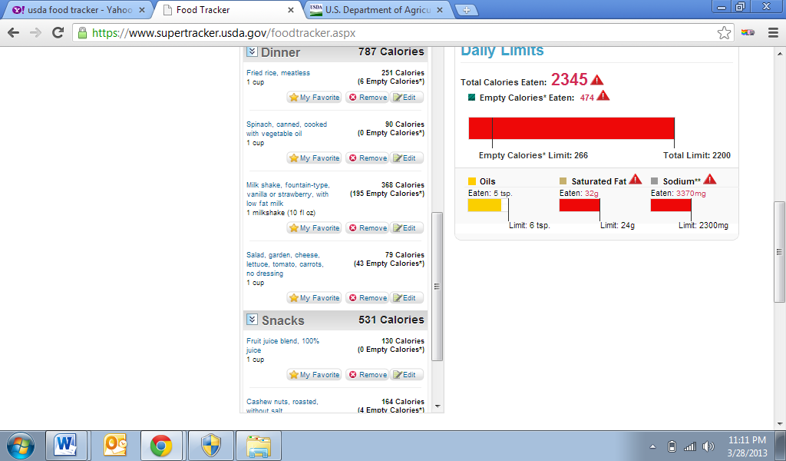

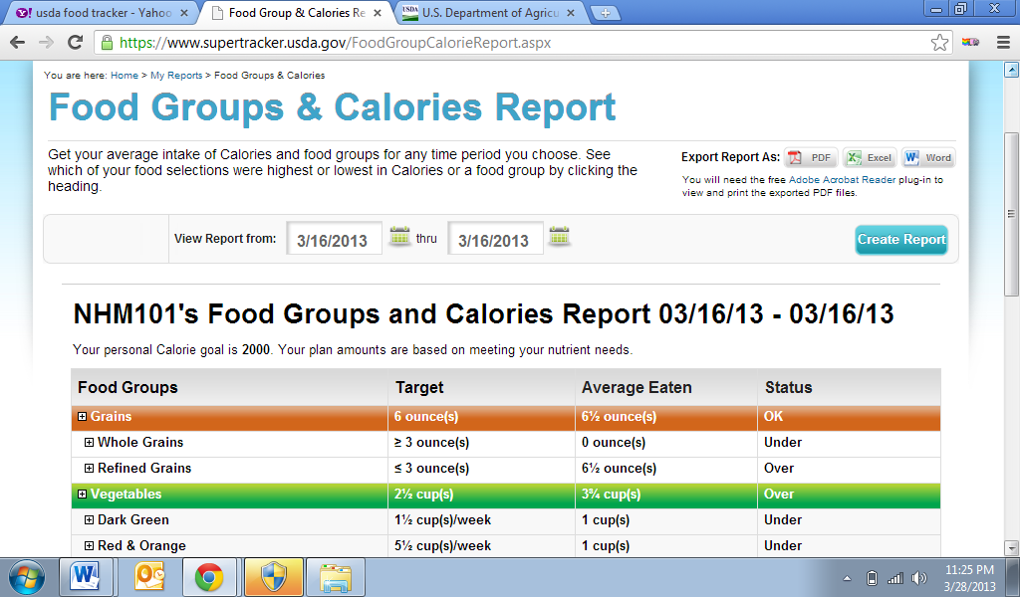
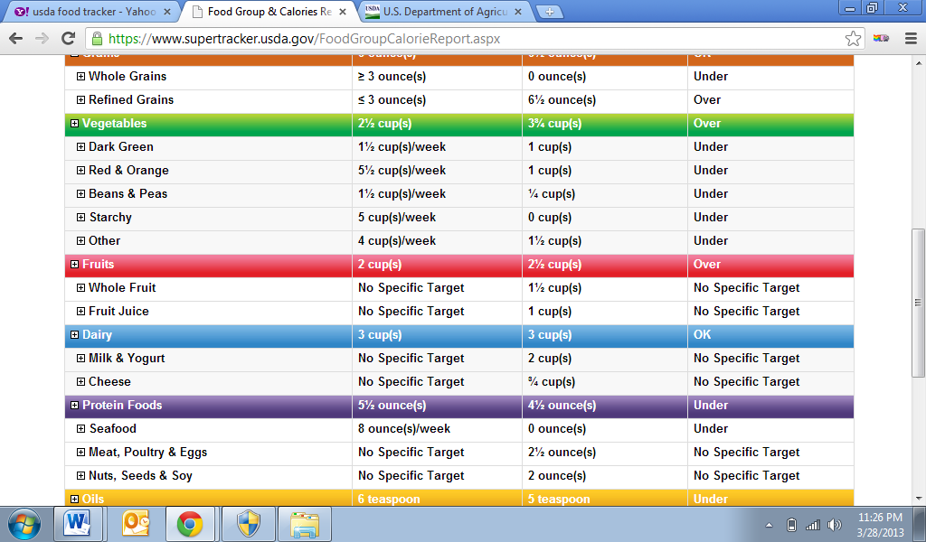
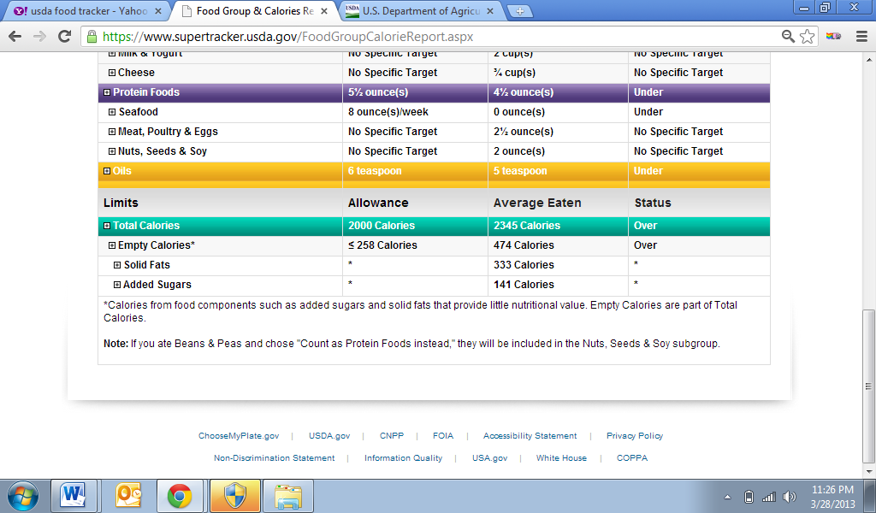

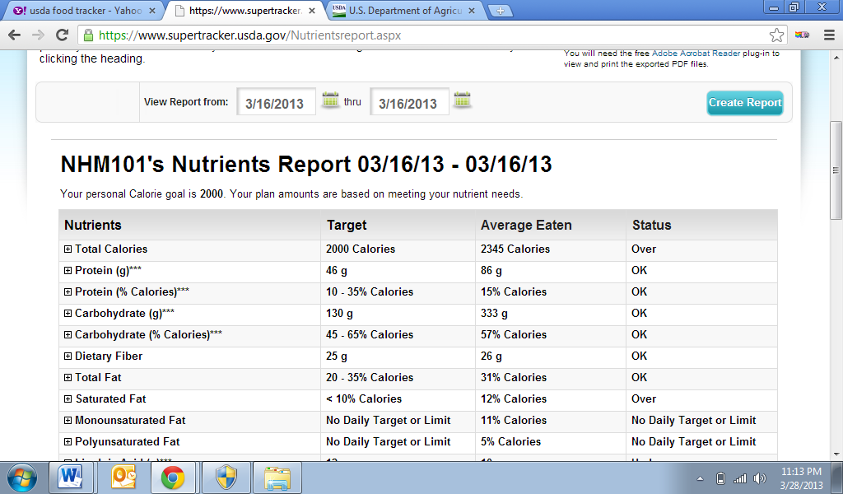
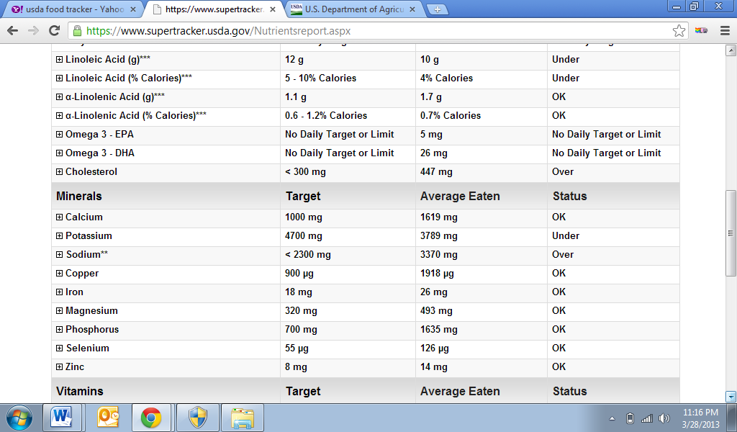
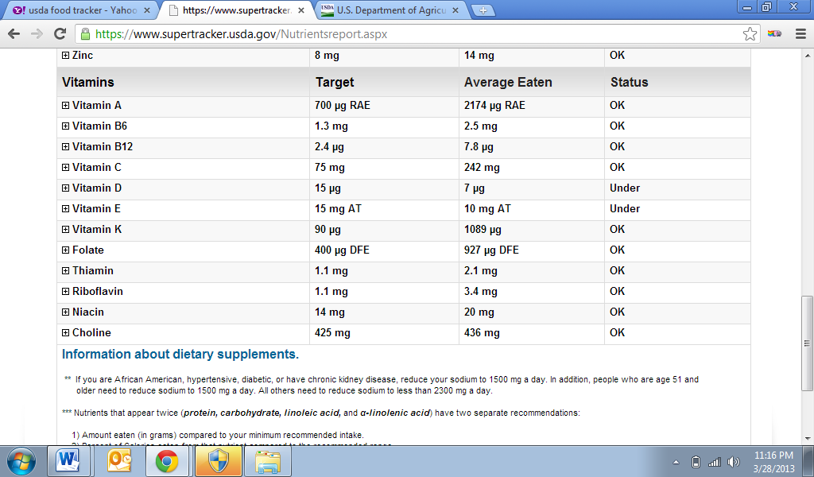
Pavani Rao’s activity tracker for 3/16/2013

p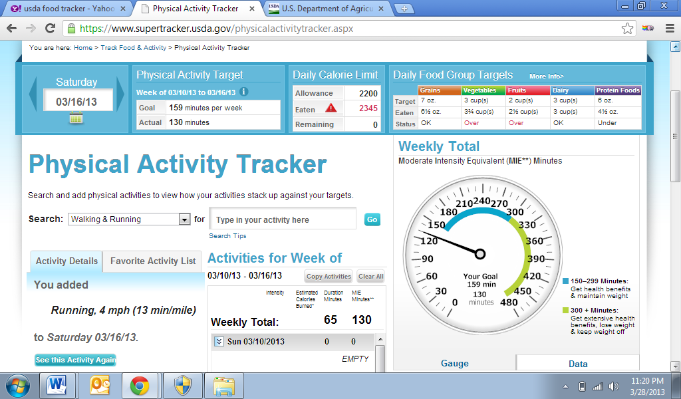
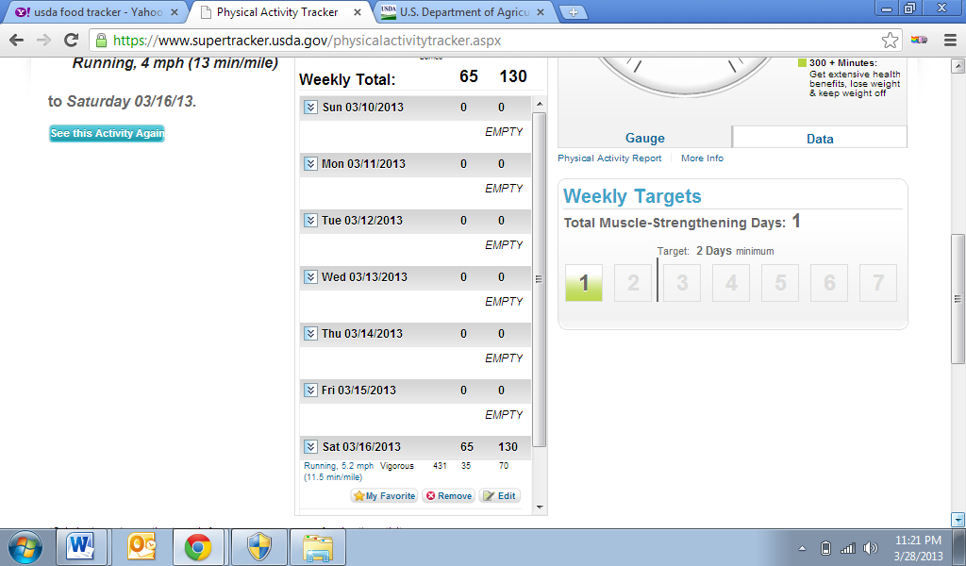
Pavani Rao food activity tracker for 3/18/2013
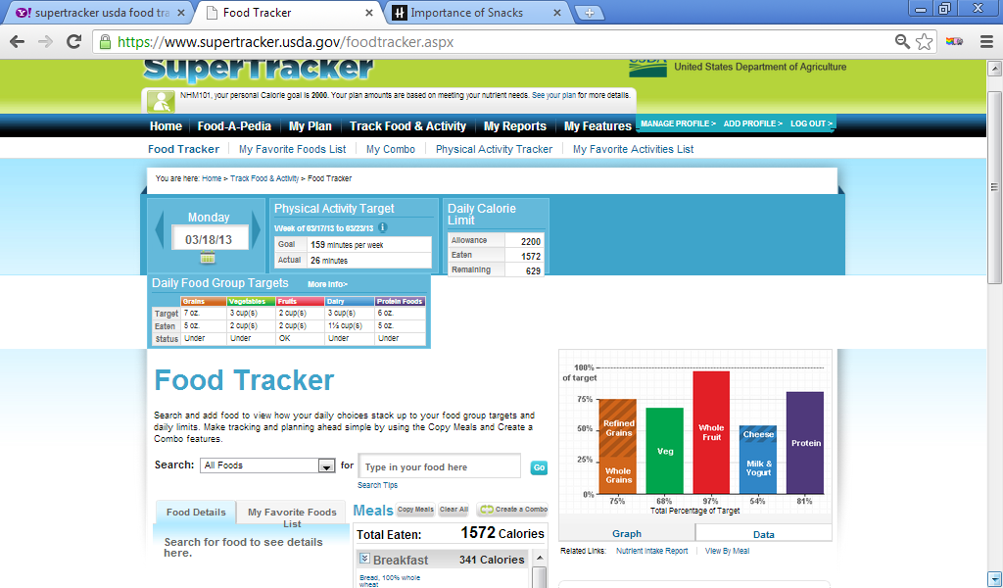
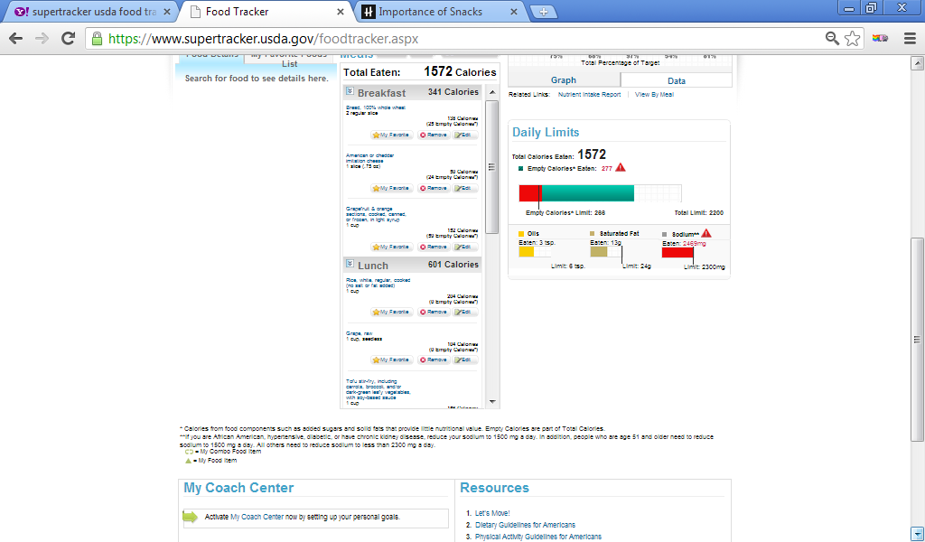
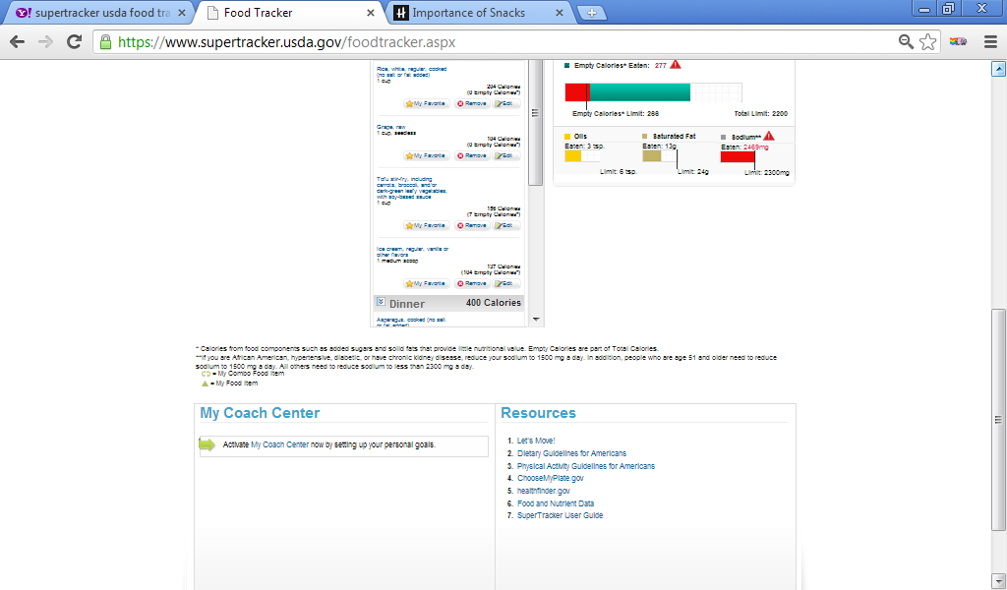
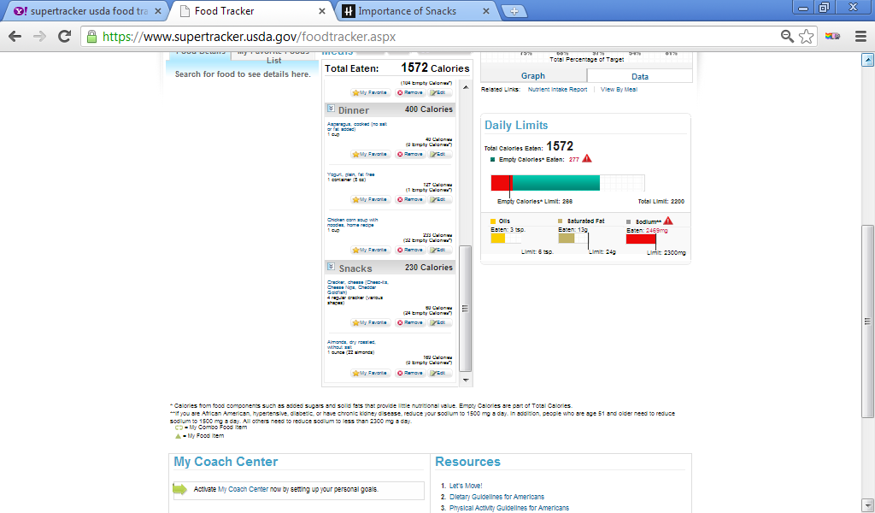

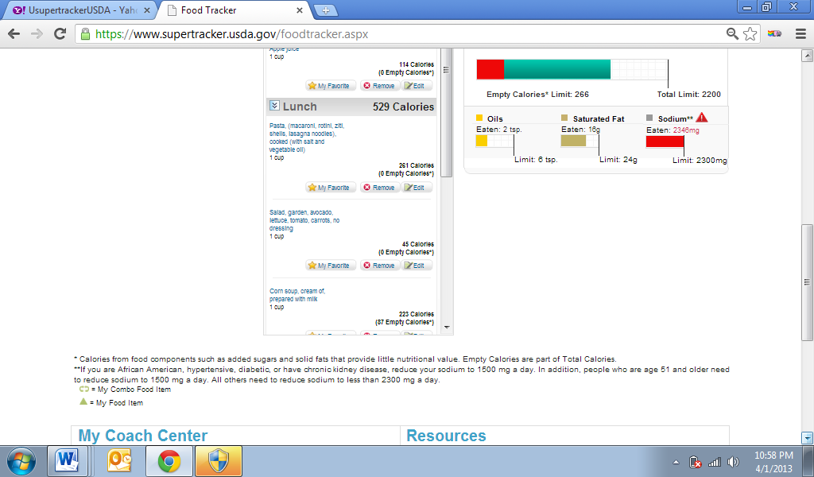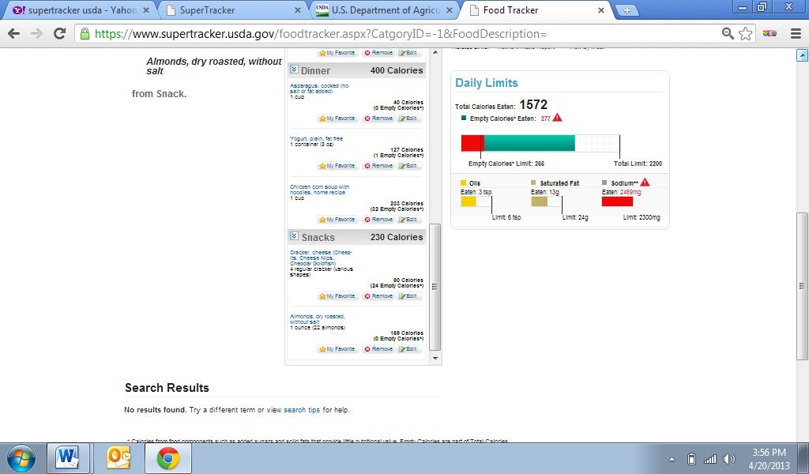

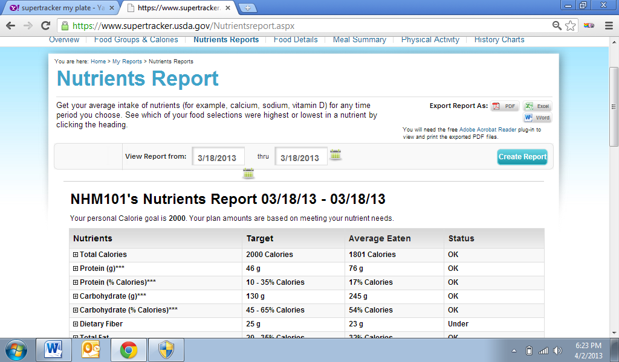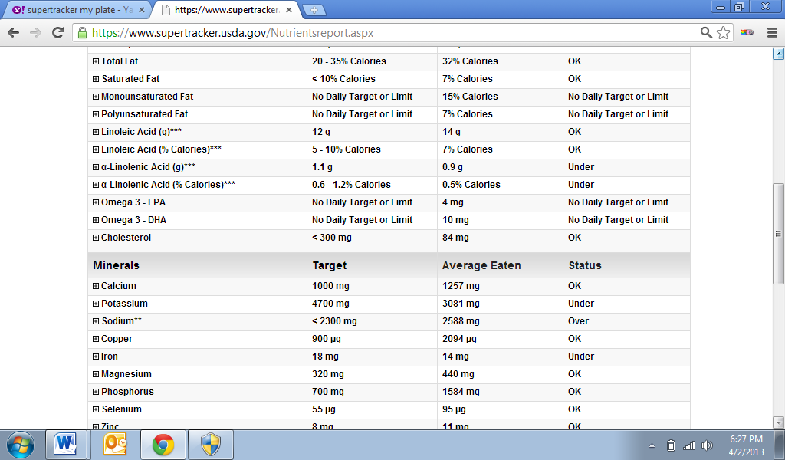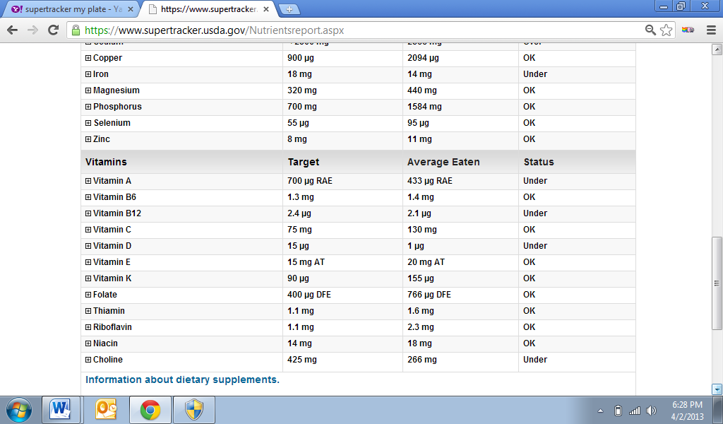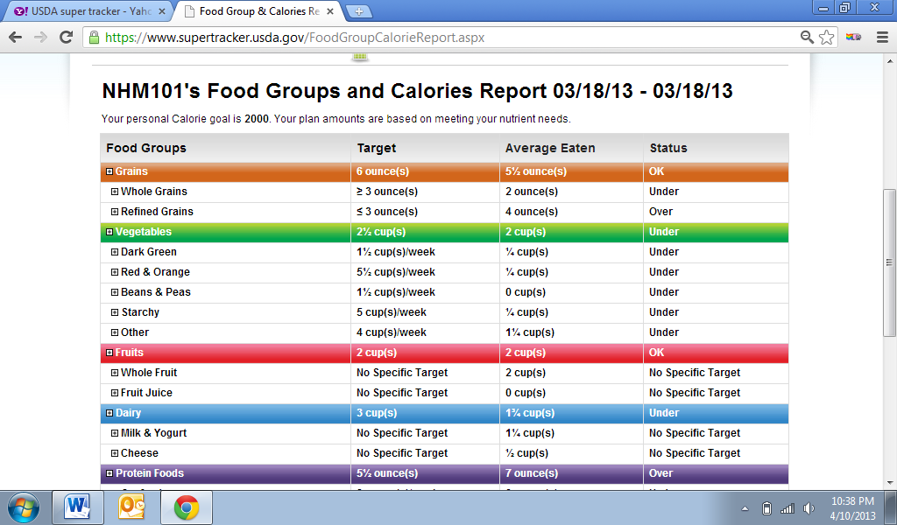
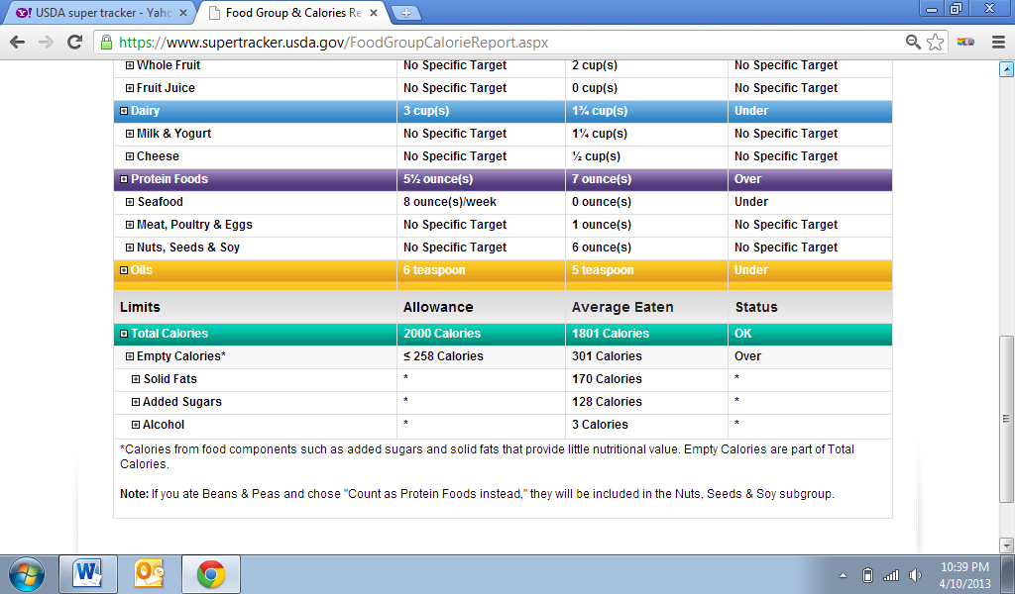
Pavani Rao’s Physical activity tracker for 3/18/2013
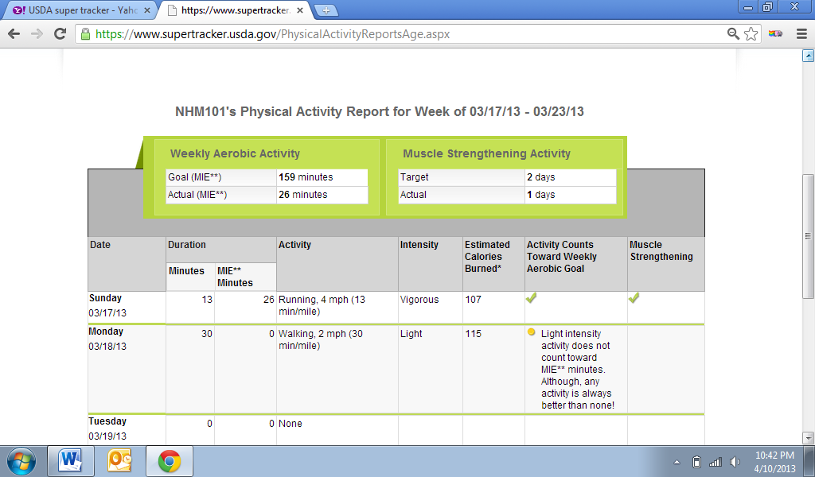
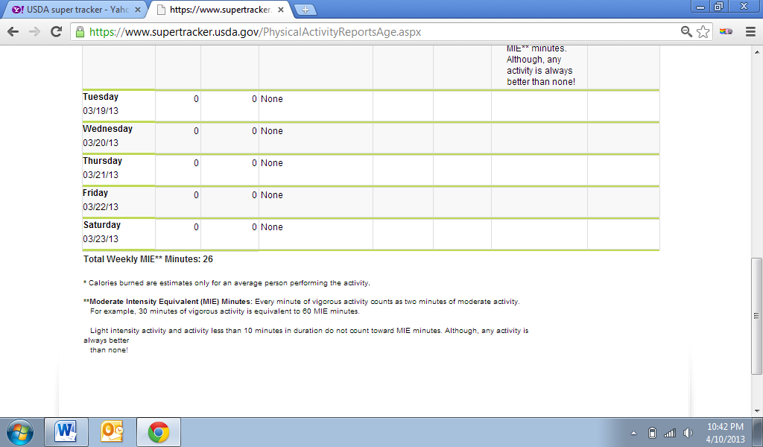
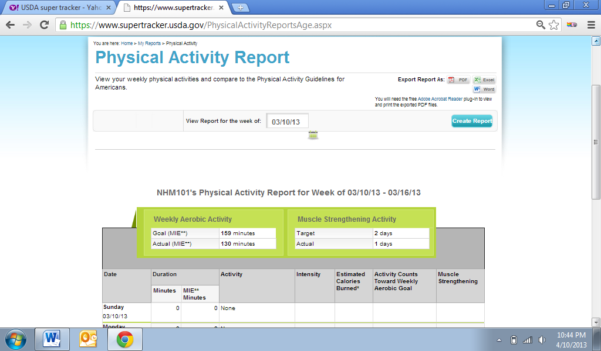
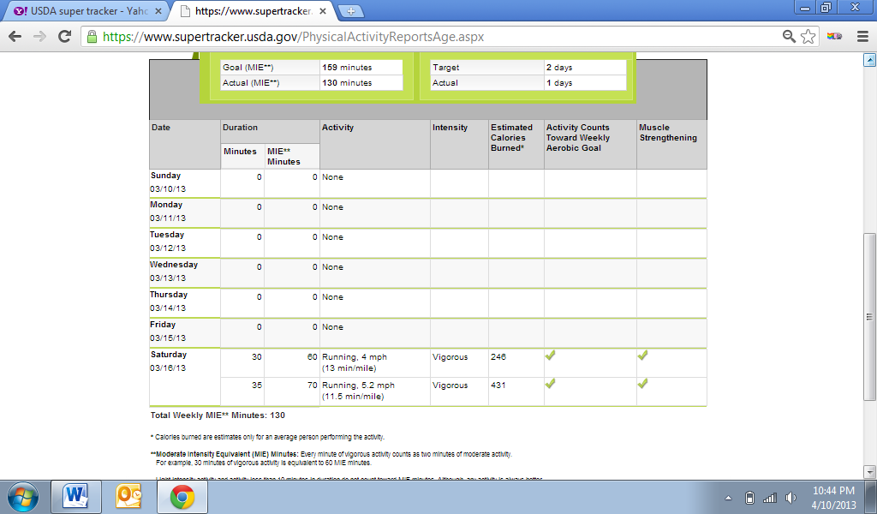

Pavani Rao’s food activity tracker 3/19/2013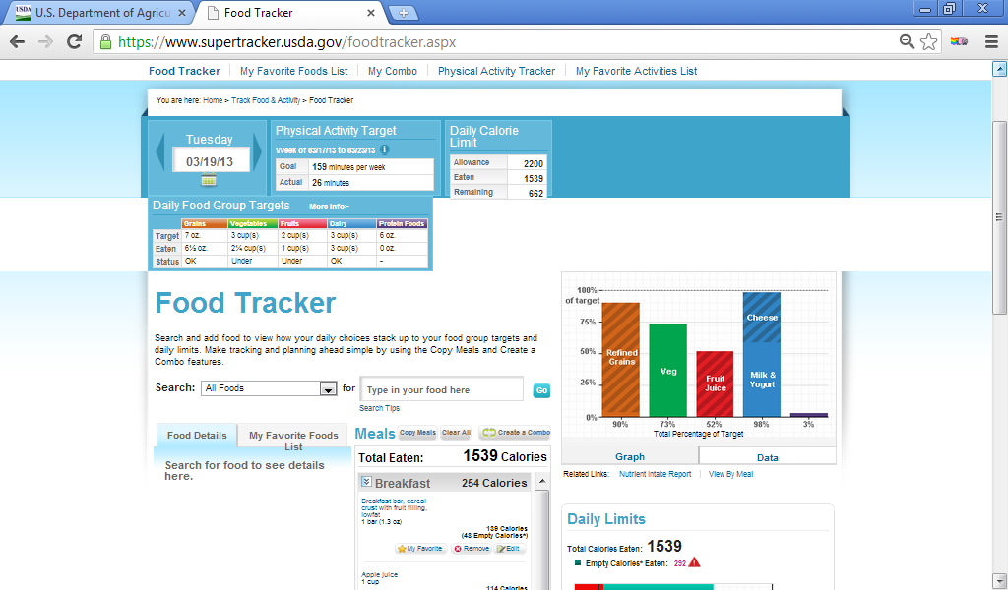
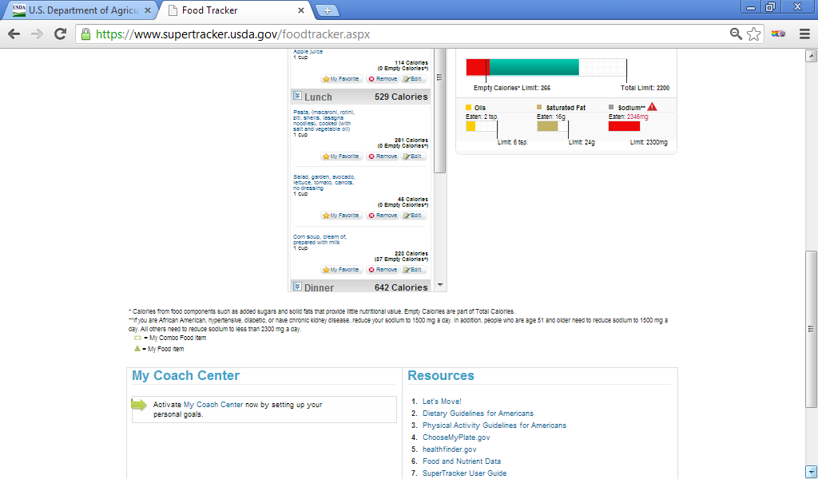
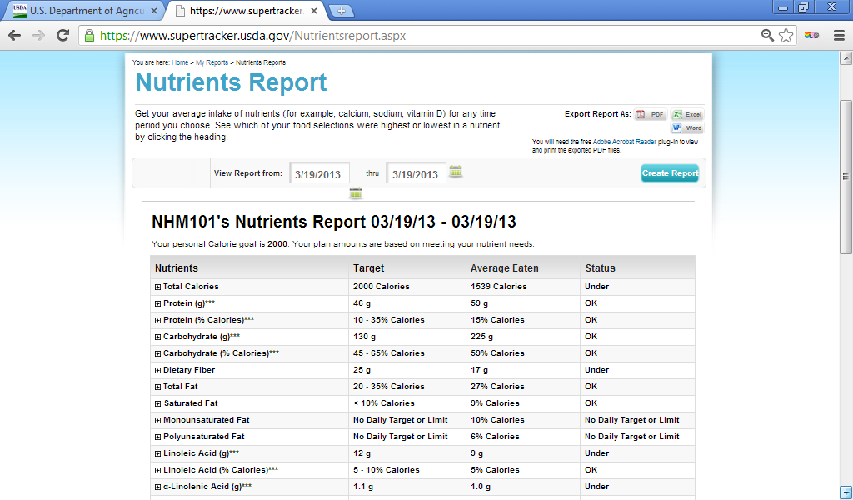
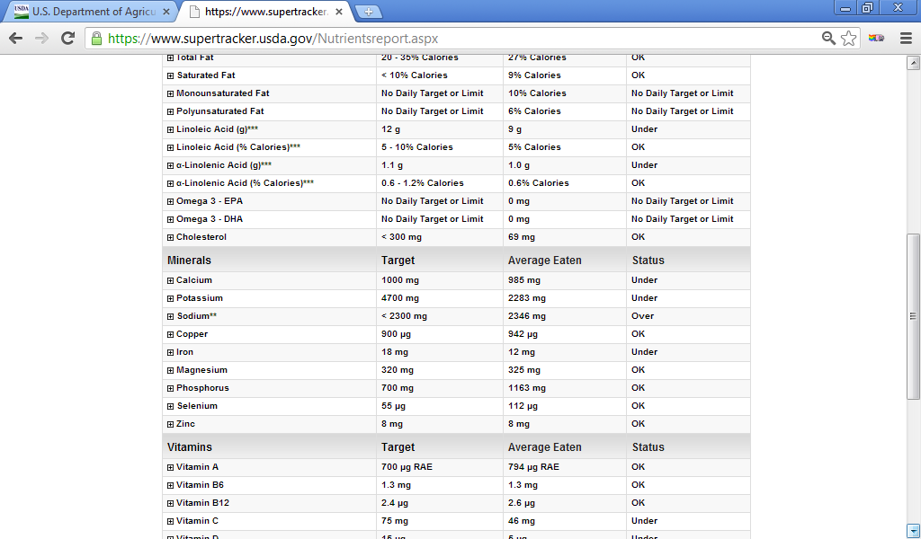
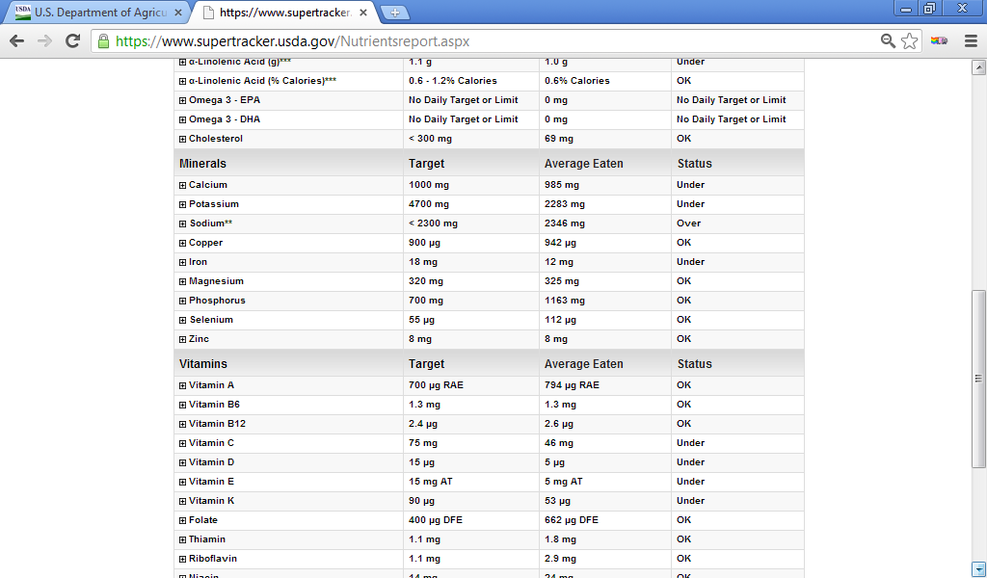
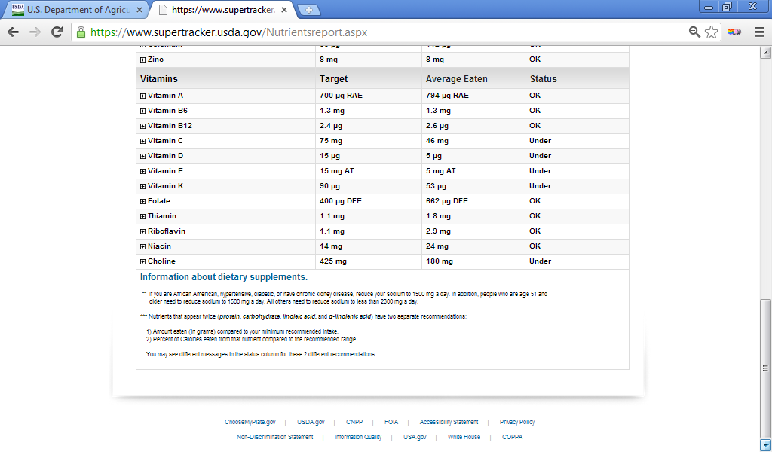
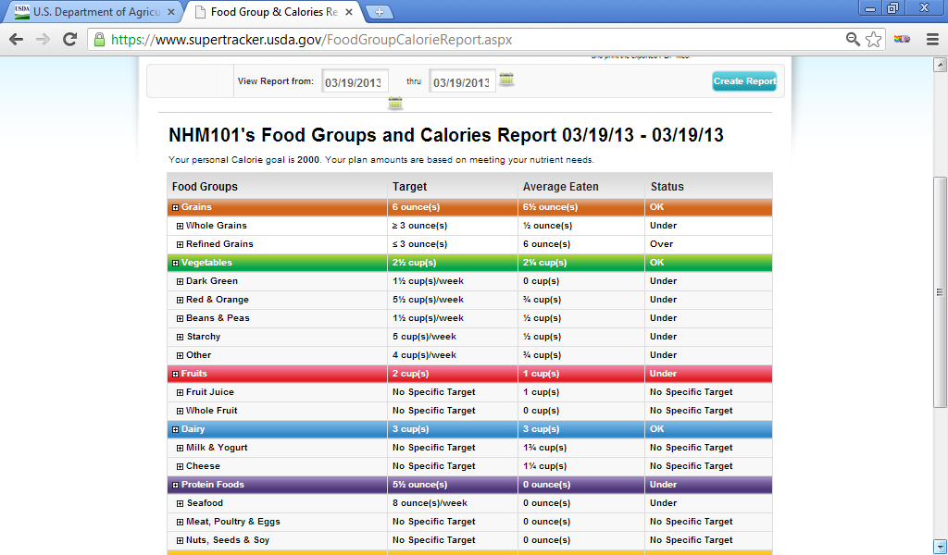
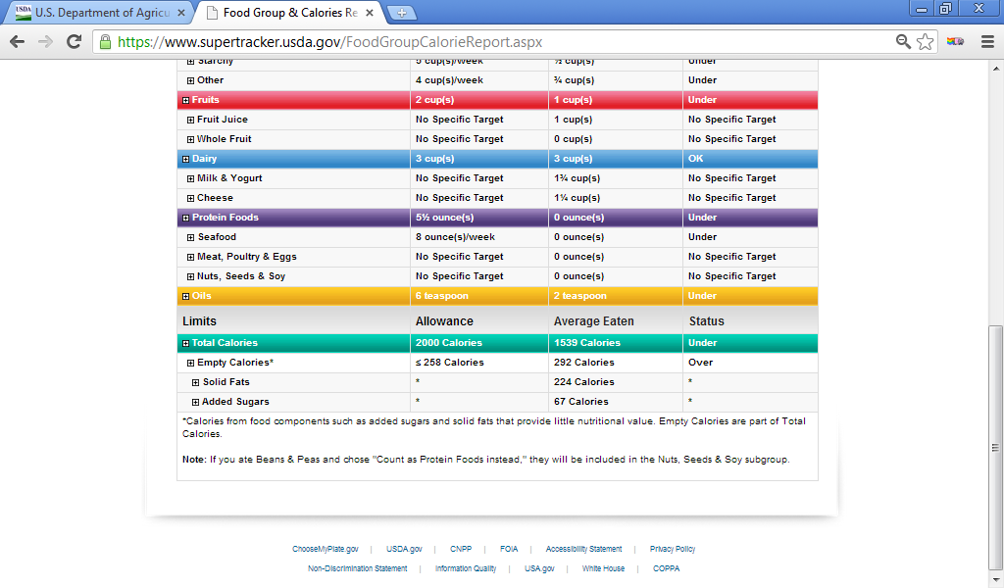
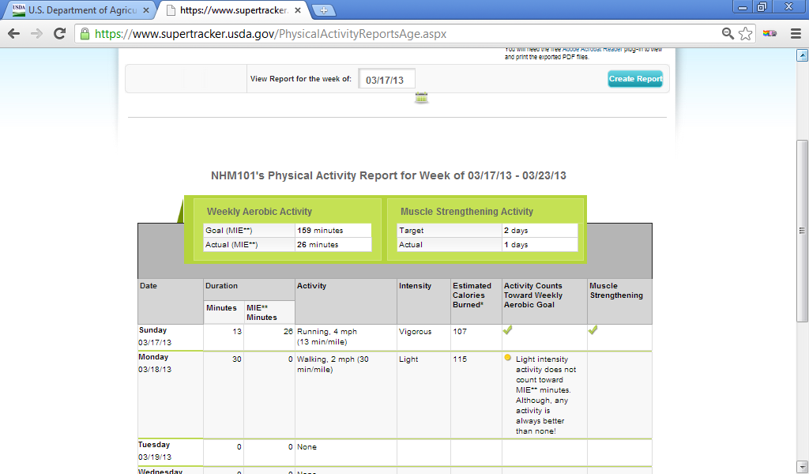f
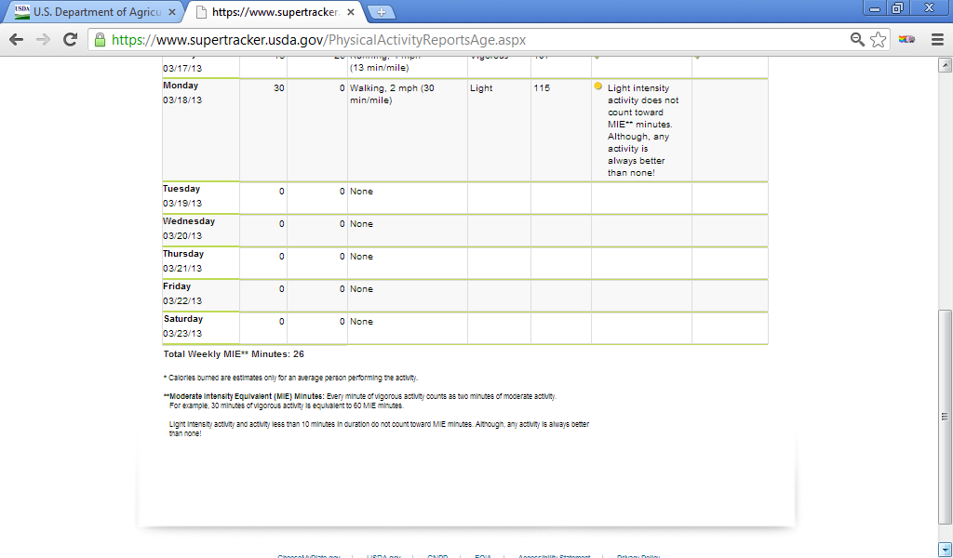
Pavani Rao physical activity tracker for 03/19/2013
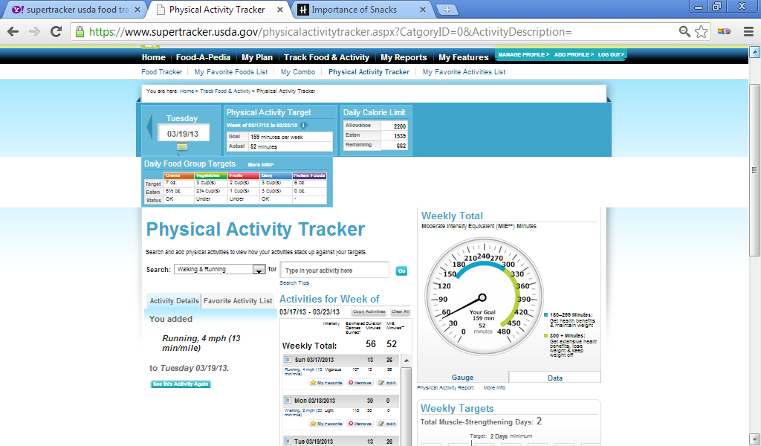
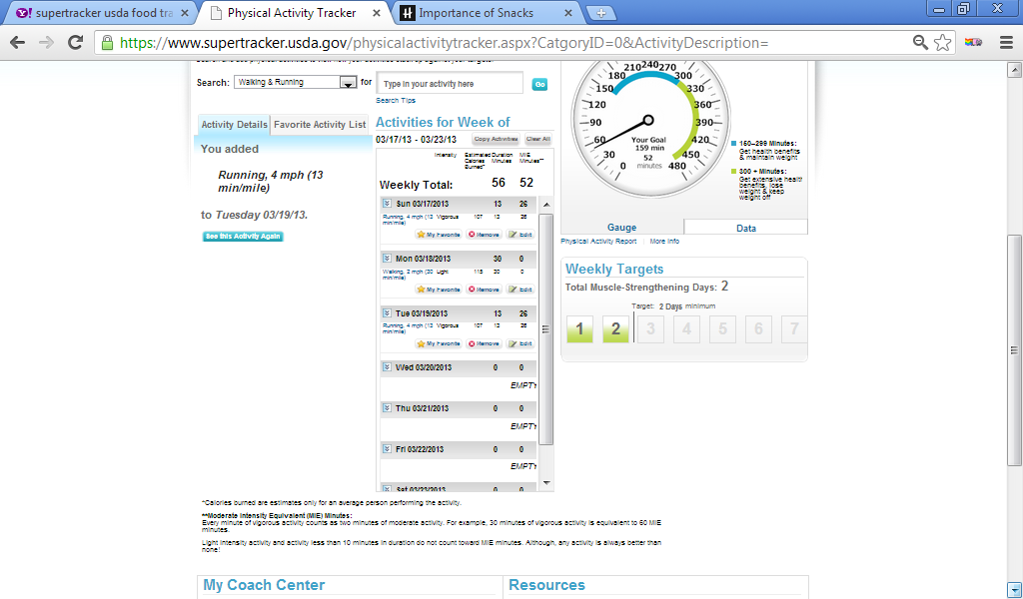

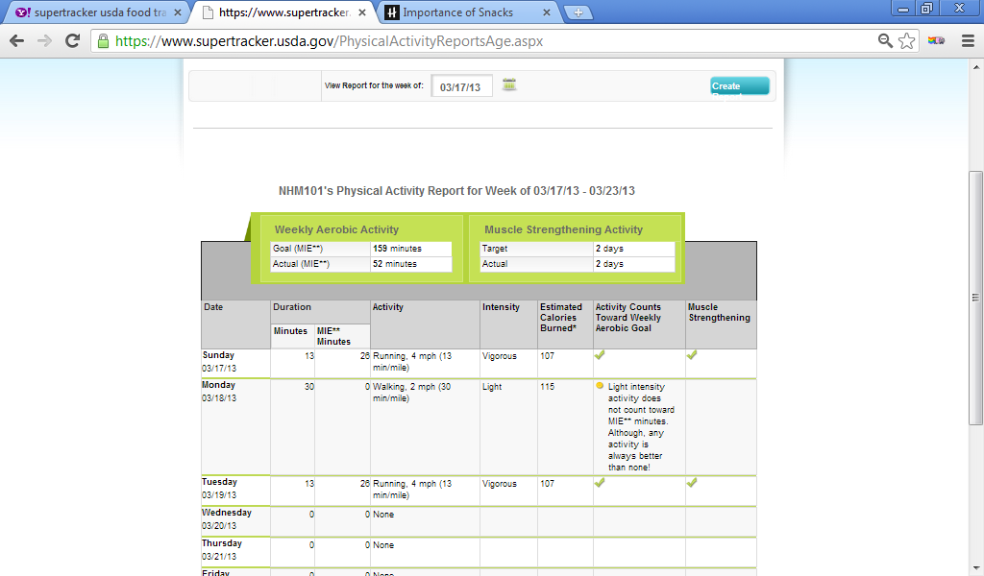
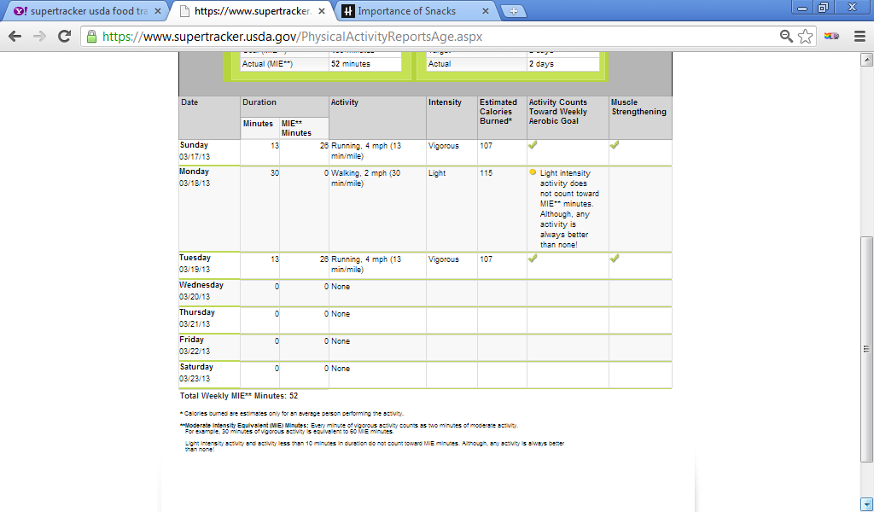

My Daily Food Plan worksheet is complete for day 1, 2, and 3
All foods and amounts eaten are recorded, all foods are sorted in to each food group,
ounces and servings are totaled for each group, physical activity is recorded

Pavani Rao’s Daily Food Plan Worksheet:
DAY 1: 03/16/2013
My food choices for today | Food group | Based on 2200 calorie pattern,  My goals are: | My food choices with each food group | My Estimated total
Breakfast:  1 medium Apple  1 large Boiled egg  1 cup Cornflakes  Boiled egg | Grains | 7 ounce equivalents | Corn flakes  Pasta  Fried rice | 6 1/2 cups
Lunch  1 cup Pasta(macaroni, rotini,  Ziti, shells. Lasagna noodles) cooked no salt or fat added ) 1 cup portion.(lettuce, 1 slice of Pine apple with cream cheese)  Pineapple salad with cream cheese.  1 cup Salad, garden cheese, lettuce, tomato, carrots, no dressing  Chili corn | vegetables | 3 cups | Lettuce, tomato, carrots, spinach | 3 ½ cups
Fried rice  Salad, garden cheese, lettuce, tomato, carrots, no dressing.  1 Milk shake, fountain type, vanilla or strawberry, with low fat milk.  1 cup spinach, canned cooked with vegetable oil. | fruits | 2 cups | Apple  Pineapple  Fruit juice | 2 ½ cups
Snacks  1 ounce Cashew nuts roasted, without salt.  1 cup Fruit juice blend, 100 % juice.  1 cup Ice cream, light without sugar. | Dairy | 3 cups | Ice cream without sugar | 3 cups
 | Protein foods | 6 ounce equivalents | Boiled eggs  Cashew nuts | 4 ½ cups
 | Physical activity | Be physically active for at least 150 minutes each week. |  | Running, 4 mph (13 min) mile.  Vigorous intensity, counts towards weekly aerobic goal and muscle strengthening.
How did I do today? So and So.
My food goal for tomorrow is:__I need to incorporate more foods from protein group
My activity goal for tomorrow is: running, 4 ½ mph (20 min per mile/day).___________________________________________________________
Pavani Rao’s Daily Food Plan Worksheet:
DAY 1: 03/18/2013
My food choices for today | Food group | Based on 2200 calorie pattern,  My goals are: | My food choices with each food group | My Estimated total
Breakfast:  1slice (75 oz.)American or cheddar imitation cheese.2 Regular slice bread, 100% whole wheat.  1 cup Grape fruit and orange sections, cooked, canned or frozen in light syrup | Grains | 7 ounce equivalents | Whole wheat bread  White rice  Corn soup with noodles | 5 ounces
Lunch:  1 cup, seedless Grape raw.  1 medium scoop ice cream, regular, vanilla or other flavors.  1 cup Rice, white, regular cooked( no salt or fat added)  1 cup tofu stir-fry, including carrots, broccoli and dark green leafy vegetables, with soy-based sauce. | vegetables | 3 cups | Broccoli, carrots, dark green leafy vegetables, Asparagus,  Corn soup | 2 cups
Dinner  1 cup Asparagus, cooked(no salt or fat added)  1 cup corn soup with noodles.  1 container (8oz) yogurt plain, fat free. | fruits | 2 cups | Raw seedless grapes  Grape fruit, orange sections. | 2cups
1 ounce (22 almonds) dry roasted, without salt.  4 regular cracker (various shapes) cracker, cheese. | Dairy | 3 cups | Fat free yogurt.  American cheddar cheese. | 1 ½ cups
 | Protein foods | 6 ounce equivalents | tofu | 5 ounces
 | Physical activity | Be physically active for at least 150 minutes each week. |  | Walking, 2 mph, 30 min/mile. Light intensity, activity still counted towards aerobic goal and muscle strengthening.
How did I do today? So and so.
My food goal for tomorrow is: My protein intake was good today; I did incorporate whole wheat in the diet. My dairy intake was lower today. I need work on that tomorrow
My activity goal for tomorrow is: I need to increase my intensity of activity from light to moderate or vigorous activity tomorrow.

Pavani Rao’s Daily Food Plan Worksheet:
DAY 1: 03/18/2013
My food choices for today | Food group | Based on 2200 calorie pattern,  My goals are: | My food choices with each food group | My Estimated total
Breakfast:  1 cup Apple juice  1bar (1.3 oz.), breakfast bar, cereal crust with fruit filling low-fat.  Lunch:  1 cup corn soup, prepared with milk.  1cup pasta (macaroni, rotini, ziti, shells, lasagna, noodles,, cooked with salt and vegetable oil.)  1 cup salad, garden avocado, lettuce, tomato, carrots, no dressing. | Grain group  Vegetable group  Fruit group  Dairy group  Protein group | 6 ounces  2 ½ cups  2 cups  3 cups  5 ½ ounces | Pasta(macaroni, rotini, ziti, shells, lasagna, noodles)  Breakfast bar  Avocado, lettuce, tomato, carrots. Bean soup.  Apple juice, cereal crust with fruit filling.  I medium latte (espresso coffee) with 1% milk.  Cream of soup prepared with milk.  none | 6 ½ ounces  2 ½ cups  1cup  3 cups  0 ounces
Dinner:  1 cup bean soup, mixed beans.  2 slice (1/8 of 12” pizza, with vegetables, regular crust.  Snacks:  1 medium (16 flo oz) Latte (espresso coffee) with 1% milk. | Physical activity | Be physically active for at least 150 minutes each week. |  | 13 minutes  Running 4 mph(13 min/mile)  Activity counts towards weekly aerobic goal with vigorous intensity.
How did I do today? So and So.
My food goal for tomorrow is: to include more protein foods like beans and nuts for tomorrow.
My activity goal for tomorrow is: Brisk walk for at least 60 minutes a day.

