Characteristics of Australian Shepherd Dogs
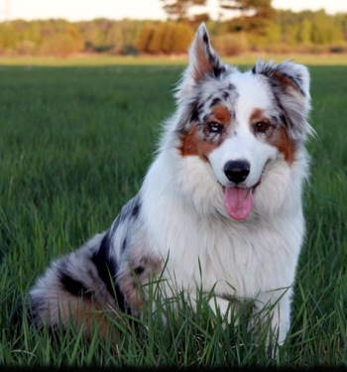
Christopher Spiegel serves as resident engineer in the project management office at the Maryland Transit Administration in Baltimore, where he not only oversees the operating budget for the metro department but also writes and edits proposed projects. Australian shepherds are one of Christopher Spiegel’s favorite dog breeds.
Australian shepherds are popular, high-energy family pets that demonstrate playfulness and loyalty in their dispositions. These qualities, coupled with their gentle nature, make them ideal dogs for children, especially those who enjoy outdoor activities.
Originally bred as working dogs, Australian shepherds have a strong need for regular, vigorous physical activity. They enjoy going for long runs or walks along with spending time outside on a ranch or farm. They do not thrive if kept indoors for long periods of time. In general, Australian shepherds prove obedient and easy to train.
Australian shepherds did not originate in Australia. The breed we know today developed in the United States, but is thought to hail from the Basque region between Spain and France. The dogs became popular among ranchers in the 20th Century for their working and herding abilities. Many Australian shepherds retain the desire to work, and therefore excel as therapy or search-and-rescue dogs.

