THE NJLS CUSTOMER

The NJLS Customer
Vision
Research
Methods
Results

Vision
- Who is our customer?
  - Action plan:
    - Interview top 300 users based on last quarter’s revenue
    - Survey based on approved questions
    - Gather data in quantifiable manner to gauge results
    - Manage client concerns and provide customer service when necessary

Research
- Concerns:
  - Out-of-date information and customers did not call back (after message was left)
  - Top 300 clients ≠ complete clientele snapshot
  - Multiple accounts with same “owner”
  - Client data static (data today could be wrong tomorrow)
- Solutions:
  - Research firm and ensure contact was made to update information
  - Suggested wider range of clients (tiered similarly to new Customer Appreciation program)
  - Consolidate, delete, and update account information
  - Design “Customer Feedback Form” and utilize throughout NJLS

Methods
- Data management:
  - Contact information, client-specific details managed through SalesForce.com
  - General customer concerns managed through Excel (this allowed for quantifying verbal data)
Issue | Code | Issue | Code
Account Updates | AU | Delivery Issue | DI
Better Tracking | BT | Same-Day | SD
Rewards Program | RP | Process Service | PR
Customer Service | CS | Address Book | AB
Billing Issues | BI | Better UI | BL
 |  | Not Intuitive | NI

- Abbreviations (e.g.: AB, NI, CS, etc.) counted via formula easily became hard data
  - Easy to manipulate (test) and determine trends (+/-)
  - Provides accurate snapshot (as per beginning of survey)
- To categorize contact hits and misses, spreadsheet was designed to label accounts as “Contact Made,” “Did not have to call,” “Left Message,” “Email Sent/Preferred,” “Wrong Number,” “No Information Verified”

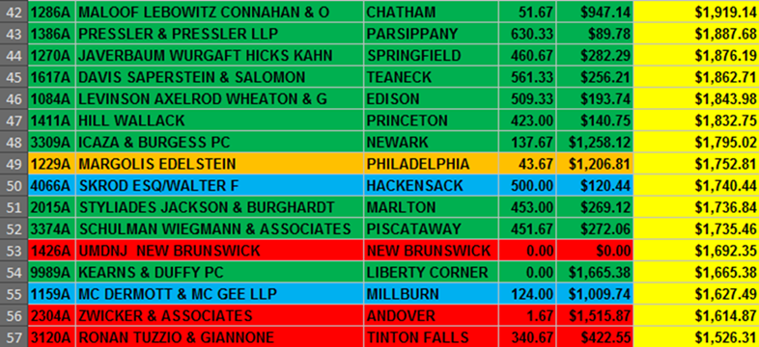
Results
- Key questions focused on four specific aspects of client relations…
  - Customer Service
Of the 180 clients surveyed…
    - 2% wanted account utilization notifications
    - 11% asked for up-to-date tracking
    - 3% had questions/concerns about the Customer Appreciation program
    - 7% wanted better customer service
    - 2% had billings concerns
    - 3% had an issue with a delivery (often isolated, rarely happened more than once to a given account)

  - Website Usage
Of the 180 clients surveyed…
    - 15% had an issue with their address books
      - The primary frustration was merging different users’ address book information so all could access data
    - 7% complained that the website was not intuitive and/or difficult to use
    - 2% held the opinion that the website could have a nicer look, better user-interface, and perform more quickly

  - Awareness of other Services
Of the 180 clients surveyed…
    - 1% did not know of our Same-Day service
    - 1% were not aware of our Process service

- Client Loyalty (NPS)
  - NPS determines how likely a customer base will recommend you to their clients or other associates
    - More recommendations = greater revenue
    - Higher NPS = more loyal customer base
  - How does NJLS stand up to other companies?
    - USAA - Banking 83%
    - Amazon.com - Online Shopping 76%
    - USAA - Auto Insurance 74%
    - NJLS - Logistics 71.19%

Summary of Findings

- Each customer tier needs to be approached differently but overall goals remain the same. NJLS needs to be…
  - Visible
  - Recommended
  - Preferred
  - Consistent
  - Opportunistic

- Going Forward, marketing strategy based on three, six, and twelve month plans:
- Three Month Goals
  - Establish social media presence
  - Track account revenue (watch for/follow-up with drastic changes)
  - Update accounts as customer service calls come in
  - Manage Customer Appreciation Program responses & engage customer to spend more (to level up)
  - See rise in customer satisfaction (NPS)

- Six Month Goals
  - Adjust website to reflect customers’ needs/wants
  - Fix address book concern in Shipping Center
  - Monitor customer feedback company-wide with Customer Feedback Form
  - See overall increase of revenue from lower-tiered companies
  - Continue fielding customer calls and updating accounts
  - Push Customer Appreciation Program and examine opportunities for individual customer growth

- Twelve Month Goals
  - Continue working with IT to ensure website is fully functional and intuitive
  - More effective advertisements targeted to specific tiers (internet and physical) (i.e.: Why waste ad $$ on cross selling to low tier customer who won’t want additional services?)
  - Higher NPS (85%)
  - With entrenched customer base, move to different markets
  - Local merchants, medical companies, small businesses
Overview
- Customer base is fundamentally solid
- Improvements could & should be made
- Increased customer outreach will open opportunities for growth
- Strong push toward social media and digital communication necessary
- Overall outlook is positive and primed for opportunity

