The Effect of Music on Puzzle Solving
G. Vania Vega & Brock C. Liles
Longwood University

Abstract
Much research indicates the detrimental effects of music when performing complex tasks. More specifically, vocalized music is especially distracting. We tested the effects of music with or without lyrics during demanding complex tasks. Participants listened to a lyrical and instrumental version of the song “Smooth Criminal” by Michael Jackson while performing a puzzle solving task. Participants exposed to music while puzzle solving assembled a significantly lower number of pieces than the control group. Those in the instrumental condition assembled fewer pieces than the lyrical condition. In the absence of music, participants assembled the most puzzle pieces. This is inconsistent with our hypothesis that the lyrical condition would assemble the least number of pieces. However, our results suggest music is distracting when puzzle solving due to external auditory stimulation. Although we measured a puzzle solving task, our results can be generalized to other important complex tasks people perform.
Keywords: background music, lyrical music, instrumental music, complex task performance, concentration, puzzle solving

Introduction
The presence of music can be a distracting factor, either facilitating or reducing performance. Its effects vary among people depending on the complexity of the task (North, Hargreaves, & Hargreaves, 2004). For example, music can enhance performance levels if the listener is involved in simple and routine tasks by decreasing the potential boredom (Huang & Shih, 2011). In contrast, intricate tasks requiring complex cognitive processes are vulnerable to concentration disruption. This is evident in neuroanatomical activity in the interruption of attention (De Fockert & Theeuwes, 2012). For example, activity in the frontal lobe is evident when attention-directing stimuli are introduced while performing complex tasks such as studying or utilizing spatial abilities.
Music negatively influences the ability to understand information while reading. Tze and Chou (2010) found that cognitive processes in complex tasks are interrupted whether participants listened to either highly arousing or less stimulating music. Furthermore, both background music and noises are distracting (Furnham & Strbac, 2002). Perceiving differences between noise and music is important because noise is expected to be more distracting due to its disrupting quality (Branbury & Berry, 1998). This is due to complexity in the sounds between both stimuli. Therefore, the addition of vocalized lyrics in a song may further increase the complexity of the music and negatively affect performance
Music with vocalizations impairs other aspects in cognition affecting concentration levels that in return, reduce task performance. When completing working memory tasks, Alley and Greene (2008) found that music with speech or vocalized lyrics reduced task performance for working memory. This is due to the thought processes involved in understanding the semantics of lyrics within music. Shih, Huang, and Chiang (2012) also found that songs containing lyrics reduced concentration levels and cognitive performance. Therefore, lyrical music in particular disrupts attention.
Familiar music negatively influences the ability to understand information while performing complex tasks such as reading. Furnham and Strbac (2002) found that participants scored worse on multiple choice responses when exposed to a familiar and popular music melody during the task. Moreover, the study supported that listening to music at all reduced the ability to recall information. Familiarity in music is more likely to disrupt intricate cognitive processes such as those requiring memory. Nittono (1997) tested whether music played forward or backwards impaired the ability to recall a series of items. Participants exposed to music played forward incorrectly recalled items more often than those listening to music backwards. Due to the lack of organization and integration, music played in reverse fails to stimulate distraction and thus cognitive processes continue successfully.
While music is debilitating to performance in intricate tasks, the absence of music is facilitating. Furnham and Strbac (2002) found that the lack of any background sound is helpful in reading comprehension tasks. Likewise, Perham and Vizard (2010) found that silence is advantageous when performing memory tasks. Participants correctly recalled more words when no music played in the background; however they recalled fewer words in the presence of music. Such studies depict the advantages of task performance in the lack of music.
We tested the extent to which music with lyrics affects ability to assemble puzzle pieces. Puzzle piecing is a complex task requiring concentration, comprehension, and spatial ability. Determining the effects of music is essential in a society where music is easily accessible. Furthermore, testing effects of lyrical music is important in reducing detrimental risks. For example, when playing a video game involving vehicle driving, participants performed the worst when exposed to highly arousing music than in the presence of other sounds (Cassidy & MacDonald, 2009). This is crucial information because it suggests that driving is negatively affected by music—a common daily routine for many. Therefore, determining whether lyrical music affects puzzle piecing is important because we can prevent unfavorable outcomes. This can be done by implementing findings to other similar tasks requiring such cognitive processes. Due to possible familiarity of a song and the mental demands required to process the meaning of lyrics, we believe that participants exposed to lyrical music assembled the least number of puzzle pieces.
Method
Participants
Seventy-one females and 28 males Longwood University students registered for the study via the experiment management software, Sona-Systems. participated in the study. There were 25 freshman, 20 sophomores, 18 juniors, 6 seniors, and 2 participants classified as other. Students ranged from 17-27 years old (M = 19.78, SD = 1.59). Participants earned one point of extra credit towards an enrolled psychology course.
Materials and Procedure
The study was under the deceptive title “The Effect of Time Limit on Puzzle Solving.” In a classroom setting, participants assembled a 100-piece small sized puzzle depicting Disney fairies intended for ages six and over (Figure 1). Simultaneously, participants listened to one of two versions of “Smooth Criminal” by Michael Jackson: Lyrical (Appendix A), Instrumental (Appendix B), or in the absence of music. We asked participants to assemble as many pieces as possible in 4 min. After 4 min, we instructed participants to stop and turned the music off, however we did not announce whether music would play or not. Participants referred to a completed image of the puzzle in front of them while assembling the pieces on the desk. We measured puzzle solving by counting the number of puzzle pieces correctly assembled after the designated time and compared the quantities in each condition.
Results
As Figure 2 depicts, a One Way Analysis of Variance (ANOVA) determined that type of music affects the number of puzzle pieces an individual assembles F(2, 96) = 7.14, p = .001. Scheffé post-hoc analyses indicated that participants assembled a significantly lower number of pieces when listening to the instrumental version (M = 19.07, SD = 4.79, 95% CI [17.28, 20.85]) than in the absence of music (M = 25.15, SD = 6.81, 95% CI [22.74, 27.56]), p = .002. Participants listening to the lyrical version assembled a significantly less number of pieces (M = 21.22, SD = 7.43, 95% CI [18.71, 23.73]) than in the absence of music, p=.048. Those in the lyrical and instrumental conditions assembled similar number of pieces, p = .412. Furthermore, males assembled a significantly lower number of puzzle pieces (M = 18, SD = 6.21) than females (M = 23.25, SD = 6.97), t(97) = 2.981, p = .004, 95% CI[1.50, 7.50]. This difference is seen in Figure 3.
Discussion
These findings partially support our hypothesis in that the presence of music, whether lyrical or instrumental, affects puzzle solving. Participants assembled a significantly lower number of puzzle pieces when listening to both lyrical and instrumental music conditions. This is consistent with previous research findings in that the mere presence of music is distracting (Furnham & Strbac, 2002). In Furnham & Strbac’s study, reading comprehension tasks worsened when either music or noise played in the background, however not in the absence of music. Similarly, our results suggest music is distracting when puzzle solving due to external auditory stimulation.
A possible argument is that perhaps participants liked “Smooth Criminal” and therefore the song was distracting. However, Perham and Vizard (2010) found that distractibility increased whether a song was liked or disliked. Furthermore, participants may have performed worse in the puzzle solving task due to the possible familiarity of the song. Nittono (1997) found that listening to familiar music is distracting and thus decreases performance level during serial recall. This is because the flow of the music beat and rhythm is organized in a flowing pattern, therefore individuals may know what to expect next. The rhythm of the song may be familiar to individuals whether in instrumental or lyrical versions due to its popularity in recent decades. For this reason, the song possibly distracted participants. In the absence of music, there are no other stimuli to distract participants but the minor, inevitable sounds made in a classroom setting in silence. The familiarity or even expectation of rhythm flow in a song may be sufficient to distract individuals; however the absence of music does not. These previous studies in adjunction to ours suggest that whether participants liked, disliked, or even recognized the song may not affect performance; the exposure to music alone is sufficient enough to divert focus.
We specifically predicted that music with lyrics reduces puzzle solving mostly due to the semantics in lyrics. Rather, results indicated that listening to the instrumental version of “Smooth Criminal” caused participants to piece the least number of pieces. Perhaps this occurred because the instrumental version of the song is not as commonly heard as its original, lyrical version. Attempting to identify the song due to the lack of words may have also distracted participants. Therefore, the absence of words to a song when expected may be disrupting.
Solving the puzzle task in silence did not affect the number of pieces assembled; rather, participants performed best in this condition. This supports part of our hypothesis: The absence of music allows individuals to focus on a task and will therefore result in the highest number of pieces assembled. These results are consistent with that of Perham and Vizard (2010), where participants correctly recalled more words when music was not playing in the background than when either pleasant or unpleasant music played.
Females performed significantly better in the puzzle solving task than males. This is inconsistent with previous research in that males have better spatial abilities than females (Ganley & Vasilyeva, 2011). However, females may have assembled more pieces due to the familiarity with Tinker Bell among other Disney characters that were displayed in the puzzle. Despite that males may be familiar with such characters, females may in general be more exposed to them in today’s society.
In a future replication of this study, assessing participants to determine introversion or extraversion prior to performing the task will increase power in the study. Much research supports that whether music is distracting to an individual depends on personality traits. Furnham and Bradley (1999) found that music impaired introverts’ performance on cognitive process tasks while extraverts benefitted from the exposure to music. Determining personality trait increases the chance that assembling a particular number of puzzle pieces is due to the presence or absence of lyrics in music alone.
Rewording the deceptive title in the study is another recommended change in a future replicated study. The words “puzzle solving” is too revealing and may result in a ceiling effect. For example, when using convenience sampling to gather participants, individuals who already solve puzzles often may be attracted to the title and thus skew the data. Rather, such words should be replaced with a general concept of the variable.
The original purpose of this study was to determine whether the semantics in music with lyrics is more distracting than instrumental versions. Determining whether songs containing lyrics affect concentration and spatial tasks is important in reducing detrimental risks. For example, when playing a video game that involved driving a vehicle, participants performed worse when exposed to highly arousing music than in the presence of other sounds (Cassidy & MacDonald, 2009). This is crucial information because it suggests that driving, a daily routine for many, is negatively affected by music.
Our research and previous studies provide support for suggestions that may enhance performance in certain situations. For example, differences between introverts and extraverts may have unique implications that help individuals maximize performance potentials in tasks involving cognitive processes such as studying. Although we used puzzle pieces for our study, our findings are crucial and can be generalized—especially given previous consistent research. Our results indicate that music, whether with or without lyrics, reduces performance. Therefore, determining whether lyrical music affects puzzle piecing is important because we can prevent unfavorable outcomes by implementing findings to other similar tasks.

References
Alley, T. R., & Greene, M. E. (2008). The relative and perceived impact of irrelevant speech,
vocal music and non-vocal music on working memory. Current Psychology: A Journal
for Diverse Perspectives on Diverse Psychological Issues, 27(4), 277-289.
doi:10.1007/s12144-008-9040-z
Banbury, S. & Berry, D. C. (2011) Disruption of office-related tasks by speech and office noise.
British Journal of Psychology, 89(3), 499-517. doi:10.1111/j.2044-8295.1998.tb02699.x.
Cassidy, G., & MacDonald, R. (2009). The effects of music choice on task performance: A study
of the impact of self-selected and experimenter-selected music on driving game
performance and experience. Musicae Scientiae, 13(2), 357-386.
doi:10.1177/102986490901300207.
De Fockert, J. W., & Theeuwes, J. (2012). Role of frontal cortex in attentional capture by
singleton distractors. Brain and Cognition, 80(3), 367-373.
doi:10.1016/j.bandc.2012.07.006.
Furnham, A., & Bradley, A. (1999). Music while you work: The differential distraction
of background music on the cognitive test performance of introverts and extraverts. Applied Cognitive Psychology, 11(5), 445-455. doi:10.1002/(SICI)1099-0720(199710)11:5<445::AID-ACP472>3.0.CO;2-R
Furnham, A. & Strbac, L. (2002). Music is as distracting as noise: The differential distraction of
background music and noise on the cognitive test performance of introverts and
extraverts. Ergonomics, 45(3), 203-217. doi:10.1080/00140130210121932
Ganley, C. M., Vasilyeva, M. (2011). Sex differences in the relation between math performance,
spatial skills, and attitudes. Journal of Applied Developmental Psychology, 32(4), 235-
242. doi:10.1016/j.appdev.2011.04.001
Nittono, H. (1997). Background instrumental music and serial recall. Perceptual and Motor
Skills, 84(3), 1307-1313. doi:10.2466/pms.1997.84.3c.1307
North, A. C., Hargreaves, D. J., & Hargreaves, J. J. (2004). Uses of music in everyday life.
Music Perception, 22(1), 41-77. doi:10.1525/mp.2004.22.1.41
Perham, N. & Vizard, J. (2010). Can preference for background music mediate the irrelevant
sound effect? Applied Cognitive Psychology, 25(4), 625-631. doi:0.1002/acp.1731
Shih, Y. N., Huang, R. H., & Chiang, H. Y. (2012). Background music: Effects on attention
performance. Work: A Journal of Prevention, Assessment, and Rehabilitation, 42(4),
573-578. doi:10.3233/WOR-2012-1410.
Shih, Y. N. & Huang, R. H. (2011). Effects of background music on concentration. Work, 38(4),
283-287. doi:10.3233/WOR20111141.
Tze, P. & Chou, M. (2010). Attention drainage effect: How background music effects
concentration in Taiwanese college students. Journal of the Scholarship of Teaching and
Learning, 10(1), 36-46. Retrieved from: http://www.eric.ed.gov/PDFS/EJ882124.pdf
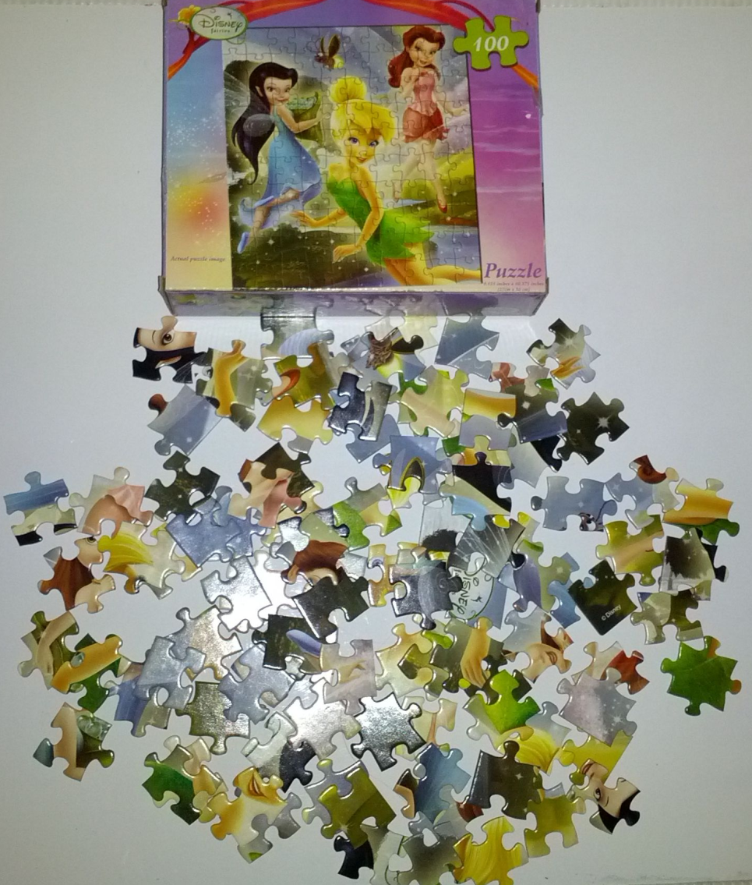
Figure 1. Puzzle participants assembled when exposed to no music, music with lyrics, or music without lyrics. Participants completed a Disney-faerie themed 100-piece puzzle in 4 min.

Figure 2. Number of puzzle pieces assembled when exposed to lyrical, instrumental,
or no music.

Figure 3. Sex differences in number of puzzle pieces assembled.
Appendix A
Please refer to the first track in the CD.

Appendix B
Please refer to the second track on the CD.

