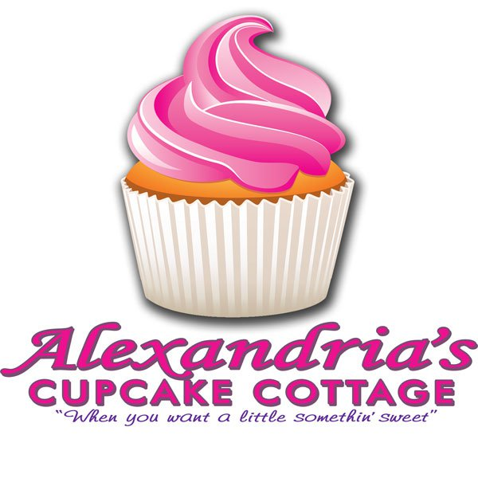
Business Overview
Media Plan
Alexandria’s Cupcake Cottage
Kayce DuVall
Drury University

Since 2007, which is considered to be the year of the cupcake boom, the number of specialty bakeries (cupcakes, cake pops, cakes, etc.) has increased throughout cities in the United States. Small businesses have played a huge role in the trend. Because the bakery field has had a surplus of small businesses in past years, these businesses are striving to gain a competitive advantage over other bakeries in their area through advertising.
Alexandria’s Cupcake Cottage is working to gain a competitive advantage in Springfield, Missouri.
Established in March 2011, Alexandria’s is owned by Alexandria Belle Blewer. It is located on the south side of Springfield on Republic Road between South National and South Freemont. The hours of operation are Monday- Saturday 10:00 a.m. to 6:00 p.m.
Alexandria’s offers a variety of items such as:

- Cupcakes
- Cannolis
- Cookies
- Candies
- Cheesecakes
- Pies
- Specialty & Birthday Cakes
- Wedding Cakes
- Candy Buffets and Dessert Bars for wedding and corporate clients

These items can be picked up in the shop as well as ordered in advance. All specialty, birthday, wedding cakes and candy buffets and dessert bars must be ordered in advance.

Their specialty service is Fairytale Tea Parties, which is a themed party created for children’s birthday parties, bridal showers or baby showers. Employees are dressed as fairies and create a fairytale atmosphere that is memorable for all attendants with the food and decorations.
Situation Analysis

In the Springfield area, there are approximately 25 competitors, one of which is less than one mile away. Many of the competitors offer items such as cakes, cupcakes, pastries and cake pops.
The strongest competitor that Alexandria’s has is a franchise company called The Cup, located in downtown Springfield. Since it is a franchise, The Cup has more allocations for advertising, which they use well. The Cup has a strong social media presence with their website and Facebook page. The Cup has strong a advertising strategy. For example, The Cup has advertisements and coupons located on the back of Springfield Cardinal tickets as well as on the envelopes that the Cardinals use.
Economical changes could have an effect on the business both positively and negatively. If there are tough economic times, there could be a possible decrease in sales, as individuals do not have excess money to spend on items that Alexandria’s sells. Good economic times could have a positive effect though, as people have more discretionary funds to spend.
Alexandria’s has various strengths, weaknesses, opportunities and threats, as listed in the following SWOT analysis:
Strengths
- Specialty parties, which competitors do not offer
- Variety of items
- Competitive prices
- Good, timely customer interaction
- Located in high traffic area
- Good customer relationships
Weaknesses
- Little social media presence
- No actual website
- Small shop
- Little advertising
Opportunities
- Could gain a larger customer base with specialty cakes
- Healthier dessert options
- Expansion of product line
Threats
- Large number of competitors
- Competitors are in close distance
- Weak economy could effect customer’s discretionary spending
- Lifestyles of individuals to become more healthy and organic
Problem Statement

Alexandria’s has low brand name awareness among women ages 24- 45. A strategic media plan is needed to introduce the target to Alexandria’s Cupcake Cottage and its products.

Marketing Goal

To increase sales by 25% for the 6-month period July- December 2013 with a media investment of $5,000.

Communication/ Media Objectives and Strategies

- Increase brand name awareness among women 35-54 in the Springfield metro area who purchase every day and special occasion baked goods.
- Increase brand name awareness based on frequency objectives. This strategy is appropriate because a frequency objective will introduce the brand to the target audience multiple times to create awareness.
- Increase brand name awareness based on a pulsing scheduling pattern. This strategy will have constant advertising with additional advertising during certain months. This is important because it will keep constant interaction with the audience as well as have more interaction during months of importance (wedding season, holidays, etc.).

Communication Tactics

Magazines
- 417 Magazine
  - With a circulation of 18,668, this magazine is popular through Springfield and surrounding communities and will frequently be in the hands of the target audience.
    - Cost per color ad: $125.60
    - CMP: 125.60/18,668 x1,000 = $6.73
    - Recommended number of ads: 9 (July, Aug., Oct., Dec.)
    - Total cost for campaign: $1,130.40

- Metropolitan Bride
  - Though the circulation could not be determined, this magazine will be helpful in frequently reaching those who would want to buy a wedding cake within the target audience.
    - Cost per color ad: $125.60
    - CMP: (cannot be determined)
    - Recommended number of ads: 8 (July, Aug., Sept., Oct.)
    - Total cost for campaign: $1,004.80

Radio
- KTTS-FM
  - As one of Springfield’s most popular stations, this will reach the largest number of people and the target audience the most frequently. (Reach: 7,200: morning, 7,700: afternoon, 4,400: weekend)
    - Cost per morning ad: $80.00
    - CMP: 80.00/7,200 x 1,000 = $11.11
    - Recommended number of ads: 11 (July, Sept., Nov.)
    - Total cost for campaign: $960

    - Cost per weekend ad: $40.00
    - CMP: 40.00/4,400 x 1,000 = $9.10
    - Recommended number of ads: 10 (July, Sept., Nov.)
    - Total cost for campaign: $400

    - Cost per weekend ad: $40.00
    - CMP: 95.00/7,700 x 1,000 = $12.34
    - Recommended number of ads: 10 (July, Sept., Nov.)
    - Total cost for campaign: $950

Direct Mail
- 5 mile radius from business
  - This direct mailer will reach those within the target audience who in a close proximity who are more likely to come to Alexandria’s. Will include a purchase incentive for those who visit Alexandria’s.
    - Total cost for campaign: $105

Guerilla Marketing
- The guerilla-marketing tactic that will be used is providing complementary cupcakes and/ or cakes to bridal shops in the area for the clients to sample.
    - Total cost for campaign: $190
Budget

Contingency: $250

Magazines: $2,135.20

417 Magazine: $1,130.40
9 times
1/12 Color
Metropolitan Magazine: $1,004.80
8 times
1/12 Color

Radio: $2,310.00

KTTS-FM:
Morning Drive: $960
11 spots
Weekend: $400
10 spots
Afternoon Drive: $950
10 spots

Direct Mail (E-Marketing): $105 (3 months)

Guerilla Marketing: $190

Total: $4,990.20

