Drury Universities Communication Portal Project

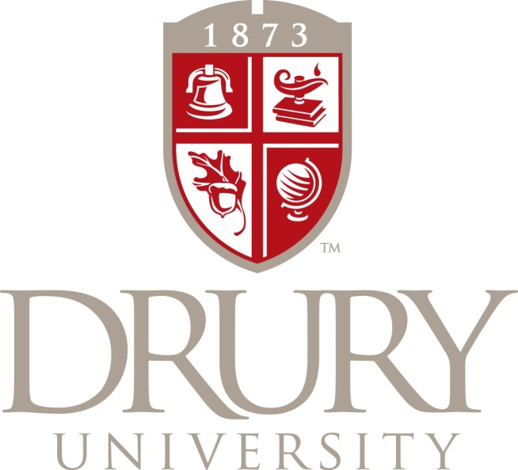
Dineke Bernier
November 7, 2013

Drury Universities Communication Portal Project

Prepared by Dineke Bernier
Senior Seminar Project

Report Distributed November 7, 2013

Prepared for
Marketing & Development Department
Drury University

Executive Summary
This report examines the communication portals which Drury University routinely uses to communicate relevant as well as crucial information to 1,500 undergraduate students on a daily, weekly, and monthly basis. The purpose of this report is to provide the Marketing & Communications Department with the information necessary for assessing the effectiveness of the current developed communication outlets in concern to the intended consumer’s needs. The consumer reference through this research is Drury University undergraduate students. Compilation of both qualitative and quantitative research is used to form five conclusive integrated themes that will positively influence how the consumers interact with the communication portals that are established and overseen by the Marketing & Communication department. Over 100 online surveys were collected, twenty one-on-one interviews were gathered, and a fifteen participant focus group was conducted.

The current communication systems that are available to be utilized by students are: email, Facebook, Twitter, text, D.CAL, and screen monitors in resident halls and student center. Results extracted from the online survey exposes four main concerns with students interactions with communication portals on campus (1)lack of knowledge of current communication tools available, (2) minimal awareness of proper knowledge in use of communication tools and their added benefits, (3) distress on placement of information, (4) general lack of awareness of current events and opportunities.
The approach that was originally allotted to the lack of student awareness of events on campus was to create a new portal of communication to elevate lapses in the current systems. After extensive exploration of students favored communication portals, their basic needs and desires, and their routine habits it was concluded that rather than the creation of a new portal, current portals must be adapted to fit the needs of students.
The recommendations that will be presented are contained under the current portal of D.CAL. D.CAL will act as the unifying umbrella for all current portals of communication. When announcements are made concerning activities on campus that pertain to students the logo of D.CAL will be placed on email, Twitter, Facebook, texts, and campus TV monitors with the event update. The uniformity of D.CAL on all portals will eliminate confusion of what source is producing the updates. Updates of events will be continued on Twitter, Facebook, and campus TV monitors. Weekly condensed updates of events will be sent to the students email with D.CAL links attached if students seek additional information. At the beginning of each academic year tutorials will be sent out to students to educate students on D.CAL as well as the use of the Drury App. It is recommended that Drury changes their mobile app button for events to D.CAL to continue uniformity of announcements. The option of syncing student’s personal outlook calendars to D.CAL will also offer accessibility to events information. Lastly, the weekly printing of significant events on campus trifold leaflet will be placed on dining hall tables.

TABLE OF CONTENTS
EXECUTIVE SUMMARY………………………………………………………………. 1
INTRODUCTION……………………………………………………………………….. 5
METHODS……………………………………………………………………………….. 6
RESULTS AND DISCUSSION ………………………………………………………… 6
ONLINE SURVEY……………………………………………………………… 6
ONE-ON-ONE INTERVIEWS………………………………………………… 10
FOCUS GROUP………………………………………………………………… 11
CONCLUSION AND RECOMMENDATIONS……………………………………… 12
APPENDICES…………………………………………………………………………… 14
PROJECT CHARTER…………………………………………………………. 14
GANT CHART…………………………………………………………..
INTERVIEW GUIDE ONE-ON-ONE………………………………………… 19
INTERVIEW GUIDE FOCUS GROUP……………………………………… 20
ONE-ON-ONE CONSENT FORM …………………………………………… 21
FOCUS GROUP CONSENT FORM………………………………………….. 22
ONLINE SURVEY CONSENT FORM………………………………………. 23
SURVEY………………………………………………………………………...
RECOMMENDATION VISUALS…………………………………………… 24
DINNING TABLE TRI-FOLD……………………………………….. 24
DRURY APP…………………………………………………………... 25
OUTLOOK CALENDAR……………………………………………... 26
DCAL INFORMATIONAL SESSION………………………………. 27
REFERENES…………………………………………………………………... 30

Introduction
The objective of this research is to analyze the current communication system and its effectiveness in concern to students’ awareness for University events, meetings, and opportunities. The Marketing & Communications Department is the predominant mediator between organizations, faculty, administration, and outside sources daily communication with students. This research solely focuses on the involvement of 1,500 undergraduate day school students in University events. All recommendations and conclusions of this research are drawn from both quantitative and qualitative research.
The undergraduate population at Drury University consists of 1,500 students who chose to pursue their education at a university that is known for its small class sizes, integrated campus life, student engagement, personalized learning, sustainability, achievement, and leadership. The University offers a great deal of engagement within the classroom setting, in addition the University strives to achieve an integrated and connected student life as well. Offering more than 100 student organizations, athletic teams, intramural sports, Greek life, connections with local entrepreneurs and organizations, Drury enables students to have an active-hands-on college experience. With an abundant quantity of activities offered at the University it is essential that a uniformed system be established to transmit important information, events, activities, and opportunities to students.
Drury’s internal communication with students includes: email, text, Facebook, D.CAL, Twitter, and screen monitors in resident halls and the Findley Student Center. The Marketing & Communication Department utilizes all of these portals to communicate University events with students. The Department sends out daily, weekly, and monthly information to students on an ongoing bases. The transmission line between Drury and its students has been highly criticized for years by the student population. Students have taken two stances on the communication agenda of the University: either they claim they are bombarded with updates and information or they are clueless to events on campus and feel secluded from educational and social opportunities.
In reply to the students stances the Marketing & Communication Department pursued a solution with the creation of D.CAL. D.CAL, an abbreviation of Drury Calendar, is the host center to all events on campus for students, faculty, and the community. Unfortunately, the student community has not adopted this new forum successfully. Thus, the need for knowledge and data concerning students’ communication requirements’ and requests to be thoroughly analyzed and applied to the current system. The results of this will aid the development of a set of recommendations that will improve the efficiency and direct nature of the communication portal.
This report’s data is taken from one-on-one interviews, a focus group, and an online survey. The scope of this research is to present plausible recommendations that can be implemented by the Marketing & Communications Department. With this in mind, each of the recommendations made through this report have not been tested for effectiveness or validity.
The structure of this report is outlined in four main communication portal concerns provided by students: (1) lack of knowledge of current communication tools available, (2) minimal awareness of proper knowledge in use of communication tools and their benefits, (3) distress on placement of information, and (4) the general lack of awareness of current events and opportunities. The research findings will be introduced in the following sections: methods, results and discussion, conclusions and recommendations. Each section will consecutively build off of the previous section’s evaluations and data, culminating with a comprehensive conclusion and the creation of five recommendations.
Methods
This section of the report focuses on students’ use of current communication portals in concern to events and opportunities offered by the University. Students were questioned on their preferred method of communication, overall knowledge of events, use of communication systems, and their thoughts and concerns with the current system. Collected data was conducted with four different research methods each segmenting a different problematic objective outlined by students.
Research testing was conducted with 20 one-on-one interviews, a focus group consisting of fifteen students, and a survey taken by 110 undergraduate students. The use of both quantitative and qualitative research was deemed crucial to ensure well-rounded recommendations. All methods of research were formally submitted for IRB approval. The profile requirement to participate in any section of this research was the proclamation that one was a full time undergraduate day school student. All participants were supplied with an informed consent form that outlined the research purposes and the autonomy of the research. Prior research was conducted through the Drury website as well as accredited journal databases.
Results and Discussion
Research gain from the surveys, the one-on-one’s, and the focus group were greatly insightful, particular insights concerning students preferred methods of communication, knowledge of existing communication portals, exploration usage trends, and familiarity of portal use. The results and discussion of each research method will be discussed separately and then collectively reasoned at the end of this section.
Online survey: 110 participants
Participants in the online survey were asked 22 questions, questions ranging from multiple choice, yes and no, ranking, and fill in the blanks. The evaluation and discussion of the survey results will be divided into four sub-themes: system use, preferred portal, application, and significance. Each theme be and analyzed specifically for significance and influence on internal communication with students in regards to activities and events on campus.
System use, this section of the survey focuses on newly implemented systems. The two specific systems investigated are D.CAL and the Drury App, a shortcut to Drury’s website content. It is evident that both D.CAL and the Drury App have high rates of non-usage. The negative result of non-student usage of both of these systems can be reasoned by the lack of publicity on D.CAL’s and the app’s benefits. The majority of students were completely unaware of the Drury app.
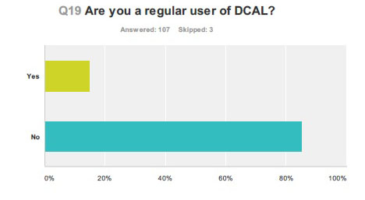
Figure 1: Regular User of D.CAL

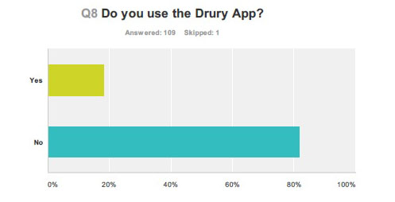
Figure 2: User of the Drury App
Preferred Portal, this question focuses on the use of all portals on Drury’s campus by students. Email received the highest ranking in comparison to all of the portals; following was word of mouth and Facebook. The rankings of preferred use of communication portals are not surprising, since students previously stated their favoritism towards email notifications. Students were also asked why they so heavily favored email as a communication portal; the overwhelming reply was efficiency and knowledge of the system. Interestingly D.CAL was not a favored means of finding out what happens on campus, although that is the systems intent.
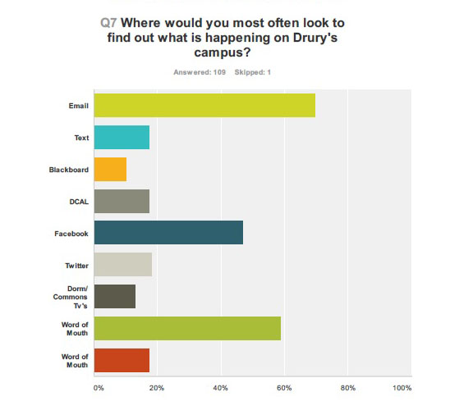
Figure 3: Ranking of Communication Portals
Application, when students were asked two different questions concerning where they would search for information on athletic and student life events their answers greatly varied per topic of search. Those who inquired about athletic events favored D.CAL as the highest search portal; in contrast, those students who were searching for student events went to their email. Perplexingly enough D.CAL holds equal information on athletic events and student activities, but students continue to look towards their email for guidance.
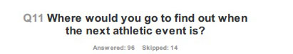
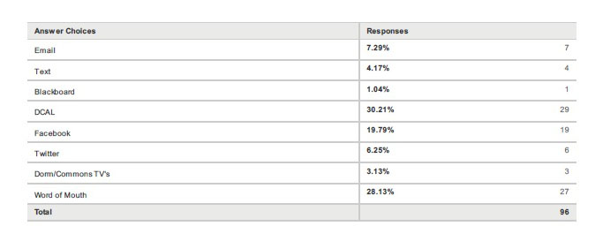
Figure 4: Athletic Search of Portals
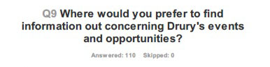
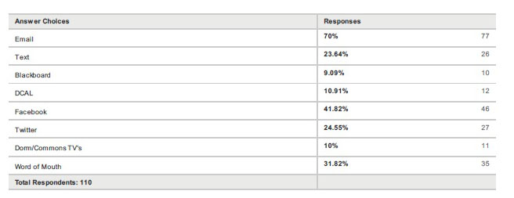
Figure 5: Drury Event Search of Portals
Significance, Drury students have continually stated their high email usage as a supporting reason for having all of the Marketing & Communication Departments messages filtered through their email, allowing students to have access to events and their email in the same place, aiding the students argument of convenience.
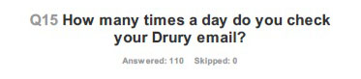
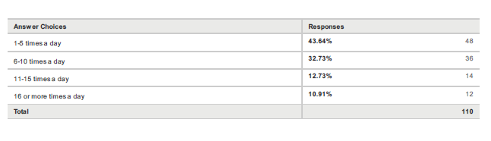
Figure 6: Email Usage
In conclusion to the 110 surveys collected significant insights were gained. Trends and preferences were expanded, resulting in new thoughts and questions arising. A clearer vision of recommendations started to form and answers provided a foundation of needs for a framework to be built off of.
One-on-One Interviews: 20 Participants
One-on-one interviews gathered qualitative data that allowed for further in-depth responses and emotion surveillance of subjects. Results gathered from this research concluded that students prefer email notifications to D.CAL because checking email is a habitual habit for their schoolwork, professor contact, and campus connections. Students were asked questions within the interview session concerning their feelings on D.CAL, Twitter, Facebook, texts, and email, and how they personally interacted with each of these portals. The common response concerning preference in portals was students’ preference to receive emails that announce events on campus. Participants were very clear that they did not want any texts from the University; one student stated, “My texts are private; unless it is an extreme emergency never send information to my personal line.”
It was extremely evident that students had great difficulty naming events that took place the previous week on campus. A large sum of students could not name one event that had occurred in the previous week on Drury’s campus. When questioned further about students’ lack of awareness of events one student said, “I don’t feel engaged. I only know about events after the fact. I don’t know exactly where to look. Some events are filtered through my email, others are on Facebook, and it leaves me unaware and confused.” When pressed about students’ confusion on location of events, one student said, “Just keep it consistent. Post all of the information in one place, and educate me on where that location is.” Another student added, “Our professors teach us about continuity and reliability. I don’t feel that Drury communication system supports either. Information always comes at me form all different sources, and all say a different message.”
A main concern that was addressed in the one-on-one interviews was the lack of knowledge of D.CAL. 15 out of the 20 participants didn’t know what D.CAL encompassed or where to even find this communication portal. Zero of the 20 participants had the Drury app on their phone. It became evident that students were unaware and uneducated about Drury’s communication portals and how to utilize these portals. One student shared, “Embrace technology, but not technology that requires a learning curve for the students. Existing forms of communication is key. People are stubborn and don’t want more apps for communicating on their phone that aren’t necessary.” Another student said, “Make D.CAL more accessible or linked with Facebook/Twitter. D.CAL could be a great tool, but many clubs and organizations do not utilize it partially because I think the majority of students don’t ever look at it.” The conclusion drawn from these responses is that students are not necessarily opposed to the use of the D.CAL system; students are just unaware of its intent and lack necessary knowledge to successfully use these portals.
Focus Group: 15 participants
The focus group’s main concentration was on potential implementations and revisions of current system, to transform current communication portals that fit the needs of students. “Our administration is great, but sometimes they need to consult us the students. We are the main users of programs so why are these programs not molded to our needs rather than the assumed needs?” said one student. Participants were engaged with one another’s ideas and concerns pertaining to the current communication portals. It was clear that students wanted email updates, but participants were open to learning and engaging with new communication portals, only if those systems aims were to clarify and dilute the current system.
The continuous conversation of the focus group led to the conclusion of four main points. First students want to be notified about events in a simplistic manner. Second, the University needs one unifying “pilot” of communication that everyone can connect to as the originator of messages that are sent to different portals concerning student involvement opportunities. Third, students should attend engaged learning sessions concerning the pilot portals benefits and tools. Lastly, students want a communication portal “pilot” which encompasses all events and opportunities on Drury’s campus.
Understanding students’ specific needs, inclinations, and dispositions is crucial. It is with these insights that the current structure can be reformed and modified to effectively fit the needs of students, resulting in a more knowledgeable and informed student community. The consensus of this qualitative and quantitative research is that students crave community awareness. Students want their information to be easily accessed; their preferred method of communication is email; they want convenience and structure. A clearer vision of the scope of student involvement, student needs, liabilities and lapses within the current communication system has resulted in the stem and formulation of a framework that will encompass the needs of current students: efficiency, uniformity, and awareness, interwoven within the current system.
Conclusion and Recommendations
The approach that was originally allotted to the lack of student awareness of events on campus was to create a new portal of communication to elevate lapses in the current systems. After extensive exploration of students favored communication portals, their basic needs and desires, and routine habits, it was concluded that rather than the creation of a new portal, current portals must be adapted to fit the needs of students.
Data gathered from qualitative and quantitative research is the fundamental support structure to the recommendation initiatives that will follow below. It must be noted that these recommendations have not been tested, they are merely evaluated on their effectiveness and plausibility. Further research and trials of these recommendations will be required to ensure efficiency and positive receptive responses.
A critical portion of this research is reliant on the comprehension of the communication portals audience, the Drury students. Sutton and Hyde write, “Millennials are results oriented experimental learners… They are impatient and typically accelerate learning by performing several tasks at once…They expect flexibility and convenience as well as the ability to personalize and customize their learning experiences just as they do their communication and entertainment experiences” (p.56). Drury students were extremely descriptive and thorough in their desired requirements for where, how, and why they want university announcements released.
The recommendations created are a marriage between the current system employed by the Marketing & Communication Department and the requests and needs of Drury students. With the knowledge learned, I offer the following five recommendations for consideration for the Marketing & Communication Department to employ:
- D.CAL to be the pilot to all University events and opportunities. Any announcement concerning these items will always have the D.CAL logo attached on the upper left corner to create uniformity for all events. Emails, Facebook updates, Twitter blasts, and student building monitors will pull information from DCAL and then proceed to promote awareness of University events. Each communication portal will work congruently with D.CAL and always offer links to the D.CAL page for further information.
- Students’ opportunity to be properly be educated on the intent and tools of D.CAL. Education will also be linked to the Drury app and its connection with D.CAL.
- D.CAL to be synced to students’ outlook email calendars, creating easy access to dates in a portal that is already so heavily used. Students can also preference certain event information regarding their interests to be placed on their email calendar.
- The Drury’s app will change the name of events on the home screen to say DCAL, to expose the connection of D.CAL’s operation on the Drury app and promote consistency.
- Weekly leaflets to be distributed to the fifty dining tables in the commons with important DCAL events. The yearly invoice for this implementation is $136.00, provided by Carbon Copy.
Continuation of the Marketing & Communications department’s current operations, with the implementations of the above recommendations, should ensure the students support of communication portals will increase as well as awareness of events on campus and overall participation.

Signature Project Charter: Communication Portal Project
DINEKE BERNIER-SEPTEMBER 19, 2013

- CLIENT/ORGANIZATION
The client of this Communication Portal Project is Marketing & Communications. This office is responsible for the release of both internal and external campus information as well as the facilitation of university publications including the Drury Magazine. The office of Marketing & Communications also acts as a facilitator between members of the media and coverage of the university. Presently the Marketing & Communications office uses Drury University Calendar (DCAL) and email to correspond news, events and important information to students, staff, and faculty.

  - The Drury University Community
    - Student Community: Transfer students, on-campus students, and commuter students
    - Mark Miller, Associate Director of Marketing & Communications
    - Jann Holland, Executive Director of Marketing & Communications
    - Amanda Seaman, Web Services

- PURPOSE OF THIS PROJECT
The purpose of the Communication Portal Project is to develop a communication method that facilitates access and retrieval of critical and pertinent organizational information by Drury students. Drury’s current method of communication with students is through email and DCAL.

Drury allocates a university-based email to all of its students; this email is often used as a means of communication between students, faculty, staff and outside sources. The dilemma that has risen from using email as a main method to communicate with students is that students feel overwhelmed by mass emails flooding their inboxes, resulting in students deleting important informational emails before they are properly read. The other method used by Marketing & Communications is DCAL. DCAL is an online based calendar that updates students on current and upcoming events and opportunities on campus. Unfortunately, students don’t use this resource and are not informed of the opportunities this resource offers.

The purpose of the Communication Portal Project is to understand the current needs of Drury students and their preferred method to receive important information. The conclusion drawn from this research will result in creating a communication method that best fits the needs of Drury’s students and then testing this new method to ensure its effectiveness. This projects success can be measured by Drury students viewing this newly created communication method in a positive light and using this new source to remain up-to-date on events, opportunities, and news regarding the university.

- PROJECT OBJECTIVE
  - Conduct 20 one-on-one interviews with students to determine strengths and weaknesses of current system
  - Trial: Create three potential communication methods to replace the current system
  - Test three communication methods by connecting with a 15- student focus group and gather their criticisms and positive thoughts toward the trial method.
  - Implement criticisms on the preferred communication method
  - Compile all research findings and present a recommendation to Marketing & Communications on the preferred communication method in connecting with students.

- TARGET AUDIENCE
  - Drury students: on-campus and commuter

- DELIVERABLES
  - A student approved and tested communication method that Marketing & Communications department can employ as a communication means between students and the release significant information.
  - Research findings from 20 one-on-one student interviews on the pros and cons of current communication portal. In addition the findings on what students are looking for as an efficient means to communicate.
    - See page five for interview questions
  - Research findings from a 15 student focus group on the three trial methods of communication.
    - See page five for interview questions
  - A list of recommendations and all research findings to Marketing & Communications
  - A final research paper concluding all of my findings and gained knowledge

- RESEARCH NEEDS
  - Approval for human subject research by the Institutional Review Board
    - Research approval conducted by Mary Utley
  - Primary Research
    - Conduct 20 ONE-ON ONE Interviews with students:
      - Interview students from all different majors on Drury’s campus to gain a better perspective on their needs of campus knowledge and how they would prefer to receive those messages. What are the preferable methods they use to find out information concerning opportunities or events? What are the flaws that are seen in the current communication system? As well as what are students interested in knowing?
- Conduct 15 student focus group:
  - Interview students to gain the pros and cons of the trial communication methods
- Secondary Research
- Review 10 peer reviewed articles on methods of communication:
- Create 10 fact sheets that hold important data and information concerning use of communication portals and how to effectively use them
- Investigate other methods:
- Research other implemented forms of communication through other schools, companies, and groups via the internet and personal connections
  - Personal conversations will be conducted over the phone or email
    - What are they using? What are the strengths of these methods? What are the weaknesses? How could it be potential implemented on a college campus?

- RESOURCE NEEDS
  - Supplies:
    - Computer Software (Microsoft Office, Adobe Creative Suite, Photoshop, and Excel)
    - Access to academic articles for secondary research
    - Access to other companies, groups and universities methods of communication
      - Will be accessed through the internet investigation and personal connections
        - Personal contacts will be contacted via personal email or phone
    - Paper and Ink, used for printing interviews and drafting ideas of solutions
    - IRB approval form
  - Outside Expertise:
    - Council from Mark Miller and Jann Holland on their needs and desires for communication methods and services between their department and Drury students
    - Outside one-on-ones, primary research
      - 20 interviews with students
      - 15 student focus group
    - Mary Utley, IRB coordinator
- Preliminary Budgets:
- Printed Materials: $15- supplied personally
  - Printing of interview questions
  - Printing of IRB form
  - Drafting ideas of potential communication implementations
  - Final research report
- Phone Calls: Supplied by my personal cellular plan
  - Will be made to contact other business, groups and students at other universities
- Computer Software: Already supplied personally

- COMPLETION DATE
  - November 7, 2013

- POTENTIAL OBSTACLES TO SUCCESS
  - Lack of communication and availability from one-on-one interviews with students
  - Lack of communication and availability to form and collect information in the focus group
  - Limited availability of Mark Miller and Jann Holland for consultations
  - Lack of secondary resources or absence of relatable topics and articles concerning effective use of communication portals
  - Unrealistic needs/ desires of Drury’s students expectations of communication between Media Services and the Drury community
  - Failure of approval from IRB, resulting prevention of one-on-one interviews
  - Difficulty in creating a new communication portal that fits the needs of both the students and information providers
  - Lack of response from students on trial communication methods
  - Failure of new communication method to promote awareness to Drury students

- PROJECT METRICS
  - The success of Communication Portal Project will be measured by:
    - Completion of all 20 one-on-on interviews with students
    - Completion of 15 student focus group and their insights
      - This will result in gain of pros and cons of trialed communication methods
- Marketing & Communications gain in knowledge and understanding of what Drury students favor in receiving important information
- The use of this new communication method by Marketing & Communications in the upcoming school year

- ONE-ON-ONE INTERVIEW QUESTIONS
- What source do you use to find out information concerning campus?
- What are your thoughts on DCAL?
- Have you ever used this source as a means to find information?
- What are your thoughts on Drury using email as a means to communicate crucial information to students?
- What do you do when you see an email for Marketing & Communications?
- When looking at your email what differentiates emails that you read and those you delete?
- On a scale of one to ten how informed do you feel about events and opportunities on Drury’s campus?
- When you want to find something out what communication source do you use?
- Twitter, Facebook……?
- What are the events that you find crucial to know regarding the events and opportunities on Drury’s campus?
- How do you feel about receiving text messages from the university giving you updates?
- How do you feel about receiving Facebook or Twitter notifications from the university giving you updates?
- What do you think would be a convenient method to communicate with students?
- Can you name one event that occurred on our campus last week?
- Would you like texts sent to your phone?
- Take me through your though process when you want to find out something that is happening on Drury’s Campus?
- What would you like to see ?
- What portals do you use regularly? Why?
- Would you attend a DCAL informational session?
- How much time in advance do you want to hear announcements about events?
- Do you find DCAL useful?

- FOCUS GROUP QUESTIONS
- What are your overall feelings about the communication system in place at Drury?
- Do you find it efficient?
- Do you find it easy to work with?
- Do you feel informed?
- What are the negatives of our current communication system?
- What are the positives of our communication system?
- Do you use DCAL? Why or Why not?
- What are the events you want to hear about? How in advance do you want to hear the specifics about that event?
- Would you go to the Mirror to find out information about events?
- What do you think is missing when announcements are made about events?
- Do you think all events are publicized equally?
- What would you like to see implemented at Drury in concern to communication system?
- Can you see any pros and cons to your idea?
- Would you read a leaflet of events placed on commons tables?
- Would you want to have your email and DCAL connected?
- Would you want an informational session on how to correctly use DCAL?
- Why do or don’t you use the Drury App?
- Any Comments or advice?

One-on-One Informed Consent Form
You are invited to participate in a short one-on-one interview to research your opinions, criticisms, and attitudes regarding Drury Universities’ communication portal with students. This information (along with secondary and primary research) is being gathered to gain insight for my senior seminar research project that will be used to create a more efficient method to communicate with students about important events and opportunities on Drury’s campus.
Procedures to be followed in the Interview: You will be asked a series of questions about your opinions, criticisms and attitudes towards Drury Universities DCAL, email notifications, Drury’s approach towards connecting with students, and your advice on a better solution. You may skip any questions that you do not want to answer and you may stop at any time. Estimated time for completion is approximately 10 minutes.
Anonymity of Participants and Confidentiality of Results: Participation in this study is voluntary. Your name will never be connected or associated with your responses. Data collected from this one-on-one interview will be presented collectively, not individually.
Compensation and Benefits: You will receive no compensation/benefits for your involvement with this interview. Involvement is completely voluntary.
Discomforts and Risks: There are no foreseeable risks or benefits in this survey process. If you feel uncomfortable for any reason you may stop at any time. There are no penalties for stopping. If you have any questions or concerns after the survey process is completed or if you would like a copy of the results of the study, you can contact dbernier01@drury.edu, researcher or Dr. Regina Waters at (417)873-7251, rwaters@drury.edu, in the Department of Communication at Drury University.
I have read the material above, and any questions I asked have been answered to my satisfaction. I agree to participate in this activity, realizing that I may withdraw without prejudice at any time.
This project has been reviewed and approved by the Drury University Institutional Review Board. The IRB has determined that the research procedures adequately safeguard the subject’s privacy, welfare, civil liberties and rights. The chair of the council may be reached at Drury University, 900 N. Benton Ave., Springfield, MO 65802. Telephone number: 417-873-7306

Signature Participants/Subject: __________________________________________
Printed Name: ___________________________________________ Date :_______________

Focus Group Informed Consent Form
You are invited to participate in a focus group to research your opinions, criticisms, and attitudes regarding a trial method for Drury Universities’ communication with students. This focus group will look at three different communication possibilities that could be substituted for the current DCAL or email methods of contact. This information (along with secondary and primary research) is being gathered to gain insight for my senior seminar research project that will be used to create a more efficient method to communicate with students about important events and opportunities on Drury’s campus.
Procedures to be followed in the Interview: You will be asked a series of questions about your opinions, criticisms and attitudes towards Drury Universities DCAL, email notifications, Drury’s approach towards connecting with students, and your advice on a better solution. You may skip any questions that you do not want to answer and you may stop at any time. Estimated time for completion is approximately 10 minutes.
Anonymity of Participants and Confidentiality of Results: Participation in this study is voluntary. Your name will never be connected or associated with your responses. Data collected from this focus group will be presented collectively, not individually.
Compensation and Benefits: You will receive no compensation/benefits for your involvement with this interview. Involvement is completely voluntary.
Discomforts and Risks: There are no foreseeable risks or benefits in this survey process. If you feel uncomfortable for any reason you may stop at any time. There are no penalties for stopping. If you have any questions or concerns after the survey process is completed or if you would like a copy of the results of the study, you can contact dbernier01@drury.edu, researcher or Dr. Regina Waters at (417)873-7251, rwaters@drury.edu, in the Department of Communication at Drury University.
I have read the material above, and any questions I asked have been answered to my satisfaction. I agree to participate in this activity, realizing that I may withdraw without prejudice at any time.
This project has been reviewed and approved by the Drury University Institutional Review Board. The IRB has determined that the research procedures adequately safeguard the subject’s privacy, welfare, civil liberties and rights. The chair of the council may be reached at Drury University, 900 N. Benton Ave., Springfield, MO 65802. Telephone number: 417-873-7306

Signature Participants/Subject: __________________________________________
Printed Name: ___________________________________________ Date :_______________
Online Survey Informed Consent Form
You are invited to participate in an online survey to research your opinions, criticisms, and attitudes regarding a trial method for Drury Universities’ communication with students. This focus group will look at three different communication possibilities that could be substituted for the current DCAL or email methods of contact. This information (along with secondary and primary research) is being gathered to gain insight for my senior seminar research project that will be used to create a more efficient method to communicate with students about important events and opportunities on Drury’s campus.
Procedures to be followed in the Interview: You will be asked a series of questions about your opinions, criticisms and attitudes towards Drury Universities DCAL, email notifications, Drury’s approach towards connecting with students, and your advice on a better solution. You may skip any questions that you do not want to answer and you may stop at any time. Estimated time for completion is approximately 10 minutes.
Anonymity of Participants and Confidentiality of Results: Participation in this study is voluntary. Your name will never be connected or associated with your responses. Data collected from this focus group will be presented collectively, not individually.
Compensation and Benefits: You will receive no compensation/benefits for your involvement with this interview. Involvement is completely voluntary.
Discomforts and Risks: There are no foreseeable risks or benefits in this survey process. If you feel uncomfortable for any reason you may stop at any time. There are no penalties for stopping. If you have any questions or concerns after the survey process is completed or if you would like a copy of the results of the study, you can contact dbernier01@drury.edu, researcher or Dr. Regina Waters at (417)873-7251, rwaters@drury.edu, in the Department of Communication at Drury University.
I have read the material above, and any questions I asked have been answered to my satisfaction. I agree to participate in this activity, realizing that I may withdraw without prejudice at any time.
This project has been reviewed and approved by the Drury University Institutional Review Board. The IRB has determined that the research procedures adequately safeguard the subject’s privacy, welfare, civil liberties and rights. The chair of the council may be reached at Drury University, 900 N. Benton Ave., Springfield, MO 65802. Telephone number: 417-873-7306

Signature Participants/Subject: __________________________________________
Printed Name: ___________________________________________ Date :______________
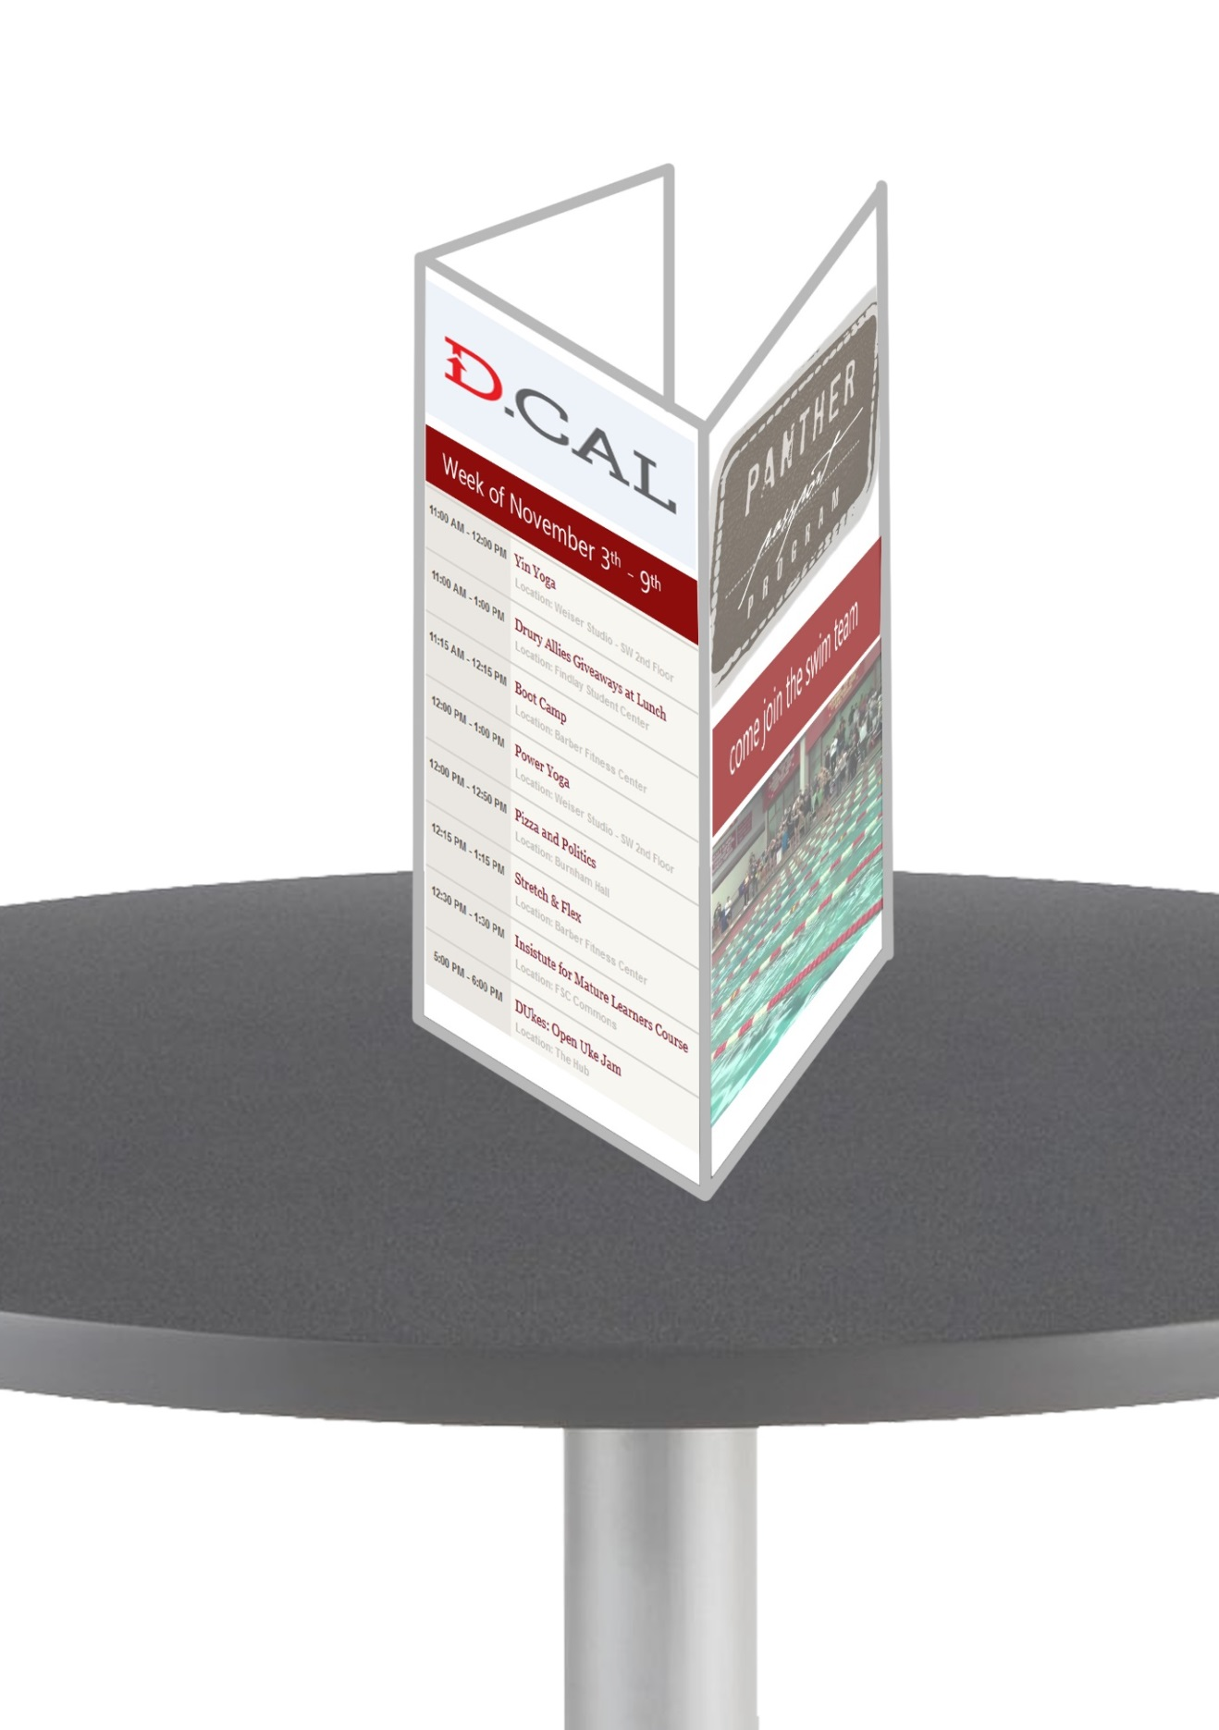
Figure 7: Dinning Tab

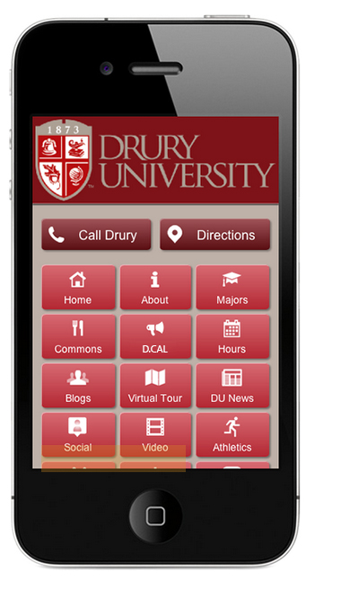
Figure 8: Drury App Recommendation

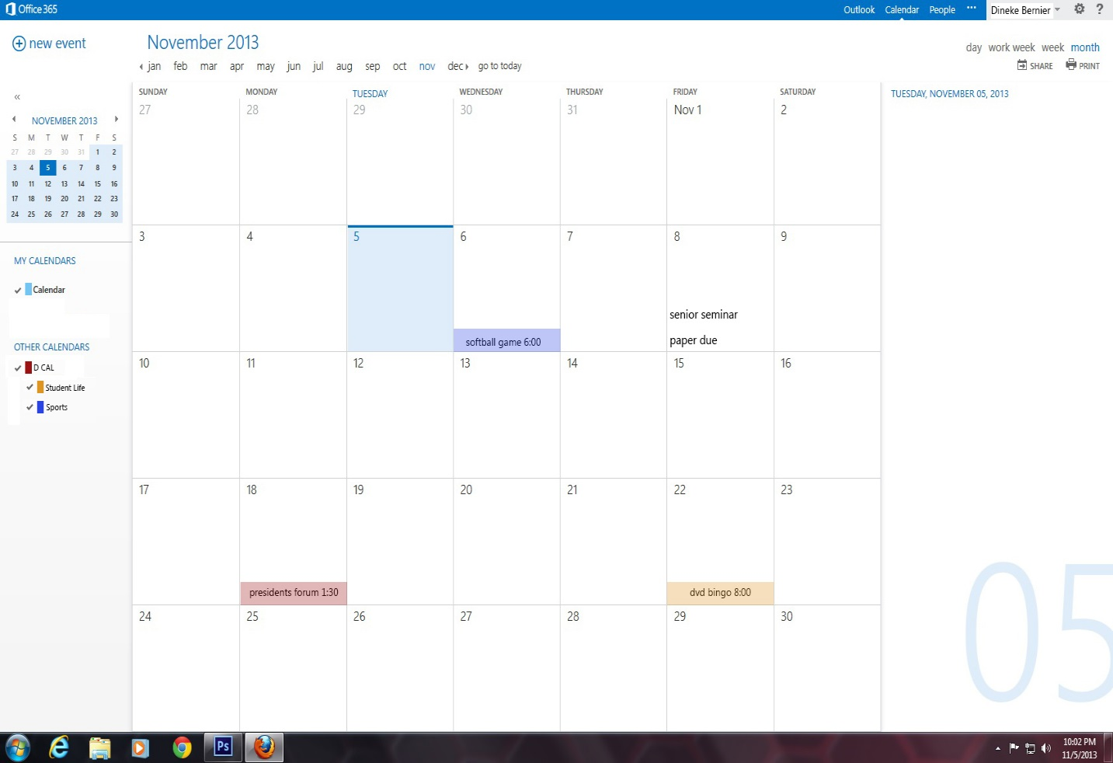
Figure 9: Outlook Email and D.CAL Integration

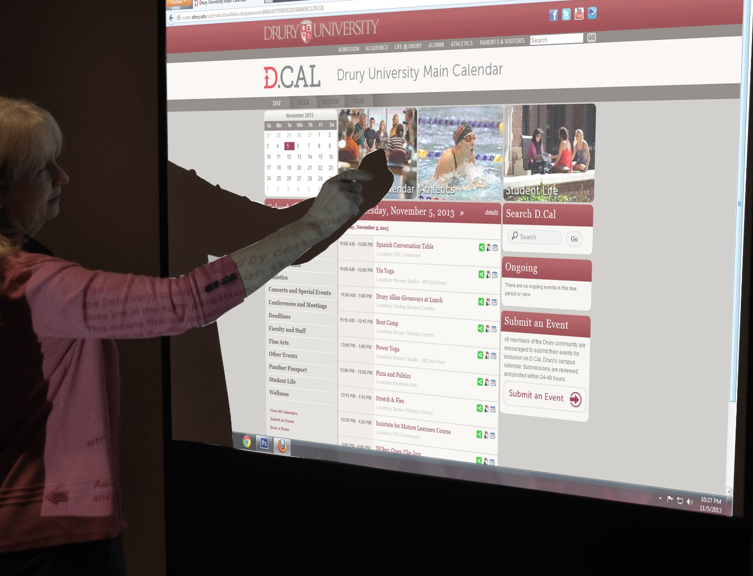
Figure 10:D.CAL Informational Session

References
Sutton, S., & Landry-Hyde, D. (63). Open Access, Scholarly Communication, and the
Millennials. Journal of Teaching Writing, 23.2, 56.

