[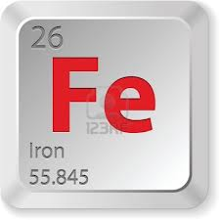](http://www.google.com/url?sa=i&rct=j&q=&esrc=s&frm=1&source=images&cd=&cad=rja&docid=XW4ADjT1EsZ6UM&tbnid=1bPi0JMcHFO5LM:&ved=0CAUQjRw&url=http://www.123rf.com/photo_16703868_iron-element.html&ei=o7VUUbyHIuLH0wGh8YGIDQ&bvm=bv.44442042,d.dmQ&psig=AFQjCNEteySZiJPCwGYuI1McuyBZz9tdJA&ust=1364592395918459)

*Courtney Shultz*

*Produced For Nutrition Connections*

*Under the direction of Nicole A. Clark DON, RD, LDN, CDE IUP Food & Nutrition April 2013*

Resources and Refrences:

<www.eatright.org>

<www.mypryamid.gov>

[www.andevidencelibrary.com](http://www.andevidencelibrary.com)

Do you want to be IRON man?

C:\Users\Owner\AppData\Local\Microsoft\Windows\Temporary Internet Files\Content.IE5\I7VVXM4U\MC900140395[1].wmf

**Dietary sources of Iron:**

1. Mollusks (clams, mussels, oysters, shrimp)
2. Liver (pork, chicken, turkey, lamb, beef)
3. Squash and pumpkin seeds
4. Nuts (cashew, pine, hazelnut, peanut, almond)
5. Beef and lamb
6. Beans and pulses (white beans , lentils)
7. Whole grains, fortified (cereals and bran)
8. Dark leafy greens (spinach , Swiss chard)
9. Dark chocolate and cocoa powder
10. Tofu

[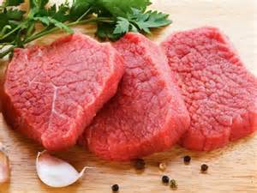](http://images.search.yahoo.com/images/view;_ylt=A0PDoS5sA3dRtncApsSJzbkF;_ylu=X3oDMTBlMTQ4cGxyBHNlYwNzcgRzbGsDaW1n?back=http://images.search.yahoo.com/search/images?p=iron+rich+food&fr=yfp-t-622-s&fr2=piv-web&tab=organic&ri=65&w=600&h=450&imgurl=www.boldsky.com/img/2012/09/28-1348826102-redemeat.jpg&rurl=http://www.boldsky.com/health/wellness/2012/blood-health-iron-foods-031168.html&size=54.7KB&name=We+all+need+to+have+a+balanced+diet+for+a+number+of+reasons.+It+is+very+important+that+we+all+have+enough&p=iron+rich+food&oid=863147a6a402130795c29b7d026654bd&fr2=piv-web&fr=yfp-t-622-s&tt=We+all+need+to+have+a+balanced+diet+for+a+number+of+reasons.+It+is+very+important+that+we+all+have+enough&b=61&ni=96&no=65&ts=&tab=organic&sigr=12fvlc61p&sigb=13amkva53&sigi=11m3pn8ma&.crumb=i6dQu4.ROqQ&fr=yfp-t-622-s)

**What is iron and why do we do need it?**

* Iron is a mineral needed by our bodies. For example iron is a protein in hemoglobin that carries oxygen to the lungs and throughout our body.
* Iron also helps our muscles store and use oxygen.
* Iron is one of the many enzymes used for cellular functions. Enzymes help our bodies digest foods and help many other reactions occur in our bodies.

**What is iron deficiency and why is it a concern?**

* Iron is a condition that results when you are not consuming enough iron.
* Iron is the most common nutrition deficiency and the leading cause of anemia in the United States.
* Iron deficiency is a concern because it can delay normal infant motor function and mental function. Iron deficiency anemia during pregnancy can increase risk for small or early babies. This can cause health problems. Iron deficiency can also cause affect memory and mental functions in teens.

**What** **causes iron deficiency?**

* Iron deficiency is caused because you need an increase in iron or a decrease in iron intake and adsorption.
* What causes iron deficiency in people who need an increase in iron need is : rapid growth, pregnancy and blood loss.
* What causes iron deficiency in people who need to decrease iron intake and adsorption: lack of Heme iron sources in the diet (vegetarian diets) and low absorption.

**Who is most at risk?**

* Young children and pregnant women at higher risk of iron deficiency because of higher iron needs. Adolescent girls and women of childbearing are at risk due to menstruation. Young children 6 months to three years due to rapid growth.

**Signs and symptoms of iron deficiency:**

* Feeling tired and weak
* Decreased work and school performance
* Slow cognitive and social development
* Difficulty maintaining body temperature
* Decreased immune function , which increases susceptibility to infection
* Gossitis

**How is iron deficiency detected?**

* Hemoglobin test which measures protein in the blood that carrier’s oxygen.
* Hematocrit tests the percentage of red blood cells in your blood by volume.
* Along with other test like complete blood count, serum ferritin, serum iron, transferrin saturation and transferrin receptor.

**How is iron deficiency treated?**

* Provide iron supplements.
* Consuming more iron –rich foods in your diet.

**How much iron do I need?**

* Women require 15 milligrams and men require 10 milligrams according to the recommended daily allowance.

[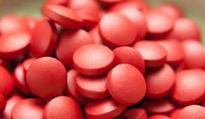](http://www.google.com/imgres?hl=en&biw=1366&bih=673&tbm=isch&tbnid=P0H_fQdaOX3_GM:&imgrefurl=http://www.drugsdb.com/blog/11-supplements-for-women.html&docid=T6AOpsIV879xrM&imgurl=http://cdn.drugsdb.com/images/2012/10/iron-supplements.jpg&w=464&h=270&ei=3wVVUa35JsWp4AOQtoCwDA&zoom=1&ved=1t:3588,r:22,s:0,i:184&iact=rc&dur=775&page=2&tbnh=171&tbnw=291&start=19&ndsp=29&tx=74&ty=81)