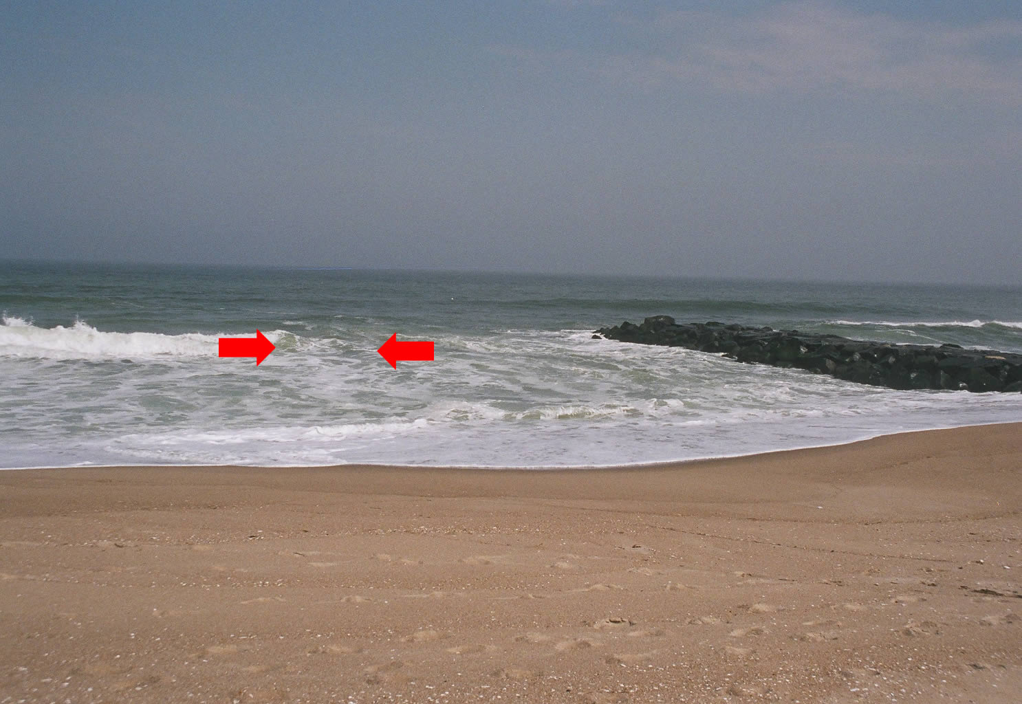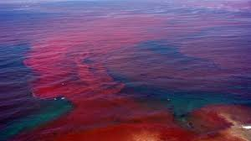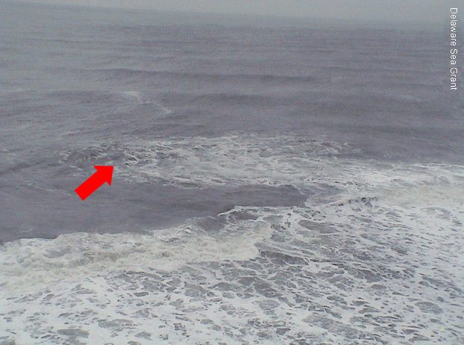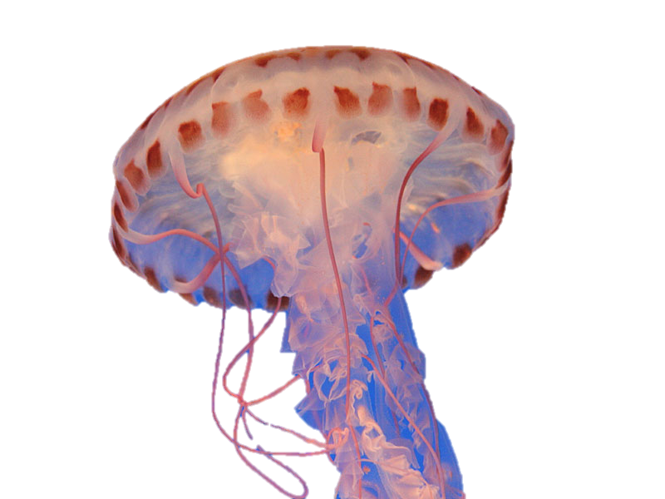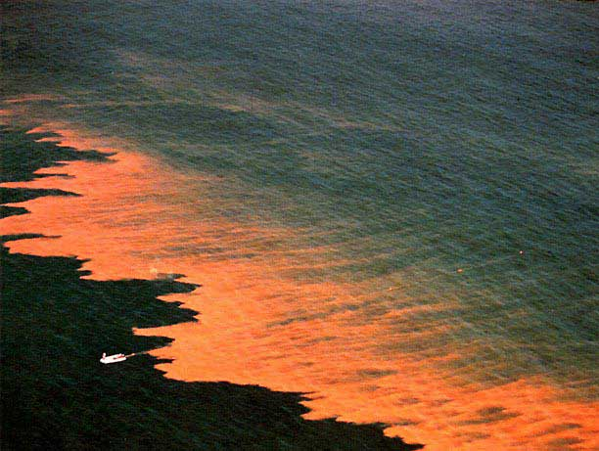

Shark attacks, Jellyfish attacks, Rip Currents, and Harmful Algae Blooms

When trying to recognize the presence of sharks, look for:

* Seals and dolphins🡪these creatures are the prey for sharks
* Sharks feed at night, dusk and dawn
* Warning signs on the beaches

If there is an attack by a shark:

* Remove victim for the water immediately
* Place direct pressure on wound
* Provide warmth
* Do not move victim unnecessarily
* Find immediate medical attention

### Sharks

* Use appropriate dialectic and tone to keep victim calm
* Display your confidence
* Effectively use Uncertainty Reduction Theory
* Communication with the surrounding people
* Keep the communication environment of all participants in the situation under control
  + Directly get lifeguard
  + Directly call 911

## Communicate attacks effectively…

Be prepared before it

happens

Oceanic Attacks

Rip Currents

Rip currents can travel at speeds of 1-2 feet per second and up to 8 feet per second. As a wave crashes, the water that moves back towards the ocean creates a rip current.

Spotting rip currents:

* Low spots or breaks in sand bars
* Different water color
* A break in incoming waves
* A channel of choppy water

If in a rip current:

* Remain calm
* Do not fight the current
* If there is someone else in a rip current make sure to try to give floatation device

Jellyfish

Prevention of jellyfish include:

* Be aware of flags on the beach
* Jellyfish often get washed up on shore
* Pay close attention in the water, especially when in knee depth water

How to address the wound if attacked:

* Pull person out of the water
* Rinse immediately with vinegar
  + DO NOT use fresh or tap water for it can re-activate the stinging cells
* Soak wound for approximately 20 minutes; cold packs can be used as replacement for hot water

Algae Blooms

If there is an increase in nutrients then an algae bloom will form. Algae blooms can also form by over fishing.

What to look for to recognize an algae bloom:

* Foam, scum, or mat like objects on the surface of the water

Symptoms of algae bloom attack:

* Rashes
* Skin and eye irritation
* Gastrointestinal upsets
* Headaches
* Malaise

If you come in contact:

* Remove yourself or person from exposure and give proper treatment