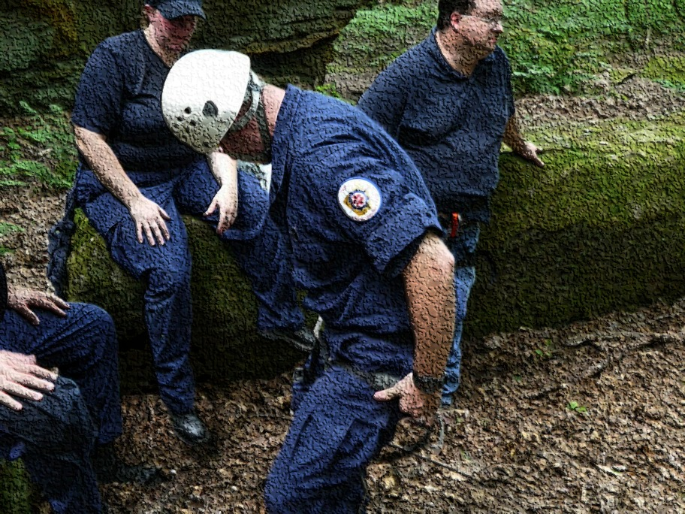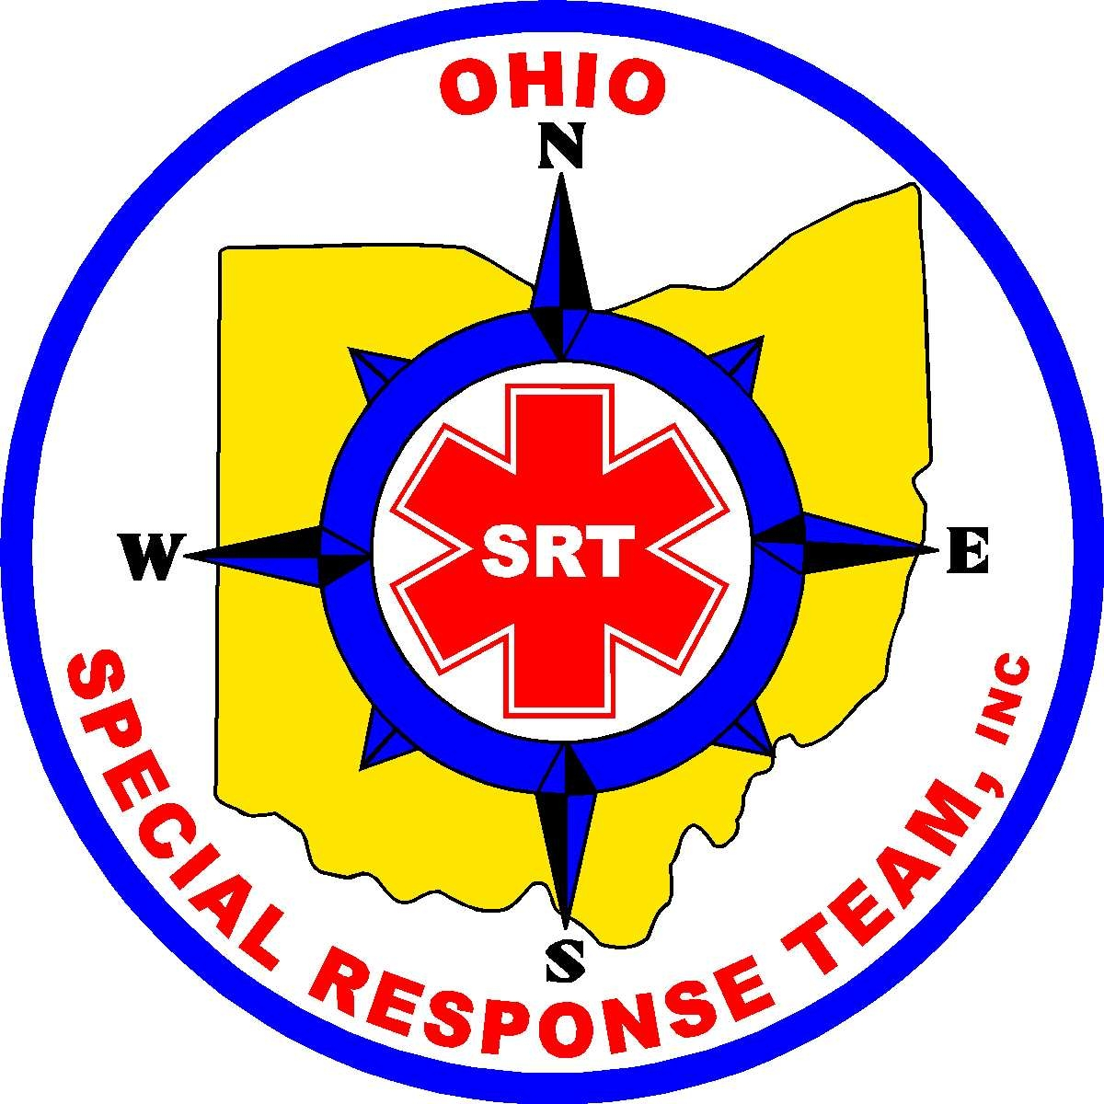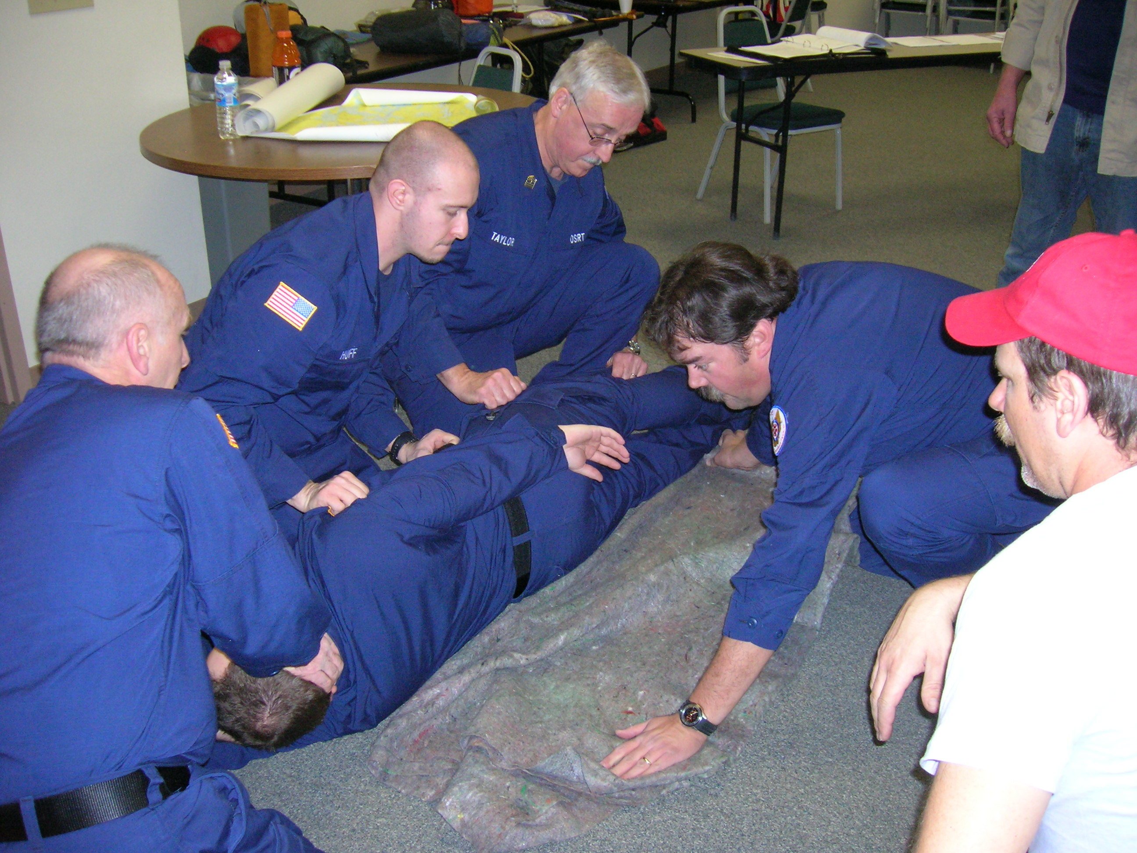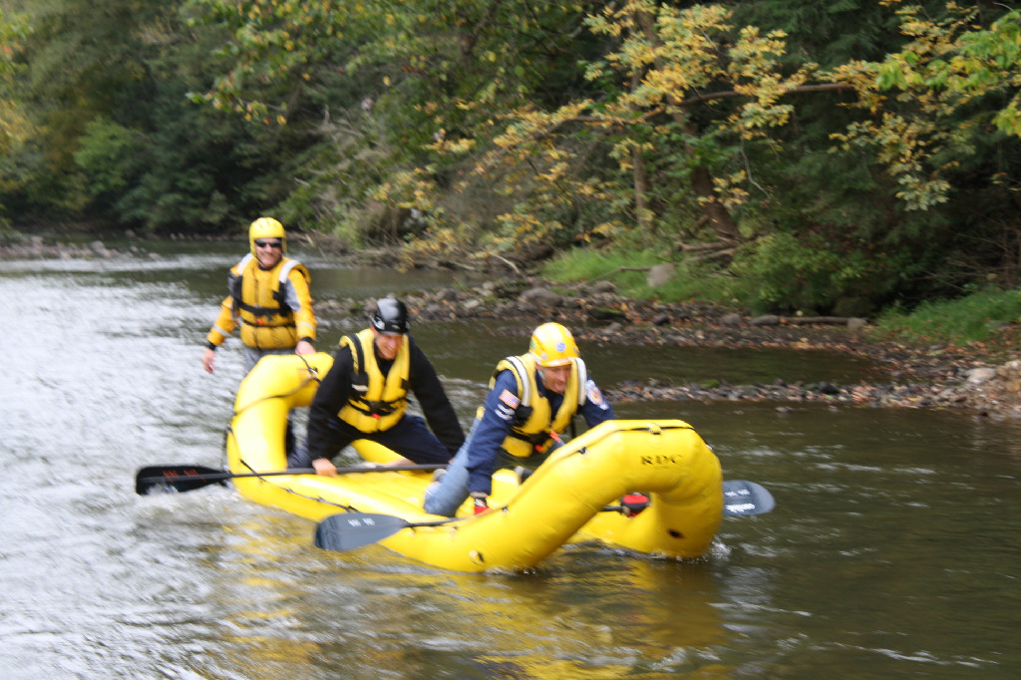

**We Support You**

### Joining OSRT is not a difficult process. You must be 18 years or older to apply. Applicants must pass a background check. Applicants must provide medical information as well as contact information. Applicants will also have an entire Background check conducted by the department of criminal investigation done.

### The application can be found at [www.ohiospecialresponseteam.org/membership_application](http://www.ohiospecialresponseteam.org/membership_application)

### Before acceptance, applicants will meet with the Unit Commander or Unit Representative.

### Mail in application (and fee) to,

### OSRT, INC.  Admin Officer  PO Box 1176  Mansfield, OH 44905

Recruiting Brochure

*Ohiospecialresponseteam.org*

## How to Join

Ohio Special Response Team,INC

Email: [osrtinc@yahoo.com](mailto:osrtinc@yahoo.com)

**597 Park Avenue East**

**Mansfield, OH 44905**

(419) 528-0041

Once you join…

After becoming a member of OSRT, participants will work closely with the Ohio Emergency Management Agency, Ohio Attorney General’s office, and many more.

What OSRT Does

Departments

1. Planning and training
2. Logistics (supply)
3. Administrative
4. Operations
   1. Search and Rescue Canines
   2. Hill angle (rope) rescue
   3. Swiftwater rescue
   4. Assist authorities on other taks

Functions/Duties

1. Leadership
2. Training
   1. CPR
   2. Risk assessment
   3. Bomb search

ffHistory

Ohio Special Response team was established in the fall of 2008. The organization provides professionally trained and certified individuals to assist with search and rescue events, natural and man-made disasters around the state.

**OSRT trained by….**

-The National SAR Training School

-FEMA Standards

-FBI

-University professors

-EMA and law enforcement

-National Association of Search and Rescue

-Specialized Training

* Members are trained to

🡪Recognize national standards

🡪Function with NIMNS Incident Commend System

* Brings an internal organized structure
* Members have extensive training and development
* Members know how to save lives while understanding how to keep themselves from becoming a victim.

# Utilize OSRT