Anna Factor
Dr. Baum
Opportunities in Zoology
October 28, 2013
Should captive bred species be released into the wild?
Introduction
Captive breeding for recovering endangered animals has been used for many years and has been an increasingly used technic in the most resent years (Syder et al. 1996). Breeding captive animals to be released into the wild has shown to be a good technic in certain species of animals, such as the California Condor, the Mauritius Kestrel, the Black-footed Ferret, and the Guam Rail (Syder et al. 1996). But not all species benefit from captive breeding, such as the Mallard, which had a low genetic introgression of the captive group that was released (Champagnon et al. 2012). Although captive breeding has many limitations that cannot be overlooked, scientists are taking a step in the right direction to help captive bred species overcome these limitations. As the endangered species list grows, different efforts are being made to preserve animals in their natural environment. Captive breeding should be viewed as a last resort in species recovery and not a long-term solution because of the inevitable genetic and phenotypic changes that ensue in a captive and controlled environment (Syder et al. 1996). Should captive bred animals be released into the wild or should alterative conservation efforts be made?
Results
There are many limitations of captive breeding. Achieving a self-sustaining captive population is something only achieved by a small percent of animals that have been bred in captivity (Syder et al. 1996). Many factors contribute to the failure to breed such as lack of psychological, physiological, or environmental requirements, effects of hand-rearing, behavioral incompatibility, and inbreeding depression (Syder et al. 1996). Without a sustaining population, the conservation will not be successful. The table below lists some species that have had difficulties with achieving a self-sustaining population (Syder et al. 1996). 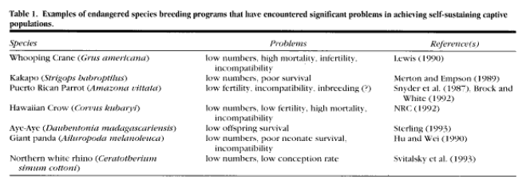
Another limiting factor captive breeding faces are the high risk of disease. Some evidences shows that endangered species are more susceptible to disease because of the reduced genetic diversity that can be the outcome of a small population (Syder et al. 1996). Evidence of disease faced in captive breeding is listed in the table below. 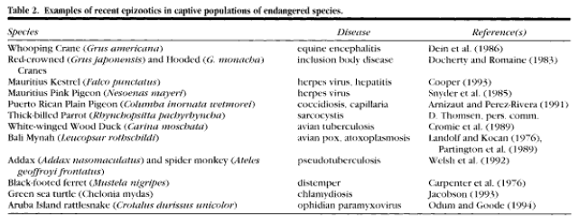
Discussion.
Although the limitations of captive breeding are difficult to overcome, steps are being made to strengthen the successfulness of animals being introduced to the wild. For example, Zoos Victoria is creating a “halfway house” for endangered species where they are working on a controlled release of Tasmanian devils, Leadbeater’s possum and helmeted honey eater (Milman 2013). The Coranderrk reserve will test the “survival fitness” of the captive species by monitoring their social habits, providing animals to hunt, and exposing them to predators to see if they can fend for themselves (Milman 2013). Allowing these animals to get a “test run” of what the wild will actually be like and giving them a safe place to cope and adjust should show to be a successful strategy. Zoos Victoria has also set a target for the Tasmanian Devils on the Maria Island where the population of devils are disease free, helping the low genetic diversity of the captive devils to have a stronger chance of survival (Milman 2013). This new conservation strategy has the potential to improve the success rate of captive breeding and the introduction of the captive bred species into the wild.

Literature Cited

Champagnon, J., M. Guillemain, J. Elmberg, G. Massez, F. Cavallo, and M. Gauthier-Clerc. 2012. Low survival after release into the wild: assessing “the burden of captivity” on Mallard physiology and behavior. European Journal of Wildlife Research 58:255-267

Milman, O. 2013. Tasmanian devils to be released back on to mainland. Online: http://www.theguardian.com/environment/2013/aug/23/tasmanian-devils-release-onto-mainland

Syder, N.F.R., S.R. Derrickson, S.R. Beissinger, J.W. Wiley, T.B. Smith, W.D. Toone, and B. Miller. 1996. Limitations of captive breeding in endangered species recovery. Conservation Biology. 10:338-348
(Milman 2013).

