Kaitlin Casillas
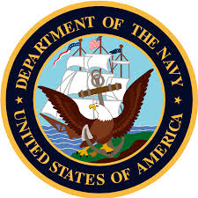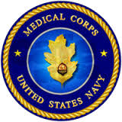
- Changed Linens
- Refilled waters
- Delivered meals
- Cleaned stations

During my internship I volunteered at Banner Boswell Medical center. I chose this internship because I plan on pursuing a career in the medical field. I didn’t gain the experience I was hoping for but enjoyed the new friendships and sense of community.

