Research on insectivorous bats communication
By: Katelyn Stewart

Abstract
The objective of this research is to create an Ohio Bat Call Library. Due to the recent crash in bat populations this research is highly applicable. The capture of bats is not only becoming increasingly more difficult but can also be dangerous. The AnaBat system is a recording device that is used throughout this study. Recording bat frequencies will allow us to identify the bats in the area using the Ohio Call Library. One weakness of the AnaBat system however is it cannot tell you how many bats are present, just the species of the bat it records. The Ohio Call Library will have the list of bat species known in Ohio and the frequencies of which they can be identified using AnaLook Software. Found in this paper will be the list of data and groups of species found in the Mohican area of Loudonville, Ohio in the summer/fall of 2013.

Introduction
We started this project the summer of 2013 with the hopes of recording many bats. However due to white nose syndrome, which has just arrived in Ohio, bat populations are decreasing. This means we did not get as many recordings as hoped for. However, the recordings we did get were able to work for classification of this project. The recordings are a great start to classify the species into groups of the bats present. The main species of bats we will find in our area are: the little brown bat (Myotis lucifugus), big brown bat (Eptesicus fuscus), Indiana Reds (Lasiurus borealis), Pips which is aberviated in AnaLook as PISU (Pipistrellus subflavus), possible Hoary (Lasiurus cinereus). Every file will have the location and date for future reference. Bat frequencies can fluctuate based on season, temperature, and species.
Materials and Methods:
Started on July 29th, 2013 at Mohican. These recordings are found in Documents-Katelyn’s AnaBat Edited-Mohican-July 29, 2013.
The next night of recording was on August 24, 2013 at Mohican to record using the AnaBat system. The AnaBat along with the PDA I was able to see the recording, however, I only got the PDA to work this one night and only for less than an hour. We recorded in Mohican from 8-11pm and captured, identified, and banned four bats. The bats we noted were the Big Brown, (2) Little Brown, and a possible Red. These files can be found on the Computer in Kettering 323. To view open AnaLook and then open the files by clicking on documents-Katelyn’s Anabat Edited-Mohican-Covered Bridge-Aug. 24, 2013. These files can have a lot of extra static make sure to push ‘z’ on the keyboard to remove static noise to better view the calls.
The next night we recorded data was on Friday August 30, 2013 this was at the Mohican Damn. We did not capture or view any bats but recordings show presence of some. We recorded from 7-11pm. All of this data can be found on the computer in the files labeled Katelyn’s Anabat Edited-Mohican-Pleasant Hill Dam-Aug. 30, 2013.
Recording at Mohican continued, on Saturday, September 7th we held a public program at Mohican Covered Bridge from 8-11pm. These recordings can be found under Katelyn’s Anabat Edited-Covered Bridge-Sept. 7, 2013.

DATA Analysis:
Group A is the unknown group. Some of the files in group A had a part of a known group but also potential for other bat frequencies. Within Group A there also is a higher and lower folder. I found that these two were almost their own groups. I separated them in hopes to make it easier to sort out and identify as the project continues.
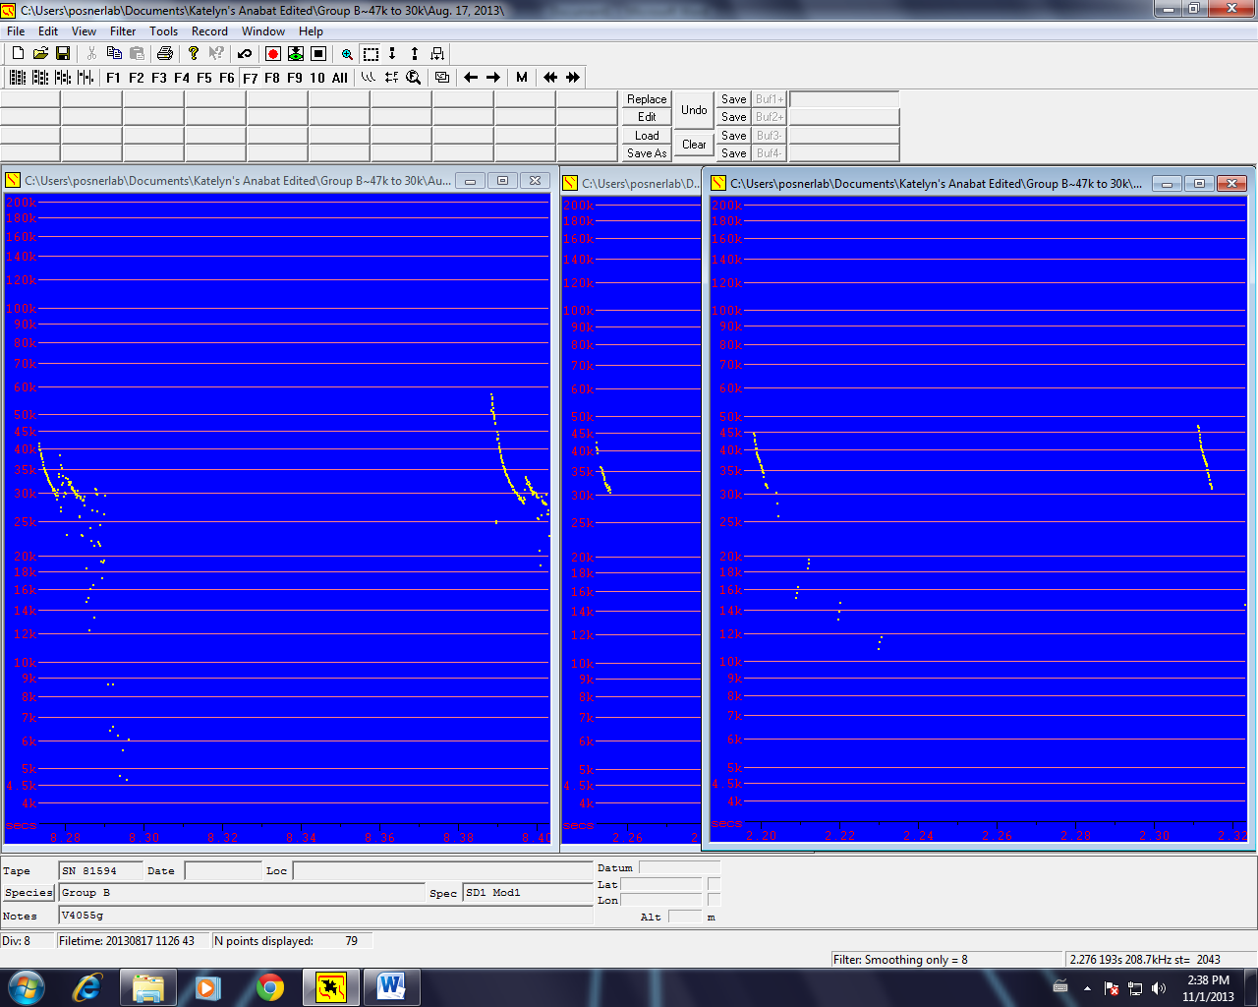
The first group to be analyzed is Group B. This group has the range of about 47-30k and can be seen in Figure 1. Figure 1 shows the “j-shaped” call of the bats from August 17, 2013.
Figure 1: These three files are from the August 17, 2013 recording that have all been placed into Group B.

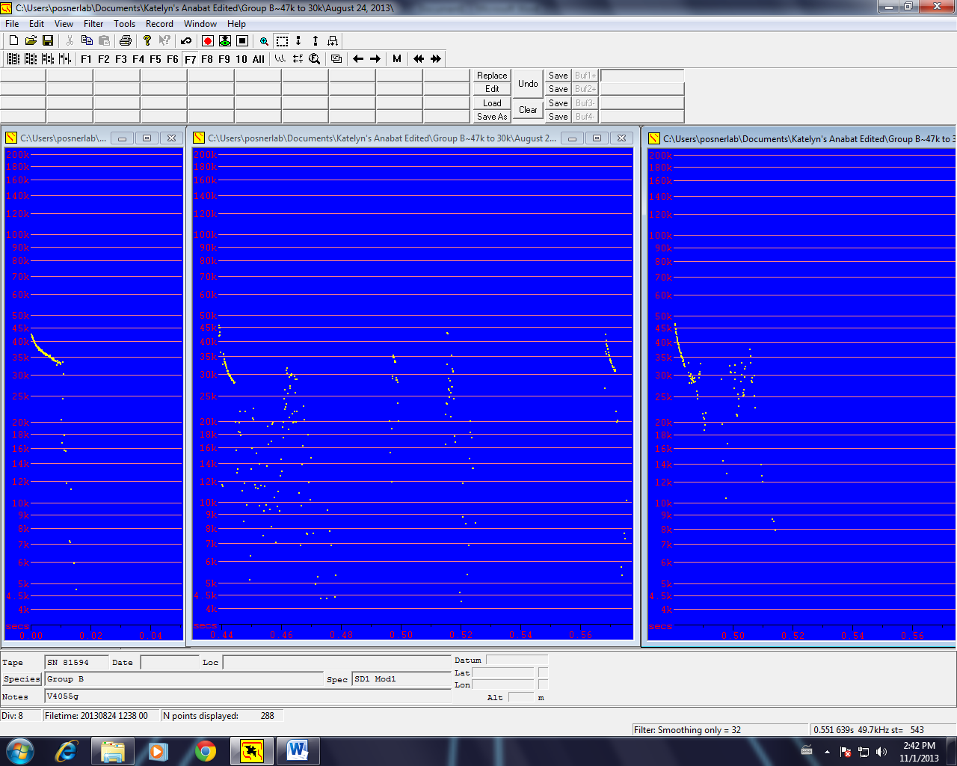
With the range of 47-30k leads us to assume this group is reds. The Indiana Red Bat has an average of 39k which falls in between this groups range. You can see the comparison of Group B from two different nights. Figure 2 shows Group B from August 24, 2013. The weather pattern for both August 17th and August 24th showed a mean temperature of 67 degrees F.
Figure 2: August 24, 2013 three files placed into Group B.

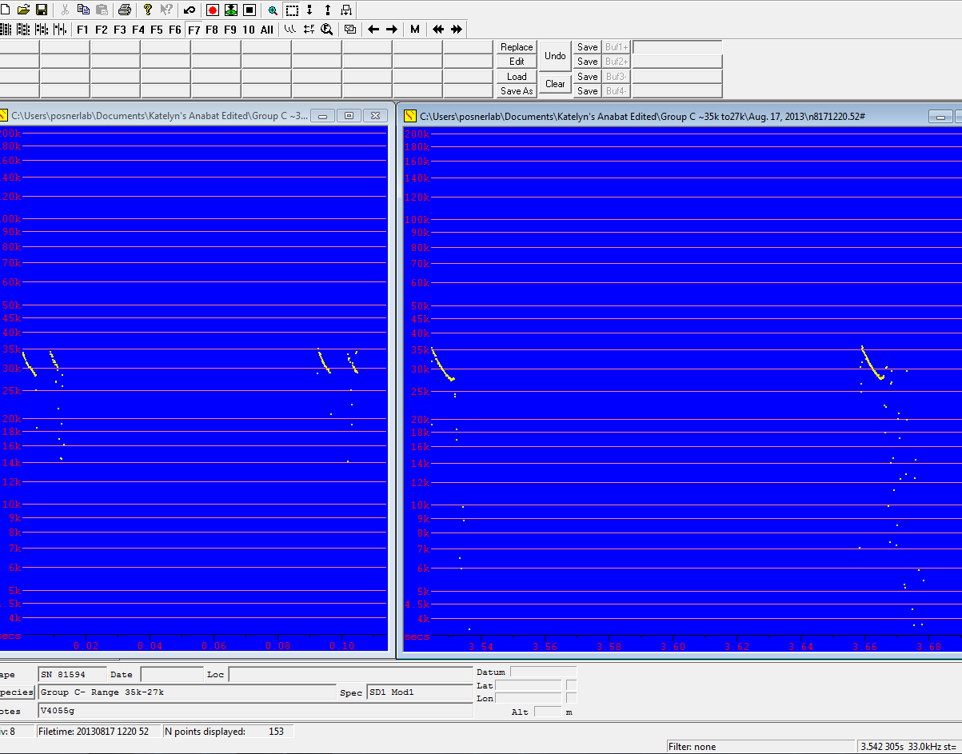
Group C was also analyzed with a range of about 35-27k. Many of these files are comparable to the Wyoming Big Brown Bat files. In Ohio, brown bats have an average range of 28-34 which leads to the idea that Group C is Brown Bats. In Figure 3 group C recordings from August 17, 2013 are shown.
Figure 3: Two files from Aug.17, 2013 Group C

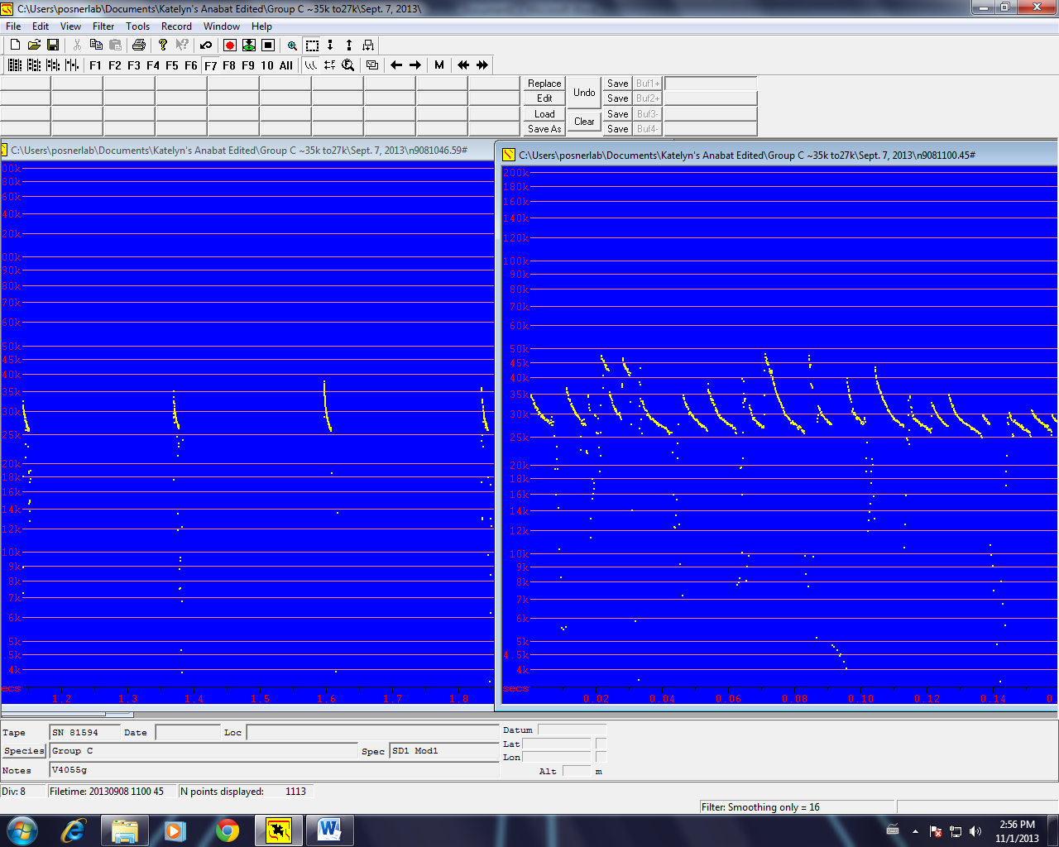
Group C has the classic bat call shape as seen above. Also seen in Figure 4 are calls from September 7, 2013 that also fall into group C. September 7th and August 17th both had a mean temperature of 67 degrees F.
Figure 4: Two call files of Group C from September 7, 2013

The last group the files are sorted into is Group D. Group D has a range of 60-40k and are very comparable to the Little Brown Bats in Wyoming. The Little Brown Bat in Ohio can range from 38k to 78k which leads to the assumption that Group D is the Myotis, little brown. In the lab we have captured little browns from the same area as the recording. Known recordings of little brown and big brown were recorded in the lab which also supports the idea of Group D being the little brown. As seen in Figure 5 are three call files from August 24th, 2013 that are placed into Group D. The higher range is common due to the smaller body size of the Myotis.

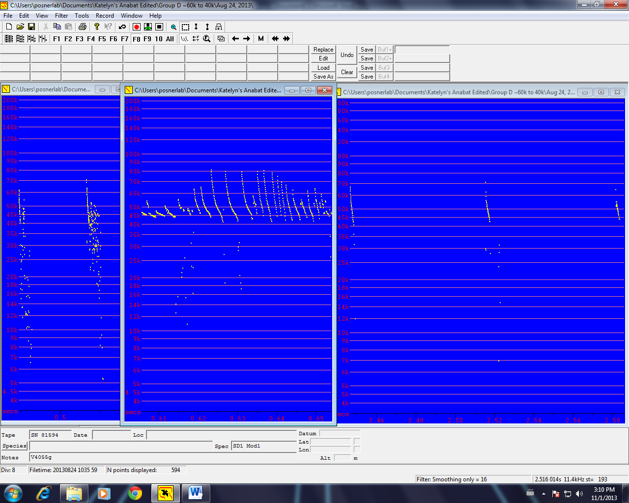
Figure 5: Group D-Three call files from August 24, 2013

The Basics:
To place recorded files on the computer you will remove the CF Card from the AnaBat system. Once you unscrew the bottom and remove the card, place the CF card into the CF reader. Use the USB connection cord to the reader and the computer.
Any file opened in AnaLook needs to be from Katelyn’s Edited because once you put files on the computer the can no longer be found on the CF Card. This is why every file ever recorded is placed into Katelyn’s AnaBat Files Unedited. Once you have the files in the unedited location copy and paste them into the Edited files to work with and organize/label. All files found in Katelyn’s AnaBat Edited should be bat calls, I have deleted most if not all of the static and other noise.
Looking at Anabat time is on the bottom (x) axis and frequency is on the vertical (y) axis. I viewed most the files by clicking on F7 to space out the time some allowing me to better view the “j-shape” of the call.
Analook keyboard shortcuts:
Use arrow keys on keyboard to go through files
When a file has a [+] after its name that means it is marked!
z= clears static
a=moves to the right, like a normal arrow button on the keyboard
q=moves through files towards the left like the Big Arrows by the Mark button
w=moves though files towards the right like the Big Arrows by the Mark button
t= takes you straight to the species label in the bottom of the screen to type species

Because Ohio does not have a call library I compared the files to Jennifer Walsh Florida files as well as Wyoming Call Library. With the knowledge that the main bats we find in our area are Little Brown, Big Brown, Indiana Reds, Pipestrella, and Hory. Knowing this I sorted the files into four common groups. Looking in AnaLook the species may be labeled with the group. Group A is an unknown group with files that did not seem to fit into any other group. Within Group A, I also classified a higher and lower range. Once you click on Group A you will see folders labeled higher and lower, those not in a folder but are just in Group A followed by a date are in the middle range. Group B is the range of about 47-30k on the left hand side of the scale. Group C is the range of about 35k-27k. Group D is the range of 55k-35k. I allowed 3-5k in leeway both directions for a call to be classified into a group. For example a large call that goes from 60k-40k was placed into Group D. The shorter more “j-shaped’ call from 48k-42k I placed in the Ohio Call Library-Pip (Ohio Files).

