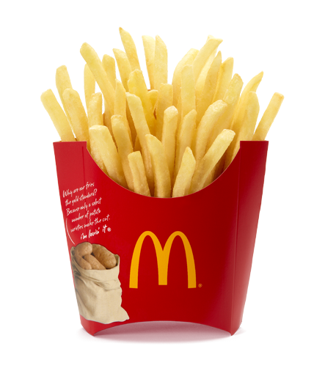

www.mcdonalds.com

Table of Contents
Table of Contents 2
CEO – Jim Skinner 3
Product 4
Stock Information 5
Corporate Profile 6
Financial Information 7
Accounting Risks 8
History of McDonald’s 9
McDonald’s Faces Lawsuits 10
Top Competitors 11
Careers Available 12
Employee Benefits 13
McDonald’s Websites 14
Ronald McDonald House 15

CEO - Jim Skinner
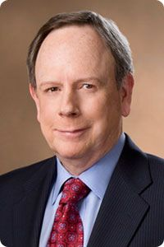

Jim Skinner leads the world’s largest food service company. There are 32,000 restaurants in 117 countries. McDonald’s serves 60 million customers each day and has 1.7 million people working for them across the globe in corporate and restaurant positions.
Priorities:
After becoming CEO of McDonald’s, Skinner set three top priorities for himself while being in leadership of the restaurant: long-term sustainable growth for the company; talent management and leadership development; and promoting balanced active lifestyles.
Accomplishments:
2007: “CEO of the Year”, “2007 Executive of the Year”
2008: Skinner was named one of “America’s Best CEOs”
2009: "2009 CEO of the Year", “30 Most Respected CEOs”
Corporate Headquarters:
- McDonald's Corporation, 2111 McDonald's Dr., Oak Brook, IL 60523
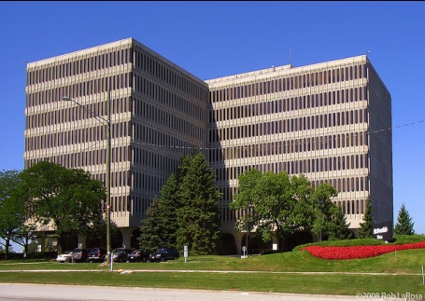

http://www.aboutmcdonalds.com/mcd/our_company/bios/jim_skinner.html

Product

World’s Famous Fries
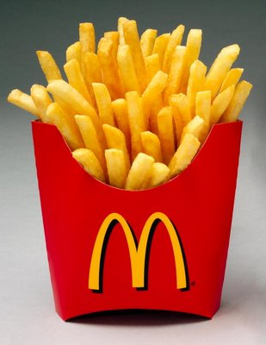

“Golden on the outside, soft and fluffy on the inside. Made with quality potatoes and cooked in our Canola oil blend for zero grams of trans fat per serving. Now that’s an epic bite.”
Small – $ 1.00
Medium – $ 1.69
Large – $ 1.99
Nutrition Facts
World’s Famous Fries
Total : | 380 | 170 | 19 | 2.5 | 0 | 0 | 270 | 48 | 5 | 0 | 4 | 0 | 9 | 20 | 1
% Daily Value ** : | - | - | 29 | 13 | - | 0 | 11 | 16 | 20 | - | - | 0 | 15 | 2 | 6
Stock Information
http://www.mcdonalds.com/us/en/food/full_menu/snacks_and_sides/world_famous_fries.html
(November 9, 2010)

Current Ticker Symbol - MCD

Current Stock Price - $ 79.16

Recent Stock Performance

http://www.investorguide.com/stock-charts.php?ticker=MCD / http://www.google.com/finance?client=ob&q=NYSE:MCD

Corporate Profile
Stock Data: | Recent Stock Performance:

 | Current Price (11/5/2010): $ 79.30 | 1 Week 2.0% 13 Weeks 4.2%  4 Weeks 10.5% 52 Weeks 28.5%

McDonald's Corporation Key Data:
 | Ticker: | MCD | Country: | UNITED STATES
 | Exchanges: | NYSE FRA MXK LIM | Major Industry: | Recreation
 |  |  | Sub Industry: | Restaurants & Fast Food Franchisers
 | 2009 Sales | 22,744,700,000  (Year Ending Jan 2010). | Employees: | 385,000
 | Currency: | U.S. Dollars | Market Cap: | 83,780,982,420
 | Fiscal Yr Ends: | December | Shares  Outstanding: | 1,056,506,714
 | Share Type: | Common | Closely Held Shares: | 1,404,468

http://www.corporateinformation.com/Company-Snapshot.aspx?cusip=580135101

Financial Information
Accounting Risks
AGR Average | Rating Published 09/10/2010
Industry Restaurants | Period End 06/30/2010 (Fiscal 2010 Q-2)
SEC Filing08/05/2010 (10-Q) | Last Audit: Ernst & Young LLP

3yr AGR® Score
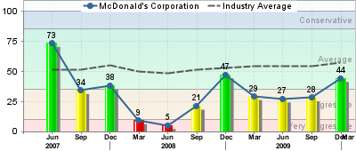

Overview
McDonald's Corporation is currently rated as having average Accounting & Governance Risk (AGR). This places them in the 47th percentile among all companies, indicating higher Accounting & Governance Risk (AGR) than 53% of companies.
RISK | AGR® IMPACT | TOP ISSUE
Corporate Governance Events | 23.7 | Comp: Incentive/Total Comp
High Risk Events | 49.6 | Share Repurchases
Revenue Recognition | 26.8 | Operating Revenue/Operating Expense
Expense Recognition | 0.0 | N/A
Asset-Liability Valuation | 0.0 | N/A
The forensic risk summary table below highlights materials risks, if any, and lists the most critical business issue for each risk. AGR Impact shows the deductions from a perfect 100 AGR score due to flagged matrics.

AGR scores are based on statistical analysis of accounting and governance risk factors. Lower scores indicate heightened corporate integrity risk, indicating an increased likelihood of future class action litigation, material financial restatements or impaired equity performance.
http://finapps.forbes.com/finapps/AccountingRisk.do?tkr=MCD

History of McDonald’s

http://www.aboutmcdonalds.com/mcd/our_company/mcd_history.html?DCSext.destination=http://www.aboutmcdonalds.com/mcd/our_company/mcd_history.html
Los Angeles Bans Happy Meals Toys

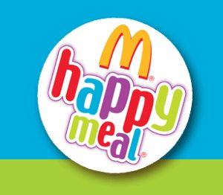
McDonald's faces lawsuit over Happy Meals

A watchdog group says giving away toys with Happy Meals contributes to childhood obesity and threatens to sue. McDonald's cites healthful menu choices.
Weeks after a Silicon Valley county became the first in the nation to ban toys from McDonald's Happy Meals and other food promotions aimed at children. A public health watchdog group called on the fast food giant to remove the playthings from all its meal packages.
The most recent toys that McDonald’s is coming out with are from the “Shrek” movie. Even though kids are dying for these toys, the Center for Science in the Public Interest said that the kids couldn’t have the toys unless they ordered under a certain amount of calories. The people of Los Angeles are worried that the plastic toys that are being promoted are making kids order food that is too high in calories, fat and salt.

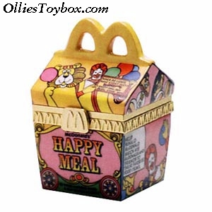

http://articles.latimes.com/2010/jun/23/business/la-fi-0623-happy-meals-20100623

Top Competitors

Burger King Holdings Inc. Miami, FL Doctor’s Associates Inc. Milford, CT
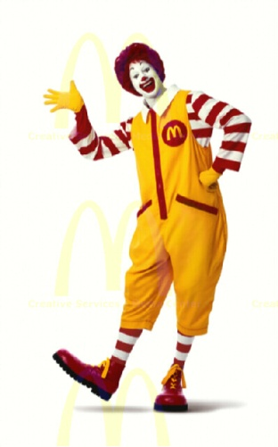
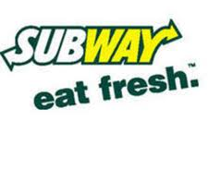
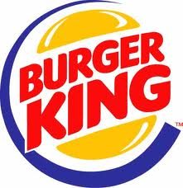

YUM! Brands Inc. Louisville, KY QUICKLY APPROACHING…
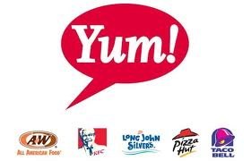
WENDY’S INC.
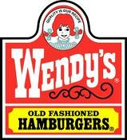

http://www.hoovers.com/company/McDonalds_Corporation/rfskci-1.html
Employment Opportunities
Murray, KY
Type | Position | Location
Support | Maintenance Supervisor | 107 North 12Th Street, Murray, KY

Maintenance Supervisor
Hours: Open availability
Pay: Based on experience
Now hiring for a Maintenance Supervisor. Person must be certified in HVAC and have restaurant equipment experience.
This position is also available at the following location(s):
Calvert City  3442 US Highway 62  Calvert City, KY 42029 | Hinkleville Road  3955 Hinkleville Rd.  Int 24 & Highway 60  Paducah, KY 42001
Lone Oak  2224 Lone Oak Road  Paducah, KY 42001 | Benton  25 Commerce Blvd.  Benton, KY 42025
Mayfield  1006 Cuba Road  Mayfield, KY 42066 | Metropolis  1545 E Fifth Street  Metropolis, IL 62960

http://www.mcstate.com/careers/jobs/16337
Employee Benefits
McDonald’s tries to give their employees benefits that will make them want to retain their position in McDonald’s. They also make benefits that will push their employees to do their best at everything they do for the business.

Your Health and Protection
Our health and insurance benefits:
- Medical
- Vision Supplement Plan
- Dental
- Flexible Spending Accounts
- Short And Long Term Disability
- Employee And Dependent Life Insurance
- Accidental Death & Dismemberment (AD&D)
- Travel And Business Travel Accident Insurance

Your Pay and Rewards
Our compensation, reward and recognition programs:
- Base Pay
- Incentive Pay
- Company Car Program
- Recognition Programs

Investing in Your Future
Our savings, investment and financial management programs:
- Profit Sharing And Savings Plan (Includes Our 401(K) Feature)
- Mcdirect Shares
- Mc$Ave
- Credit Union
- Financial Planning Services

Helping Balance Your Work and Life
Our work/life benefits:
- Vacation
- Holidays
- Anniversary Splash
- Sabbatical Program
- Summer Hours
- Leave Of Absence
- Alternative Work Approach
- Adoption Assistance
- Child Care Discount
- Educational Assistance
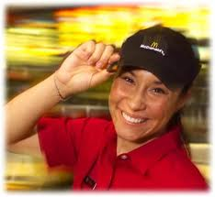
- Matching Gifts Program
- Employee Resource Connection
- Auto And Home Insurance Group Discount Program
- International Fitness Club Network
- Beyondwork Internet Discount Program

http://www.aboutmcdonalds.com/mcd/careers/employee_benefits.html?DCSext.destination=http://www.aboutmcdonalds.com/mcd/careers/employee_benefits.html

McDonald’s Websites

McDonald’s has a home website and also a variety of other websites available for customers to visit if they have the desire! The following are examples:

McDonald’s Happy Meals  Activities, games, art projects and your kids’ favorite foods. |  | McDonald’s for Tweens  McDonald’s knows that being a kid is all about meeting up with friends, playing favorite games and enjoying great food.

365 Black
McDonald’s celebrate African-American culture and achievement every day of the year.

Me Encanta
Join in promoting the Latin spirit with music, fútbol and family fun.

About McDonald’s
McDonald’s serves more than 60 million people around the world every day.

Ronald McDonald House Charities
For 35 years, McDonald’s has been helping children in need—and their families—in 52 countries.

International Websites
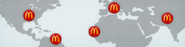
McDonald’s has over 32,000 locations in more than 100 countries around the globe.

www.mcdonalds.com/us/en/websites.html

My InspirAsian
Take the Asian Phrases Challenge and discover the wide mix of cultures in the Asian Pacific American community.

Ronald McDonald House

Ronald McDonald House Charities has been McDonald’s "charity of choice" for 36 years.
We are a non-profit corporation, but McDonald's is our largest corporate donor. Portions of the annual operating costs for Ronald McDonald Houses are graciously funded by McDonald's and owner/operators of local McDonald's restaurants. The remainder of our annual operating income comes from the generosity of individual and corporate donors.
Payton’s Story
On Friday, May 7th Payton started running a fever. The fever spiked throughout the weekend, up and down with the aid of Tylenol. On Monday, Payton began to vomit and was taken to Primary Care in Murray. Upon testing, they determined she had extremely low levels of White Blood Cells, Hemoglobin, and Platelets. Doctors in Murray consulted with St Jude Children’s Hospital in Memphis, TN who sent an ambulance to pick up Payton and Missy. We arrived at St Jude around 9:00 PM and they immediately began testing blood and everything else.
On that Tuesday, we met with the doctor who will be caring for Payton who advised Payton was being diagnosed with Acute Lymphoblastic Leukemia (ALL).
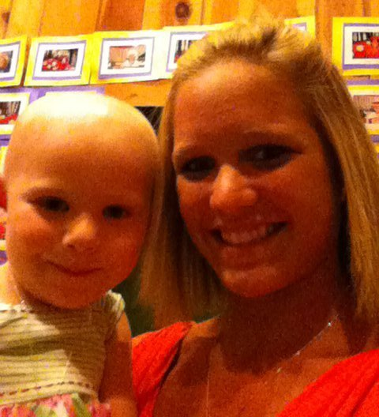
Where She’s At Now
Saturday morning, November 21, Payton was having more rectal pain and I noticed a jelly bean size "knot" on her bottom. I called and St. Jude and they wanted her seen ASAP by a clinician here. A HUGE THANK YOU to Dr. Kim Burch who met us at the office and got the ball rolling. After a visit with her we went to Murray ER) and got antibiotics started. We arrived in Memphis around 11:00 Saturday evening.

www.ronaldmcdonaldhouse.com

