

## **Segregation**

References:

Bennett, Sheila, and Don Dworet. “A View From The North: Special Education in Canada. *Teaching Exceptional Children.* (2002): 22-27.

Bennett, Sheila, Don Dworet and Ken Weber. *Special Education in Ontario Schools.* Ontario: Highland Press, 2013.

“Gifted Child.” Photograph. 2013. http://www.adventuresingiftedness.com/?p=841

“Include Me.” Image, 2013, http://montville.patch.com/groups/volunteering/p/pathways-celebrates-10-years-promoting-inclusion-for-c0cb568502.

Joshi, Mohit. “Autism.” Photograph. 2011. http://www.topnews.in/health/diseases/autism

Pazar. “Special Education Wordie.” Image. 2013. http://nurullahdemircan.blogspot.ca/2013/05/reflection-journal-4-special-education_19.html.

Takano, Junji. “Down Syndrome.” Photograph. 2013. http://www.pyroenergen.com/articles07/downs-syndrome.htm.

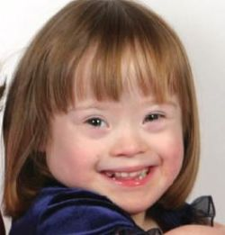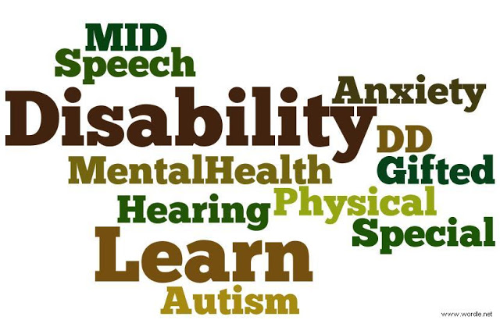

**Prior to the 1980s students with an obvious exceptionality could be turned away from “regular” schools based on the idea that they would be too difficult to teach. The first formal special education project began in 1831 thanks to Ronald Mcdonald and was directly for those who were deaf and/or blind. Although this project did allow some students with exceptionalities to attend school it did not include all exceptionalities. Schools with similar sentiment appeared around Canada following this project. However they were not in every town and city so students with exceptionalities in smaller communities could still face being denied access to schooling in “normal” schools. There are many examples of these students never attending school at all.**

Integration of Exceptionalities in Ontario Education

I/S 1   
EDUC 4306

November 6th, 2013

Marisa Valois

The Supreme Court of Canada ruled that children with exceptionalities should be placed in what is deemed the best fit for them. In most cases this means placing them in regular classrooms. The decision to place an exceptional child considers what is the best interest for the child from a child-centered point of view. Regular assessments must also occur to ensure the student is reaching their maximum possible potential. The Ontario Ministry of Education regularly reviews funding for exceptional students by assessing their IEP (Individual Education Plan) and deciding on the severity.

Children with exceptionalities generally require special education services. In Ontario there is a large focus on identifying what particular exceptionality students have and then assessing what can be done to aid them in their education. The categories include: physical, behavioral, learning disabled, speech and language, giftedness, autism spectrum disorder, developmental delays, or vision and hearing impairments. Teachers of exceptional students generally begin the identification process by noticing an issue in class and bringing it to the attention of an In School Team (IST), who discuss strategies for aiding the child. The child is then referred to an Identification, Placement and Review Committee (IPRC) who then identifies them as “exceptional” and distinguishes which category they fall under. Parents have the right to appeal decisions if they disagree.

# Identification

On December 12, 1980 Lieutenant-Governor John Black Aird signed Bill 82, the Education Amendment Act into law. Thanks to this act any child with an exceptionality of any kind could not be denied schooling. Boards of Education no longer had the option to deny a child the right to learn. Following this Bill were many more changes in government to allow exceptional students to be treated fairly. The Charter of Rights and Freedoms passed in 1982 stated that all members of Canada be treated equally and could not be discriminated against based on any disability.

# Bill 82, the Education Amendment Act

### Placement