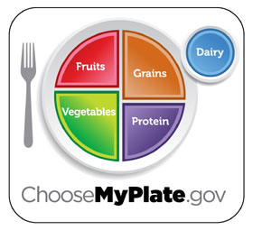

Food | Portion Size | A portion is about the size of…
Bread | 1 ounce or 1 regular slice | CD cover
Dry cereal | 1 ounce or 1 cup | Baseball
Cooked cereal, rice or pasta | 1 ounce or ½ cup | ½ baseball
Pancake or waffle | 1 ounce or 1 small (6 inches) | CD
Bagel, hamburger bun | 1 ounce or ½ piece | Hockey puck
Cornbread | 1 piece | Bar of soap
Orange, apple, pear | 1 small (2 ½ inches in diameter) | Tennis ball
Raisins | ¼ cup | Golf ball
Baked potato | 1 medium | Computer mouse
Vegetables, chopped or salad | 1 cup | Baseball
Fat-free or low-fat milk or yogurt | 1 cup | Baseball
Cheese | 1 ½ ounces natural cheese 2 ounces processed cheese | 9-volt battery
Ice cream | ½ cup | ½ baseball
Lean beef or poultry | 3 ounces | Deck of cards
Grilled or baked fish | 3 ounces | Checkbook
Peanut butter | 2 tablespoons | Ping-pong ball
Butter or margarine | 1 teaspoon | Standard postage stamp
Oil or salad dressing | 1 teaspoon | Water bottle cap

