Collection Development Policy:
Alexander Library-Reference

Albert Haddad
Rutgers, the State University of New Jersey
Purpose Statement:
The Collection development policy will serve as a guideline in order to build and sustain the Reference collection of Alexander Library in Rutgers, The State University of New Jersey and ensure an ongoing growth and development of the collection.
The policy will guide the librarians and selectors through their work or duties, when it comes to selection, budgeting, planning, responsibilities and communication internally and externally. Moreover, it will promote the communication between the users and the library to safeguard a consistent, relevant, up-to-date, historical and proportionate collection. In this way, students, staff, faculty members, alumni and the community can understand how the collection development is done. In addition, the policy will describe the collection materials what to be collected and what not to be collected. Furthermore, the policy will assist the library in responding to the users’ needs and at the same time it will protect the library from any complaints or litigations raised by any user. The policy tries to be flexible in order to be able to adapt to new changes and overcome new challenges.
Not to forget that, the guidelines will serve as a guiding tools and a marked trail for new comers.

Missions and Goals of the Library:
The Reference collection should provide quality and a well-balanced collection supporting Rutgers University academic programs, curriculum and research programs at all levels undergraduate, graduate and post-graduate. The collection should meet its users’ needs and demands especially when it comes to reference material and information.
The collection consists of highly academic and scholarly materials, in addition to quick reference materials.
The collection will offer information on a wide selection of well-established and emerging disciplines and subjects. The main emphasis will be on the social sciences and humanities.
The Reference section should collect information sources in all formats, but will focus more on online resources, to be able to support the given programs.
We should be able to anticipate new trends and challenges in the academic field especially in reference.
The material will be maintained, assessed and developed by the librarians with the cooperation of the academic departments and faculty members.
The reference collection will be highly used; thus, the collection will not circulate and will be used only inside the library.
The existing collection should be checked, studied and evaluated on a regular basis. And the gaps must be filled in the most economic and advantageous way.
The collection must help undergraduate, graduate, post graduate, staff, alumni and faculty members to find what they need. And the collection will be affected by their demands and needs. However, as a state university, all individuals in the community are welcome to enter and use the print collection but the library will not be affected by their demands or needs.
The library should be informed if a new program is integrated in the University curriculum. When informed, the selectors or librarians must study the collection and meet with faculty members or liaisons to check if there is a gap in the existing collection in order to fill it.
The library will embrace the university mission to promote education and research and to teach the effective use of information.
The library will perform surveys and statistical works to keep aware of the changing needs and demands of the users.
Description of the community:
According to the facts and figures on the University website, Rutgers University has more than sixty five thousands students. Forty five thousands are undergraduates and twenty thousands are graduates. Forty seven percent are men and fifty three are women. Eighty six percent are residents in New Jersey and fourteen percent are from out of state. As per the faculty body, more than nine thousands faculty members teach at Rutgers. Rutgers is a very diverse university and its community comes from 50 US states and more than one hundred fifteen countries. The curriculum covers more than one hundred undergraduate majors and more than two hundred graduate programs.

- Undergraduate Enrollment by Attendance Status Fall 2012

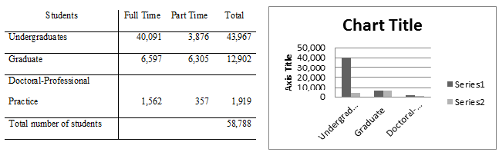

- Undergraduate students according to race and ethnicity Fall 2012
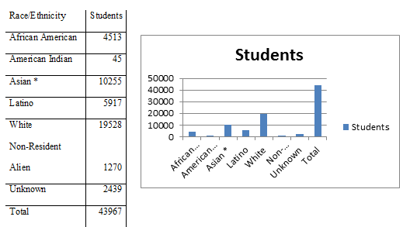

- Professors numbers according to race/ethnicity Fall 2012

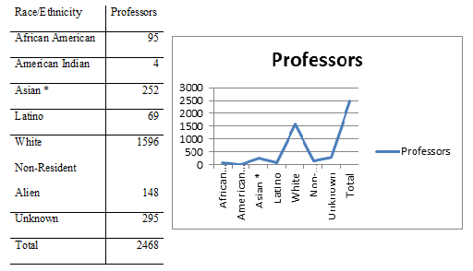

Types of Material collected
Material should be proper to the academic needs of the Rutgers University community. In other words it should support the curriculum, student research, staff and faculty research at all levels.
The collection will emphasize more on the Social sciences and humanities.
The collection consists of literary, scholarly and academic sources.
The works in the reference section should be authoritative. Either the author or the publisher should be reputable and well-known. And the works should include essential reference tools.
The collection should contain information about different cultures, religions, languages, countries and ethnic groups represented in Rutgers University.
The sources should be current, in addition to sources that have historical values and cover historical information.
The collection comprises encyclopedias (general or multidisciplinary and subject and specialized), dictionaries (English, multi-lingual and bi-lingual), biographies, bibliographies, atlases, annual publications (but not journals), quick reference, quotations, almanacs, indexes, yearbooks, tests and measurements, style manuals, concordances and general reference books.
The format is print (monograph and serial), online and audiovisual (DVDs, audio CDs and microform). The decision on the format will be based on several criteria like coverage, cost, currency, content, usability, maintenance and reliability on the vendor, authority…
Electronic resources (e-books, databases and directories) are preferred in the reference collection. Core and essential reference works will be bought as print. And if the item is very important and is on high demand and is not available neither print nor online, it will be bought on a microform if available.
The main language of the collection is English.
Documentary and educational films (only DVDs) are bought if they are required by a major or a program.
What not to be collected are works intended for juvenile or smaller audiences, recreational readings, commercial readings or material, non-authoritative publications, textbooks, outdated material, material in obsolete formats, duplicates, subject that have specialized libraries like business, art, sciences, math, law and medicine.

The Selection Criteria
- Relevant to the reference collection.
- Currency and historical coverage.
- Date of publication
- Pertinent to the users’ needs and demands.
- Cover the curriculum, majors and research programs.
- Authoritative and accurate.
- Well-kwon authors and publishers.
- Primary or secondary material.
- Cost
- Availability and accuracy.
- Usefulness and usability
- Format of the resources (electronic, print and AV).
- Degree of specialization.
- Duplication is to be avoided.
- Availability in other branches.
- Selection tools are to be examined and cross-checking.
- Existing material, weakness and overlaps to be checked.

Who does the selection
A committee is responsible for the selection. The committee consists of the reference librarians and the subject librarians and a representative from the branch libraries. Moreover, faculty members, who are the subject specialists, should be part of the selection process. Furthermore, library liaisons should be founded with selected librarians. The Reference head and the director of the library have the final word in case of dispute. Librarians will use different assessment tools to meet the selection criteria. For example, YBP, Gobi and OCLC; review sources (Choice…); publisher catalogs, announcements and websites; bibliography lists; comparison with peer libraries sources; bibliographical tools and online lists (books in print…) bookstores; book fairs and users’ (student and faculty) demands.

The Allocation
The funding comes from the parent institution. The director of the libraries will divide the amount according to reports done by selected librarians from different sections and branches. The reference report is prepared by the reference librarians. The collection will get its share. A small percentage will be kept aside as a contingency fund. The size of the allocation is based on many factors like: last year expenditures, number of students, faculty and programs given and the cost of the material. Any changes on the curriculum level will affect the funding for example, the hosting of new programs or new disciplines. On the other hand, the reference department can receive funds from the state funding program, grants, gifts and endowments. All expenditures should be monitored by the director, the reference head and the collection development librarian and well documented.
Statistics must be checked to view the percentage of the material used and in what subject. When usage pattern decreases and if the budget is tight we might consider cutting some titles that are not used.
The bigger part of the money is allocated to online resources.
Purchase v/s subscription is a major idea to be taken into consideration.

Gifts
Gifts will be received if they are relevant to the reference material, and then will be evaluated by the committee. The committee maintains the right to accept or reject the gifts. Some of the factors to be studied are:
- Gifts are accepted if space permits it.
- Duplicates are rejected
- Cost of maintenance
- Condition of the gift
- Relevance
- Value
- If multimedia, it should be in its original state. The library will reject any used item.
The material accepted becomes the library property. The library has the right to discard, throw, donate to any other institution of its choice and even put it for sale.
The library cannot appraise the material. For book appraisal list kindly check appendix 1.
Every donor should fill a form.
The library will send a thank you to all the donors and if the gift is rejected the reason will be stated in the note.
If the library is on a tight budget it can mandate a fee for accepting gifts in order to be able to maintain them over time.

Weeding and replacement
Weeding of material will be executed according to the below factors:
- Damaged/torn material
- Not relevant anymore to the programs or majors
- Not used anymore
- Obsolete
- Outdated
- Online availability
- Duplicate
- Availability of newer edition
Replacement will take place if:
- The material is damaged or in bad condition and is still needed or has great academic value.
- Lost or stolen and still in use or needed or has great academic value
- Obsolete/outdated and new edition is available

Evaluation
The evaluation process includes the several considerations below:
- Currency
- Authority and reputation of the authors and publishers
- Content, completeness and objectiveness
- Relevance to the reference collection and to the curriculum
- Comparison to a similar item in other library or bibliographic list
- Cost in relation to quality
- Quality
- Physical quality
- Access points and ease of use
- Demand and usage
- Citation tools to be consulted to check the frequency of referencing
- Newer versions and updates
E-resources have further criteria to be studied:
- License and obligations
- Price, discount and offers
- Comparison with the print copy to see if the content is the same
- Currency and embargos
- In case of a package, can we select from the titles or we have to take them all.
- After sale service and instructional sessions
- Compatible with link resolver and the ability to export the citation to citation software
- Friendliness of the interface
- What are the publishers archiving, maintenance and preservation plans.
- Update plans
- Technologically up-to-date.
For the audiovisual materials:
- Logistical and technological requirements.

Intellectual freedom
During the selection process the codes of the intellectual freedom as defined in the Library Bill of Rights and the ALA’s “Freedom to Read Statement” will be followed. The library will provide as much material and information as possible to meet its goals, even when it comes to debatable issues. The librarians will not censor any of the material. All the collection should be accessible to our users. The goal of the collection is instructional, educational and informative. The collection supports the mission of the university.
Users who wish to challenge or complain about a title should fill the reconsideration form, see appendix 2, and send it to the library administration. A committee consisting of the reference head, library director and collection development librarian will study the request and answer the user in a period of thirty days. The library retains the right to keep the title and is not obliged to comply with the user complaint.
Any user questioning the absence of a title will be directed to the collection development policy.
User requests:
Users can request items that the library doesn’t have. They can do so through the inter-library loan or the patron driven acquisition PDA. Each request will be studied by the selection committee. The committee will decide either to buy the item or loan it from a peer institution.

Appendix 1
Here are two links for book appraisal:
http://www.booksappraised.com/
http://www.abebooks.com/books/old-books-antique-appraising-pricing/book-values.shtml

Appendix 2
Reconsideration form:
Name:
Title of the book:
Reason:

References
Johnson, P. (2009). Fundamentals of collection development and management. (2nd ed.). Chicago: American Library Association.
American University of Beirut. University libraries. (2013). Collection development policy. Beirut.
University of Mary Washington Libraries. Collection development policy. Washington.
http://libraries.umw.edu/library-info/library-policies/collection-development-policy/#purpose

