Insolvency to Success Story
A National Blueprint to Privatize the United States Postal Service

July 2012
Executive Summary:
With the advent of e-mail and continued use of devices such as fax machines the competition for the decreasing mail market is intense. One such mail organization, the United States Postal Service reported a $3.2 billion budget deficit between the months of January and March 2012, which was up from $2.2 billion the prior year.
The Postal Office Accountability Act (POAA) of 2006 severely limited the ability of the USPS to compete with FedEx and UPS. Its aim was to require the USPS to prefund pensions 75 years in advance in a 10-year window. This costs the USPS approximately $5.5 billion per year. Without this act during a four-year period from 2006 the USPS would have had a $611 million surplus. Congress is doing little to remedy this.
To make things more complicated the postal service cannot fire someone under union contract terms when they have worked for greater than 6 years at the agency. Also complicating the matter is the fact that Title 39 US Code Section 404 B states no post office can be closed for revenue reasons.
The POAA was passed partly because of UPS and FedEx being members of the lobbying group ALEC (the American Legislative Exchange Council). (Postal Service’s Enormous…). ALEC could be blamed for the problems of the USPS, however the projected net revenue between 2006 and 2010 without the pension burden pales in comparison to the net revenues of UPS and FedEx. This in addition to high pension expenses, which congress was merely trying to guarantee for solvency’s sake, but nonetheless meddled in should lead the US government to the supposition that it must release its grasp upon the USPS. This would give the agency the opportunity to self-govern and compete; a benefit that the other two mail companies enjoy. Perhaps the proposed solutions, which include consolidating postal offices; eliminating Saturday service and restructuring the pension requirements are effusively inadequate for dealing with the magnitude of the USPS problem. Nonetheless, the USPS must be allowed to compete and continue America’s legacy as a capitalist country.
Consider the following facts regarding the broken USPS:
Labor expenditure and revenue: The UPS and FedEx have net revenues in the billions in the 2006-2010 4-year window this can be surmised from the ensuing figures 2 and 3. Simultaneous to the slow business for the USPS labor represented 80% of their costs. In comparison FedEx and UPS had labor represent 53 and 32% of their costs respectively. (Greenhouse). Subsidies are clearly not a viable solution for the federal government to use.
Closures do not solve the problem: Despite a USPS closure of 3,700 potential post offices in 2011 as aforementioned the losses continued to increase. This is because this many closures will only save $200 million. This all the while the debt is projected to be $20 billion by 2015. (Post Offices Releases List…). So essentially the postal service’s main strategies entail of cutting 1/100th of their projected 2015 deficit and/or defunding their pensions and ending up like bankrupted cities across America. Again, the federal government should not subsidize a business without effective strategies.
High Number of employees is burdensome: FedEx, which is a more profitable company, had 247, 908 employees in 2009 and UPS had 425,300 in 2007 while the USPS currently has around 546,000. This is an agency with more workers leading to more pension payments and a workforce that cannot be fired.

Competition: In 1970 the agency was given some autonomy (allowed to borrow and make investments) clearly the agency couldn’t compete in the private market. This is partially the government’s fault for still controlling aspects of the agency, but also the agency’s fault itself for not developing a strategy. It is likely they assumed regardless of the competition they would receive a bailout if needed. (Morris).
The following four figures further illustrate the stated points.
Figure 1: represents the 2008-2010 budget highlights and shows the billions of dollars of losses per year at the USPS.

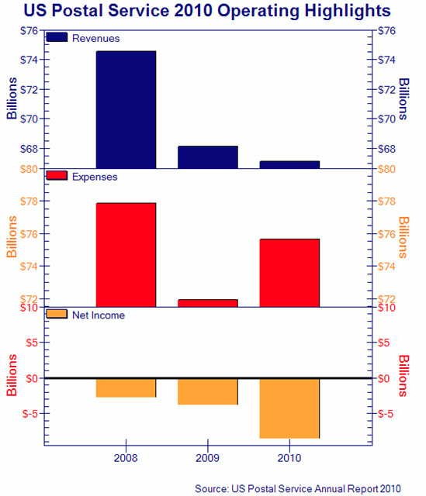

Figure 2: From the financial website “The Motley Fool” conversely shows the profitability of the FedEx corporation. Which posted profits in the billions.

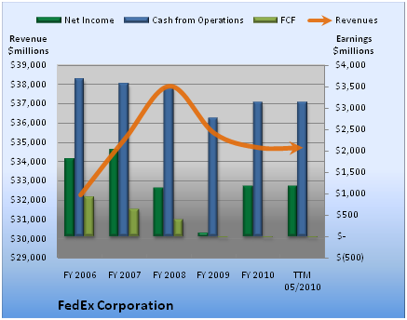

Figure 3: Also on “The Motley Fool” is a graph depicting the billions of dollars of net revenue for the corporation UPS which aren’t as striking as FedEx’s but are greatly larger than the USPS numbers.
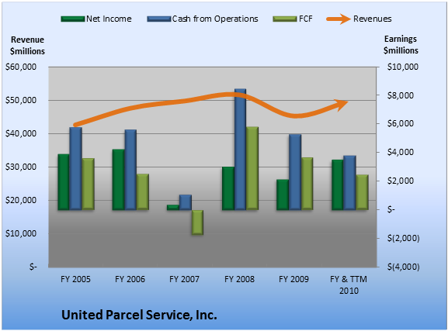

Figure 4: As earlier mentioned mail volume is decreasing and there is more competition to capture it. The USPS workforce is only slowly decreasing while delivery points are increasing and net income as a consequence keeps falling. These, however are problems that the agency itself must tackle since it has been semi-autonomous since 1970. They are no longer problems of the U.S. government. Greenhouse’s New York Times figure below depicts this phenomenon.

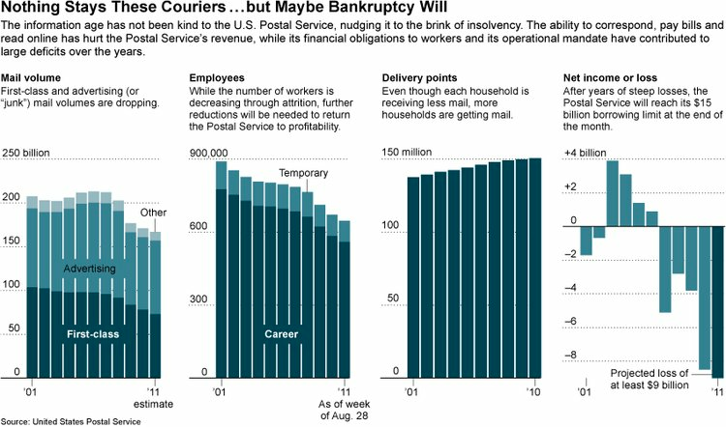

Recommendation:
For the above listed reasons it is recommended that the USPS be privatized and the subsidies be suspended. The agency should be permitted to fail or succeed without government interference. If the recommendation is followed these benefits would ensue:
- Since the 3 for-profit companies would solely control the mail the USPS if it survives would hopefully evidence better customer service.
- The tricky business of not being able to fire postal workers could be eliminated and private business could easily control the size of that work force.
- Offering a wider array of services due to less regulation from the government would further competition among the top 3 mail companies.
- It would eliminate the need for a costly US subsidy to “bail out” the ailing agency. (Will).
- Budgeting techniques may be able to be practiced to balance the current USPS budget.

Conclusion:
The USPS cannot fire employees due to union contracts. Their cutbacks are not austere enough. Consequently the reality is the USPS cannot compete with other mail industry businesses. Therefore ending Saturday service, consolidating offices and giving further autonomy with regard to pensions to the USPS are probably not realistic solutions. But they should be allowed to figure out what works rather than the federal government deciding for them. Article I Section 8 explicitly gives congress the power to “establish post offices and post roads.” But it does not state that congress must do this so based upon this and the prior evidences, congress can only make matters worse for the USPS and for the federal deficit with further interference. Because of these past interferences, even though the USPS is crumbling, it must be given a chance to become an effective competitor. This can be achieved through privatization. Success can be defined in terms of the post office’s fiscal problems being solved, or at least being given a chance to succeed and failing. Either way, the capitalist market eventually leads to more successful outcomes than government intervention.

Works Cited
Greenhouse, Steven. "Losing Billions, Postal Service Is Near Default." The New York Times. The New York Times, 05 Sept. 2011. Web. 05 July 2012. <http://www.nytimes.com/2011/09/05/business/in-internet-age-postal-service-struggles-to-stay-solvent-and-relevant.html?_r=1>.
Morris, David. "How Phantom Accounting Is Destroying The Post Office." The Huffington Post. TheHuffingtonPost.com, 25 May 2012. Web. 05 July 2012. <http://www.huffingtonpost.com/david-morris/usps-budget_b_1545430.html>.
"Post Office Releases List of Nearly 3,700 Closings." CNNMoney. Cable News Network, 26 July 2011. Web. 05 July 2012. <http://money.cnn.com/2011/07/26/news/economy/post_office_closings/index.htm>.
"Postal Service's Enormous Deficit Must Be Addressed." The Villager Newspaper. N.p., n.d. Web. 05 July 2012. <http://www.thevillager.com/?p=5214>.
"Show Me the Money, FedEx." The Motley Fool. N.p., n.d. Web. 05 July 2012. <http://www.fool.com/investing/value/2010/07/22/show-me-the-money-fedex.aspx>.
United State Postal Service 2010 Annual Report. Rep. N.p.: n.p., n.d. Print.
"Why the Earnings at United Parcel Service Aren't So Hot." The Motley Fool. N.p., n.d. Web. 05 July 2012. <http://www.fool.com/investing/general/2011/03/15/why-the-earnings-at-united-parcel-service-arent-so.aspx>.
Will, George F. "Privatize the Nation’s Mail Delivery." Washington Post. The Washington Post, 25 Nov. 2011. Web. 05 July 2012. <http://www.washingtonpost.com/opinions/privatize-the-nations-mail-delivery/2011/11/23/gIQAe2J7wN_story.html>.

