**How to Create and Navigate a GMAIL Account**

**Scenario:** *Your employer has made it mandatory for each employee to create an online GMAIL account. He will be implementing the use of Google Docs, Presentations, Picassa, Dropbox, Spreadsheets, etc. which is all located under Google Drive; however, in order to use these applications, you must obtain a GMAIL account. Below is the list of instructions for setting up your GMAIL account. By completing this process, you will be adhering to company procedures and protocols.*

The following process will provide authentic imaging to help a user create and navigate a GMAIL account. Whether a user is collaborating with a group or following this process individually, the process should be easily followed by a beginner or an expert web browser user. The anchor in this process is learning how to create a GMAIL account. Each image provided will give a visual as well as auditory technique to learning. The images are original images from the given web browser, and the text was created by an expert user of GMAIL, which authenticates the instructions. Please follow the step-by-step process given below. If you have any questions, please feel free to e-mail me at [Shonda.bourn@gmail.com](mailto:Shonda.bourn@gmail.com).

Happy E-mailing!

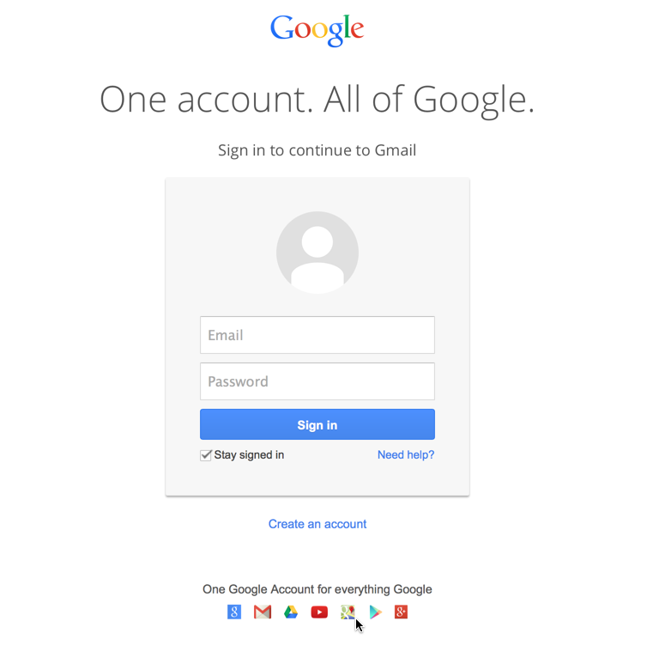

Step 1: Type [www.gmail.com](http://www.gmail.com) in your internet browser.

Step 2: Click the hyperlink “Create an Account”

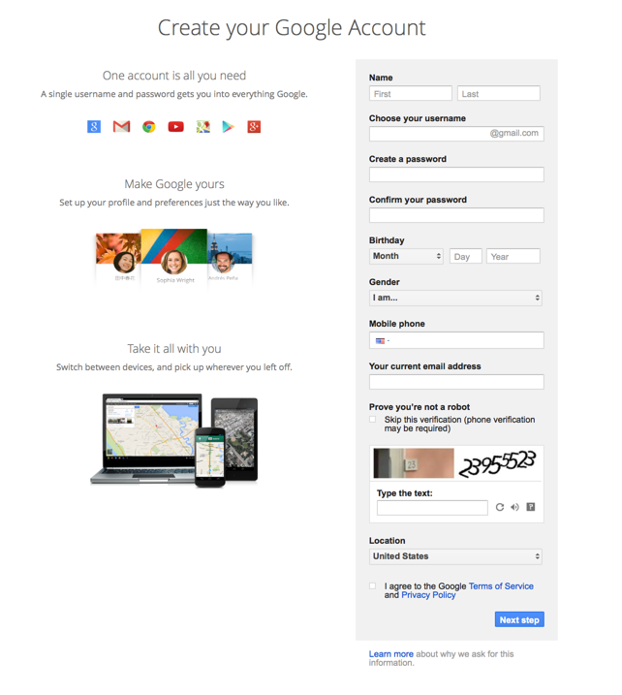

**Step 10:** Click Next Step which will lead you to your new GMAIL account. (See next screen shot)

**Step 9:** You must agree to the terms of service and privacy policy to move forward. You can read these policies by simply clicking on the link.

**Step 8**: Enter the code exactly how it is provided on your screen. This code will verify that you acquire the appropriate web tools to run the program.

**Step 7:** Enter your current e-mail address for an alternate contact in case you forget your password in the future.

**Step 4:** Create a password that is at least 8 characters in length. Using uppercase and lowercase letters with numbers will make your password strong. Ex: (John081324)

**Step 3:** Choose a username. (Ex: janedoe) If the username has already been taken, the site will prompt you to choose a different name.

**Step 1:** Enter your “first” name.

**Step 2**: Enter Your “Last” Name

**Step 6:** Enter your area code + phone number

**Step 5:** Enter your date of birth (month, day, and year)

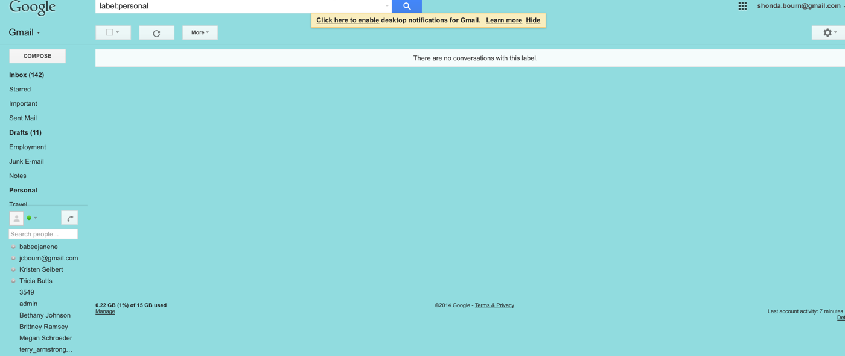

This icon is the “settings” tool. You can change the theme of your GMAIL, configure your inbox, change the display, etc. under this tool. GMAIL is user friendly, and you can personalize it under this icon.

Emails will pop-up in this section as they are received. The most recent emails will be displayed at the top (unless you change the results in the filter settings).

This is a list of your saved contacts for future e-mails.

Compose: Create New Message

Inbox: Emails received.

Starred: E-mails saved by you.

Important: Priority E-mails Saved

Sent Mail: Items sent by you

Drafts: Emails you are creating but have not sent yet.

Junk E-mail: Spam files