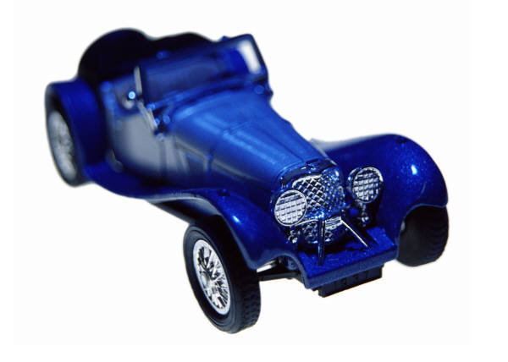

Ford Motor Co.
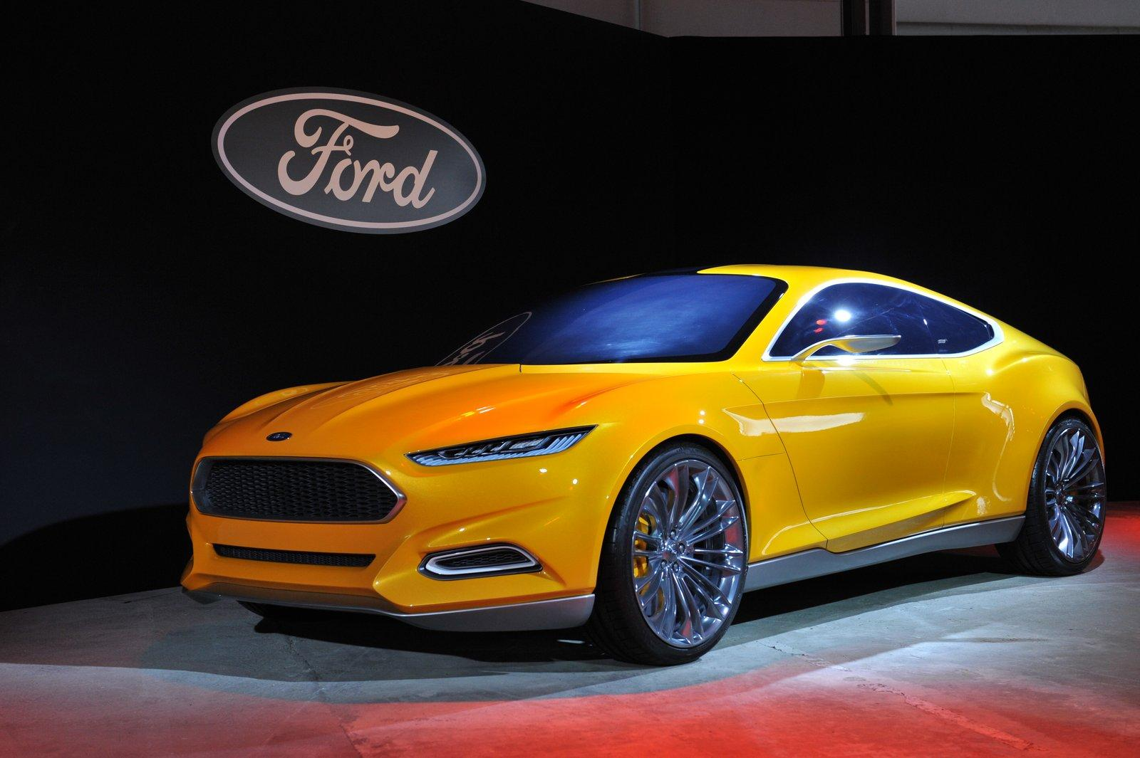
Ford Motor Co. Industry analysis
Prepared By: Richard A. Brown
TABLE OF CONTENTS
1 Industry overview 3
1.1 History 3
1.2 Factors that affect growth 4
1.3 Government regulations 4
1.4 Leading businesses in the industry 5

2 Business specifics 5
2.1 Estimated size of auto manufacturing industry 5
2.2 Recent sales trends 6
2.3 Prevalent marketing trends in the industry 7
2.4 Sensitivity to economic fluctuations 7

3 industry developments 7
3.1 News 7
3.2 Innovations 8

4 Conclusion 9

overview Primary SIC 3711
According to Euler Hermes a preeminent provider of trade credit insurance, Many auto companies restructured their operations, in or out of bankruptcy, during The Great Recession. As a result,
the industry emerged stronger and more flexible to the current operating environment. Post-recession, the U.S. auto industry landscape has changed significantly resulting in a leaner, more efficient sector. As consumer finances continue to improve, they are more willing to purchase big ticket items like homes and vehicles. Revived consumer spending, improvements in credit availability, the shift to green vehicles, and the aging vehicle fleet are all predicted to drive auto sector growth in the upcoming years.” “In 2013, auto manufacturers are seeing and will continue to see an increase in new car sales, with projected revenue growth of 8.6% for the year.” (Euler Hermes)
The first Ford Motor company automobile was the model A, by the time the fourteenth rendition model N hit the market; Ford Motor Company had the bestselling automobile in America and that was only the tip of the iceberg. Henry Ford and his Ford Motor Company are symbolic of the innovation, practicality, inclusion and perseverance of Americans. Many renditions after the original article; Ford Motor Company remains a diverse, vibrant, integral part of the global economy. Henry Ford had laid the foundation of the twentieth century.
“The assembly line became the century’s characteristic production mode, eventually applied to everything from phonographs to hamburgers. The vast quantities of war material turned out on those assembly lines were crucial to the Allied victory in World War II. High wage, low skilled factory jobs pioneered by Ford accelerated both immigration from overseas and the movement of Americans from the farms to the cities. The same jobs also accelerated the movement of the same people into an ever expanding middle class. In a dramatic demonstration of the law of unintended consequences, the creation of huge numbers of low skilled workers gave rise in the 1930s to industrial unionism as a potent social and political force. The Model T spawned mass automobility, altering our living patterns, our leisure activities, our landscape,even our atmosphere” (Henry Ford).
Ford Motors it seems is always conjuring its next model N.
“Ford Motor is engaged in producing automobiles. Co. and its subsidiaries also engage in other businesses, including financing vehicles. Co.'s business is divided in two sectors: Automotive and Financial Services. Within these sectors, Co.'s business is divided into reportable segments. Reportable segments in the Automotive sector include: Ford North America, which primarily includes the sale of Ford- and Lincoln-brand vehicles, service parts, and accessories in North America (the U.S., Canada, and Mexico); Ford South America, which primarily includes the sale of Ford-brand vehicles, service parts, and accessories in South America; Ford Europe, which primarily includes the sale of Ford-brand vehicles, components, service parts, and accessories in Europe, Turkey, and Russia; and Ford Asia Pacific Africa, which primarily includes the sale of Ford-brand vehicles, service parts, and accessories in the Asia Pacific region and South Africa. Substantially all of Co.'s vehicles, parts, and accessories are marketed through retail dealers in North America, and through distributors and dealers outside of North America. In addition to the products Co. sells to its dealerships for retail sale, Co. also sells vehicles to its dealerships for sale to fleet customers, including commercial fleet customers, daily rental car companies, and governments. Co. also sells parts and accessories, primarily to its dealerships (which in turn sell these products to retail customers) and to authorized parts distributors (which in turn primarily sell these products to retailers)” (Mergent Online).

History
The Ford model T changed the landscape for automobiles forever! Henry Ford’s decision to adjust pricing allowing for the inclusion of the “common man” was pure marketing genius. Ford Motor Company is incorporated (born) on June 16, 1903 and the basis for many generations of success the model A is begun.
“Incorporated in Delaware on July 9, 1919, and subsequently acquired all the assets of Ford Motor Company, organized in Michigan, June 16, 1903. “The predecessor company was capitalized for $100,000 of which only $28,000 in cash was actually paid in. There were 12 stockholders, including Henry Ford who held a 25 1/2% interest. In 1906, Henry Ford increased his holdings to 51% and shortly thereafter to 58 1/2%. In 1919, Ford family interests purchased the outstanding minority interest of 41 1/2%” (Mergent Online).

Factors affecting growth
Fuel prices, regulations, affordability, safety, social change as it relates to Eco friendliness, access to credit in emerging as well as mature markets.
“The automobile industry crisis of 2008–2010 was a part of a global financial downturn. The crisis affected European and Asian automobile manufacturers, but it was primarily felt in the American automobile manufacturing industry. The downturn also affected Canada by virtue of the Automotive Products Trade Agreement. The automobile industry was weakened by a substantial increase in the prices of automotive fuels linked to the 2003-2008 energy crisis which discouraged purchases of sport utility vehicles (SUVs) and pickup trucks which have low fuel economy. The popularity and relatively high profit margins of these vehicles had encouraged the American "Big Three" automakers, General Motors, Ford, and Chrysler to make them their primary focus. With fewer fuel-efficient models to offer to consumers, sales began to slide. By 2008, the situation had turned critical as the credit crunch placed pressure on the prices of raw materials” (Factors Affecting Demond Supply of Automobile Industry).

Regulations
Ford Motor Company as well as its competitors all operate under the auspices of regulatory bodies, some of the major regulatory bodies are the National Highway Transportation Safety Administration (NHTSA), Environmental Protection Agency (EPA), and the United States Department of Transportation (DOT). Ford has continually been cooperative with the agencies that bear responsibility for the massive auto manufacturing industry. The excerpt attached is an example of Ford’s proactive approach to environmentally sound practices: “Ford has participated in the public discourse on broad-based, national climate policy for some time. In 1999, for example, we discussed greenhouse gases in our first corporate citizenship report. In late 2005, we published a special report on the Business Impact of Climate Change, and in 2007 we joined the U.S. Climate Action Partnership (USCAP) to support the prompt enactment of national climate legislation” (U.S. Policy - Sustainability).

Leading businesses in the industry
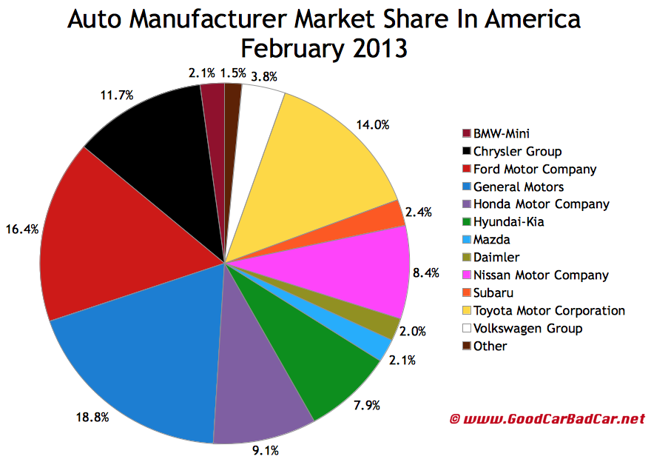
Ford Motor Company is headquartered in Dearborn Michigan; the company enjoys a 16% market share in the industry. Some of Ford Motor Co.’s key competitors are General Motors, Toyota Motors, Hyundai-Kia, Honda Motors, and Nissan Motors. Ford Motor Company remains a driving force in the industry as Euler Hermes reports “The Big Three (GM, Ford, and Chrysler) continue to be major players in the U.S. automotive marketplace, accounting for a combined 45.5% of YTD deliveries through September (2013). Their combined market share is up 51 basis points due to strong performance by Ford, whose revamped line up and continued success of the F-Series truck platform is driving improvement.”(Euler Hermes)

2.1 Estimated size of auto industry
The auto industry is a trillion dollar enterprise; the data below sheds some light on its scope along with some regional anecdotes.

“The global automotive industry involves the manufacture and sales of automobiles and other retail activities, such as gas-station retail and the sale of car parts. The industry’s yearly growth rate is expected to exceed 5.5% from 2010 to 2015, reaching a value of more than $5.1 trillion by 2015, according to research from MarketLine. US vehicles sales and production account for around 40% of the global automotive industry, according to Global Automakers, whose members have contributed close to $45 billion to US automotive activity. The investment represents 300 facilities and employment for around 80,000 people with a combined yearly payroll of $6 billion. Leading US manufacturers include Ford, General Motors and the Chrysler Group. The European automotive market is led by production in Germany, Italy and France. In the EU, the industry employs 2.3 million people directly and almost another 10.5 million indirectly, according to the European Automobile Manufacturers' Association. The region produces more than 17 million vehicles a year, representing a quarter of overall global production. There are just less than 170 facilities in operation across 16 member nations, run by 17 vehicle manufacturers. Leading players include BMW, Fiat, Renault, Volkswagen, Volvo and Peugeot Citroën.Overall, Japanese market share fell around 4% year-on-year to just under 35% in August 2011. Japan holds around a 45% share in both the compact car and compact crossover markets, and 48% in the mid-size car market, according to a Kelly Blue Book report. The March 11 earthquake and tsunami cut revenue for leading carmakers Toyota and Honda by $5 billion and over $3 billion, respectively. Leading Japanese automotive manufacturers include Toyota, Suzuki, Honda, Isuzu, Mazda, Daihatsu, Yamaha and Kawasaki.” (Automotive Industry: Market Research Reports, Statistics & Analysis)

2.2 Recent sales trends
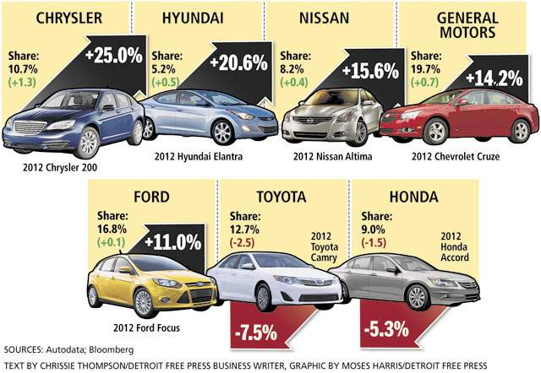
The Bush-Obama era economic recession seems to be getting smaller in the national rear-view mirror and automotive sales are revving up to reach pre-recession levels! “Good things come to those who wait, and everyone waiting for new car sales to once again pass the pre-recession threshold of 16 million will finally be rewarded in 2014. Edmunds.com's forecast of “16.4 million light vehicles expects car buyers to continue to flock to market, taking further advantage of more freely flowing credit to refresh the oldest vehicle fleet in history. Sales also will receive a boost in 2014 from an expected 300,000 additional lease returners, compared to 2013, who will lease or buy a new vehicle when their current leases end. At the same time, the downside risk to sales growth will be lower as the economy and consumer confidence continue to improve. While economic growth will remain modest overall, enough progress has been made that car buyers will be largely undeterred by the next rounds of U.S. fiscal crises” (Edmunds). The distinguished analysts at Euler Hermes seem to share my optimism that the market is indeed brimming with opportunity “The outlook for the auto manufacturing industry and its suppliers is bright, as consumer spending is expected to rise and the aging vehicle fleet is at record highs. Automotive sales are highly correlated with consumer confidence which is generally improving as consumers continue to strengthen their finances and reduce household debt levels. As a result, banks are more willing to extend favorable credit terms making it more feasible for consumers to purchase big ticket items. Auto loan originations increased in 2013 to $92 billion, the highest level since 2007. Coupled with an expanding population, favorable demographics, and new vehicle line-ups, these trends further bolster the long-term growth outlook.”

2.3 Prevalent marketing trends in the industry
The meteoric rise of social media has created a great new culture of direct interaction between producer and customer. The plethora of social media outlets available in the marketplace brings the seller and buyer together much earlier in the sales experience. An integrated marketing strategy has become a vital asset in the current sales environment. Clients are now able to have direct and valued input into what products are made and sold to them. The largely informal setting and direct feedback between buyer and maker leads to a more efficient concept to market process; because the manufacturer knows more clearly what the market wants. “Throughout their journey, customers increasingly rely on digital channels, for example, checking brands’ Web sites, reading reviews, and visiting social networks and community forums in the consideration phase. Recent insights have revealed that more than 50 percent of customers make their decision online, emphasizing the importance of managing the online channel for car maker. Our research shows that a new phenomenon is changing the landscape: customers who research online but purchase offline. These customers compare brands, obtain advice, and often also check pricing online before they move offline to the traditional retail channel to buy their car. This heavy, and growing, reliance on online information sources requires marketers to pursue an integrated marketing approach that cuts across different channels and customer touchpoints. In the future, it will not be sufficient to understand customer needs; companies must also grasp their channel behavior” (McKinsey).

2.4 Sensitivity to economic fluctuations
The auto industry is highly responsive to economic fluctuations; evinced by the lurch in auto sales during the most recent global financial recession. There is a positive correlation between the level of disposable income and auto sales. The automobile and business cycles usually move in line with each other but the amplitude of the cycle is higher in the automobile industry. The volatility of the automobile industry is also higher than that of the manufacturing industries as a whole. Evidence for the United States and Canada suggests that the reduction in car sales since mid-2008 has been magnified by the lack of access to credit, leading many households to postpone their car purchases. This implies that continued improvement in financial market conditions could provide an impetus to car sales” (The Organisation for Economic Co-operation and Development).

News
Ford Motor Company and Ford Motor Company Fund to award more than $800,000 to 13 area nonprofit organizations in 2014:
NASHVILLE, TN--March 27, 2014: Ford Motor Company and Ford Motor Company Fund today announced total donations of more than $800,000 to 13 area nonprofit organizations in 2014.“With these resources, we can Go Further to tackle such issues as education, healthcare and community life – all while making a difference for our neighbors” (The Auto Channel).

Innovations
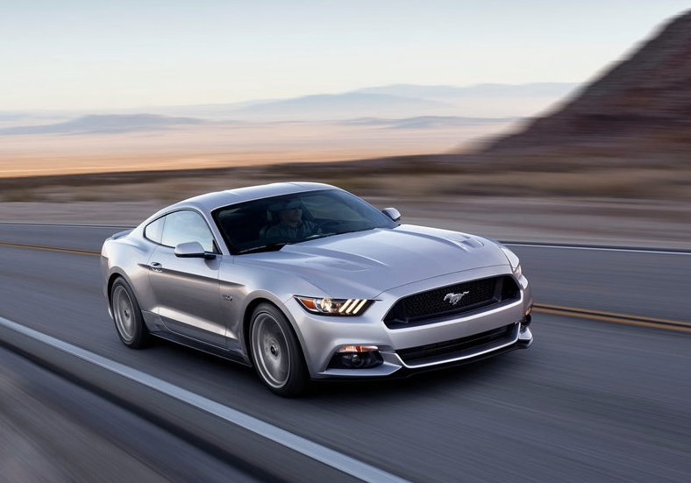
In line with the common theme at Ford Motor Company, innovation is a paramount part of the organization and is evident in daily operations. An excerpt from a recent article in the Sydney Morning Herald sheds some light on an iconic Ford Motor Company product and its ride into the technology age. “The halo car long known for raw horsepower will be offered in Australia with a suite of tech and performance programs aimed at making it more tailored to individual driver needs. Unlike the original Mustang launched 50 years ago, the sixth-generation model due to be introduced locally in 2015 will come standard with a launch control system (on Mustang GT) and four different driving modes, among other functions. “While Mustang unquestionably has always been about the ride, we can now do a lot of cool things with technology to let the true personality of the car come through the driver’s fingers and backside,” said the chief engineer for the Mustang, Dave Pericak.“Everything we added to Mustang is designed to let its drivers personalise the car to their tastes and wants to get the most out of it. ”Headlining the list of features is Ford’s newly-developed stability control system that provides improved performance on high-traction surfaces. Ford’s so-called Curve Control system will help to slow the car if the driver goes into a corner with too much speed. Ford has confirmed the Mustang will inherit the MyKey system already fitted to the Fiesta ST, enabling parents to set restrictions on speed for younger drivers. “A customer would have to spend thousands more on a premium German sports coupe to get all of the technology,” …a 4.2-inch colour screen and smart key access with push-button start complete the tech features.”

Conclusion
Source http://www.mergentonline.com/chartloader.php?img=multichart153387d2f1fedc&id=c4oiqupgtqun25qifv9if6815453387d2f29340&
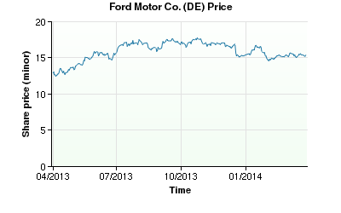
Ford Motor Company has long been an iconic American brand; both in terms of product substance as well as the soft factors i.e. the philanthropic, social and political ideals the company represents by virtue of its various actions. In the midst of an evolving market place which is welcoming burgeoning consumer markets in India, China, Brazil, Australia to name a few of the emerging first world economies; Ford Motors continues to deliver an appealing array of products across the market segments. My recommendation is; invest in Ford Motor Company whether it is your dollars or your talents because they will continue to innovate while being good corporate citizens and of course will provide a great return on investment.

Works Cited Web. 01 Apr. 2014. <http://www.mergentonline.com/companydetail.php?compnumber=3424&pagetype=synois>. "Automotive Industry: Market Research Reports, Statistics and Analysis." Automotive Industry: Market Research Reports, Statistics and Analysis. Web. 31 Mar. 2014. <http://www.reportlinker.com/ci02294/Automotive.html>. "Factors Affecting Demand Supply of Automobile Industry." Scribd. Web. 01 Apr. 2014. <http://www.scribd.com/doc/35849396/Factors-affecting-Demand-Supply-of-automobile-industry>. "Ford Motor Company and Ford Motor Company Fund to Award More than $800,000 to 13 Area Nonprofit Organizations in 2014." Ford Motor Company and Ford Motor Company Fund to Award More than $800,000 to 13 Area Nonprofit Organizations in 2014. Web. 03 Apr. 2014. <http://www.theautochannel.com/news/2014/03/27/107496-ford-motor-company-and-ford-motor-company-fund-to-award.html>. "Henry Ford's Legacy." Henry Ford's Legacy. Web. 01 Apr. 2014. <http://www.hfmgv.org/exhibits/hf/Henry_Ford_Legacy.asp>. "U.S. Policy." - Sustainability 2012/13. Web. 01 Apr. 2014. <http://corporate.ford.com/microsites/sustainability-report-2012-13/environment-climate-policy-us>. Web. 01 Apr. 2014. http://www.edmunds.com/industry-center/commentary/auto-industry-trends-for-2014.html The Organisation for Economic Co-operation and Development. Web. 01 Apr. 2014. <http://www.oecd.org/economy/outlook/44089863.pdf> Web 04 Apr. 2014 http://www.eulerhermes.us/economic-research/economic-publications/Documents/eh-industry-outlook-automotive-Fall2013.pdf

