[](https://www.google.com/url?sa=i&rct=j&q=&esrc=s&frm=1&source=images&cd=&cad=rja&uact=8&docid=NKEVBlj89faNrM&tbnid=PHuJjHYKCHnKhM:&ved=0CAUQjRw&url=https://www.facebook.com/BannerBoswell&ei=x_JnU-jNOouCogTA6ICQAQ&bvm=bv.65788261,d.cGU&psig=AFQjCNGvPhEYlX_Mgq2JIHNfG1VVYQ6RFA&ust=1399407676823724) [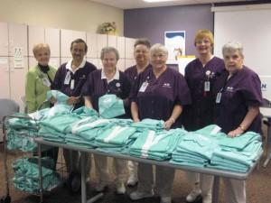](http://www.google.com/url?sa=i&rct=j&q=&esrc=s&frm=1&source=images&cd=&cad=rja&uact=8&docid=nEXTmHjotxiBLM&tbnid=vRek20JoUN4KeM:&ved=0CAUQjRw&url=http://www.yourwestvalley.com/topstory/article_cc97a38c-a6e2-57c6-a677-790697f267d6.html&ei=6_JnU-m0Coz0oASN2IKwAg&bvm=bv.65788261,d.cGU&psig=AFQjCNGvPhEYlX_Mgq2JIHNfG1VVYQ6RFA&ust=1399407676823724)

CTE INTERNSHIP

Shiragi Bhakta

Ms. English

CTE Internship

09 May 2014

[](https://www.google.com/url?sa=t&rct=j&q=&esrc=s&frm=1&source=web&cd=11&cad=rja&uact=8&ved=0CIgBEKgfMAo&url=https://plus.google.com/110662243308695783716/photos?hl%3Den%26socfid%3Dweb:lu:kp:placepageimage%26socpid%3D1&ei=ifNnU7_9F4veoATLkoDoAg&usg=AFQjCNGKIfcMr0SB5Iy4XJMnx8gKrVlOOg&bvm=bv.65788261,d.cGU) 