Lesson Plan Template
ETAP 524
SPRING 2014
Name: Melyssa Swett | Module: 4
Lesson Plan Title
Using Listening Maps to Understand Dynamics

Discipline and Topic
This lesson will teach students about dynamics in music (pp, p, mp, mf, f, and ff). Listening maps will be used to deepen student’s understanding of the relationships between the dynamics in various musical selections.

Target Population
This lesson was designed for a third grade integrated general music classroom of approximately twenty students. The students receive music once a week for thirty minutes. There are a variety of learning styles present in the room including audio learners, visual learners, and tactile learners.

Students have previously learned the definition of dynamics (the volume of the music). They should already understand that piano means quiet and forte means loud from previous instruction. They have already shown proficiency in recognizing these two specific dynamics in sheet music and audio recordings. However, this will be their first introduction to the full range of dynamics that exist in the musical field (including pp, p, mp, mf, f, and ff).

Curriculum Alignment and Standards
NYS Grade K-4 Music Standard 5: Reading and notating music.
From this lesson, students are able to identify the symbols for dynamics in sheet music. Students will also understand what the symbols mean when they are found in music.

NYS Grade K-4 Music Standard 6: Listening to, analyzing, and describing music.
In this lesson, students will show they are capable of identifying dynamics when listening to a musical selection. Students will be capable of describing the dynamic changes to classmates in class discussions.

ISTE NETS Standards
For students…

1) Students demonstrate creative thinking, construct knowledge, and develop innovative products and processes using technology.
a. Apply existing knowledge to generate new ideas, products, or processes.

Rationale: In this lesson, students use the listening map examples from the teacher and their new knowledge of dynamics to create their own listening maps.

For teachers…
1. Teachers use their knowledge of subject matter, teaching and learning, and technology to facilitate experiences that advance student learning, creativity, and innovation in both face-to-face and virtual environments.
a. Promote, support, and model creative and innovative thinking and inventiveness

Rationale: The teacher uses the computer/ projector to model a listening map to students. The listening maps allow students to use their creativity and knowledge to create their own product and create a deeper understanding of the relationship between dynamics in music.

2. Teachers design, develop, and evaluate authentic learning experiences and assessments incorporating contemporary tools and resources to maximize content learning in context and to develop the knowledge, skills, and attitudes identified in the Standards S.
a. Design or adapt relevant learning experiences that incorporate digital tools and resources to promote student learning and creativity.

Rationale: Students are getting a “real-life” experience since they are using their knowledge of dynamics and applying it to actual pieces of musical literature. Modern tools such as computers, projectors, and electric keyboards are used throughout the lesson to aid students in their learning.

Goals
Students will use listening maps to strengthen their understanding of dynamics in music, including identifying dynamic symbols in music notation & audio selections and giving the definition of each dynamic.

Objectives (State)
1) Students will be able to recognize dynamics while listening to an audio recording.
2) Students will be able to explain their listening maps to others during class presentations.
3) Students will be able to create their own listening maps while listening to a musical example.
4) Students will be able to explain the differences of the musical dynamics: pp, p, mf, f, and ff in class discussions.

Underlying Educational Theory
This lesson plan uses a constructivist approach. While students initially learn material through lectures and examples, they will then construct their own listening maps to reinforce information learned.

Materials Description and Timing
1- Computer and projector: for the teacher to display examples of the listening maps
Rationale: The computer/ projector combination allows the teacher to show examples to the student simultaneously. It also allows the teacher to zoom in on specific sections of the listening map and have both hands available to point at relevant info (unlike a poster which would need to be held).

2- Poster of music dynamics: to show students the symbols that are used for each dynamic level
Rationale: The poster allows students to see the symbol which is used to represent each dynamic so they are able to identify the dynamics in sheet music. Also, by putting the dynamics in order (from softest to loudest) it allows students to see the relationship between the various dynamics.

3- Electric keyboard
Rationale: An electric keyboard is used for students to hear the musical selections. The keyboard allows the teacher to choose the instrument sound heard (violin, saxophone, clarinet, etc.) so it can be closest to the natural timbre of the original song instrumentation.

4- Paper, pencils, & clipboards
Rationale: Students will each need a paper, pencil, and clipboard to draw their listening maps on. Traditional paper/ pencil combination is used because there is not enough computers in the room for each individual student to have their own. Also, the various shapes & lines that must be drawn on the listening map is easiest to draw on hand (unless a touch screen device was available). This allows students to focus on the listening map rather than spending class time trying to figure out how to draw the desired shape with the software programs.

(Selection Rubrics are included in separate attached documents).

Lesson
(1 minute)
1. The teacher will review what dynamics are: the volume of the music.

(3 minutes)
2. Students will discuss what they already know about dynamics (ex: piano is quiet, forte is loud, dynamic symbols are written in music, etc.)

(1 minute)
3. The teacher will explain to students that listening maps can be used to show the dynamics of a piece of music.

(4 minutes)
4. The teacher will show students a listening map for the song: “Hallelujah” by Handel. The teacher will play the song of the piano while students look at the listening map projected on the screen. The class will then discuss what they see in the listening map (the lines goes straight up if the song gets immediately loud, the line is less steep if the song gradually gets louder, etc.)

(4 minutes)
5. In particular, the teacher will refer to the various dynamic symbols which have been written onto the map. The teacher will show students the Dynamic Poster to show them the relationship between the various dynamics.

(2 minutes)
5. Student helpers will help the teacher pass out a sheet of blank paper, a pencil, and a clipboard to each student.

(8 minutes)
6. Students are instructed that they will make their own listening map for the musical selection: Surprise Symphony by Haydn. Students will be reminded to draw in the required dynamics in appropriate sections.

(6 minutes)
7. The teacher will divide students into partners to discuss the listening maps they drew (why is the line going up here, why does it immediately go down here, etc).

(2 minutes)
8. Students helpers will collect clipboard, pencils, and the finished listening maps (will be assessed for feedback purposes).

Assessment of Students
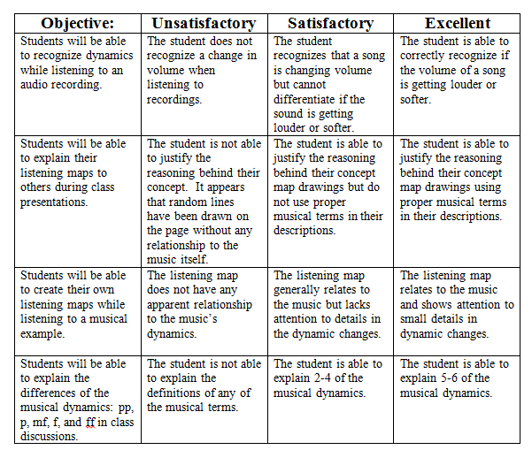

Evaluation of Students and Lesson
The teacher is able to evaluate the lesson by looking at students’ concept maps. 80% of students should have a concept map which resembles the dynamics in the musical selection. Again, 80% of students should have labeled dynamic marking in appropriate sections (p where sections are quieter/ lines lower and f where sections are louder/ lines higher). As students discuss I should hear students use their musical vocabulary to describe their concept maps to their partner.

One change I would make in the future is to have audio recordings of the musical selections rather than playing them myself on the piano. This would allow me to point to areas on the concept map in the example when first introducing the topic and I would also be able to walk around the room and watch students/ question them about the concept maps they have drawn. I had avoided using technological audio in the lesson part per request of the lesson plan directions but in reality I would prefer to use audio alongside the visuals in this module.
Low Tech Modification
In general this is a fairly low tech lesson plan in the first place. However, it could be stripped entirely of technology by having listening maps printed for students to view rather than looking at them on the computer/ projector. Also, the teacher could use a traditional piano or xylophone rather than an electric keyboard to perform musical examples for students.

1. 1st Musical Selection (for teacher’s model listening map): Hallelujah Chorus by George Friedrich Handel

If you are unfamiliar with this song here is an example: http://www.youtube.com/watch?v=usfiAsWR4qU

The sheet music used is the following arrangement (due to copyright laws only an excerpt has been included here). Music may be purchased at the link that follows.

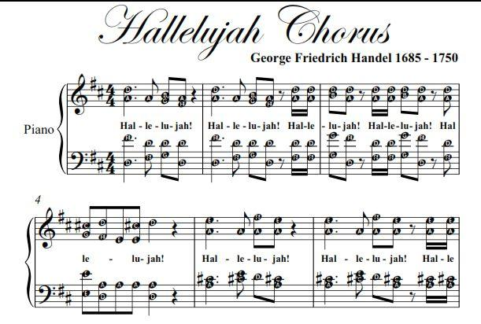
Taken from: https://www.google.com/search?q=easy+sheet+music+hallelujah+messiah&espv=210&es_sm=93&source=lnms&tbm=isch&sa=X&ei=pqMgU9uHLsnYqgGbpoHAAw&ved=0CAcQ_AUoAQ&biw=1281&bih=671#q=easy+piano+sheet+music+hallelujah+messiah&tbm=isch&facrc=_&imgdii=_&imgrc=mB3NMW6bEtIoZM%253A%3B8hxKN8JlPV5GEM%3Bhttp%253A%252F%252Fimages.addoway.com.s3.amazonaws.com%252Fitems%252F8869%252F2498165%252Facloudyday_1_27d376.jpg%3Bhttp%253A%252F%252Fwww.addoway.com%252Fviewad%252FHallelujah-Chorus-Messiah-Handel-Elementary-Piano-Sheet-Music-PDF-2498165%3B611%3B412

2. Teacher model of listening map

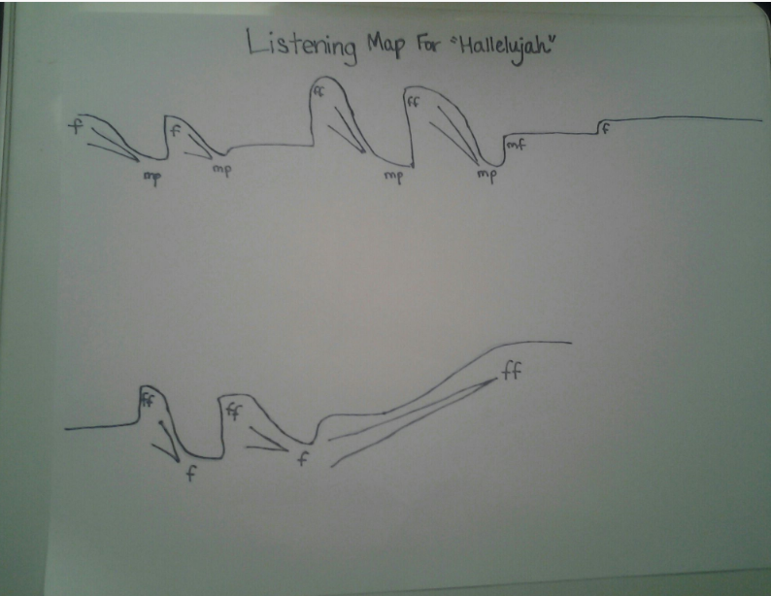

3. Poster Board Used

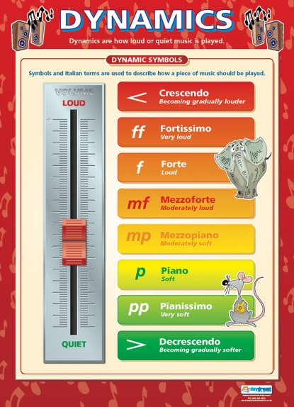

Can be purchased at: http://www.daydreameducation.co.uk/poster-dynamics

4. 2nd Musical Selection (for student’s creating listening map): Surprise Symphony by Haydn

If you are unfamiliar with this song here is an example: http://www.youtube.com/watch?v=tF5kr251BRs

The sheet music used is the following arrangement (due to copyright laws only an excerpt has been included here). Music may be purchased at the link that follows.

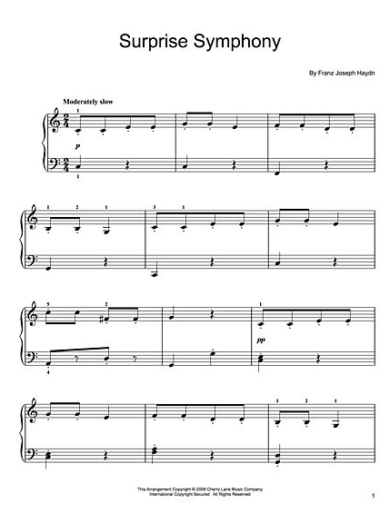

Taken from:
http://www.sheetmusicplus.com/title/the-surprise-symphony-digital-sheet-music/19456244?gclid=CIiznoDbjb0CFUcV7AodBR8AXA&d=sem_ggl_PLA&popup=false&ac=1&pdv=c&pcrid=29078649142

5. Example of student’s listening map



