Dow Chemical Company

Chemical; Manufacturing
SIC/ NAICS: 2873, 2821, 2899, 2865,
2824, 2869, 2879, 2812,
2819, 2874, 2891, 2823

History:
Dow Chemical Company was founded in 1897 by Herbert Henry Dow, an electrochemical pioneer of Midland, Michigan(Britannica). Dow Chemical Company was to supplement the Midland Chemical Company and the Dow Process Company, by using the wastes from the bromine extraction processes performed by Midland Chemical Company(Britannica). Dow Chemical began extracting other chemicals such as chlorides, magnesium, and calcium from Michigan plentiful brine deposits(Britannica). Dow is one of the leading suppliers of chemicals, plastics, synthetic fibers, and agricultural products(Britannica).

Government Regulations:
Dow Chemical Company follows all EPA regulations, including releases of dioxin-like compounds from air sources(Dow).

Leading Businesses in the Industry
Dow
DuPont
BABASF

- Dow is the largest chemical company in the U.S.(Hoover)
- Ranked #2 behind BASF worldwide (Hoover)
- #52 in Fortune 500 (May 2013)(Hoover)
- #220 in FT Global 500 (July 2013)(Hoover)

How Big is Dow Chemical?
- In 2013 Dow had annual sales of more than $57 billion (Dow)
- More than 6000 products are manufactured at 201 states in 36 countries across the globe (Dow).

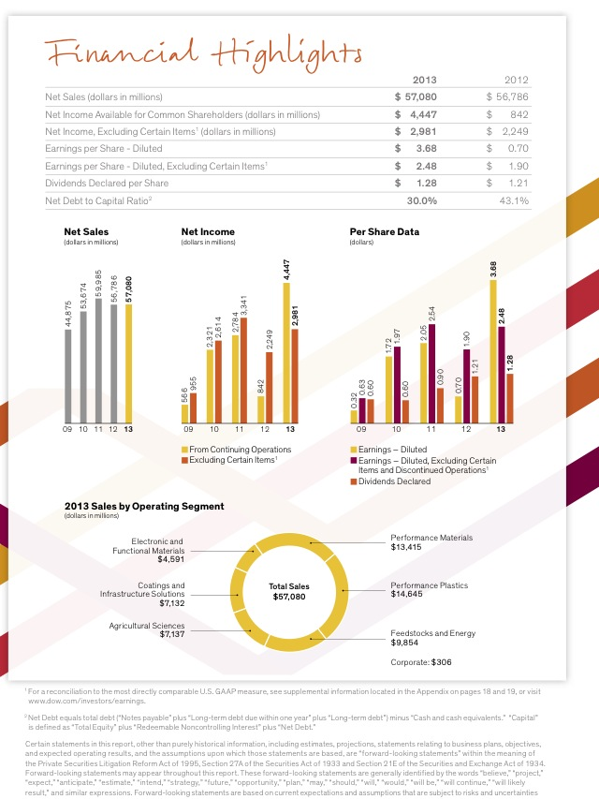
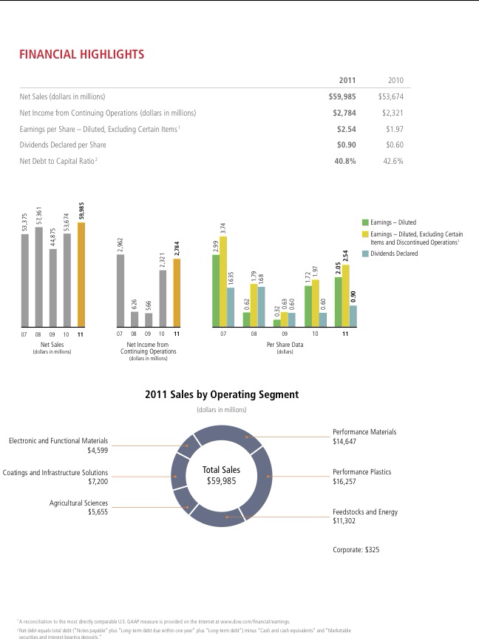
Financial Highlights
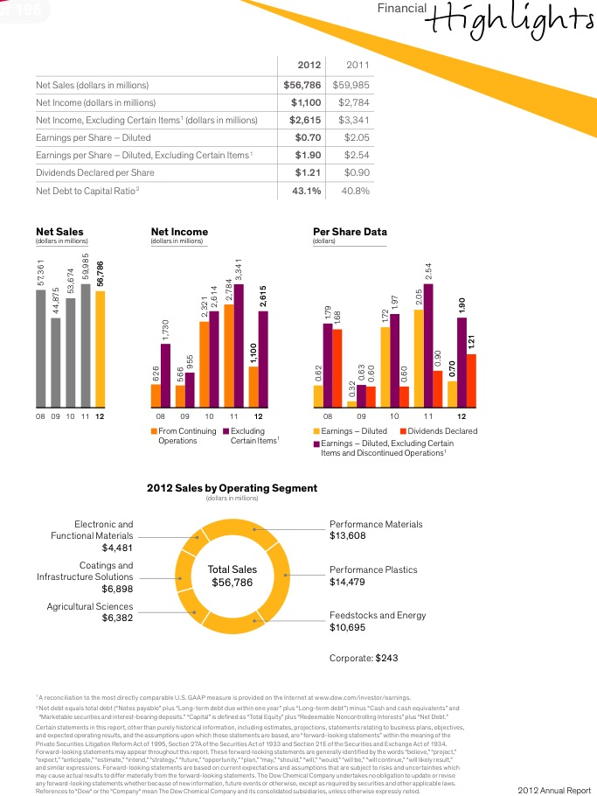
2011-2013
(Dow)

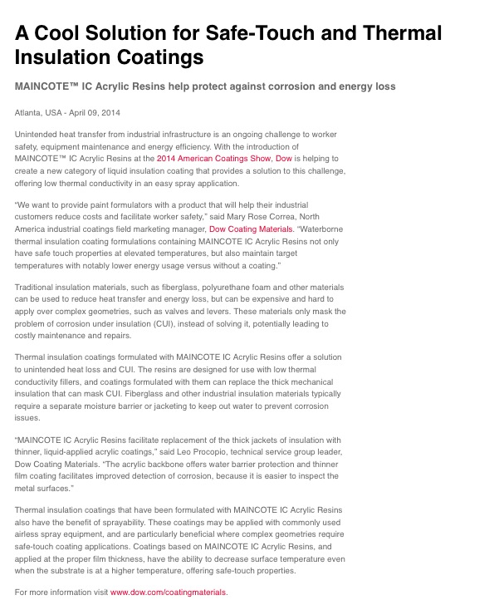
What's The Big News?
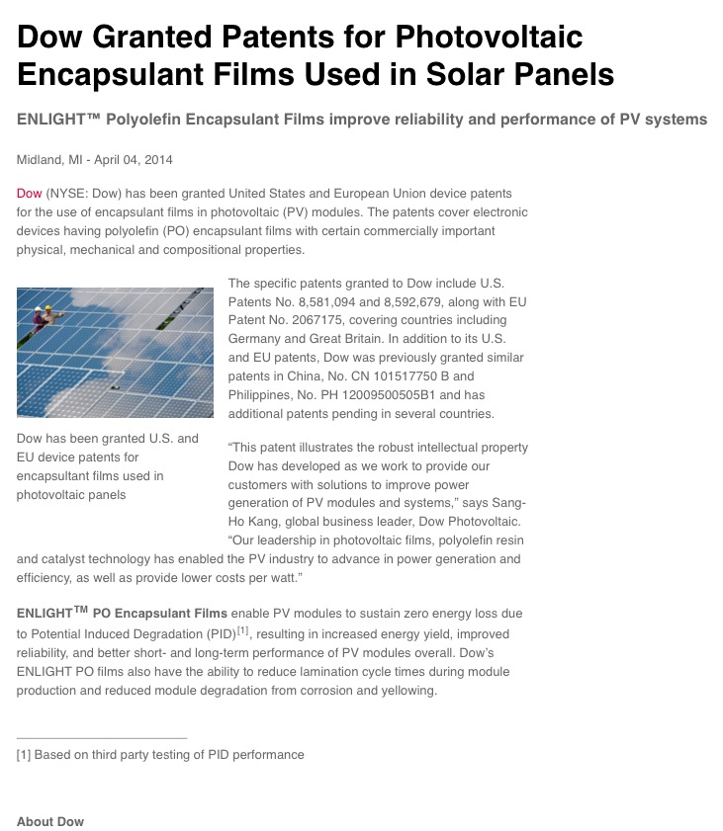
(Dow)

Meet the Competition
BASF
- Founded in 1865 by Friedrich Engelhorn (BASF)
- Headquarters are in Mannheim, Germany (BASF)
DuPont
- Founded in 1802 by Eleuthère Irénée du Pont (DuPont)
- Headquarters are in Wilmington, Delaware (DuPont)

Works Cited
http://www.basf.com/group/corporate/us/en/
http://www.britannica.com/EBchecked/topic/170379/Dow-Chemical-Company
http://www.dow.com
http://www.dupont.com
http://www.hoovers.com/company-information/cs/company-profile.The_Dow_Chemical_Company.669e4de7d9376016.html

