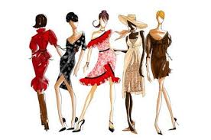

Women’s Fashion Industry

NAICS CODE- 448120 SIC CODE 5621
Abriela Cavalier
Fashion Industry- makers and sellers of fashionable clothing fashion industry, fashion business, garment industry, rag trade industry - the people or companies engaged in a particular kind of commercial enterprise.
Industry Overview
Brief history

The clothes we wear and the trends we follow are often associated with superficiality and materialism. Fleeting styles come rapidly into vogue, and then disappear as quickly as they came. But fashion has always been intrinsically connected to deeper elements of the American experience, from the economy and labor system to culture, religion, and class. From our underwear to our Levi's to our sneakers, what we wear has, for centuries, spoken volumes about who we are, what we do, and what we want. Whether Americans have dressed to make a political statement, to assert their class status, or simply to be irreverent, every style has carried a certain social meaning. This is in part because our culture has long ascribed great significance to individuals' public image, and because image has long been intertwined with the American capitalist economy. As Mark Twain once wrote, "Clothes make the man. Naked people have little or no influence on society."1. Clothes remain central to contemporary American culture and integral to our national history. The textile industry was brought to America in the 19th century from England. But the fashion industry is an American creation at the turn of the 20th century in the Greater Boston area by Jewish tailors. Prior to their efforts garments were made individually for each woman by dressmakers. These tailors became aware of some commonalty in the shaping, fitting and making of garments, and pattern making was born, one pattern that would fit more than one woman. They developed a mathematical sizing system to accommodate most women with very few patterns. As businessmen they continued developing these patterns to become paper “information systems” engineered to control quantities of exact reproductions in cutting and stitching clothing in mass production systems.
The mass production of women's clothing developed more slowly. Women's outfits generally continued to be custom-made well into the 1920s. In that decade, factors such as the development of industrial production techniques, the rise of the advertising industry, the growth of an urban professional class, and the development of national markets accessed through chain stores and mail order catalogs, contributed to the success of the women's ready-made fashion industry. Ready-made articles of clothing were portrayed as modern and fashionable during a time when the new consumer industries were rapidly redefining the way Americans viewed mass-manufactured goods. Instead of seeing the purchase of mass-produced clothing as entailing a loss of individuality, American women began to accept the pieces of ready-made merchandise as convenient, affordable, and up-to-date fashion items that could be replaced easily as styles changed. However, the new ready-made clothing often fit poorly. Each manufacturer created its own unique and sometimes arbitrary sizing system based on inaccurate body data or no body data at all. Garments of widely different dimensions were frequently labeled the same size by different manufacturers. This situation resulted in additional costs for alterations and large volumes of returned merchandise. This, in turn, increased costs for the consumer of ready-to-wear clothing. In 1937, the U.S. Department of Agriculture prepared to conduct a study of women's body measurements for the purpose of creating a sizing system which the entire industry could follow.
Factors that affect growth
Macro environmental factors affecting the clothing industry are those which lie outside small companies and their competitors. Business owners have less control of these external factors, and their impact in changing them is minimal. Instead, small companies must adapt to these macro environmental factors, which include consumer characteristics, technology, government influence and the economy. The way small companies adapt to macro environmental factors determines both their ability to differentiate themselves from key competitors and overall success.

Government Regulations affect many aspects of fashion retail. First, labor regulation affect how you can fire, hire, pay, and treat employees. Next, the Internal Revenue Service regulates and determines what sorts of taxes you need to pay. Many types of clothing must meet government flammability standards. Children's clothing must comply with child safety regulations. Since retail stores are public spaces, they come under the regulations concerning accessibility of the Americans with Disabilities Act, and must have no barriers to access for either customers or employees. Also, the retail space must comply with fire regulations concerning maximum number of people in a room, exits, fire detection, and sprinklers. Advertising laws and regulations exist at both the federal and state levels. In the retail industry, advertising rules dictate the messages companies may convey when attempting to sway consumers to purchase products and services. Violations of these regulations can lead to stiff financial penalties that far exceed any actual monetary damages consumers may suffer.
Government Regulations
Leading Businesses in the Industry

Cato Corporation, Charming Shoppes , Chico's FAS, Inc., Christopher & Bank, Coldwater Creek , Let It Rock , New York & Company , Talbots, Victoria's Secret , Wet Seal, Inc.

Estimated size of the industry – Dollars? Products/Services sold?
According to the latest annual report released by the U.S. Commerce Department in 2013, total retail sales in 2011 were $4.7 trillion, which represents an 8% increase over 2010 total retail sales (including food service and automotive). The 2011 increase was the largest year-over-year increase since 1999, indicating that economic recovery is well underway and that the future of the U.S. economy is expansion, not recession. The U.S. fashion industry is large, mature, and highly fragmented. Fashion sold in the United States is produced both domestically and in foreign locations.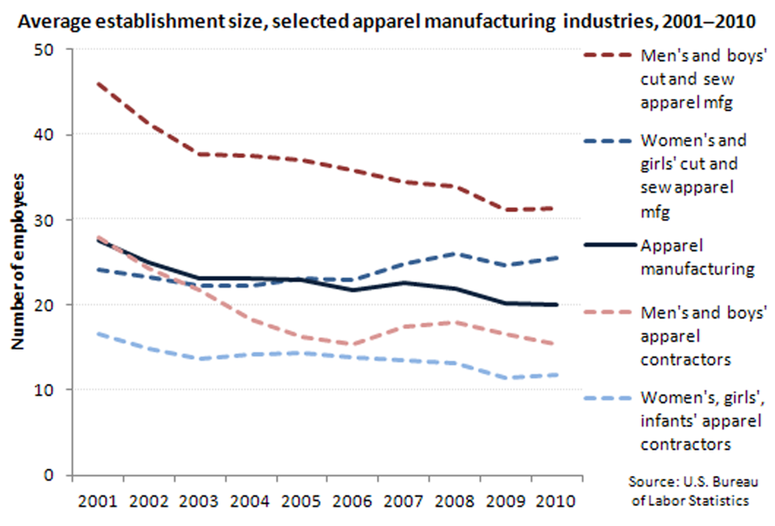 According to estimates from the American Fashion Manufacturers Association (AAMA), an industry trade group based in Arlington, Virginia, the dollar value of domestic fashion production was $39 billion at the wholesale level in 1997 (latest available), which was less than the $46 billion (U.S. wholesale value) of goods imported into the United States. In addition, $15 billion of goods were produced in both the United States and other countries.
Establish trends in sales over recent years

The U.S. fashion market can be divided into two tiers: national brands and other fashion. National brands are produced by approximately 20 sizable companies and currently account for some 30% of all U.S. wholesale fashion sales. The second tier, accounting for 70% of all fashion distributed, comprises small brands and store (or private-label) goods. Fashion is sold at a variety of retail outlets. Based on data from NPD Group, discount stores, off-price retailers, and factory outlets accounted for 30% of 1998 fashion sales, while specialty stores and department stores accounted for 22% and 18%, respectively. Another 17% were sold at major chains, and direct mail/catalogs accounted for 6%. The remaining 7% of fashion sales occurred through other means of distribution.
The Fashion Industry Seasonal
The retail fashion industry is highly seasonal, with the highest levels of sales during the fourth quarter. Our profitability depends, to a significant degree, on the sales generated during these peak periods. Any decrease in sales or margins during these periods, whether as a result of increased promotional activity because of economic conditions, poor weather or other factors, could have a material adverse effect on our Company. Generate our highest levels of sales during the fourth quarter, particularly during the November through December Holiday periods, and we typically experience higher sales of men’s products and accessories in June for Father’s Day. Our profitability depends, to a significant degree, on the sales generated during these peak periods. Any decrease in sales or margins during these periods, whether as a result of economic conditions, poor weather or other factors, could have a material adverse effect on our company.
Fashion Industry sensitive to economic fluctuations
The fashion industry is highly cyclical and heavily dependent upon the overall level of consumer spending. Purchases of fashion and related goods tend to be highly correlated with changes in the disposable income of consumers. Consumer spending is dependent on a number of factors, including actual and perceived economic conditions affecting disposable consumer income (such as unemployment, wages and salaries), business conditions, interest rates, availability of credit and tax rates in the general economy and in the international, regional and local markets where our products are sold. Our wholesale customers may anticipate and respond to adverse changes in economic conditions and uncertainty by reducing inventories and canceling orders. Furthermore, in such circumstances, our customers may encounter difficulties in other fashion categories or their non-fashion businesses that may cause them to change their strategy with respect to intimate fashion. As a result, any deterioration in general economic conditions, reductions in the level of consumer spending or increases in interest rates in any of the regions in which we compete could adversely affect the sales of our products. A return to recessionary or inflationary conditions, whether in the United States or globally, additional terrorist attacks or similar events could have further adverse effects on consumer confidence and spending and, as a result, could have a material adverse effect on our financial condition and results of operations.

