April 27, 2014

Ms. Dawn Garrido
10401 W. Thunderbird Blvd.
Sun City, AZ 85351

Dear Ms. Garrido

I would just love to point out the fact that I had an absolute blast these past 3 months. I could not have asked for anyone better to help mentor me and show me the ways of the radiology department. Since day one when I first stepped foot in the area, I was welcomed by you any many with open arms and comfort. Whether I would be having a bad day at school or home, every day at 12pm-4pm I knew for a fact that my mood would change and you guys always brought out the happiness in me. There are many things that I was taught when underneath your wings and I feel that with the skills you shared with me will help with any future jobs as any type of Medical Assistant. Not only did you teach me about the life lived within the hospital walls but how to mature as a man and how to deal with everyday problems that could occur as I get older. I appreciate all the wisdom you have shared with me through our time together and not one moment will pass were I will ever forget about you or the team that I was graciously offered to work among. I plan to visit the front desk squad again soon and maybe we can all go out for lunch and some non-alcoholic drinks. Thanks again for putting up with me even though you guys enjoyed the company. Till next time.

Sincerely,

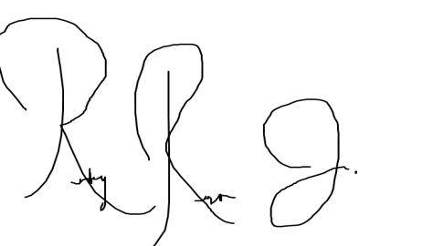

Ricky Rosa

