Destructive Cultural Warfare: Stereotyping Culture in Video Games

Steven Morris

Rogers State University

ABSTRACT

This study is an in-depth exploration, within the video game industry, and how cultures are discriminated against in gaming content. Also analyzed, are the perspectives of a random sample of college students and an experimental group on the discriminatory depictions of cultures within the gaming industry. Through triangulation and a combination of qualitative and quantitative research methods, the survey methods and content analysis are built. The results from this study explain if and how cultures are stereotyped and discriminated against, specifically Middle-Eastern and African-American cultures. Results also show that many games, especially military based video games, can be biased towards the United States of America. There are other results indicating a bias towards Caucasians in games as well, and how minorities are discriminated against in the process. There are other studies that go into deep exploration of culture stereotyping in video games, and some correlate with the following study. The overwhelming reality is that there are culture stereotypes in video games, which negatively effect the cultures discriminated against.

Video game participants are exposed to an increasingly high rate of cultural stereotypes in the content they play. There are many ways that multiple cultures are being stereotyped, and this specifically includes Middle-Eastern and African-American cultures. Steven Morris, the researcher of this study, finds many shocking results, involving the cultural discrimination in video games and the stereotypical content portraying these groups of people. There are many video games, portraying Middle-Easterners as the enemy as participants engage in military warfare, where racial slurs run rampant in series such as Call of Duty Modern Warfare. Game series like Grand Theft Auto and Resident Evil, show African-Americans in video games in a savage type manner. This brings up the Magic Bullet Theory, which is discussed later on. The article analysis or the researcher doesn’t emphasize this theory. However, the researcher analyzes how this theory could have some truth to how video games can play a role, even if only a small role, into the shaping of individuals’ constructs about other cultures. This leads to the researcher’s hypothesis.
Hypothesis: Video games depict contrasting cultures in negative ways.
Research Question: Are other cultures stereotyped in video games to make the “home country” look like the good guy?

ARTICLE REVIEW
Anna Everett and S. Craig Watkins discuss the ways that race is conceptualized in video games in their article titled, “The Power of Play: The Portrayal and Performance of Race in Video Games”. They begin with an introduction that emphasizes how important these video games are in terms of helping construct the education that gamers receive during gameplay. Much of this has to do with how gamers are being influenced by video games and the way their social constructs are being shaped. They even went onto claim that, “they provide a new means to engage young people by producing rich educational experiences…”, (Everett & Watkins, p. 143). This leads me to my overall hypothesis. My hypothesis is that video games stereotype races and cultures of other nations to create an experience that American gamers can relate to, based on what they have already perceived these cultures to be through news media. However, this has become much more obvious in games recently. Their research included the study by the Children Now organization, which “concluded that black and Latino characters were often restricted to athletic, violent, and victim roles”, (Everett & Watkins, p. 143). The game my personal research follows is the Grand Theft Auto series, which portrays the African –American and Latino immigrant cultures as strictly violent. This is a clear stereotype that is not true of everyone from these backgrounds. However, Everett and Watkins argue that these stereotypes result from the video game developers, who are trying to authenticate cultural spaces within video games. There is no argument that they do not do that. I have played for my research the title Grand Theft Auto San Andreas. In this game, they developers attempted to recreate the gang-filled section of South Central Los Angeles. I verify that it is accurate in terms of layout, especially since I have been there. However, there are people of all kinds in these neighborhoods and to generalize everyone there as violent is simply unfair. Therefore, it seems as though Everett and Watkins are discussing this controversial situation without regard to the Magic Bullet Theory. I am not saying that the Magic Bullet Theory is a valid argument to use. However, it is important to understand that heavy exposure to these types of games can help shape the social constructs of gamers, especially if the gamers are young adults or even teens. There are even instances where specific nationalities are criticized. The online user Nickelplate states in Everett and Watkins research about the game Grand Theft Auto San Andreas, “Sure the game portrays everyone negatively, but Haitians…are explicitly referred to in the game…The Statement ‘Kill all the Haitians’ could be replaced with, say the name of that Haitian gang”, (Nickelplate as cited by Everett & Watkins, p. 150). The explicit reference to the Haitian nation is one of many examples where American video games stereotype a nationality. There is a great deal of evidence throughout Everett and Watkins’ study. They made great use of gamer commentary, especially with the bit of information they received about the Haitian discrimination and generalization. Also, the evidence through the gameplay itself is extremely helpful to their study of how African-American and Latino cultures are negatively stereotyped as constantly violent. I think that Everett and Watkins were pretty neutral when conducting their research. They presented a lot of facts, but presented some of the data as trying to defend the creation of these stereotypes in a way. I thought this due to their explanation of why game developers created the characters and environments the way they did. I didn’t think much was ignored. Therefore, Everett and Watkins did a pretty good job with presenting contrasting information as well.

Omar Yusuf explains in detail the racism and cultural stereotyping that goes on in video games in his article titled, “Stereotype vs. Humantype: Race and Culture in Video Games”. He introduces this article by discussing how the majority of video game stories are told through the perception of white men. Yusuf also details that in many games, the protagonist is usually a younger to middle-aged white male. The few exceptions include the games that are highly offensive to opposing cultures. Yusuf also used research conducted by the Center of Media and Child Health. This study, “concluded that racial representation was poor and stereotypes were reinforced in the 1,716 games which they surveyed”, (Yusuf, 2009). He emphasizes that some of these stereotypes occur when video game developers get lazy and take shortcuts in making video game characters of other cultures. A fantastic example that I specifically remember and that Yusuf presents in his research is the Grand Theft Auto San Andreas character, OG LOC. According to Yusuf, “By creating characters like OG LOC in San Andreas, they appeal to an almost-racist template in the public consciousness. Instead of creating a more intriguing, deep character, Rockstar simply presents a shirtless, rapping, drug-addicted African-American who doesn’t require much of an introduction”, (Yusuf, 2009). This emphasizes the problem that video games pose in misrepresenting cultures. This poses a problem, especially if the game sells very well. If a game developing company such as Rockstar, creates a game and it sells well, then they get a feeling of reassurance since people are continuing to buy the game. Yusuf turns the discussion over to inaccurate depictions of the Arab culture in video games that usually, stereotypically start with the kidnapping of a young female. One of the specific examples that Yusuf refers to is the game Prince of Persia: Harem Adventure. He insists that games like these, “only serve to promote negative stereotypes of arbitrary cruelty conducted by Arabs”, (Yusuf, 2009). Yusuf also brings another heavy game producing nation, who is also presenting these cultural stereotypes in their video game content as well. He is speaking, of course, about Japan. He claims that Japanese games present a distasteful representation of African-American and Latino cultures within their video games. He states that in Japanese games, “Most Black characters possess stereotypical facial or personality features. Large lips, low brows, and loud mouths seem to be the foundation of Black ethnic depiction”, (Yusuf, 2009). This further emphasizes how the misrepresentation of cultures through video game production is cross-cultural. Yusuf concludes that video game developing shouldn’t be giving life to “outdated perceptions”, rather they should be trying to appeal to their entire gaming audience by refraining from these negative cultural depictions. There is much evidence and great usage of examples with Yusuf’s research over this controversy. However, he introduced one side of it. He did not mention the reasoning behind the developers’ sides as much as the previous article. Video games are becoming a major media source and it is important that these games are not negatively influencing the social construct of participants. Contrary data isn’t represented as much from Yusuf. However, it is from the developers and the participants themselves. This further emphasizes my hypothesis of how video games team with news media in depicting other national cultures in a negative way.

David Leonard discusses the inaccurate depictions of other nations that America has engaged in military battle against in his article titled, “Unsettling the Military Entertainment Complex: Video Games and a Pedagogy of Peace”. He begins by talking about how video games that have been militarized have increased significantly since the September 11th attacks in 2001. Leonard also mentions how declaring war on terror has made these games justifiable to many. This leads to what he would call the “Military-Academic-Entertainment Triangle”. According to Leonard, “In 2001, the Department of Defense began to use Tom Clancy’s Rainbow Six: Rogue Spear, a game featuring secretive operatives disarming (murder) terrorist cells, as part of its military training in how to conduct operations in urban settings”, (Leonard, p. 3). Since the War on Terror, video games that have been militarized have soared in terms of sales. This means that people of all ages now have access to this type of content. This is disturbing as it is training the next generation these cultural stereotypes that are also presented by the news media. Leonard continues, “Americans of all ages are thus able to participate collectively in the War on Terror and in Operation Iraqi Freedom, just as if they were members of the military. This is where some extremely controversial content comes into play. These video games allow players to participate in acts that would outrage the cultures that the games are portraying as the “bad guys”. For example, Leonard discusses that in the game Kuma:War, gamers have the ability to go to Iraq and be a part of a raid killing both of Saddam Hussein’s sons. It comes as no shock that some of these games are banned in other countries. Therefore, the stereotyping of these opposing military nations is now being accompanied by some propaganda as well. This leads to the enforcement of my hypothesis of other national cultures being stereotyped inaccurately and lumping everyone in those cultures into the same category of individuals. Leonard states, “War games such as Desert Storm, America’s Army, and Splinter Cell portray Arab-Americans as savages, uncivilized warriors, and terrorists”, (Leonard, p. 5). These games also justify the war actions by leaving absent important variables that exists in real life combat. One major variable that is usually absent from video games is the presence of innocent civilians. Leonard states, “In general, Conflict Desert Storm portrays Iraq, Kuwait, and Saudi Arabia as countries without people”, (Leonard, p. 5). This has national cultural stereotype written all over it. This further strengthens my hypothesis of video games teaming with news media to enforce negative cultural stereotypes. The author’s arguments were backed up well with in depth examples, strengthening my hypothesis as well. I definitely think that Leonard was against these negative stereotypes, but he presented contrasting information of uses on both ends. I think he used a sufficient amount of evidence to help his educational piece provide valid and relevant thoughts to the reader.

Helga Tawil Souri expresses her concern of cultural representation through the video game industry in her article titled, “The Political Battlefield of Pro-Arab Video Games on Palestinian Screens”. This details the how in the Middle East games are now being produced to retaliate the games that America has produced. This article is more of a narrative from Souri as she explains the intensity of gamers in an internet café. She discusses how gamers in these cafes yell at the screens, shouting at the game characters. This is just a taste of the effect that games have on its participants. She also takes through one of her experiences with a friend who is a gamer. The gamer states, “In all other games you can shoot Saddam Hussein, you can shoot Iran and Libya…Syria is also a target. My friends and I would try to turn the planes around to shoot at Israel but the game wouldn’t allow it…You can’t shoot at America and Europe either”, (as cited by Souri, 2007). Her friend goes into depth regarding a new game released where the tables are turned and the Middle Eastern gamers now have the ability to kill Israelis in simulated combat. These “pro-Arab” video games are allowing backfire to the American militarized gaming world. This is very much a direct retaliation to video games that are militarized that makes Arab countries their targets. The friend of Souri is a twelve-year old girl. This is a perfect example of how video games are a source of media to start shaping social constructs at young ages. Souri conducted her research through physically visiting multiple online cafes, computer labs, and even some living rooms in the area across the West Bank to the Gaza Strip. She noticed that these “pro-Arab” military video games were a majority in usage of these computer users. Therefore, this enhances the ideal that all military games can be a form of propaganda, regardless of the side being portrayed as the “good guys”. Once again, my hypothesis is continuing to be strengthened as video games prove to team up with news media and helping shape the social constructs of gamers and promoting cultural stereotypes within the content of these video games.

Methodology

When conducting research over any topic, it is extremely important for one to know exactly, who they are sampling, how they are sampling, and why they are sampling. The research methods used for conducting surveys, is important for the overall conclusions that the researcher may obtain. There are many ways to gather evidence for a research topic, but the researcher must know why they are using specific methods. Fortunately, there are many avenues to explore in terms of conducting research for a topic. However, the researcher may not fully comprehend how variables correlate with each other, if they don’t fully understand why certain methods were chosen. In the following paragraphs we will discuss aspects surrounding the research methods including the measurement and operationalization, how the sampling was conducted, the data collection techniques, and an analysis over how results will be used.
First, the measurement used for obtaining data and operationalization of it is essential for relating variables within research. There are many variables in conducting research over cultural discrimination in video games. Some of these variables include gaming participants, games chosen for emphasis within the research, reactions they have when in the experiment phase, and many more to be discussed further on. There are many other factors to consider with variables that are mentioned in the optional surveys to take. Some of these factors include sex, age range brackets, racial background, religious background, and how many weekly hours of gameplay the gamers participate in. Racial background is critical when conducting the surveys and the experimental phase, which will be discussed later. However, the surveys will provide valuable viewpoints, providing what the opposing racial backgrounds believe about how culture is discriminated in video games. This will be very important because it will help determine the opinions of gamers and will possibly strengthen or weaken the hypothesis of video games portraying cultures in a certain way. There also may be racial biases that come out of the surveys and it would be extremely important to detect those. The surveys would include some questions that would qualify as quantitative methods. The number of gamers that one surveys and also uses for the experimental phase of the research is a quantitative method, by the fact that a specific number of gamers were chosen. However, there are also some qualitative methods to the surveys. These are the open-ended questions, where opinions on video game portrayals are relevant to the reasoning behind gaming behavior. If the video game portrayals become a common factor among research participants, then the cultural discrimination could be a strengthening factor for the hypothesis. Therefore, triangulation becomes the overall method due to the combination of qualitative and quantitative methods used in surveys and the experimental phase. The age brackets are another important factor because different aged gamers may have other influences determining their reasoning behind decisions, such as traditional religious backgrounds or any religious backgrounds. Therefore, religious background is another important factor to analyze in the surveys. Another major factor taken into consideration is the weekly hours of gameplay that gamers participate in. The hours of weekly gameplay can be a determinant for how much of the content in these games they may have been exposed to. Therefore, it is possible that gamers, who play a lot of weekly hours, may have more insight to the opinions they express. This leads to the qualitative research of the open- ended questions and the experimental phase, which will be explained more in depth later on. However, the experimental phase will be very qualitative. This will consist of one group of five gamers, being exposed to various gaming content associated with a post experiment survey. All of these factors, methods, and variables are essential in this phase of the research and all of the steps to follow.
Second, the sampling techniques are also critical, as well as the population. The sampling frame is a major factor because it is important to understand how participants are selected. The technique this research engages in, is stratified sampling. Stratified sampling is the method that includes choosing individuals carefully in order to represent all groups relating to the topic. In the sampling displayed in this research men and women are represented. Also, they all have to fit into the criteria of playing video games at least once a week. Population is very important as well. However, because the research is limited to those participating in video game playing on a weekly basis, there stratified random sampling is being limited to seventy participants for the original base survey. Also, there will be an experimental phase consisting of one group of five gamers. This group will be divided, based on hours of gameplay per week. Once the experimental phase is over, the participants will take an exclusive post-experience survey. The sampling frame is important because it could restrict one’s ability to create a sample that is well represented. This is why this topic’s research methods may be small in quantitative terms, but is thorough in the criteria the individuals must have in order to participate. This will eliminate possible participants, who may not even fit the criteria of a weekly gamer. As previously mentioned, this topic’s research methods are small in quantitative terms. However, the research methods are qualitative in many ways. The qualitative aspects include the specific pool of individuals chosen, the specific open- ended questions in the base surveys, and the experimental phase. The experimental phase is extremely qualitative because of specific organization of the one group of five gamers. Also, the post experience survey will be thoroughly qualitative with open-ended questions in reference to the experience they just endured in the experimental phase. These are all things to consider when analyzing and altering the sampling frame. The specific population that this research narrows down to emphasizes the stratified random sampling technique that is used. The technique is stratified because of the credentials participants must have. The technique is random because gamers are selected at random, yet they must have the characteristic of being a weekly gamer. Another aspect that may be considered in this research, in terms of techniques, is convenience sampling. The researcher is a participant in the gaming community. Therefore, the researcher has access to convenient participants for the sampling pool. Also, the researcher may use another avenue of convenience. This would include people within the researcher’s workplace or even school, fitting the criteria of the pool to be experimented with. All of these factors play vital roles within the sampling section of research and must be analyzed to eliminate as many biases as possible.
Third, the data collection techniques are some of the primary ways for obtaining information in all of the research. The data collection techniques focused on in these research topics, are surveys and experiments. The surveys contain structured and open- ended questions, as well as some likert scale questions. The structured questions focus primarily on demographical characteristics of the participants. This includes sex, age bracket, racial background, religious background, and gameplay hours on a weekly basis. These are the basics and they are essential for dividing the gamers into sub categories, which can be tested in the experimental phase. After the basic structured questions, there are likert scale questions. These questions are important for interpreting how gamers feel about specific topics within the research being conducted. This allows for the researcher to scale how a majority of gamers feel about topics within video game stereotyping. The likert scale includes statements that the gamers answer on a scale, which includes the phrases strongly agree, agree, no opinion, disagree, and strongly disagree. The statements relate to stereotypes of cultures in video games. Some of the statements are as follows. “Military video games are a form of propaganda.” “Video games show countries other than the U.S. as bad.” “Video games portray minorities as violent.” These types of statements and how the gamers answer them will help give the researcher an idea of what ideologies they lean to as a whole. This will also be insightful to the opinions of the participants. If the majority of gamers answer “agree” instead of “strongly agree” on a particular statement, then that may lead to a discovery of a particular statement being thought to be sometimes true, but not in every instance. This allows for intense, in depth analysis. Therefore, the likert scale statements are an extremely important aspect to the surveys. The surveys end with open ended questions, which allow for the gamers to be specific in their gaming experience in connection to the statements from the likert scale. This is where the participants are able to tell experiences, which can strengthen or weaken the hypothesis of video games portraying opposing cultures in a negative way. The structured questions, the likert scale statements, and the open-ended questions all correlate and are critical to the research. The next data collection technique used is the experimental phase of the research. The experimental phase consists of one group of five gamers. These gamers will sign the researcher’s permission to observe them, just as those did to fill out the base survey. The four groups are individually exposed to many instances of “potential” gender discrimination from three game franchises the researcher chooses. These three franchises will be discussed for emphasis of the hypothesis in the final research. The three franchises are Call of Duty, Resident Evil, and Grand Theft Auto. The researcher will observe the individuals within the group’s behavior. The analysis of their reactions will help lead to conclusions, possibly strengthening, weakening, or doing nothing for the hypothesis. Once these organized groups are exposed to the content and participate in the content, there is a post experience survey the gamers will partake in. The post experience survey consists of open-ended questions, specifically requiring the gamers to recall their experience from the content exposure. Once these data techniques are utilized, the researcher can conduct the data analysis.
Fourth, the data analysis is an important step because of the interpretation of the data. When analyzing and interpreting the data, it is possible for a researcher to allow their own biases to be implemented to the research. This is why it is extremely critical that the researcher analyzes all of the data techniques together and how all of the possible variables correspond with each other. Therefore, a “for sure” fact will most likely not be found, rather a speculation of what could be true based on evidence found within the research. When analyzing data obtained from data collection techniques, it important to consider how results will be evaluated, how data will be presented, and the procedures used to interpret the results. The results will be evaluated critically and the majority will not be the only significance to the research. Every percentage is crucial to discoveries within the research. The majority of a specific belief will be helpful in determining what could be true, but the lesser percentages could reveal a new discovery of how a specific sub group feels about the topic. The results must be evaluated thoroughly in relation to all of the possible variables to avoid possible biases. Once the results are evaluated, conclusions are brought to the forefront. The next step is data presentation. It is important to include all variables when presenting data. Therefore, presenting graphs is useful, but must be done carefully with all variables considered. This means a detailed graph, which can demonstrate the results from the surveys and experimental phase. Also, it is pivotal to give the audience an insight to the experimental phase. This is done, by exposing evidence of the research, within the presentation. The evidence is exposed, by data tables and possibly media, if the participants sign off and give consent to be recorded or photographed. In terms of procedures for interpreting results, some data reduction is implemented. However, the central evaluation is within the measures of central tendency. This is where the researcher analyzes the data and includes the results in the mean, median, and mode. This allows for all of the data to represented, not just majority. It is important because all aspects of the data present results. When a researcher looks solely at the majority, there is essential data they are missing out on. This would strengthen the initial procedure of data reduction, where the data is first summarized.
Finally, the significance of the research is just as critical as any of the previous steps. If the researcher isn’t conducting the research for any significance of finding an answer to a question, then they are moving forward with no plan in place. The research methods within the whole process and the conclusions derived from them seek to obtain a possible answer to the hypothesis of video games portraying opposing cultures in a negative way. This comes back to many ideologies throughout research within the content analysis. However, if the hypothesis is strengthened, then this could lead to an emphasis of the Magic Bullet Theory. Therefore, gaming participants may be affected by the cultural stereotypes they are exposed to in video games. If the hypothesis is strengthened and the theory is emphasized, it may enlarge the controversy over some types of games on an even larger scale than before.
In conclusion, the survey methods are an important building block to the entire research. It emphasizes how important it is for a researcher to know who, how, and why they are sampling. The final conclusions are brought to the forefront, after the previous steps are implemented. Therefore, the researcher must remember to evaluate all of the research evidence, based on all variables and their relation to one another. The reasons behind methods chosen help strengthen the researcher’s attitude toward the research. Thus, the research gains more purpose and the researcher is inspired to find conclusions to their questions and hopefully find answers to the hypothesis. The measurement and operationalization, how sampling is conducted, the data collection techniques, and the data analysis are all important aspects surrounding the research methods. They must be utilized efficiently to obtain thorough results. All of this must be led by a purpose. This research is searching for possible reasons gamers play specific types of games and their thoughts on the possible stereotypes within them.

Content Analysis

When conducting a content analysis, many things must be considered. One driving force is behind these things. This is the research question or hypothesis. There must be a research question or hypothesis identified to enforce a plan of action, which would attempt to retrieve non-biased results. However, a content analysis is much more than the hypotheses, research questions, or results. The content analysis is everything in between from the frequencies of specific behaviors to the reasoning behind choices made by participants. It is also important to define the sample population, especially while defining the unit of analysis. These, among other factors, all play a role into the overall content analysis. In the following paragraphs the researcher will discuss the hypothesis, population or universe, units of analysis, category construction, coding schemes and sheets, processes of training coders, data analysis, and interpretation of results.
First, formulating a hypothesis is essential for any research. The hypothesis being carried out is whether or not video games portray opposing cultures in a negative way. There are many cultural stereotypes in gaming that go both ways. There are many critical aspects of cultural discrimination, which some of the article reviews went into depth about. These critical aspects presented, helped formulate the hypothesis used for analysis in the research phases. The hypothesis became relevant to the researcher because of the multiple outcries about how video games portray cultures, specifically Middle-Eastern and African-American cultures. However, a research question came into creation due to the article reviews also. Are other cultures stereotyped in video games to make the “home country” look like the good guy? This is where the Magic Bullet Theory has some say. The reason for this hypothesis becoming so prevalent is due to the outburst of games, allowing gamers to pick sides in cultural warfare within video games. Within choosing to affiliate with certain types of games they see part of themselves associate with the views in the game portrays. Therefore, this caused the researcher to build a desire to dig deeper into this phenomenon regarding video games discriminating against culture, as well as video game developers, creating other cultural characters as violent or stereotypical. Identifying a hypothesis or multiple hypotheses is the first big step. The reason for the heavy weight on the hypothesis is because defining methods, population, and many other things depends on a hypothesis for direction. Where there is no direction, there is no plan. Where one fails to plan, one plans to fail.
Second, defining the population or universe is one of the mandatory aspects brought forth, once a hypothesis or research question is defined. The population for stereotyping cultures in video games is very specific. The basic criteria to participate in the surveys, is to have a played video games or know someone who does often. This is where the demographics also come into play. The surveys included demographical characteristics, which the participants identified. Therefore, a good way to classify the researcher’s universe is gamer and gamer association population. This clearly represents that all participants have played or know someone who plays video games. The population sample is taken within a period of two weeks. These two weeks contained the surveys and the experimental group, which witnessed and participated in some of the gameplay used for the research methods. The demographical characteristics included race, age range, racial background, religious background, and two others the researcher found to be the most important. These two demographical characteristics, which the researcher heavily put emphasis on for the study of gender stereotyping in video games, are racial background and hours of gameplay on a weekly basis. This reduces the population sample to more reliable sources in terms of experience. After all, wouldn’t a researcher want to eliminate all sources, which may have little value to the research processes? This is where it becomes critically important to make sure the participants fall within the population that the researcher is seeking. Therefore, the results will be much more informative, allowing the researcher to distinguish motives and possibly remove or take into account possible biases.
Third, selecting and defining the unit of analysis is the next important step in the content analysis. This involves the coding of frequencies of specific characteristics. Stereotyping cultures such as Middle-Eastern and African-American cultures, in video games contains many things to record frequencies of. For instance, the recording of Middle-Eastern warfare, or even the number of times minorities, specifically African-American, are seen in a violent manner. This would also include possibly the frequency and number of games that portray the Middle-Eastern society as bad. There are key things to look for in the gaming content, such as the frequency of racial slurs in specific titles like Call of Duty: Modern Warfare and Grand Theft Auto V. However, before the surveys, the researcher participated and documented frequencies of specific behaviors in multiple video games. The researcher observed Middle-Eastern military forces strictly trying to eliminate the U.S. armed forces in Call of Duty: Modern Warfare. There were also instances in Grand Theft Auto V, where African-Americans are shown shooting each other and participating in gang violence. In one of the opening scenes of Grand Theft Auto V, the researcher documented three instances of African-Americans encountering police in violent altercations. There are also increasing frequencies of video games coming out in which the male protagonist is not only male, but is specifically Caucasian. Through the researcher and the experimental group’s findings, both share a common ground when it comes to how many of the selected titles displayed minorities in a discriminatory manner. The common finding is that there were five, who agree that other cultures portrayed through stereotypical characters in multiple video games explored including Grand Theft Auto and Call of Duty. This is also documented for the purpose of comparing frequency of overall game titles portraying Middle-Eastern cultures as violent or bad. This also is a coding factor used into the research of minorities being portrayed violently and stereotypically in behavior. The surveys prove to be especially important here because they provide whether or not some things are frequent as some research displays them to be. Another code frequency proved to be relevant without the researcher knowing. This is the use of code words. In some of the survey responses, a frequent game keeps showing up in answers. This is in the answers of the open-ended question asking, “Have you experienced game characters of other ethnic backgrounds and other cultures portrayed as vioent?” There are multiple responses, referring to the Call of Duty and Grand Theft Auto series. However, not just the series, but specific titles. Grand Theft Auto V and Call of Duty: Modern Warfare 2 makes its’ way onto many of the surveys. It proved to be such a high frequency in answers that the researcher decided to use scenes from Grand Theft Auto V and Call of Duty: Modern Warfare 2 in the experimental group. There were also frequencies used for the participants within the experimental phase. The participants witnessed six different scenes and participated in some of them as well. The common frequency of the content the researcher provided is material, containing different cultures, committing violent acts and stereotypically voice acted. The frequencies of these negative stereotypes of minorities and other cultures could skew towards a bias. Therefore, the researcher contained scenes of minorities, who were influential protagonists as well.
Fourth, constructing categories is essential for the content analysis process. When constructing categories, the researcher must anticipate common themes. The common themes emerging from the data, mostly deal with the agreement of Middle-Eastern and African American cultures being stereotyped violently. This also lines up with many of the common themes presented in the article review. The article review includes many common factors, which also include the Magic Bullet Theory. This is important to construct as a category because cultural stereotypes in video games must be included in the research in order to get accurate results that are not biased towards a one racial background or point of view. Therefore, the most prevalent common themes are violent acts, racial slurs, and reactions to the opposing cultured characters. These factors include many racial backgrounds respectively. Once these common themes are identified, there are steps taken to try and validate certain ideologies. Specifically, these common themes will attempt to help support and possibly validate the overall hypothesis or hypotheses.
Fifth, developing a coding scheme and a sheet is extremely important in the content analysis process. The coding scheme consisted of counting the number of frequencies of different types of responses in the surveys. The coding scheme also recorded frequency of game titles with characteristics of Middle-Eastern cultures being portrayed as only violent and African-American cultures being portrayed as criminal. This also analyzed the consistency of specific answers and which answers proved to be less popular choices. This also consists of the division of answers based on racial background. For instance, how did this particular racial background approach and answer this type of question? Therefore, there is also a third party, who rechecks and analyzes the frequencies of specific answers. Also, there is need for the frequencies to represent the research accurately. This means eliminating the biases that the researcher may have. Therefore, it is necessary to have a third party involved in the experimental phase and even to verify survey results. This, among many other factors, provides an analysis with results that eliminate many possible biases that are pre-existing. The next major step within developing a coding scheme is to compare results and begin the arrival of conclusions. In this process the hypothesis is either strengthened or weakened, and in result other conclusions may arise that the researcher never thought of at the start.
Sixth, training the researcher’s coders is essential to arriving at a conclusion with as much bias elimination as possible. The purpose of this process is to arrive at a much more reliable analysis. The need for a reliable analysis is necessary to make the research, as a whole, worthwhile. The research must be justified by having a reliable analysis, so that the research is utilized efficiently. The research needs to be utilized efficiently in order to make the research process worth all of the work. If the research analysis is not reliable, then the research surveys, experimental group, and the analysis of each are all for nothing. The third party must also be familiar with everything the research entails, especially the purpose of the study. Therefore, training the researcher’s coders becomes a process where the coders can identify with the research and help come up with conclusions as well. However, the researcher and the coder allow for the research to have less bias, than just one doing everything. For instance, in this research analysis the coder counted the frequencies in the surveys and so did the researcher. While both are counting, they arrive at specific conclusions. Some regarding whether the hypothesis is strengthened or not. The coder and the researcher compare conclusions and arrive at consistent conclusions that represent the data in a non-biased manner. Once the common themes are found, they are then used as arguments to help strengthen the hypothesis, or prove how false the hypothesis is. In this case, the hypothesis seems to be strengthened due to the fact that close to seventy percent of gamers agreed that opposing cultures and minorities are portrayed as violent as well the video game portrayal of countries other than the U.S., being portrayed as bad. Therefore, there could be a correlation between these statistics and cultural discrimination in video games.
Seventh, the second to last important step involves analyzing all of the data. This is done, by counting the number of occurrences and the reporting of frequencies. There are multiple things to consider in the surveys and the experimental group. The experimental group recorded frequencies of specific behaviors in the games. All five participants recorded violent acts, stereotyped behavior, criminal activity, and opposing the U.S. law or government in Call of Duty: Modern Warfare 2 and Grand Theft Auto V. Over fifty percent of gamers think that minorities are culturally portrayed violently in video games. Also, over sixty percent of gamers believed that other countries are portrayed as bad in video games compared to the U.S. The next likert scale question on the survey has more of an inverse in the style of the statement. Less than fifty percent of gamers believed that minorities weren’t protagonists in video games. Therefore, white males may not be as favored as previously thought. However, these protagonists are still portrayed violently. Therefore, there could be a valid argument to make for the Magic Bullet Theory. Overall over sixty percent of all participants believe that minorities and other cultures are portrayed stereotypical, violent, or bad. The experimental group witnessed Middle-Eastern characters torturing U.S. soldiers as well as a raid by U.S. soldiers through Iraq in the Call of Duty series. One of the scenes depicted in Grand Theft Auto V showed a Caucasian person being scared by an African-American robbing their house and the character states, “help he’s black!” This shocked some of the gamers, especially since this game is a pioneer in terms of that kind of uncensored content.
Eighth, interpreting the results is the final step where the researcher comes to conclusions about specific data results and in result strengthens or disproves the theory. There are many ways to interpret the results of the research and that it why there must be critical analyses done to eliminate as many biased results as possible. The results are vast in terms of interpretation. All of the likert scale statements and their results strengthen and thus far have proven the hypothesis of minorities and opposing cultures negative portrayal. The next realization is the strengthening of the Magic Bullet Theory. Both the researcher and the article review go into depth regarding this theory. According to the results of gamers, they think that minority game characters are portrayed criminally violent. This could have some effect on gamers, if these participants are acknowledging this problem. Therefore, the Magic Bullet Theory is strengthened also. However, there are few other supporting facts to back up the Magic Bullet Theory. Therefore, the theory is not as reliable as it was thought of in previous history. The research question of other countries, other than U.S., being portrayed as bad also held up. Therefore, could games possibly help shape the construct of how gamers understand other cultures if they allow heavy exposure to the content.
In conclusion, the hypothesis and the research questions are the driving force behind the steps of conducting a content analysis. The comparison between the researcher’s results and the results of the literature review are quite interesting. They both contained similar claims in all topics and the hypothesis and research question is upheld. A plan of action to retrieve non-biased results is only attainable when a hypothesis or research question is identified. The content analysis has proved to be effective from the frequencies of specific behaviors to the reasoning behind the choices the participants make. Many factors play a role into the overall process of the content analysis. The previous paragraphs discussed the hypothesis, population, unit of analysis, category construction, coding schemes and sheets, processes of training coders, data analysis, and interpretation of results. In the end, the content analysis is the final step in strengthening or disproving a hypothesis.

Limitations & Conclusions

Multiple processes can be enhanced to further this study. Many of the limitations primarily dealt with lack of variety with some of the demographics, as well as time constraints. The time constraints played the most as a limitation and more time allows for more chances to reach out and obtain diversity within the demographics for the surveys. The majority of the participants are Caucasian, which could have an effect on the results, but there is no guarantee of this affecting the overall results. In terms of the accuracy of this study, the results thus far are accurate. The researcher encourages this as a base study for someone attempting to explore gender stereotyping in video games in more depth. In conclusion the hypothesis is strengthened by the results, but the research question is not. Further study is encouraged for more results to help strengthen the hypothesis more.

Results

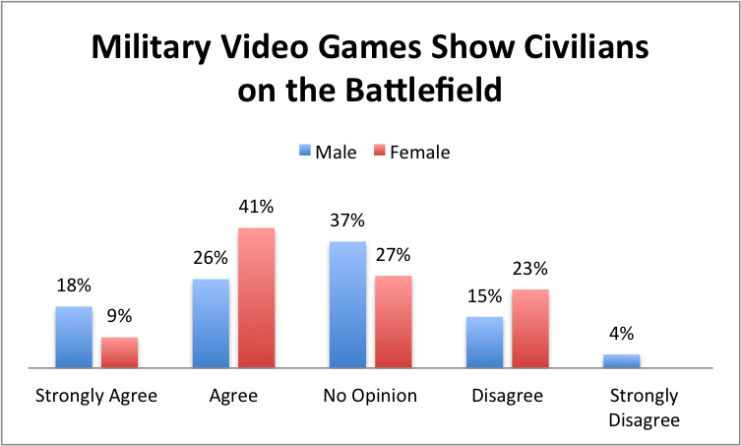

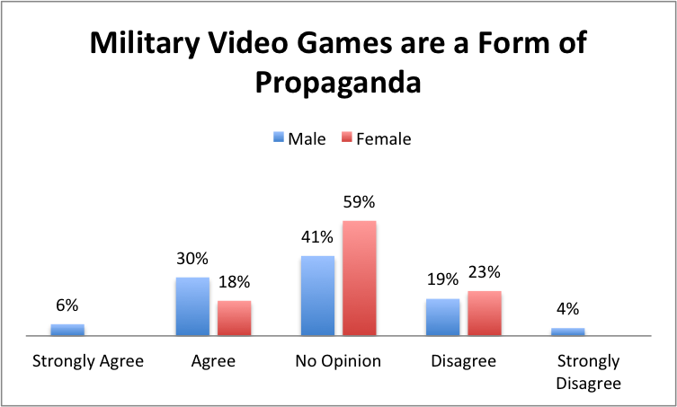

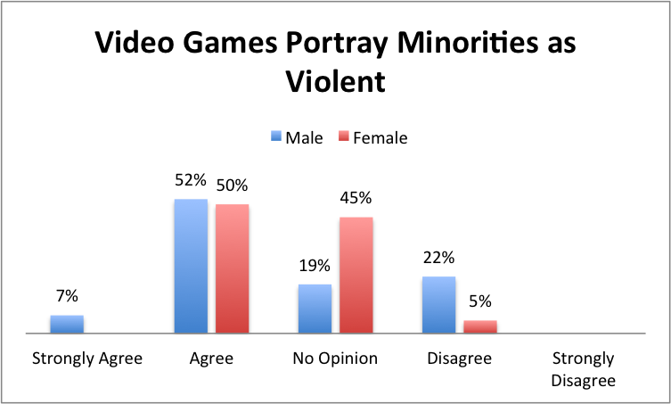

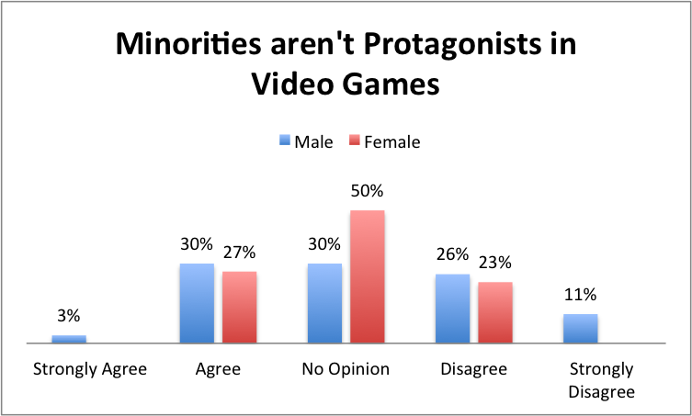

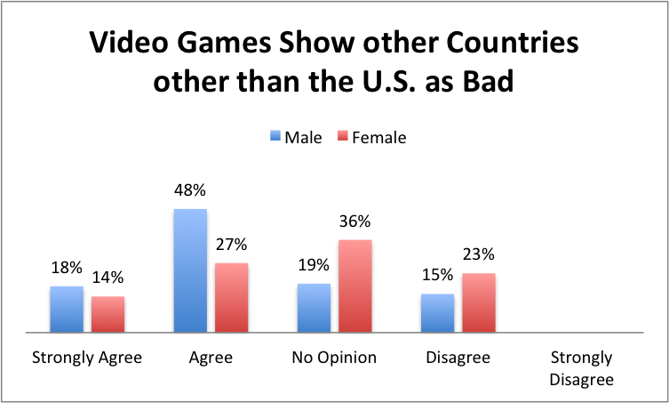

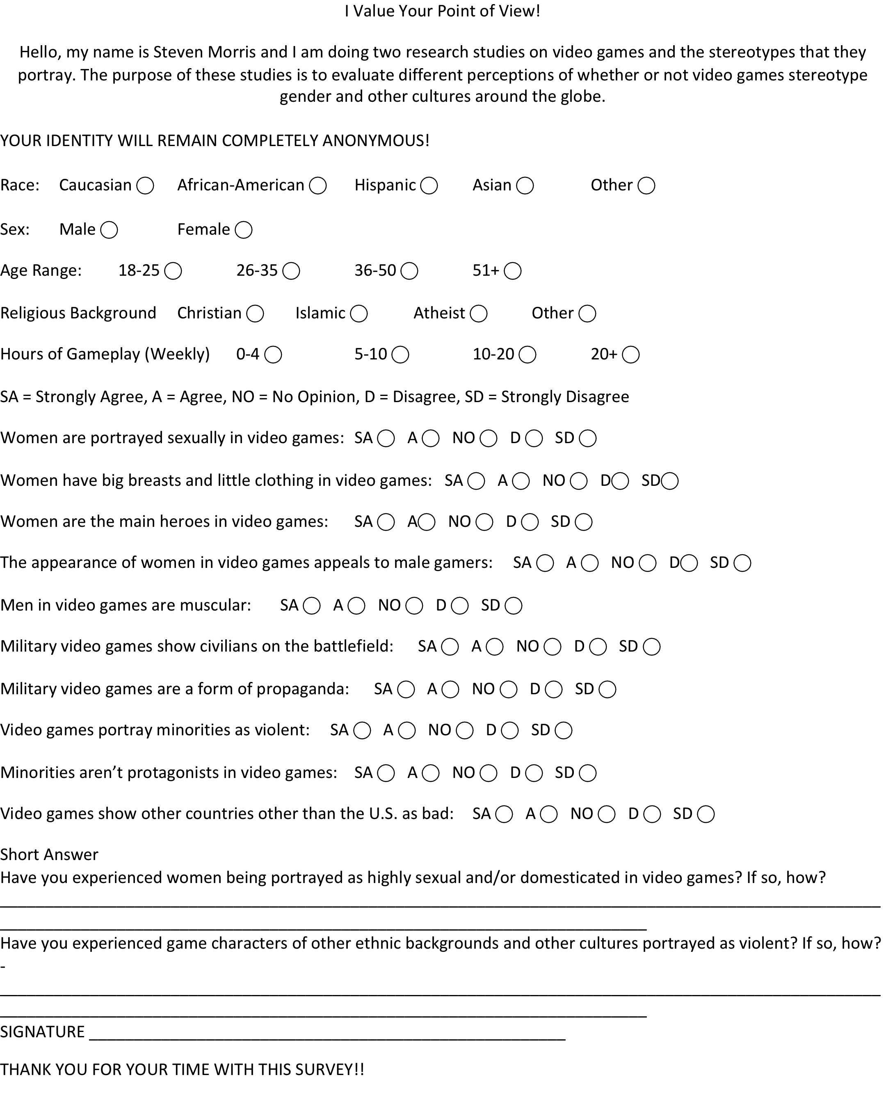

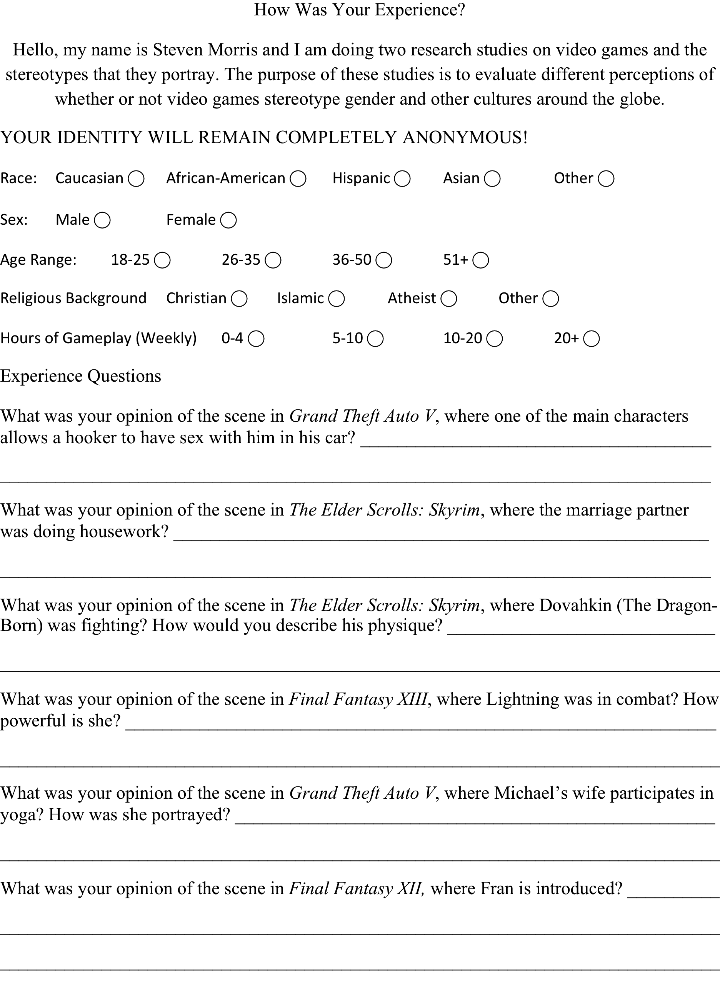

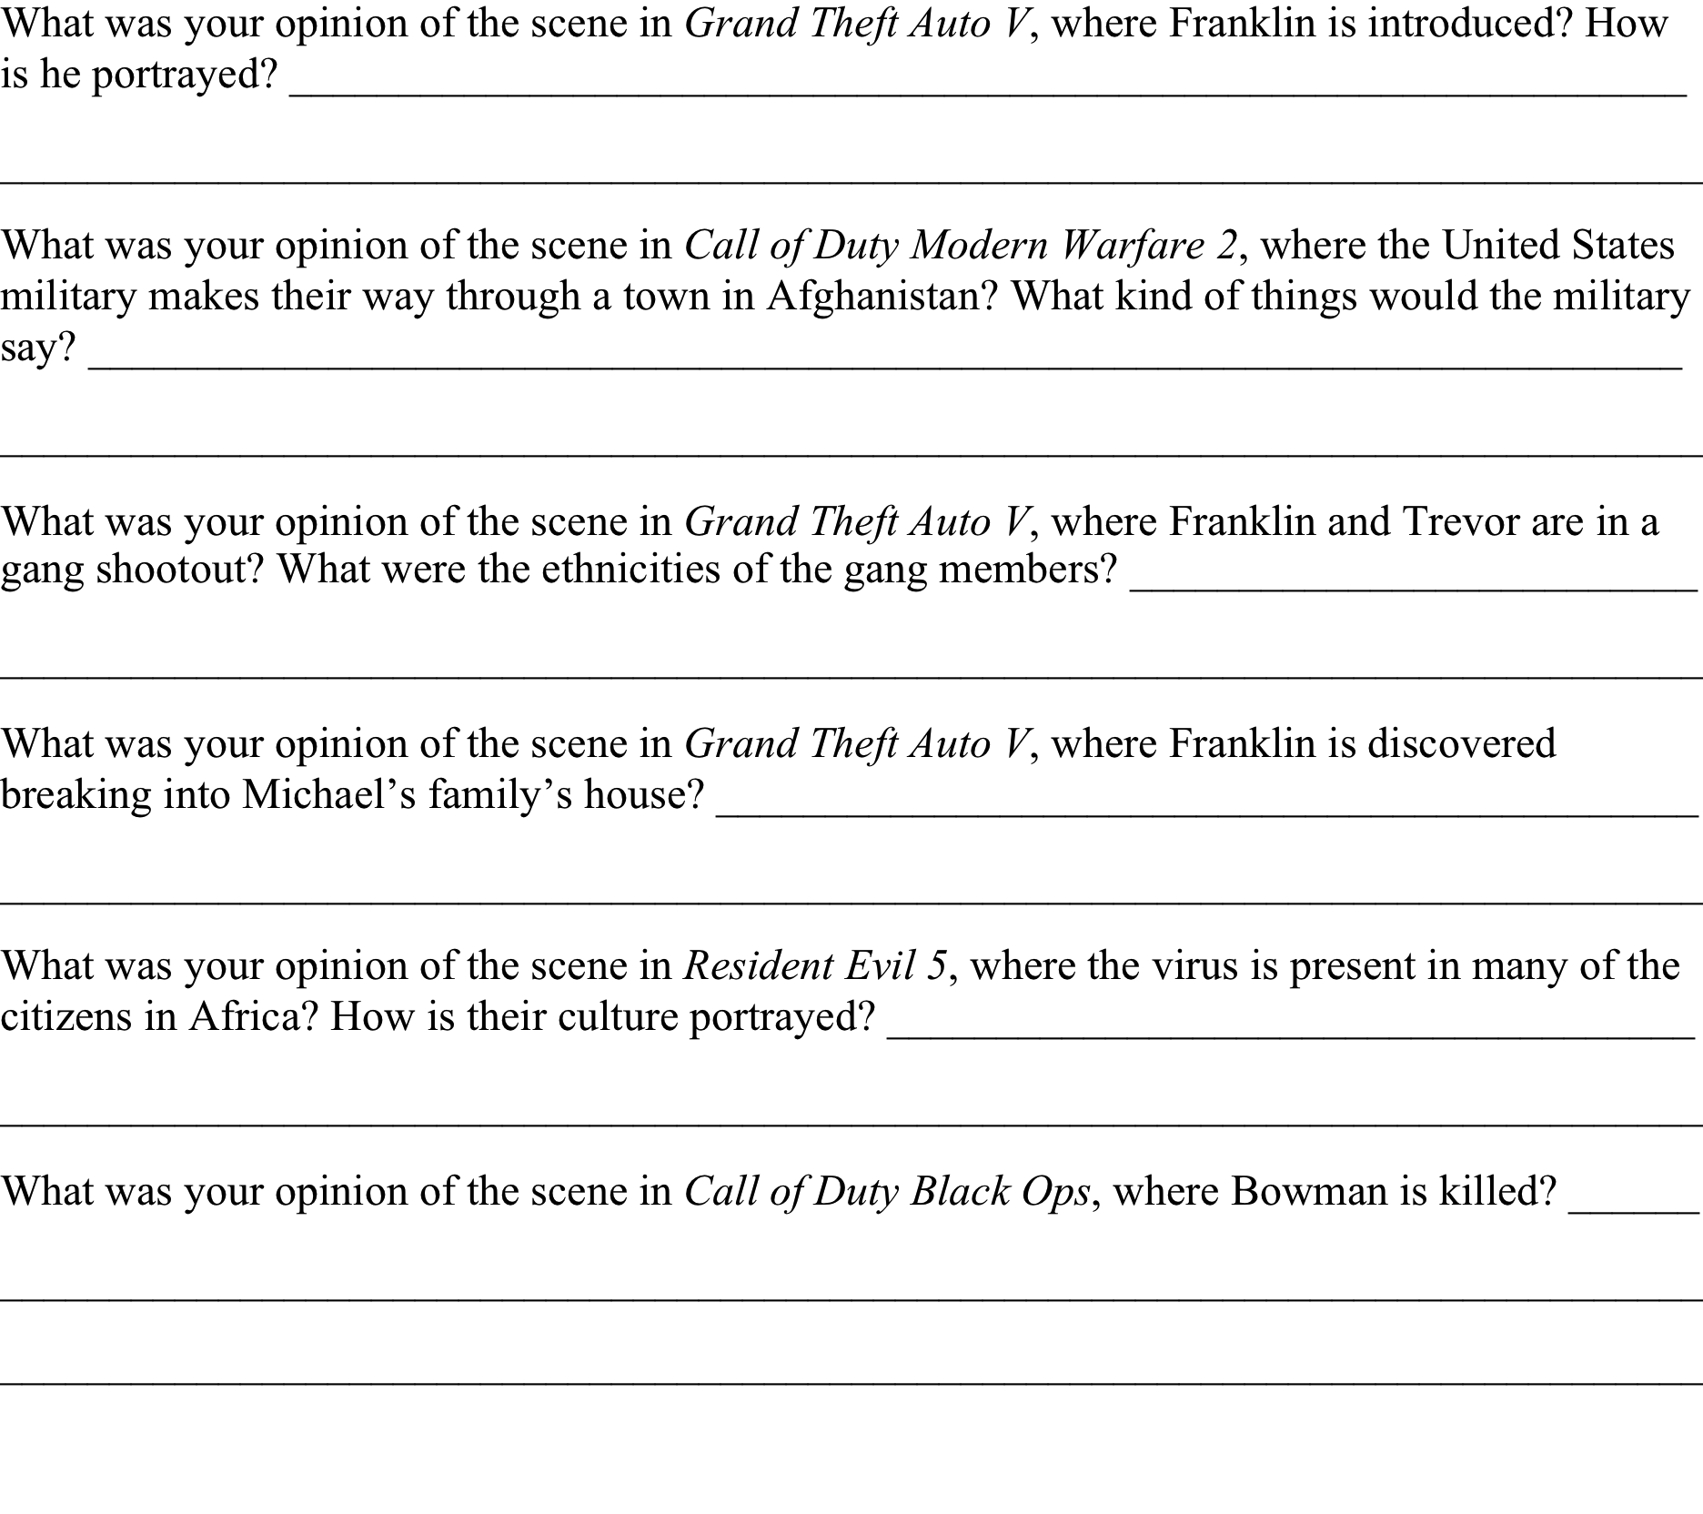

References

Everett, A., & Watkins, S. C. (2010). The Power of Play: The Portrayal and Performance of Race in Video Games.
Leonard, D. (2004, November). Unsettling the Military Entertainment Complex: Video Games and a Pedagogy of Peace. Toronto.
Souri, H. T. (2007). The Political Battlefield of Pro-Arab Video Games on Palestinian Screens. Middle-East.
Yusuf, O. (2009, July 30). Stereotype vs. Humantype: Race and Culture in Video Games.

