This advertisement is an example of the Theory of Reasoned Action. Because the theory itself focuses on behavior as the outcome rather than the attitude change, the advertisement aims to bring a positive light to the hospitality industry by including job growth statistics and the flexibility of the industry. Normally, it is assumed that the hospitality industry is currently viewed in a low light, as it is assumed that college-level individuals do not consider hospitality as a viable post-graduation option. However, these students know the importance of choosing a degree program in order to receive financial assistance and graduate. By including facts, this advertisement allows for students to obtain information to share with salient others to help motivate them to make a decision. By including volition, correspondence, and time through the various portions of the advertisement, the ad ensures that there is a valid relationship between intentions and behavior. Assuming that college students undecided in their degree program are wanting to make an informed decision regarding their education quickly, their resulting behavioral beliefs know that failure to do so will cost time and money—therefore strengthening the belief as a whole. Finally, it is assumed that readers will evaluate this advertisement positively, as it is reaffirming their present behavioral beliefs. By including a call to action and focusing on time, this advertisement will ensure they will act quickly.
The second factor that predicts intention to perform a behavior is predicting the subjective norm. It is assumed that the normative beliefs of this target audience will expect support from his/her salient others as they declare their new major. Since the ultimate decision is not based on the salient others, their motivation to comply will remain high, as they will want to remain supportive.
Since this advertisement’s intention is to change attitude towards the hospitality industry, it is important that the three factors mentioned in the textbook are supported. First, it is assumed that the information regarding job growth and flexibility will add a new behavioral belief, as it will prove that the industry is not as bad as once thought. Second, this text also aims to change belief evaluation, as it aims to paint the industry as a viable option for those that enjoy helping others. Finally, there is a change in belief strength, as the new behavioral belief regarding the benefits of the hospitality industry will show that there is an opportunity for a more positive attitude after reading the advertisement. Because all three factors are included in this advertisement, it is expected that members of the target audience will change their attitude after reading the ad.
THEORETICAL RATIONALE: THEORY OF REASONED ACTION
Target Audience: Non-degree seeking/undecided students
Tenet 1: Change behaviors, not attitudes. | The goal of the advertisement is to change student behavior from indecision to seeking a degree in Hospitality.
Tenet 2: There is a relationship between intentions and behaviors: 1) volitional control; 2) Correspondence between intentions & behavior (action, target, context, and time); 3) Time between the intention and the behavior. | Yes, there will be a close relationship between intentions and behaviors based on the three factors mentioned in the textbook. Volitional control will be present, as the student him/herself is the only person able to speak with their advisor and make the final decision regarding their major. There is also a correspondence between intentions and behavior, as the action refers to switching their major to the target—a hospitality degree. By including an icon for National University and urging them to change their future now, context refers readers to choose National University to change their degree quickly—as they know the financial penalty for waiting. Students are aware that college classes are expensive, and taking unnecessary courses will cost unnecessary money. This ensures that the amount of time between the intention and behavior is as low as possible.
Tenet 3: Attitude toward behavior -The strength, salience, and type of beliefs will affect behaviors | Non-degree and indecisive students currently hold an attitude that it is important to choose a degree program. Since each course they complete costs both time and money, they believe that it is important to make this decision early. Otherwise, it will cost them. Because of this, any advertisement assisting in this decision-making process will greatly benefit members of this target audience, as it solidifies their beliefs that it is important to quickly choose a degree program. Plus, including a call to action will further persuade the reader to react quickly.
Tenet 4: Subjective norm - Attitudes and thoughts about the beliefs of salient others & motivation to comply (or be in agreement with) salient others | Before making a decision on their educational goals and degree programs, students will speak with at least 2-3 salient others to ensure they are making the right decision. This is why it is important that the advertisement includes pertinent facts to discuss with their salient others.
Tenet 5: People have a different balance between their reliance on their own attitudes and the attitudes of others | While this target audience values the opinions of others as they make their final decision regarding their degree program, potential students are self-focused. At the end of the day, the degree will directly benefit the student him/herself, while only indirectly benefiting their friends and family members.
Tenet 6: All these issues lead to an intention (or not) to adopt a behavior, and hence to the adoption of a behavior (See Tenet 2) | Since colleges know that a student’s thought process may partially rely on the thoughts and opinions of others, the ultimate decision is up to the student him/herself. By including facts and statistics, a glimpse into the industry’s flexibility, as well as a call to action to “change their future”, this advertisement aims to persuade the reader to look into the industry further, and adopt the desire to complete a degree in Hospitality.

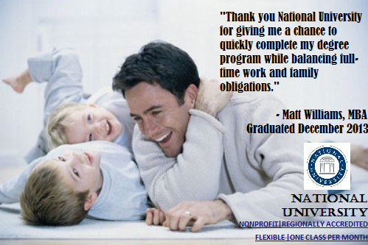
This advertisement is an example of the Theory of Planned Behavior. The advertisement itself allows readers to consider their control beliefs when making the final decision to continue their education, as it is assumed that single dads will connect with the graduate’s story and realize that they have the opportunity and resources available to achieve their educational goals. This perceived power created through the ad is expected to urge readers of the target audience to respond to the advertisement. The advertisement aims to alter the readers’ perceived behavioral control by providing information on National University’s ability to allow for single parents to complete a degree without sacrificing family or work obligations. Because of this, it is expected that reading the advertisement will result in stronger behavioral intentions towards going back to college.
THEORETICAL RATIONALE: THEORY OF PLANNED BEHAVIOR
Target Audience: Single dads
Tenet 1: Focus on behaviors rather than attitudes. Includes behaviors that are under volitional control…and those that are not. | The goal of the advertisement is to show busy dads that they can still choose to complete a degree program without sacrificing other important duties.
Tenet 2 Attitude toward behavior -The strength, salience, and type of beliefs will affect behaviors | Since members of this target audience are currently busy with work, family, and social obligations, current attitudes regarding education are weak, as it is difficult to find time to return to school. However, even though the task itself is difficult, many members of the target audience understand that it is important to complete a degree, as it will allow them to better support their family. The purpose of the advertisement is to use a personal story as a viable option to meet educational goals without having to sacrifice their other needs.
Tenet 3: Subjective norm - Attitudes and thoughts about the beliefs of salient others & motivation to comply (or be in agreement with) salient others | Because their children are a major part of a single father’s life, the attitudes of their children are extremely important, as they need to ensure the child supports their decision.
Tenet 4: People have a different balance between their reliance on their own attitudes and the attitudes of others | Members of this target audience are other focused, as their ultimate goal is to benefit their children.
Tenet 5: People perceive whether or not they have volitional control over a given behavior. | The person will think they have volitional control, over the behavior to choose to complete a degree, as they are the only ones that can decide whether or not they can find the time to take a college course.
Tenet 6: All these issues lead to an intention (or not) to adopt a behavior, and hence to the adoption of a behavior (See Tenet 2) | Because the advertisement’s intention is to show members of the target audience that there is an alternate option to allow for a healthy balance of full time family, work, and school obligations, it is expected that members of the target audience will be more likely to adopt the behavior after reading the ad.

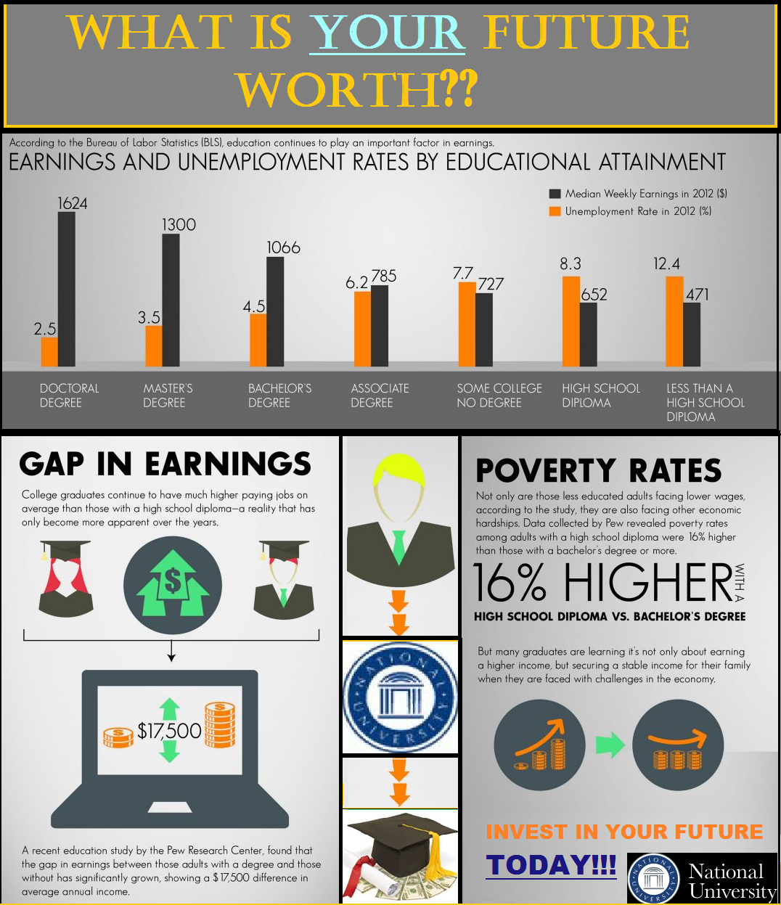
This advertisement is an example of the Elaboration Likelihood Method – Central Route. Because members of the target audience know the importance of education, but understand that the process is time consuming, expensive, and difficult, they are more likely to engage in high elaboration and cognitive energy in order to ensure they are making the right decision about going back to school. By including charts, graphs, and information from valid, powerful sources, this process is made much easier, as the advertisement itself allows readers to answer preliminary questions without having to conduct additional research.
THEORETICAL RATIONALE: ELABORATION LIKELIHOOD METHOD-CENTRAL ROUTE
Target Audience: Individuals without degrees
Tenet 1: There are two ways to persuade: Through thinking and through feeling | The advertisement aims to persuade others to return to school to obtain a Bachelor’s degree.
Tenet 2: The central route is one where people think, use cognition: 1) product is expensive; 2) complex; 3) difficult to attain; 4) unfamiliar. | For members of the target audience, although they know that completing a Bachelor’s degree is expensive and difficult to attain, they are unfamiliar with the process. Therefore high elaboration and central processing will be needed before a reader will react.
Tenet 3: The central and peripheral routes require different strategies. | Attention – The presence of graphs and charts grab attention from the reader  Interest – The information discussing the benefits of an education will generate interest, as members will be interested in earning more money and gaining employment  Comprehension – The graphs, charts, and sources will help readers better comprehend the ad, as the visual assistance will help with mental processing.  Acceptance – Since valid sources are being used in the charts, graphs, and information, readers will be more likely to accept the ad’s message.  Motivation – The increase in money and opportunity for employment will help motivate readers to react.  Retention – The ad’s information will assist in retention, as readers are forced to think deeply about the contents of the advertisement. Therefore, the ad will remain in their thoughts afterwards.

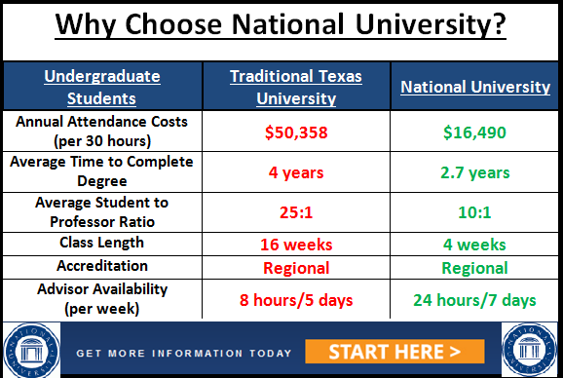
This advertisement is an example of the Elaboration Likelihood Method – Peripheral Route. Because the advertisement uses large graphics and little information, the ad itself requires little cognitive energy to understand. This will appeal to cognitive misers, as peripheral cues (presence of evidence) and coloration of the advertisement will ensure the message is received with little to no brainpower needed. Since it is assumed that college-bound individuals are bombarded with advertisements discussing which school to choose, it is important that any messages or advertisements present succeed in embedding the mindset that National University is the more valuable choice. As long as this message is received, persuasion is expected to occur.
THEORETICAL RATIONALE: ELABORATION LIKELIHOOD METHOD-PERIPHERAL ROUTE
Target Audience: College-bound individuals
Tenet 1: There are two ways to persuade: Through thinking and through feeling | The advertisement aims to persuade college-bound individuals to choose National University because of its value to students.
Tenet 2: The peripheral route is one where people are not motivated to think about the product, service, or idea because it is 1) inexpensive; 2) simple; 3) taken for granted – commodity; 4) easy to find; 5) familiar | People will not be motivated to think deeply about the advertisement because:  Inexpensive – the chart proves that National University is clearly the more valuable choice  Simple – The advertisement is simple and refrains from unnecessary information. Bold, bright red and green colors are also included to increase the ease of understanding.  Taken for Granted – In the state of Texas, individuals are expected to attend college after high school. Therefore, many view college as a commodity.  Easy to Find – There is an abundance of college choices in the state of Texas.  Familiar – Because National University is familiar in the state of Texas, they will recognize the name when reading the ad.
Tenet 3: The central and peripheral routes require different strategies. | Presence – By using large graphics, large button, and bright colors, the ad’s message can be easily understood during times of low elaboration.  High Frequency – The graph proves at a glance that National University is the better choice when choosing a college.

