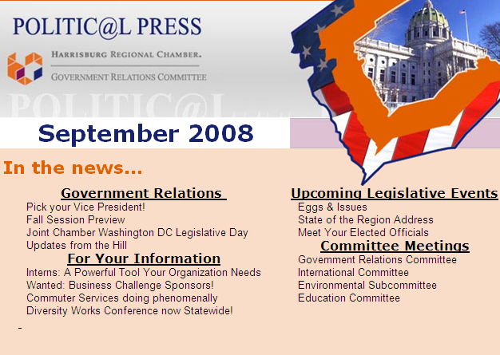
For Your Information
Interns: A Powerful Tool Your Organization Needs
by Brian Reilly, Coordinator-Harrisburg Keystone Innovation Zone KIZtoobox.com
"I don't have time to train an intern." "We’re too busy to start an internship program." "We don't have the resources to oversee interns in our office."
All three of these responses are quite popular excuses from employers destined to fall behind the pack in the knowledge economy and represent a fundamental misunderstanding of the importance of internships in today's workforce. While most employers assume running a successful internship program requires a high time commitment with taxing oversight, others like Google, Exxon Mobil and Nike understand that effectively utilizing interns can actually yield huge benefits and save employers substantial time to focus on what is most pertinent. In fact, a five year study by the Internship Institute found that, "a qualified manager can gain 225 full 8-hour workdays of productivity, in a calendar year, by effectively utilizing college interns."
Got your attention?
I know a lot of people that would be very interested in 225 extra days to work on a task or two. Unfortunately, when presented with the idea of creating an internship program the most common response from an employer is one of those listed above – there’s just not enough time for interns. This is such a strange misconception to those who understand effective internship programs actually save immense amounts of time. Not only that, but internships are a proven, cost-effective way to recruit and evaluate potential employees. If, for whatever reason, you feel less than content with the performance of a college intern you have no obligation to do anything except let their internship expire at the end of their semester. While you may wish you could let a few employees expire after they've been on payroll for 4 months, it gets a little more complicated after you've taken them on full time.
So perhaps you're willing to consider an internship program but don't know how to get started? (If you're still not convinced on the value of hiring interns check out the Top 10 Reasons Your Organization Benefits from an Internship Program) The most comprehensive resource available to employers at no cost on starting and maintaining a successful internship program can be downloaded from StayInventCentralPA.com. The website provides a number of resources completely clear of any cost for organizations located in Southcentral Pennsylvania, including a page where employers can submit an internship opportunity to over 70 college career centers at once. Since the website launched in August of 2007, over 100 local companies have posted nearly 200 internship positions using the site. Exit surveys from organizations that have used the site indicate that 83% of employers saw an increase in applications for posted positions, and 92% of the users would recommend the site to other organizations.
If you're interested in additional turnkey tools for effectively facilitating your internship program, the Internship Institute, hands down, offers the most complete and affordable toolkit for managing the entire internship program from beginning to end. I have personally reviewed their products and can attest they are well worth the investment.
As much money as it costs to find great employees by advertising online and in the paper, it's a wonder to me that more companies both large and small are not taking advantage of internship programs to replace their costly recruiting efforts and fulfill future workforce needs. Especially in today's marketplace of daily evolving technology, the average college student is much better suited to bring new perspectives to old problems than any workforce before it.
The real question is not how to find time to manage an internship program, but rather how can you afford the time not to?
For more information, please contact Brian Reilly at (717) 213-5046 or breilly@hbgrc.org.

