

Manufacturer of High Performance Analog
and Mixed Signal Integrated Circuits

COMPETITIVE ANALYSIS

JANUARY 2008

Table of Contents
Summary………………………………………………………………….… 3
Website…………………………………………………………………....… 3
Date Established……………………………………………………………....3
Company Focus………………………………………………………….…...3
Main Office/Headquarters…………………………….…………………..… 4
Manufacturing/Principal Facilities………………………………………...… 4
Executive Management…………………………………………………….... 4
Partners/Alliances …………………………………………………..…….…. 4
Total Number of Employees ………………………………..……………..… 5
History ……………………………………………………………………. ....5
Latest Development and R&D …………………………………………….... 6
Mission…………………………………………………………………… .... 6
Vision …………………………………………………………………….…..7
Product Line ……………………………………………………………….…7
Target Market/Applications ……………………………………………........ 8
Main Customers …………………………………………………………… 10
Sales Channels ……………………………………………………………....11
Apparent Strategy ………………………………………………………........11
Brand Recognition ……………………………………………………….….12
“Claim to Fame” …………………………………………………………….13
Quality …………………………………………………………………....…14
Lead Time. ……………………………………………………….……….…14
Comparative Analysis (Strengths/Weaknesses) …………………………......14
Opportunities……………………………………………………………...… 16
Threats ……………………………………………………………………… 16
Market Share ………………………………………………………………... 17
Sales ………………………………………………………………………….17
Patents …………………………………………………………………….… 17
Events…. ……………………………………………………………………. 18
Key Financial Information………………………………………………...… 19
Press Releases/Articles……………………………………………………… 20
Relevant Supertex Conference Call Transcript Quotes………………………29
High Voltage LED Driver Data Sheets……………………………………….30
COMPETITIVE ANALYSIS

Summary | Company is a publicly held mixed signal semiconductor manufacturer, focused in high performance analog and high voltage interface products for use in the medical, flat panel display, automotive, industrial electronics and telecommunications industries. Supertex designs, develops, and manufactures these high voltage semiconductor devices and integrated circuits utilizing state of the art DMOS, HVCMOS, and HVBiCMOS analog and mixed signal technologies  Supertex was established in 1976 and is headquartered in Sunnyvale, California. During the 2007 fiscal year net profit increased by 35% and sales grew 22%.
Website | www.supertex.com
Date Established | Incorporated in October, 1976; current president/CEO and senior VP since 1976 as well. Publicly traded in December 1983.
Company Focus | Design, develop, manufacture and market high voltage semiconductor devices and integrated circuits. Their products are primarily used in: medical ultrasound imaging systems; flat panel displays; high speed printer heads; EL keypads and displays; LEDs backlighting systems for LCD TVs, telecommunication and networking systems; and LEDs for general lighting fixtures.
Main Office / Headquarters | Supertex, Inc.  1235 Bordeaux Drive  Sunnyvale, Ca. 94089  Ph: (408) 222-8888  Ph: (800) 222-9883  Fax☹408) 222-4800  mktg@supertex.com  kennethv@supertex.com
Manufacturing Facilities | Silicon Valley Wafer Fabrication Facility  71 Vista Montana  San Jose, Ca 95134  63,000 square feet- 6 inch wafer fab (6,000 starts per month)  24,000 square feet- Class 10 Clean Room  Phone: (408) 222-8833  Fax: (408) 222-8840  Hong Kong  10 Sam Chuk Street G/F  1st/F and 2nd/F  San Po Kong, Kowloon  Hong Kong  23,600 sq ft. w/ additional 4,500 sq ft.  Sunnyvale, Ca  1235 Bordeaux Dr.  Sunnyvale, Ca  42,000 sq. ft.
Executive Management | Henry C. Pao, Pres/CEO  Benidict C.Choy, Senior VP/Secretary  Phillip Kagel, VP of Finance/CFO
Partners / Alliances / Subsidiaries | Innovion-Foundry Ion Implantation  Partner (Supplier) Supertex  Chandler Facility  7030 West Oakland St  Chandler, AZ 85226  hr@innovion.cc  Sales Office  tel: (480) 763-7042  fax: (480) 763-7099  Minco Technology Labs Inc.  (Value Added Die Products Distributor)
Total # of Employees | 401
History | Supertex began in 1976 by Henry C. Pao, and Benidict C.Choy, who currently serve as the CEO/President and Senior VP/Secretary, respectively.  In December of 1983, Supertex became a publicly traded company.  Supertex foundry business starts- 1976  Paradigm, a supplier of advanced memory products, builds a 5” fab in the early 90’s, upgrades it to a 6” in 1996.  Supertex purchases fab from Orbit Semiconductor- February 1999  Acquisition significantly boosts foundry business.  Henry C. Pao, Ph.D. (69 years old) President, Principal Executive and Financial Officer, founder of Supertex since 1976. Previously worked at Fairchild Semiconductor, Raytheon, Sperry Rand and IBM. Mr., along with his father and brother own greater than 13% of outstanding stock.  Benidict C.K. Choy, (61 years old) Senior Vice President and Secretary, Technology Development, founder since 1976. Previously worked at Fairchild Semiconductor, National Semiconductor and Raytheon.  Supertex Inc.’s Corporate Governance Quotient (CGQ®) as of 1-Jul-07 is better than 51% of S&P 600 companies and 72.8% of Semiconductors & Semiconductor Equipment companies
Latest Developments/R&D | During this fiscal year, (2007) Supertex launched 30 new products including LED backlight drivers for flat screen LCD and DLP TV’s and LED drivers for automotive and general lighting applications.  3 LED Driver ICs:  CL320  CL325  CL330  Each consisting of three channels of constant current output, designed to drive three LED strings at currents of 20mA, 25mA and 30mA each, respectively.  HV9980-  New 3 channel high voltage, LED driver IC. The IC is well suited for both LCD and DLP television applications.  HV9982-  New 3 channel LED driver IC designed to provide high LED current accuracy through closed-loop control of the output currents. It is specially designed for applications using RGB LED backlighting or multiple strings of white LEDs.  They foresee another record number of new products for 2008 including; IC’s for medical ultrasound imaging systems, Multi-segment EL driver ICs for keypads and displays and LED driver ICs for backlighting LCD and DLP TVs.
Mission | Supertex is focused on high performance analog and high voltage interface products for use in the medical, flat panel display, automotive, industrial electronics and telecommunications industries.  They focus on designing new products with existing process technologies, while also developing new process technologies to be used in future products. Their direct and close customer involvement allows them to develop products and processes that have real market value and bring timely and cost effective solutions to meet the needs of their customers.  “Our goals are to run an efficient operation, create value for shareholders and meet all our responsibilities as a good corporate citizen.”
Vision | “Supertex is committed to meet or exceed customer expectation in quality, delivery and cost. Continuous quality improvement, solidifying partnerships with customers and being a success in select markets drive the vision behind Supertex.”
Product Line | LED Driver IC’s for Backlighting, General and Automotive Lighting Applications, EL Lamp Driver ICs, Medical Ultrasound ICs and High Voltage Interface/Driver ICs.  High Voltage LED Driver ICs For Backlighting:  - HV9980  - HV9982  - HV9910B  - HV9911  - HV9912  LED Driver ICs for General and Automotive Lighting:  Switching Converters for the General Market  - HV9982  - HV9912  - HV9931  - HV9930  - HV9925  - HV9921/22/23  - HV9911  - HV9910B  Linear Regulators  - CL320//25/30  - CL6/7  - CL2/25  Switching Converters for the Auto Market  - AT9933  EL Backlight Driver IC Family:  Inductorless EL Drivers  - HV853  - HV850  - HV852  Single Segment EL Drivers  - HV860  - HV857L  Multi Segment EL Drivers  - HV862  - HV856/858  - HV509
Target Markets/Applications | They attempt to choose markets which are sizable enough to be worth pursuing but which are not large enough to attract fierce competition.  LED Driver and IC Family:  - Switching Converters for the general market  - Traffic signals  - Street lamps  - Offline LED lamps  - Decorative lighting  - Building accent lighting  - Wall dimmers  - Battery powered LED lamps  - LCD TVs and monitors  - RGB backlighting  - LCD panel backlighting  - DLP TV applications  - Switching Converters for the automotive market  EL Backlight Driver IC Family:  - Cell phones  - Luminescent watches  - PDAs  - Pagers  - Transceivers  - Measuring Instruments  - GPSs  - MP3 players  - Industrial/Power Controls  - Consumer electronics products  - Medical/Ultrasound ICs  - Entry-level medical ultrasound imaging applications  - NDT  - Ultrasound diagnostic imaging equipment  - Non-destruction metal flaw detection  - Piezoelectric transducer driving  - High-resolution scanners and cameras  - High Voltage Interface/Driver ICs  - High speed printers  - LCD displays  - Inkjet and Electrostatic Print heads  - Plasma Panels  - Vacuum fluorescent  - Large Matrix LCD Displays
Main Customers | GE for ultrasound, Motorola for handsets, Samsung for LCD TV’s.  Others are unknown  According to the transcript for the Q2 Earnings Conference call, Supertex has smaller handset customers in Korea, Japan and China which contribute to less than 5% of sales for that market.
Sales Channels | Direct Sales Offices:  - US Sales Offices  - VP World Wide Sales  Pete Petersen  Irving, Tx  - Western U.S. Sales  Rex Caballero  Sunnyvale, Ca  - North, Central and South America Sales Manager  Robert W. Salter  Novato, CA  - Eastern U.S. Sales  Andy Sabol  Oley, PA 19547  - Central U.S. Sales  Frank Roso  Irving, Tx  - Supertex International Sales  - European Sales  Nic Houslip  United Kingdom  - Taiwan Sales  Charles Hsu  Taiwan R.O.C.  - VP Asian Sales  Hong Kong  - Southern China Sales  Shenzhen, China  - Japan Sales  Kan Shida  Tokyo, Japan  - Northern China Sales  Fei Xia  Shanghai, China  - Korea Sales  Henry Kwon  Korea  Indirect Sales:  - North American Sales  - 49 US states  - Canada  - Mexico  Distribution:  - North American Distributors  - 27 US states  - Canada  - Mexico  International Distributors:  - 41 European Countries
Apparent Strategy | Their apparent strategy seems to be one of low cost  Supertex strives to be the leader in designing new products with existing process technologies as well as new process technologies to be used in future products, while promising unmatched quality, cost and customer service.  They have a variety of markets including LED Driver ICs, EL Lamp Drivers ICs, Medical Ultrasound IC’s and High Voltage Interface/Driver IC’s.  With 31 years of experience, Supertex boasts many successful products in each of these markets.  Their strategies for the LED/LCD markets include custom and proprietary.
Brand Recognition | Within the EL market, it can be assumed Supertex has good brand recognition by virtue of the fact that they have obtained orders from Motorola and other large companies.  Their brand recognition throughout the LCD TV market is unknown at this time, however, they have obtained orders from Samsung to backlight LCD TVs.
“Claim to Fame” | Supertex offers an extensive line of high-performance LED driver ICs for automotive lighting, display backlighting and general lighting applications.  Their claim to fame in regards to LED drivers and High Voltage Interface/Driver ICs would be the variety of products for multiple applications they offer at low cost.  The LED driver ICs range from simple, low-cost linear regulators to feature-rich switching regulators configured in buck, boost, buck-boost, and SEPIC (single ended primary inductor converter which is a DC-DC converter which allows the output voltage to be greater than, less than, or equal to the input voltage) topologies.  They claim their High Voltage Interface/Driver IC’s offer excellent channel density and small footprints, suitable for multiple applications requiring high voltage output.  ”We compete primarily on the basis of product innovation and responsiveness to the changing needs of customers, including both product specifications and delivery requirements.”
Quality | Supertex is committed to meet or exceed customer expectation in quality delivery and cost. As the level of their expectation increases every year, continuous quality improvement is critical to success in the competitive marketplace.  The following standards and specifications are integrated into Supertex’s manufacturing operations and process control programs:  - ISO 9001 International Standard  - FED-STD-209 Clean Room and Work Station Requirements  However, in discussion with M. Schade, she is unsure as to whether or not Supertex has overcome their EMI issues.
Lead Time | 2-4 weeks ARO
Comparative Analysis (Strengths / Weaknesses/ Product Comparisons) | Strengths:  - Company:  - Broad product line and market segments  - Over 30 years in business  - Solid partnerships established (Motorola, Samsung, GE)  - CGQ is better than 51% of S&P 600 companies and 72.8% of Semiconductor companies  - High Voltage Interface/Driver ICs:  - Suitable for multiple applications  - Voltage up to 300V  - Excellent channel density  - Current Source/Sink Compatibility  - LED Driver ICs  - Variety of applications for LED Drivers (backlighting, general automotive, flat panel TVs etc)  - Simple low-cost to feature-rich regulators  - Buck, boost, buck-boost, SEPIC topologies  - High efficiency (degree unknown at time)  - LED current matching  - Low noise  - Wide dimming range  - Wide input voltage  - Multiple output capabilities  - Low-cost LED solution  - HV Driver Experience  Weaknesses:  - Company:  - Product names- Boring!  - Customer Service on website inactive  - US Foundry (Delivery to Asia)  - Small number of customers  - Highly competitive market segment  - No long-term contracts with customers  - High Voltage Interface/Driver IC’s:  - Claims small footprints but no CSP or integrated LED driver  - LED Drivers:  - Inexperience in the field  Comparative Advantages  - 3 Channel LED Driver (HV9980)  - More efficient?  - Environmentally friendly?
Opportunities | - Over 30 new products launched in 2007 and claim more to come for 2008.  - Opportunity to expand market segment even more as well as increase sales and customer base.  - Supertex has its own foundry.
Threats | - Introduction of a more efficient 3-channel driver by competitors  - OLED  - Market acceptance of LED TVs is less than anticipated  - Shortage of copper  - General economic conditions  - Domestic and foreign markets  - Inability to launch new products in a timely manner  - Inability to maintain, create and enhance customer relationships.
Market Share | Dominant in EL driver provider, handset market and ultra sound segment.  Small share in LCD TVs.
Sales | Sales grew 22% and net profit increased 35% year-to-year in fiscal 2007.  Net Sales (in thousands) $98,020  Net Income (in thousands) $21,427  Imaging sales resulted in $41,058  (42% of the company’s sales)
Patents | - High voltage analog and mixed signal circuit design and device intellectual property  - Hold 15 US patents which will expire between 2008-2020  - Have additional US Patents pending.  - 1 LED Patent:  - Method and apparatus for efficiently driving a low-voltage device from a wide-range input supply
Events | - Strategies in Light 2008  Santa Clara, Ca  Feb.11-13, 2008  Santa Clara Convention Center  - SID Display Week 2008  Los Angeles, Ca  May 18-23, 2008  Los Angeles Convention Center  - Electronica 2008  Munich, Germany  Nov. 11-14, 2008  New Munich Trade Fair Center

Key Financial Information
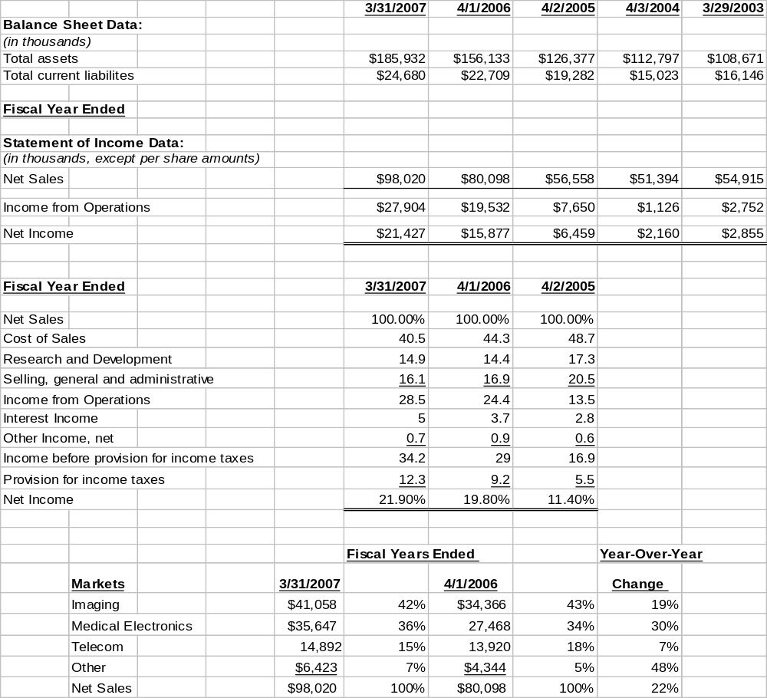

PRESS RELEASES / ARTICLES / OTHER ITEMS OF INTEREST
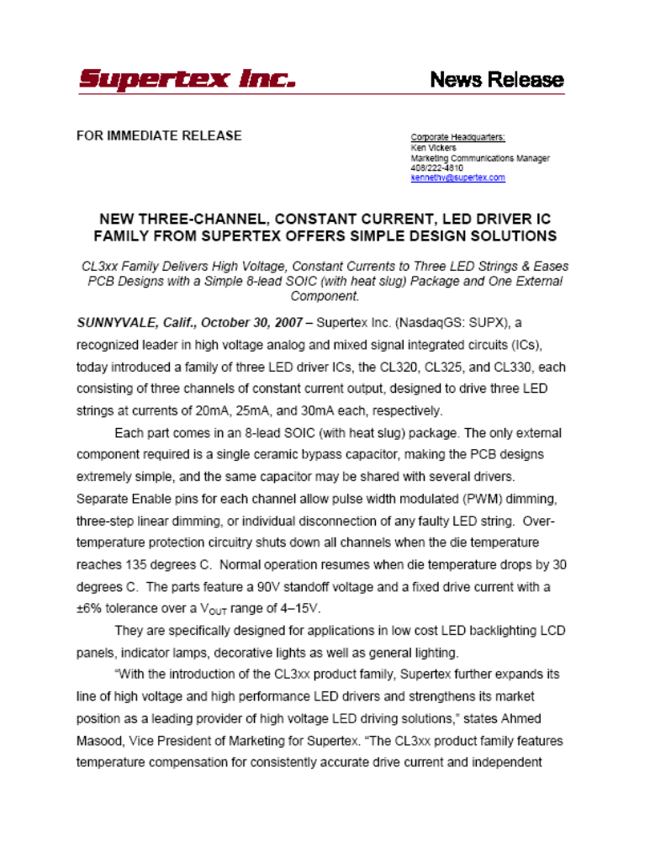

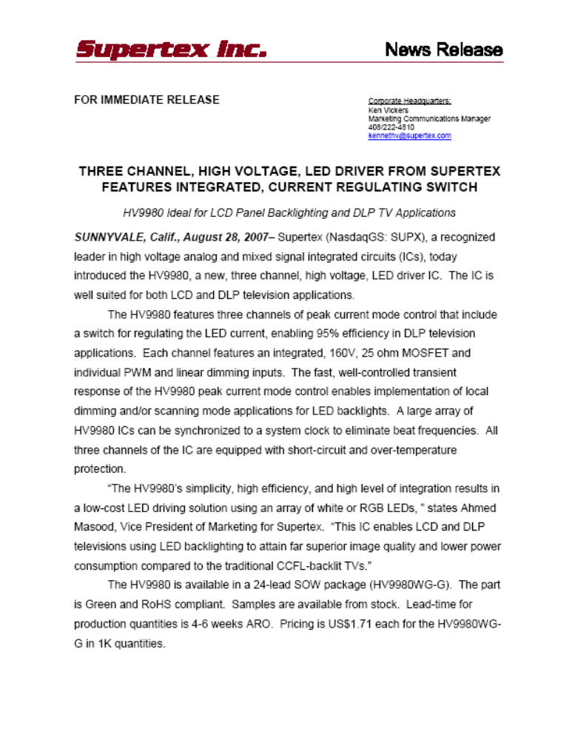

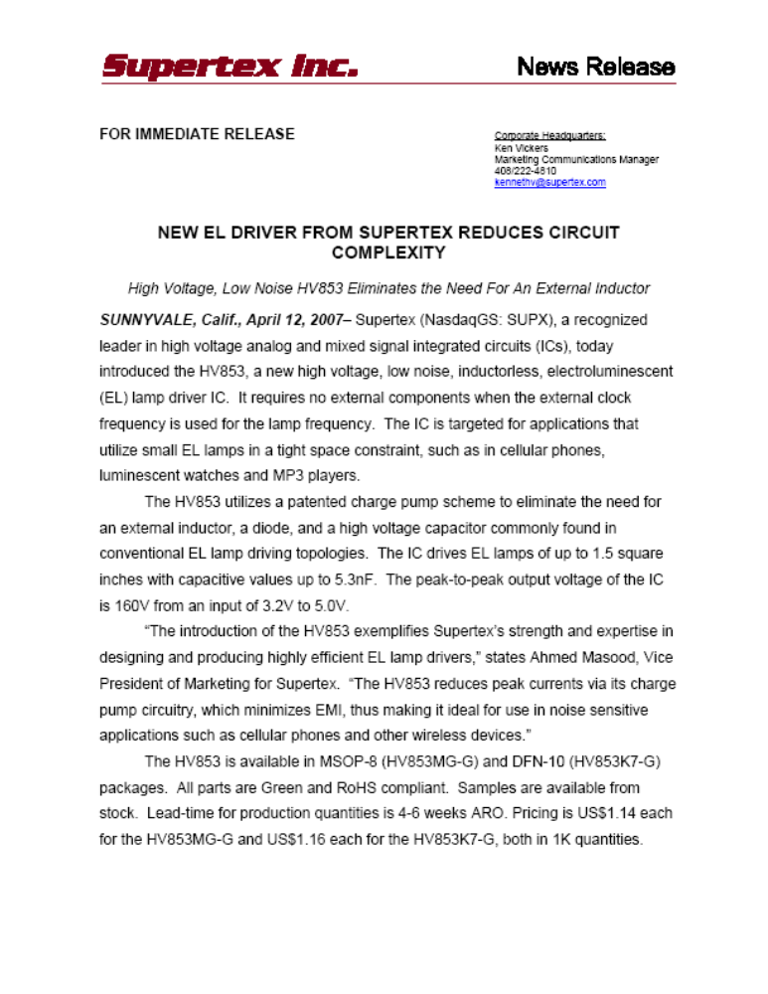

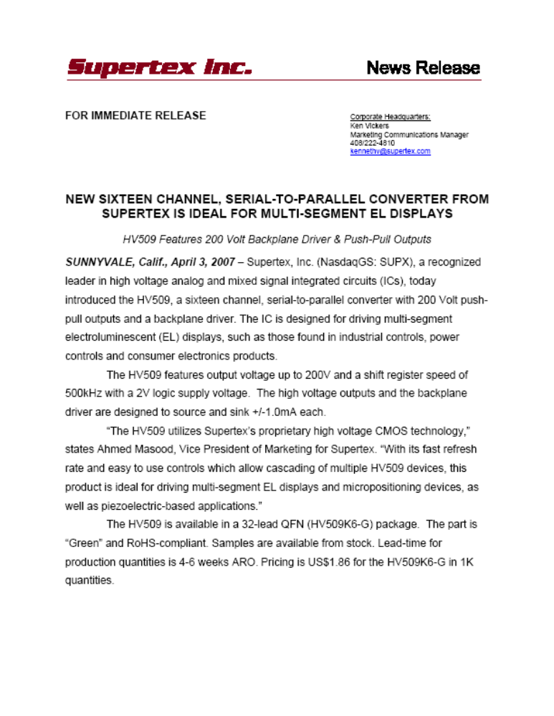

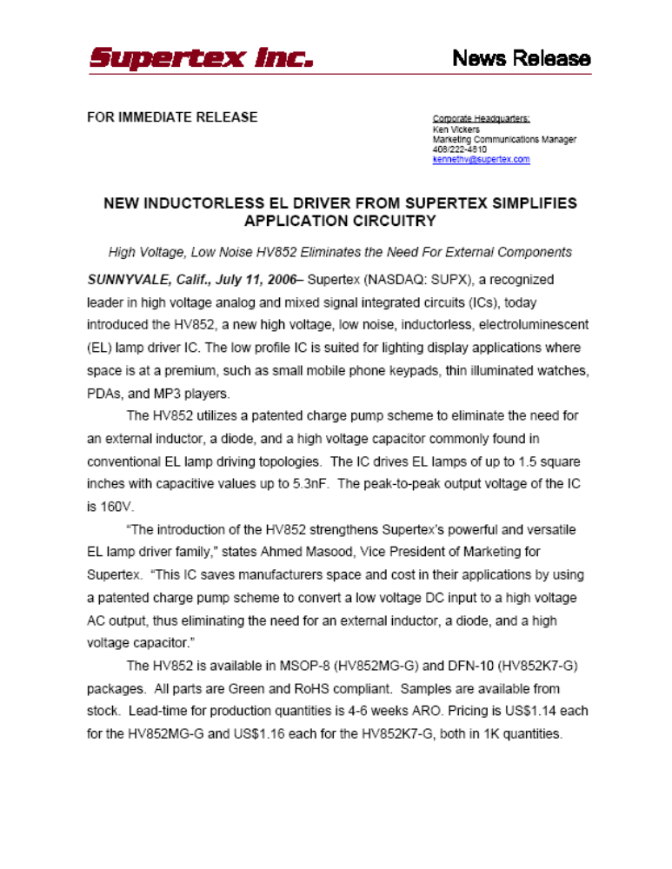

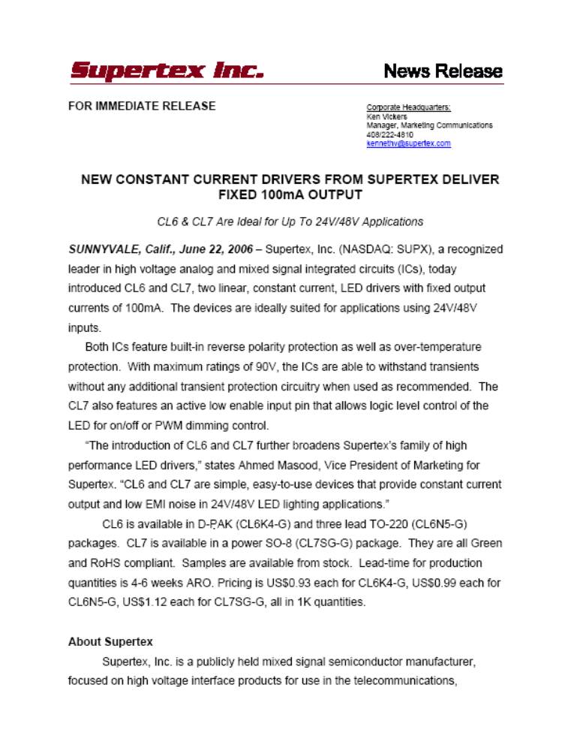

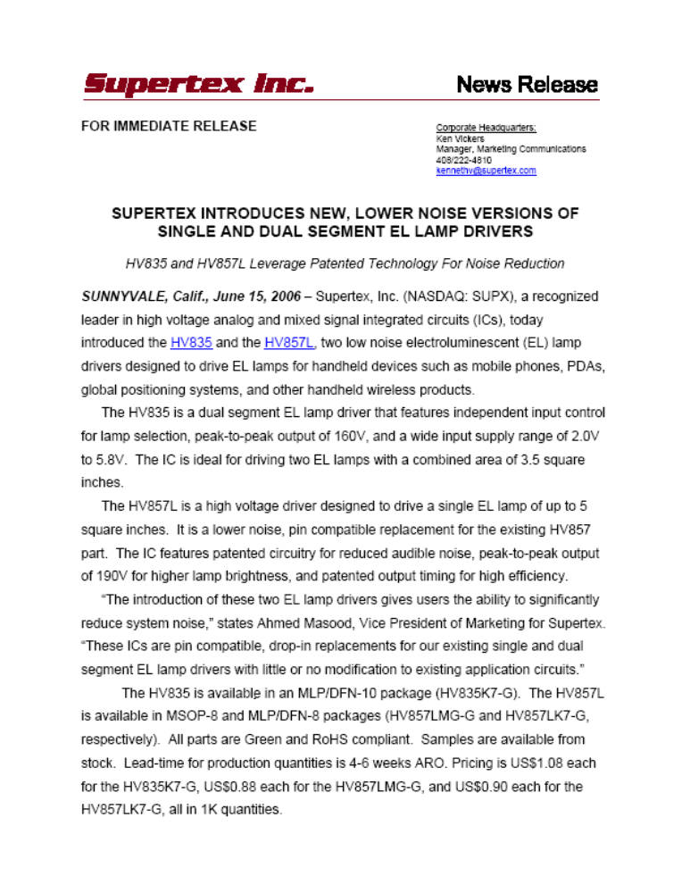

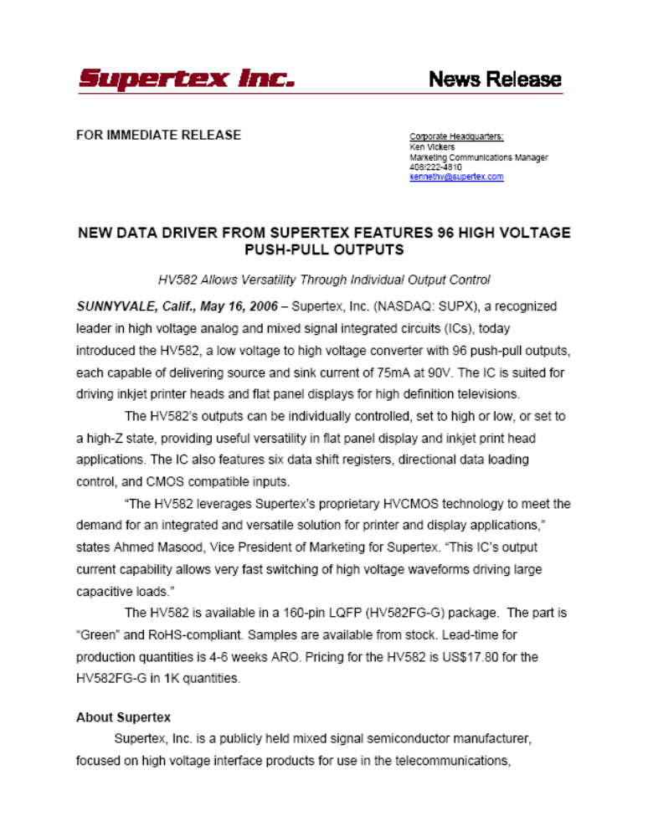

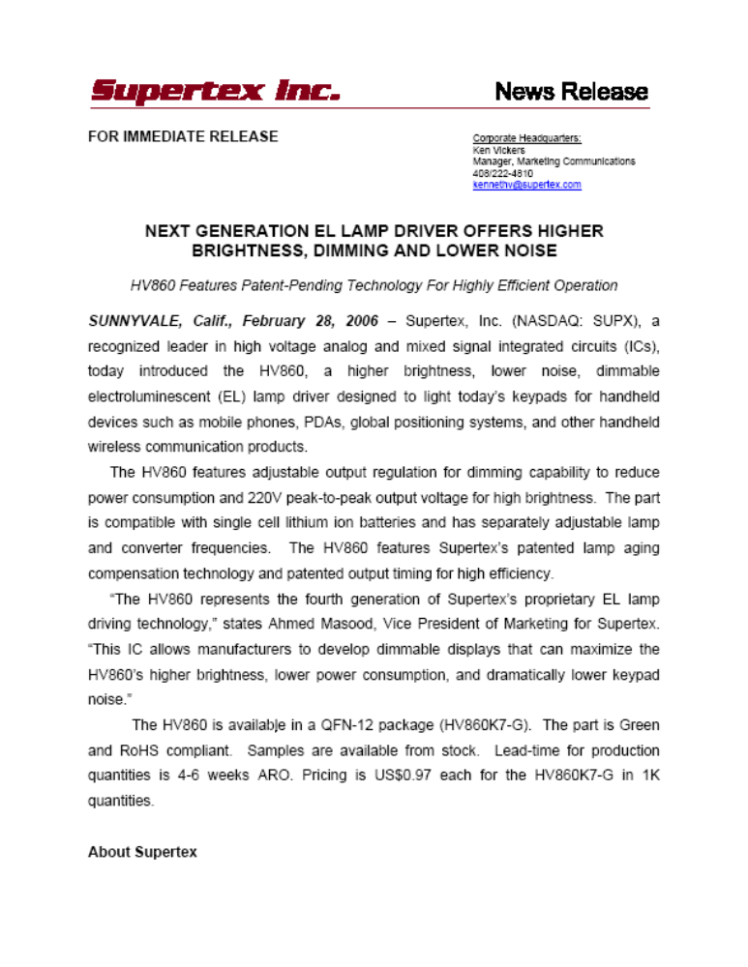

Relevant Supertex Inc. Q2 Earnings Conference Call Transcript
(Taken from Q&A Section)
10/23/2007
Concerning Handsets:

Henry Pao- Supertex, CEO, President
“…these are like multi-segment applications, Rob, so it could be a clamshell phone, it could be let’s say an iPhone type of phone. Touchpad.

Robert Katz- Investec-Analyst-
“Touchpad. And that’s with more than one customer?”

Henry Pao-Supertex CEO, President
“Right now, yes, we are working with more than one customer. Yes.”

Concerning LCD TV’s:

Robert Katz- Investec-Analyst-
“…Okay. And back to the TV, what type of content are you looking at in the TV right now? I know that varies by size but on average for a ---I guess a 46 or 52 inch TV?

Henry Pao-Supertex CEO, Preside-t-
“It depends on what kind of – like for instance on the DLP, the content is only three chips, so it’s less than $10, but for the LCD, it could vary from $20-$10.

Evan Wang-Thomas Weisel Partners-Analyst-
“I was wondering if you could talk a little bit about the LED drivers again for the LED backlit LCD TVs. Did I hear correctly you mentioned there’s some tier 2, tier 3 vendors interested now?

Ahmed Masood- Supertex-VP Marketing-
“Yes, that’s correct, Evan. Typically these guys follow what the first tier guys are doing, so those models are out and they’re busy taking them apart and all of a sudden, they found our phone number, so that’s why they’re calling us wanting parts from us, and wanting to help to get them designed into similar backlighting unit like the other guy is using.

Henry Pao-Supertex-Ceo, President-
“And that’s also true with the first tier other customers as well.”

Evan Wang-Thomas Weisel Partners-Analyst-
“Okay. Right now, for the LED drivers, do you have more than one customer, one user of this?”

Ahmed Masood-Supertex-VP Marketing
“Yes. We have a number of folks who are designing with it, one guy who has actually announced a number of products with it, other guys have not announced yet.”

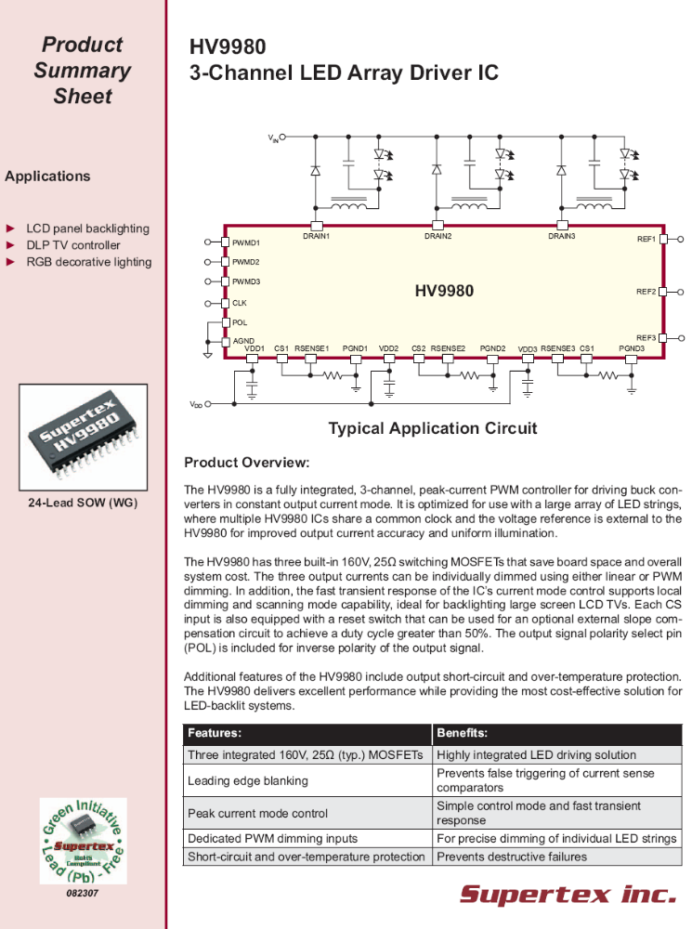

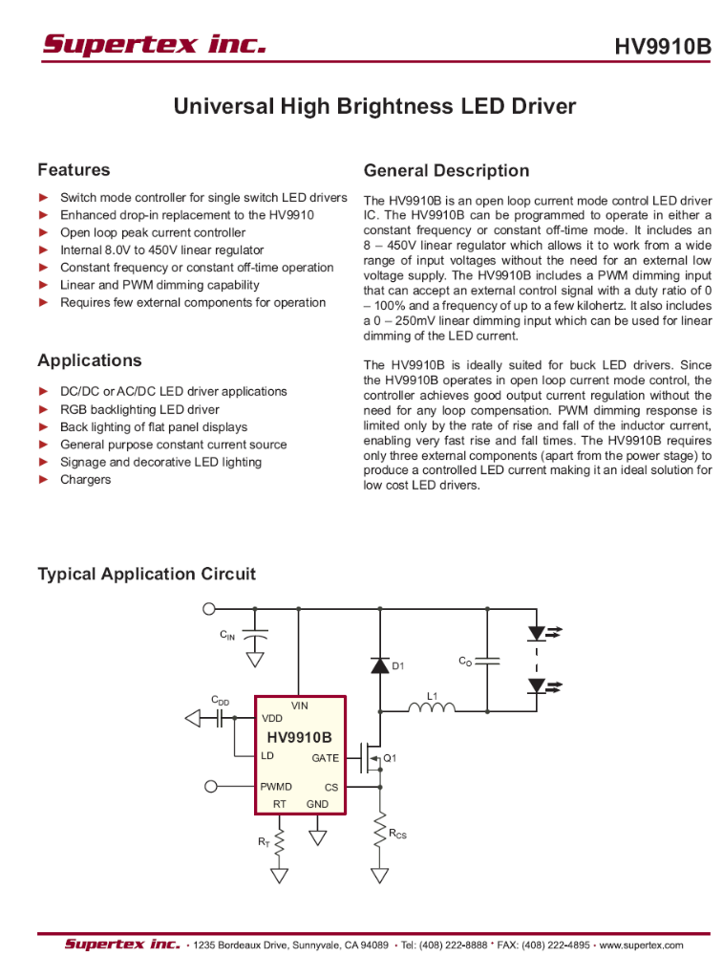

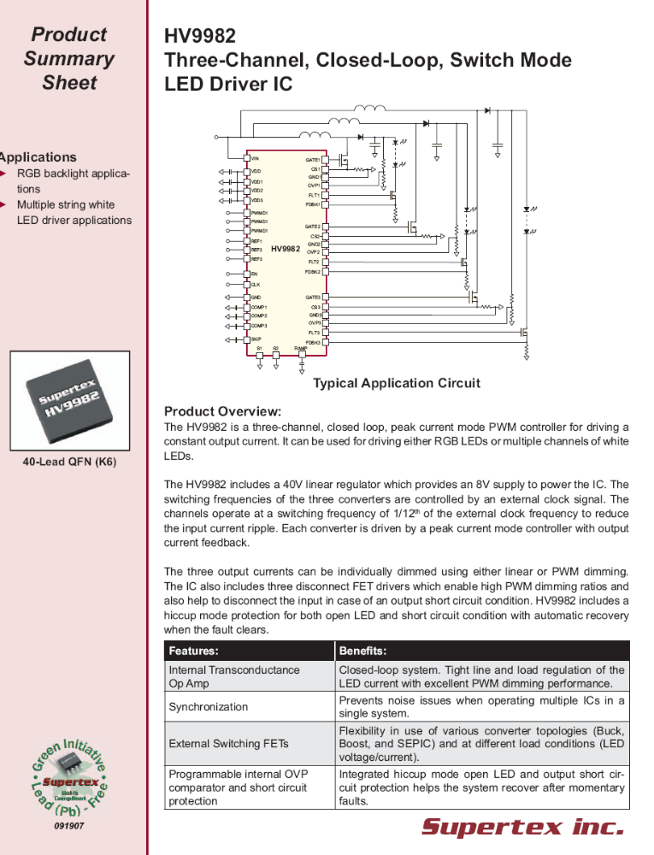

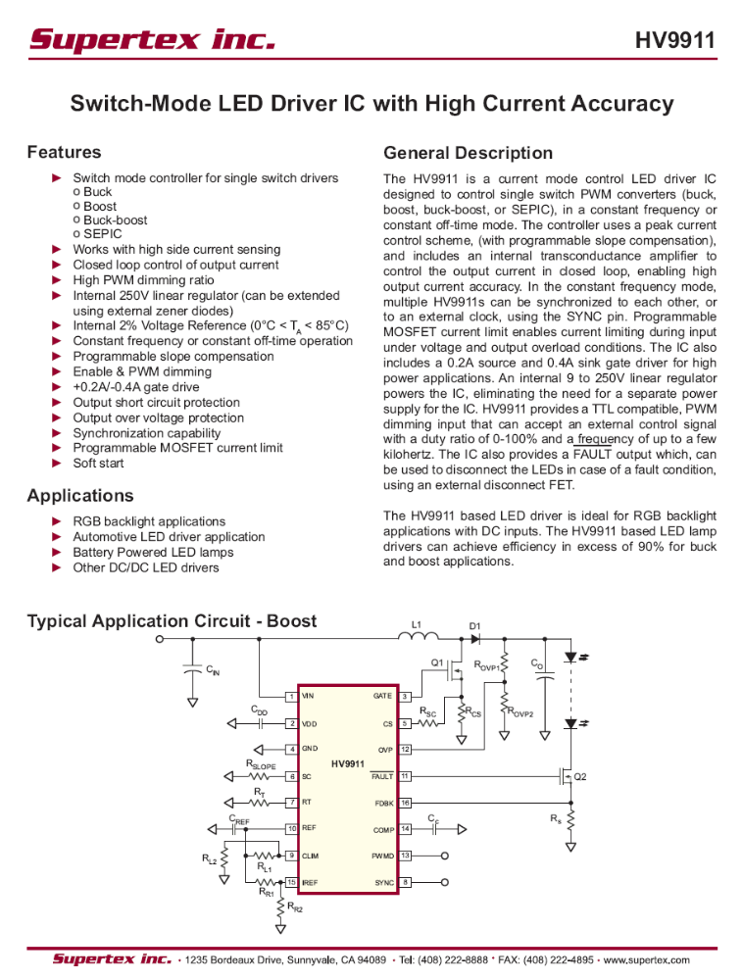

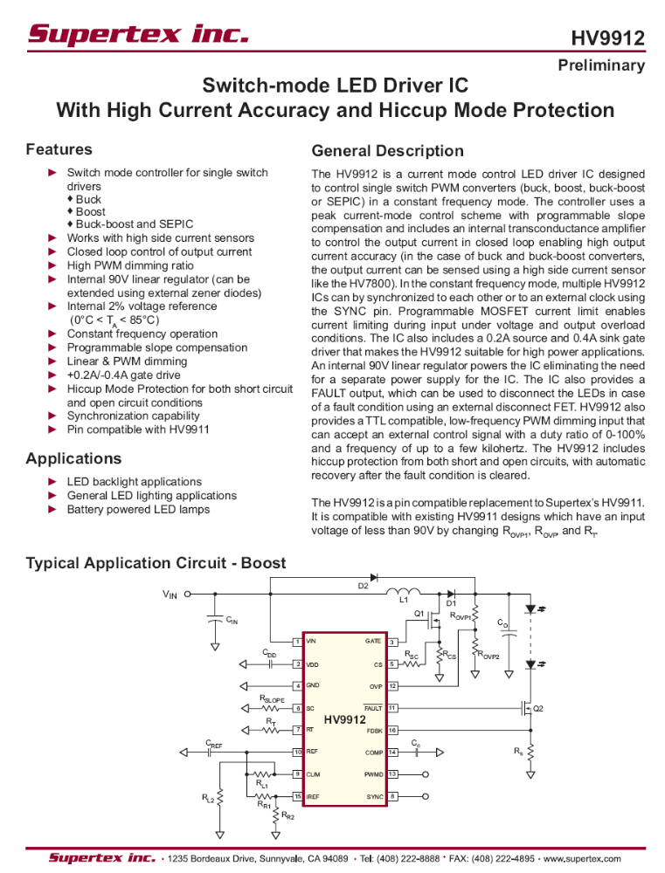

? Information from Supertex Inc. 2007 Annual Report SEC Form 10-K

