## UML for Actor – Scholarship Office

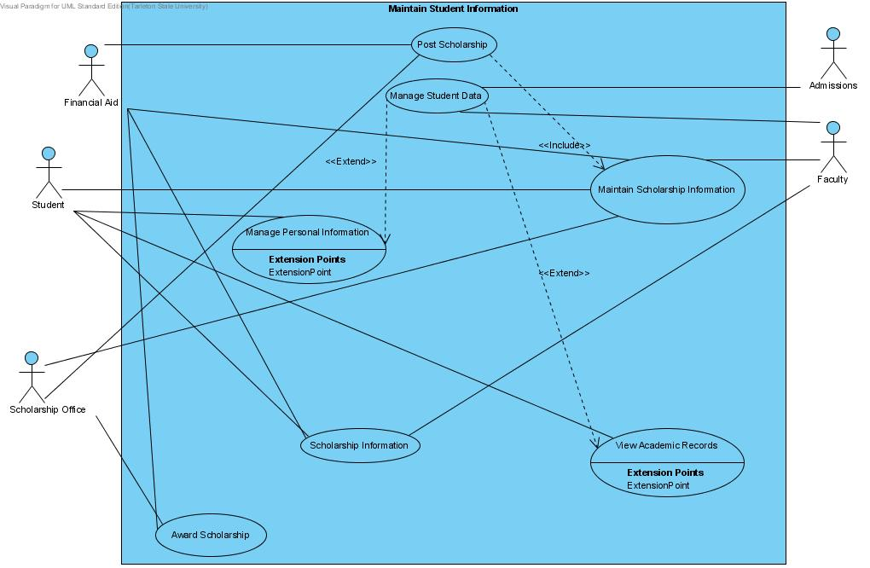

## UML Diagram for Actor – Student

